UNIT ASSET COORDINATOR GUIDE: USE the ASSET ALERT NOTIFICATION TO FIND ASSETS REQUIRING UPDATES IN WORKDAY – QUICK REFERENCE GUIDE (QRG)
Reference guide on how to find and update Asset Records requiring updates in Workday
Workday Job Aid – Quick Reference Guide

Quick Reference Guide (QRG)
Purpose
The purpose of this Quick Reference Guide (QRG) is to provide a high-level overview of the asset acquisition & registration processes before the Unit Asset Coordinator (UAC) becomes involved and then illustrate the UAC steps that need to be followed to finalize an asset record by adding:
- The physical location of the asset
- The physical inventory tag# (in Workday this is the “Asset Identifier” field)
- The asset custodian information (in Workday this is the “Issued To” field)
- If available, the serial number of the asset

This document includes:
- a brief summary of the asset acquisition and registration process
- an explanation of the Unit Asset Coordinator Alert notification report
- steps for using the Alert report to navigate to asset records requiring attention
- instructions for adding Location and Issued to information to new asset records
- instructions for adding Missing Asset Identifier and Serial number information
- an explanation re: why it is important to respond to alert notifications in a timely fashion

Audience
- Unit Asset Coordinator
- UWA Business Asset Tracking Specialist (for information only)
- UWA Business Asset Accountant (for information only)

Asset acquisition and registration
Equipment will be requisitioned in Workday. The person completing a requisition will enter Worktags that apply to the purchase, including a Cost Center and Spend Category. If a “trackable” Spend Category is used for an equipment purchase, when the PO line is marked as received, it will trigger the Business Asset Accountant (BAA) and the Business Asset Tracking Specialist (BATS) to begin the asset registration process and select the correct accounting for the asset. Both the BAA and BATS roles are reserved for Central Office use only and will be assigned to staff in the Equipment Inventory Office.

What is the Unit Asset Coordinator Alert Notification Report?
Unit Asset Coordinators will see an “Alert” notification when they have asset records that require their attention. The alert is generated for any asset that is missing one of more of the following three fields:
1) asset location 2) Asset Identifier (used to hold the physical tag#) or 3) Asset Custodian ( “Issued to” field

UNIT ASSET COORDINATOR RESPONDS TO ALERT

As UAC, respond to Asset Alert Notifications
Alert notifications can display to any Workday user for a variety of reasons. UACs will want to check their Homepage regularly to see if they have asset alert notifications and if yes, respond to them in a timely manner.
As a UAC, log into Workday and perform the following steps to update assets requiring attention:
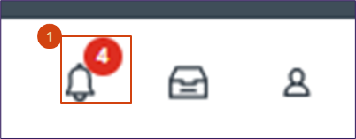
- Click the displayed Alert bell to review the list of Notifications.

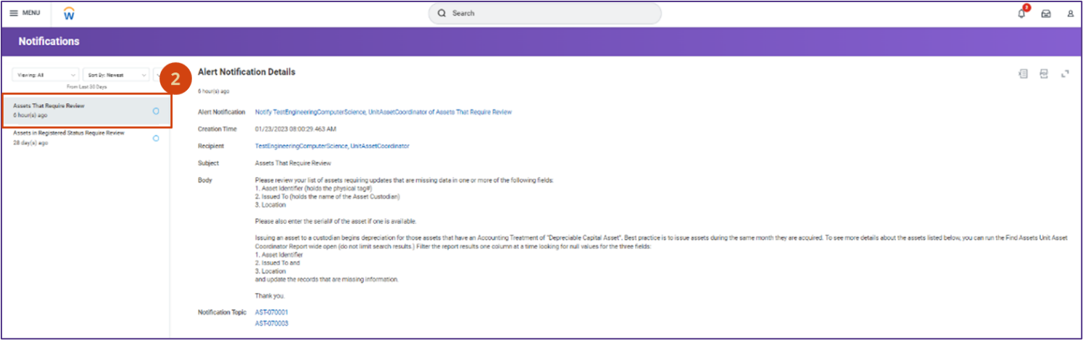
- Click on the most recent asset notification to see the Alert Notification details

Note: The Draft Message text may be updated.

- From the displayed list of Workday Asset IDs on your Asset Alert Notification, right click the linked assets to open them in a new window and review each record for missing information
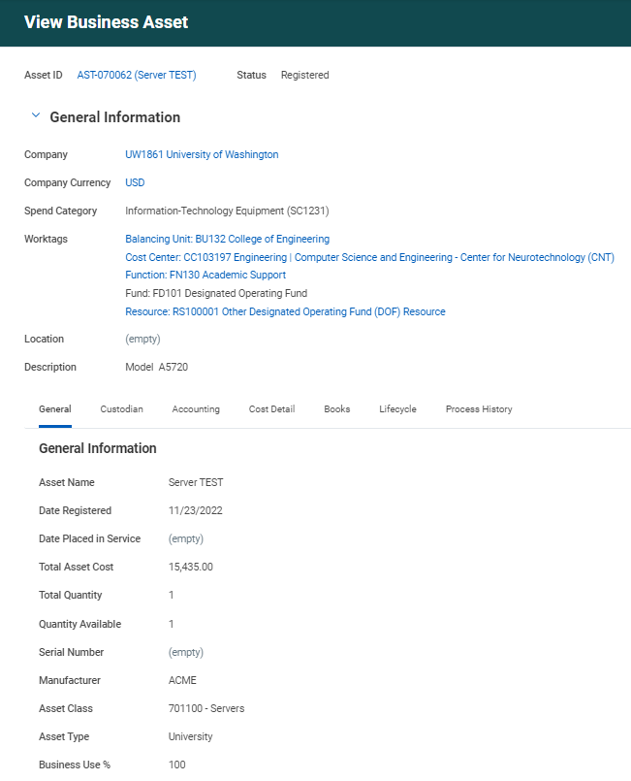
This is a newly registered (test) asset that is missing:
- Asset location
- Issued to information: (when populated, the Issued to field displays below location)
- Asset Identifier (a.k.a.: physical tag number) (when populated, appears above the Serial number field)
Note: A missing serial number will not trigger the alert notification, but this information should also be added when available for the asset.

How to Update missing Location and Issued To fields:

- Click the related actions icon ( )
- Click Business Asset
- Select Issue to a Worker
6
5
4

- From the Issue Asset to a Worker screen, follow the instructions to enter an effective date. For assets procured in Workday, this will be the acquisition date.
- In the Issue To field, enter the name of the person responsible for the asset (the Asset Custodian)
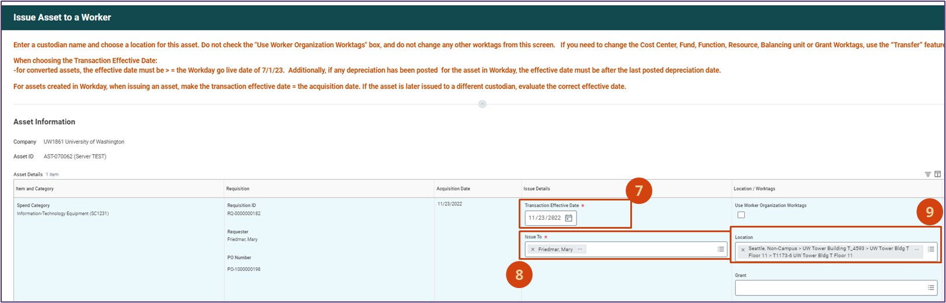
- In the Location field, search for and select the location of the asset at the room level

- Click Submit
- You will now see the Location and Issued To information populated on the asset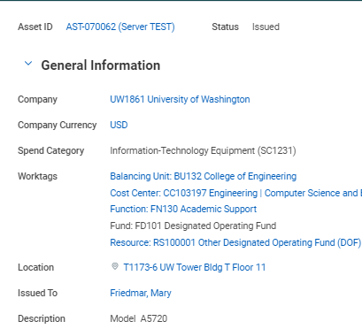
11

Update Missing Asset Identifier and Serial Number fields:
- Click the related actions icon ( )
- Click Business Asset
- Select Edit
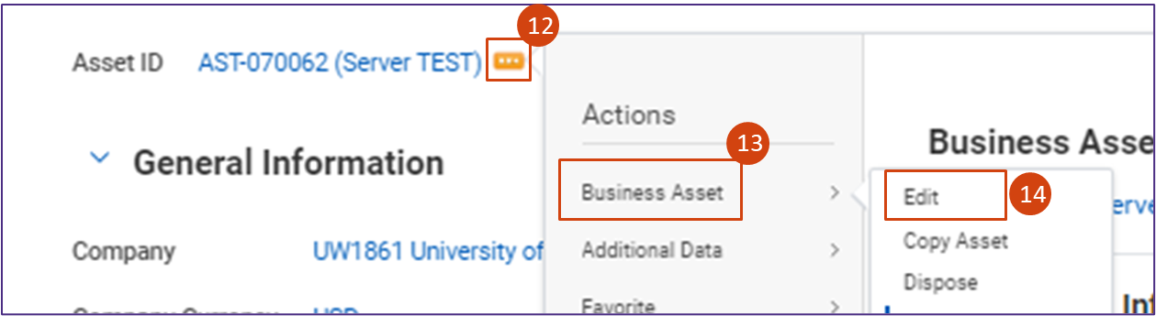

- From the Edit Asset screen:
a) Add the physical tag number to the Asset Identifier field
b) If available, populate the Serial Number
- Click OK
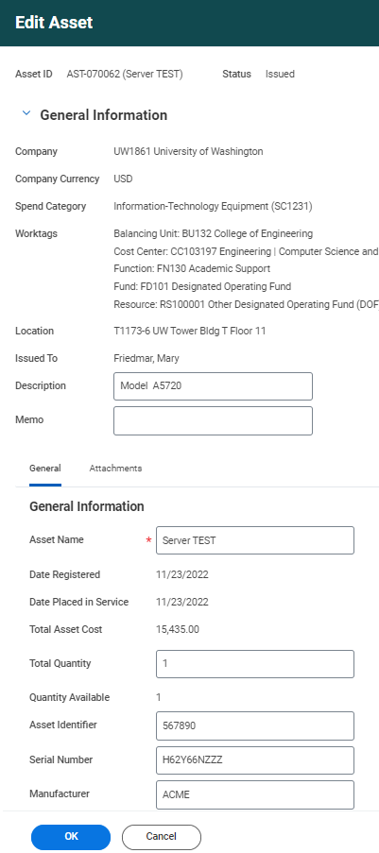
16
15a
15bb

- You will now see the Asset Identifier and Serial Number populated for the asset:
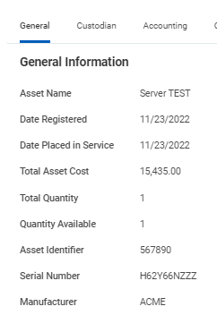
17
- Continue reviewing your list of Assets requiring updates to add the missing information to each asset that appears on your alert report.

Why it is important to respond to Alert Notifications quickly?
UW will be recording depreciation monthly, so it’s important that assets be issued in the month they are acquired. Issuing a newly registered asset to a custodian is what triggers depreciation to begin for the asset. In the example above, the entered effective date was 11-23-22, this means November will be the first month depreciation calculates for this Asset as shown below. When we issued the Asset, two depreciation tabs were created for the Asset: Depreciation Summary and Depreciation Detail. The depreciation detail page looks the same, but also includes all the worktags for the asset for each period.
