How to Add K Award Cost Share to the FEC

as a Source for Cost Sharing Sharing

UNIVERSITY OF WASHINGTON MANAGEMENT ACCOUNTING AND ANALYSIS

Finance and Facilities

W

Review K Awards for Level of Effort Requirements

Independent Mentored Awards (K01, K07 Developmental, K08, K22, K23, K25, K99/R00)

* For mentees, determine the K Award effort requirement, typically 9 person months or 75%.

Institutional Mentored Awards (K12, KL2)

* Scholars on these awards generally have a 9 month, 75% effort commitment.

Non-Mentored Awards (K05, K07 Leadership, K18, K24)

* Normally the non-mentored awards require between 3-6 month -25%-50% effort. The K02, however, may require 75% effort. Review each non-mentored award to determine the effort requirement.

Determine Compliance with Effort Commitment

* Determine if the level of paid effort meets the requirement (e.g. 75%). If it does, no cost sharing is required.
  + Salary cap cost sharing is considered effort on the K Award and included in the total effort requirement.
* If the K Award was not active for the entire cycle, prorate the percent requirement accordingly.
* For faculty whose average paid FTE is less than 100%, departments should ensure that the faculty member is contributing the 9 months required by the award.

To add cost share documenting required effort (e.g. 75%)

* Click the “Adjust/View Cost Share” button on the online FEC.
* Choose “Add Item”

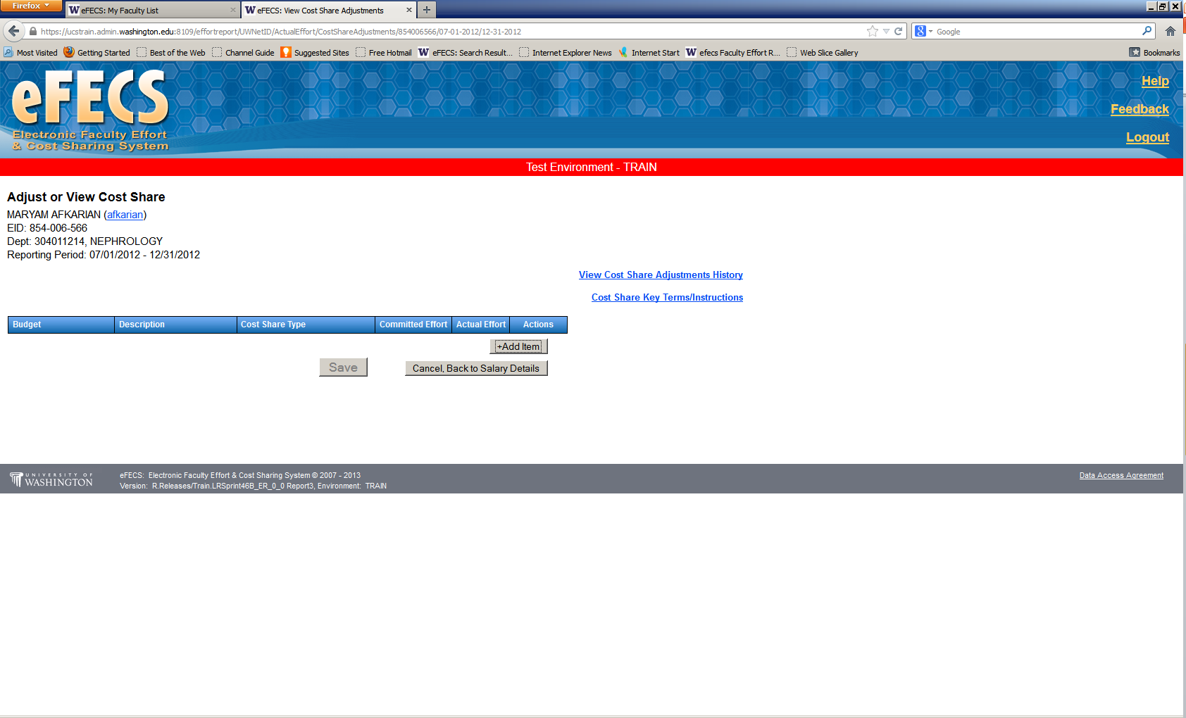

* Select the K Award budget # from the drop down list
* Select “K Award” as Cost Share Type
* Enter the Cost Share %
* Press “Save”

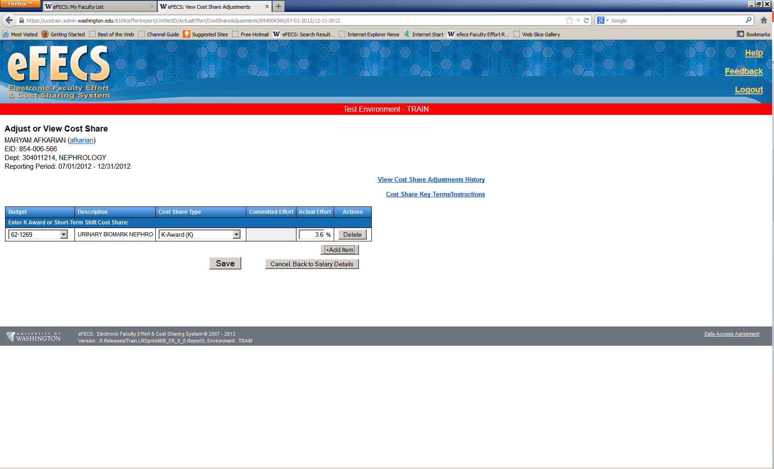

* Cost share percentage will now appear on the FEC. The % in the total line should be 75% or the negotiated effort commitment, if different.

Faculty Cost Share: <http://f2.washington.edu/fm/maa/fec/costshare> Questions: [efecs@u.washington.edu](mailto:efecs@u.washington.edu)

[efecs@u.washington.edu](mailto:efecs@u.washington.edu)

[efecs@u.washington.edu](mailto:efecs@u.washington.edu)

[efecs@u.washington.edu](mailto:efecs@u.washington.edu)

[efecs@u.washington.edu](mailto:efecs@u.washington.edu)