Uninstall Firefox
To uninstall Firefox, follow these steps:
- At the top of the Firefox window, click on the Firefox button and then select Exit
- Click the Start Menu and select Control Panel. The Control Panel window will open.
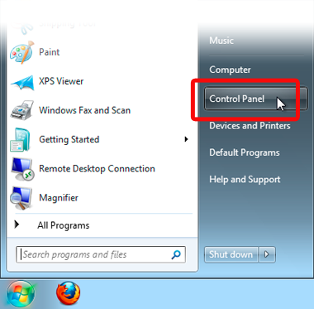
- In the Control Panel window, click the Uninstall a program link under the Programs section.
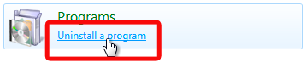
- From the list of currently installed programs, select Mozilla Firefox.
- To begin the uninstall, click the Uninstall button at the top of the list.
If the Uninstall Wizard does not run, you can start it manually by runninghelper.exe, which is located in one of these locations by default:
(32-bit Windows) C:\Program Files\Mozilla Firefox\uninstall\helper.exe
(64-bit Windows) C:\Program Files (x86)\Mozilla Firefox\uninstall\helper.exe
- In the Mozilla Firefox Uninstall Wizard that opens, click Next.
- Click Uninstall.
  - If Firefox is still open, you must close Firefox to proceed with the uninstall.
  - If you want to remove your Firefox user data and settings, put a check mark in the box that says Remove my Firefox personal data and customizations. If you select this option, Firefox will not preserve your bookmarks, saved passwords, and other data if it is installed again.
  - To provide feedback on your Firefox experience to the development team, select Tell us what you thought of Firefox.
- Click Finish.
- To remove other files and folders that may not be removed by the uninstall, you must manually delete the Firefox installation folder, which is located in one of these locations by default:
  - (32-bit Windows) C:\Program Files\Mozilla Firefox
  - (64-bit Windows) C:\Program Files (x86)\Mozilla Firefox

