**Uninstall Internet Explorer 11 on Windows 7**

[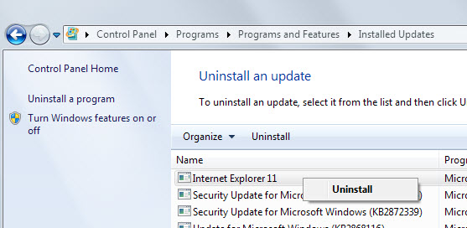](http://cdn.ghacks.net/wp-content/uploads/2013/09/uninstall-internet-explorer11.jpg)

Windows 7 users can uninstall Internet Explorer 11 on their system. It needs to be noted that this restores the previous version of Internet Explorer that was installed on the system. This can be IE8,9 or 10 depending on whether the browser has been upgraded in the past.

1. Click on the start menu and select Control Panel from the menu that opens up.
2. Select Uninstall a program under Programs.
3. Internet Explorer 11 is not listed in the installed programs listing. It is listed as an update, so select View installed updates from the left sidebar.
4. The browser is listed in the Microsoft Windows group. You have two options to find it here. Either click on the first entry and type Inter in rapid succession, or sort the whole listing by date.

This removes Internet Explorer 11 from the Windows 7 system and replaces it with the version of the browser that was installed before it. On my system, Windows 7 Pro 64-bit, that was Internet Explorer 8. You can then keep using that browser, or update to Internet Explorer 9 or 10 instead.