**University of Washington**

**Faculty Effort and Cost Share Certification**

**Guidelines for Determining and Adjusting**

**Salary Cap Cost Sharing for UW/VA Appointed Faculty**

**Overview:**

After careful consideration, including consultation with the National Institutes of Health (NIH) and peer institutions, the University of Washington (UW) will no longer require faculty with salary paid directly by Veteran’s Administration (VA) to prorate their UW Institutional Base Salary (IBS) for determining if they exceed the NIH salary cap provided they have a fulltime appointment at the University. Faculty having less than a fulltime appointment with the UW, will be required to prorate their University IBS to determine if they exceed the salary cap.

The change recognizes that the fulltime rate of compensation reflected in the University’s payroll system (HEPPS) for UW/VA faculty includes both the UW and VA salary components. The NIH has clearly indicated that universities are not required to include the VA component for jointly appointed faculty and that their VA salary is not part of their University Institutional Base Salary. See GIM 35 for more information on IBS.

For purposes of University of Washington Faculty Effort Certification (FEC), this document summarizes the way in which faculty effort is recorded, and salary cap cost share is calculated, for faculty with a VA paid direct (PDR) salary component.

**Definitions:**

***Base Salary:*** The sum of X + Y at 1.0 FTE. Base Salary represents a fixed sum that does not change. Base salary is a component of Total Compensation.

X = UW salary component. X includes all base salary funding reported in the UW Payroll System including: hospital (University of Washington Medical Center (UWMC), Harborview Medical Center (HMC), Seattle Cancer Care Alliance (SCCA)), and certain outside funding sources for which the School exercises control in setting and tracking the salaries, such as the Veteran’s Administration (VA). Outside funding sources appear on the X with an earn type of Paid Direct (PDR).

A/B =A/B is a subcomponent of X and is the sum of a faculty member’s tenure level and other grant and contract funding.

Y = Practice plan salary component (University of Washington Physicians (UWP) and Children’s University Medical Group (CUMG))

***Fulltime Appointment FTE:*** 1.0 (100.00%) employment FTE which includes UW and PDR components as reflected in Appointment FTE in HEPPS/OPUS (*see ‘A’ in screen print below*).

***Institutional Base Salary:*** Institutional base salary represents specific compensation components paid by the UW and UWP/CUMG for an employee's appointment, whether that individual's time is spent on research, instruction, administration, service or clinical activity. Institutional base salary excludes any income that an individual is permitted to earn outside of their duties for the UW as well as incidental UW compensation such as Excess Compensation and Temporary Supplements. See GIM35 “Effort Reporting Policy for Sponsored Agreements” for the detailed salary sources and components that are considered as part of the IBS.

**Examples:**

The following steps are intended to assist departments in determining the correct salary cap cost share amount for faculty with UW/VA appointments and making the necessary adjustments on the Faculty Effort Certification (FEC) report. Faculty affected by these guidelines are those with a fulltime rate in OPUS that includes both UW and VA components.

**STEPS:**

1. Identify UW/VA faculty. Note, faculty with both UW and VA salary components in the OPUS fulltime rate will always reflect an FTE of less than 100% **on their FEC.** (*see ‘B’ in bullet 2.)*

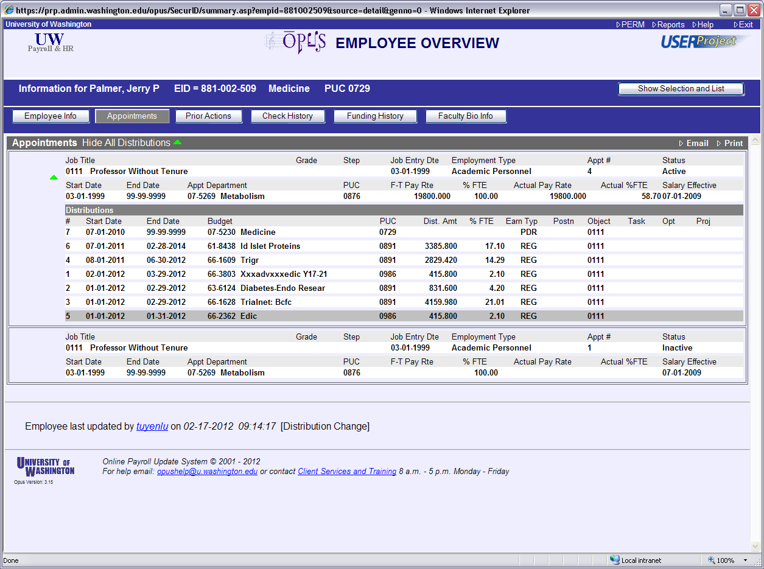

**A**

1. Review the online FEC report to determine if the total “Compensation Dist.” dollars exceed the salary cap for the FEC cycle. Since the FEC is for 6 months this will be ½ of the annual salary cap amount.

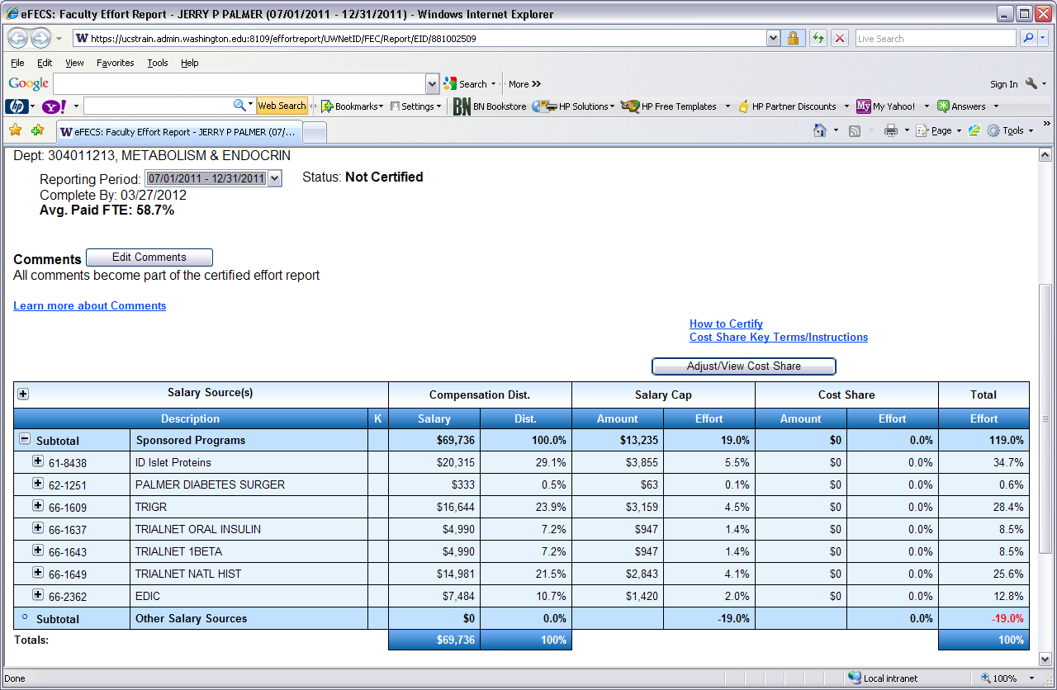

**B**

1. **If the total is** ***LESS* than the salary cap** amount there is **NO SALARY CAP COST SHARING** therefore all salary cap cost sharing reflected on the FEC should be removed. To do this click on the “Adjust/View Cost Share” button that will take you to the “Adjust or View Cost Share” screen.

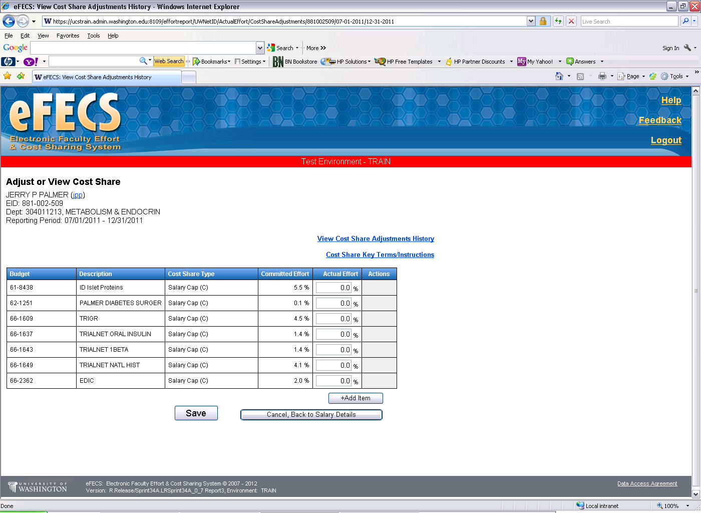

1. Reverse the cost share by entering 0.0 in the “Actual Effort” box(es) then click on the “Save” button.
2. This will return you to the online FEC which will now reflect $0 “Amount” and 0.0% “Effort” for “Salary Cap”. Note, the “Avg. Paid FTE” percent should remain unchanged.

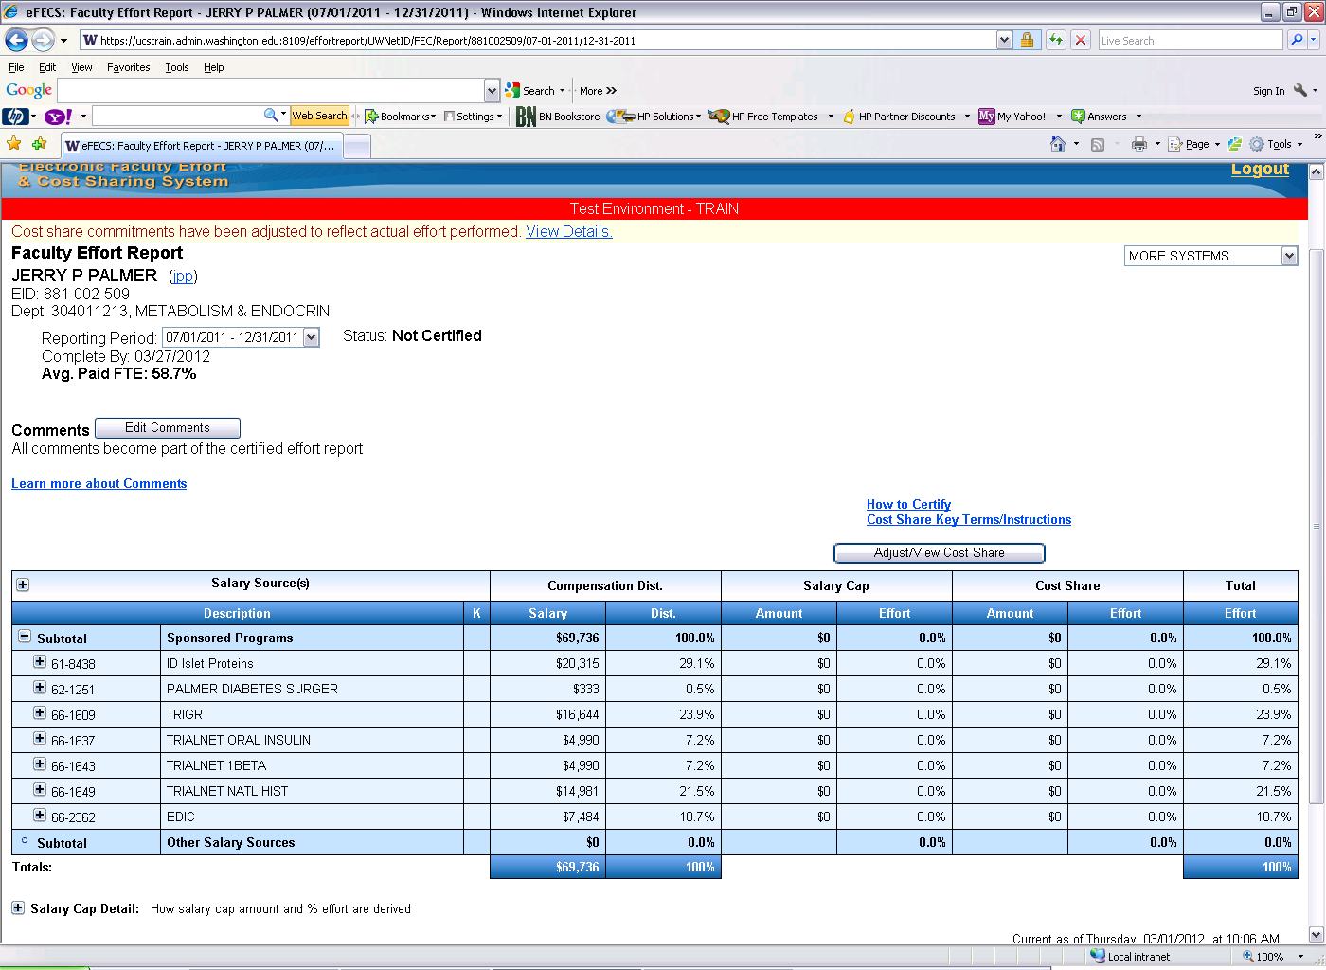

1. **If the total “Compensation Dist.”** ***EXCEEDS* the salary cap** for the FEC cycle **SALARY CAP COST SHARING IS REQUIRED** however the amounts reflected will need to be adjusted given eFECS determined the amounts based on a fulltime rate that includes the VA salary component.

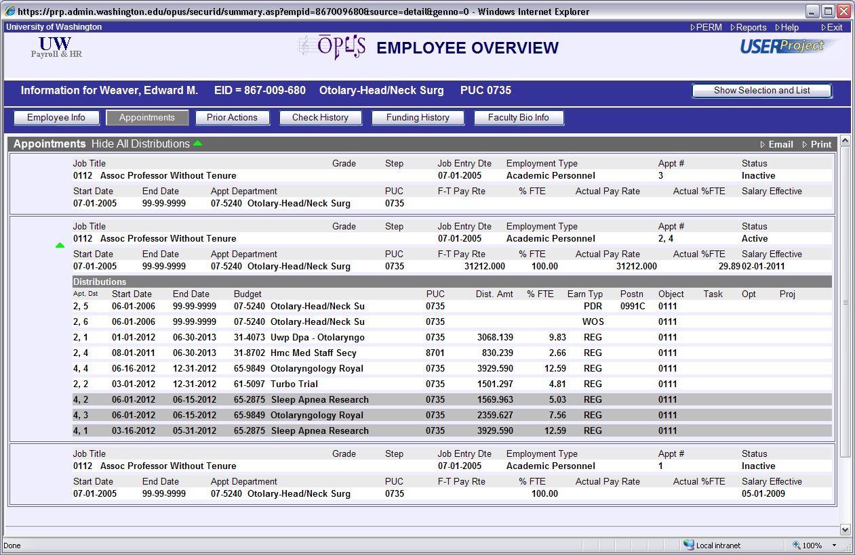

1. To determine the adjustment go to the MAA website, “Faculty Effort Certification”, “Calculator Tools”, “Salary Cap Calculator - for Adjusting FECs” (<http://f2.washington.edu/fm/maa/fec/fectools>). This will take you to an Excel spreadsheet for determining the correct salary cap cost share amount. **Note, when determining the correct salary cap it is necessary to recognize there are two salary cap amounts presently in effect as a result of the recent DHHS announcement of a reduced salary cap ($179,700) applicable to funds issued on or after 12/23/2011.**
2. Enter the “Budget Number”, “$ Paid on Budget” (from the online FEC), the “Avg. Paid FTE”, the “Salary Cap Level” and “% Effort from FEC” for DHHS grant(s) subject to the salary cap as reflected on the online FEC.

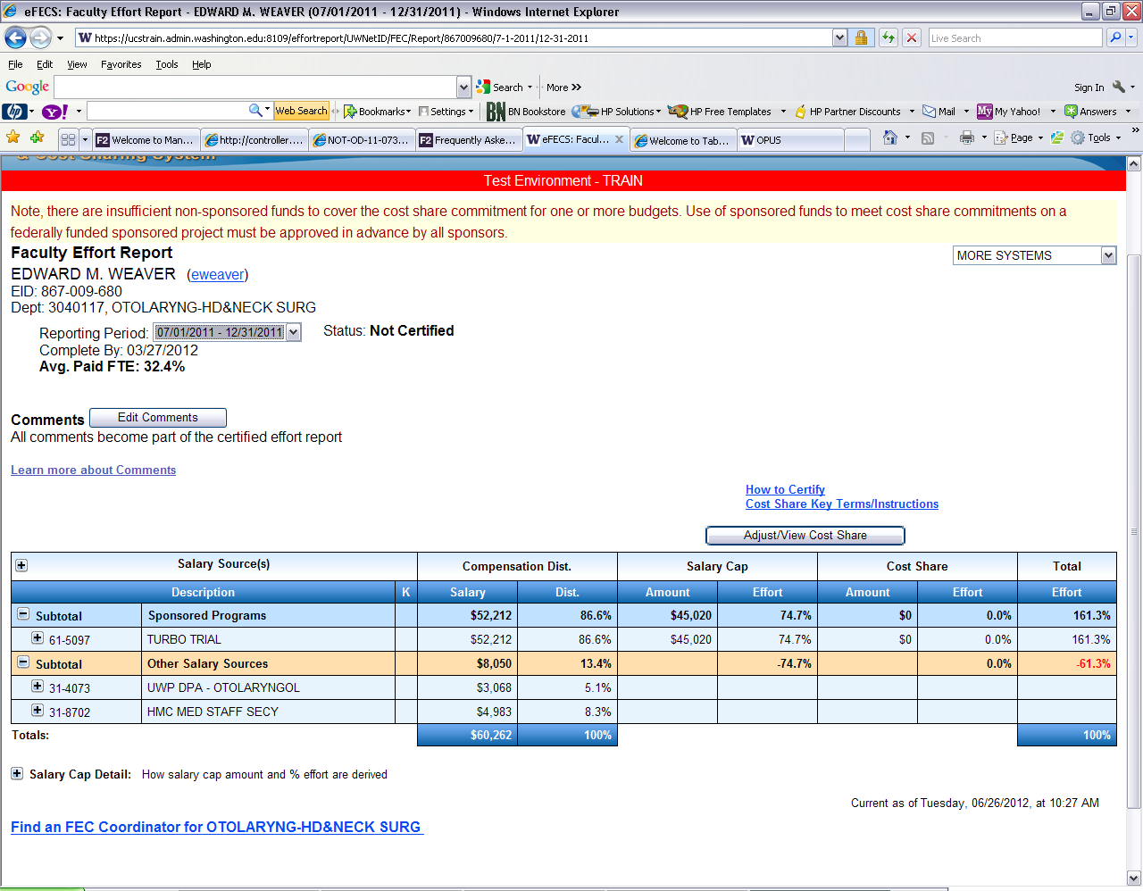







1. Using the above FEC the following information would be entered into the spreadsheet.



1. The result is the salary cap cost sharing for each of the budgets needs to be adjusted (reduced) from 2.3% to 1.7% to reflect the true salary cap cost sharing determined using only the UW compensation and salary components. This is done in the same manner as above, i.e., using the eFECS “Adjust or View Cost Share” screen (steps 3-5).

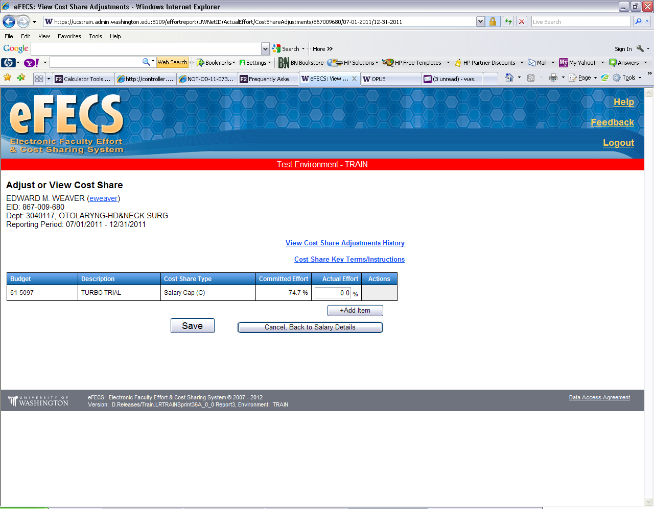

From Salary Cap Calculator spreadsheet

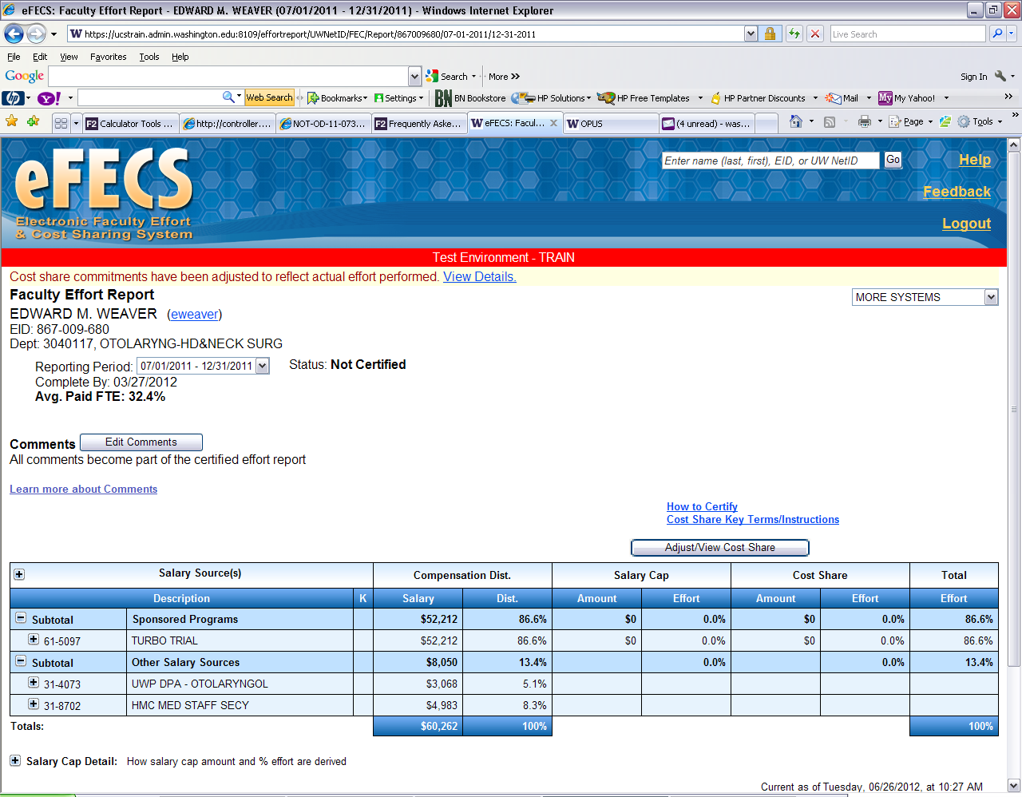

In all cases where a cost share adjustment is required as a direct result of the UW/VA click on the “Edit Comments” box on the FEC

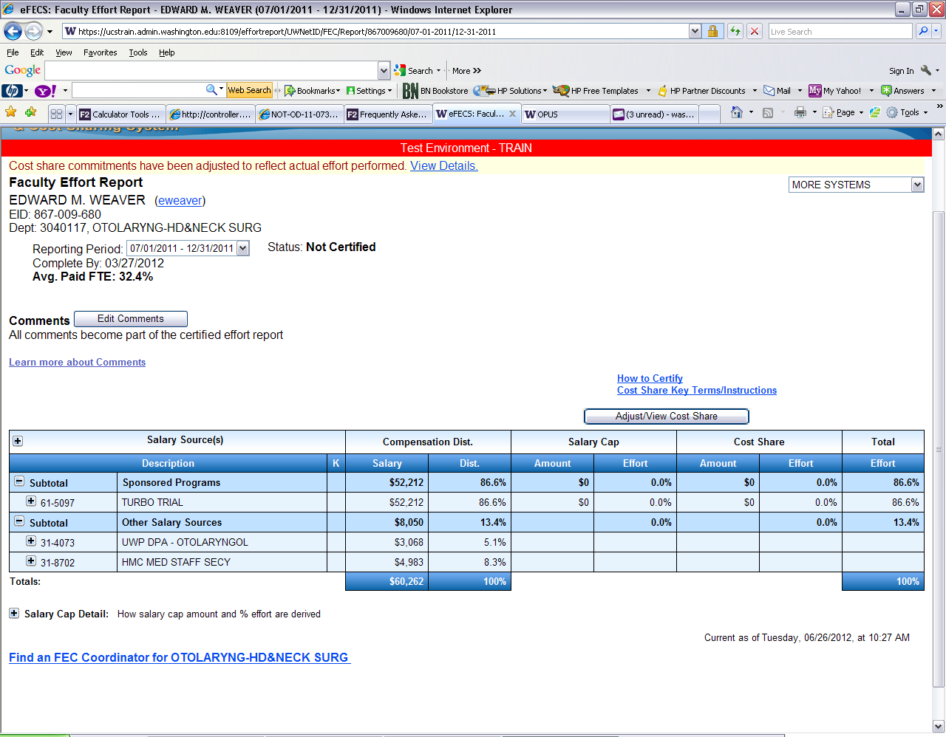

Select the comment “‘VA/UW appointment, faculty does not owe salary cap, however, average paid FTE will continue to reflect less than 100% FTE.’” Then click on “Save”

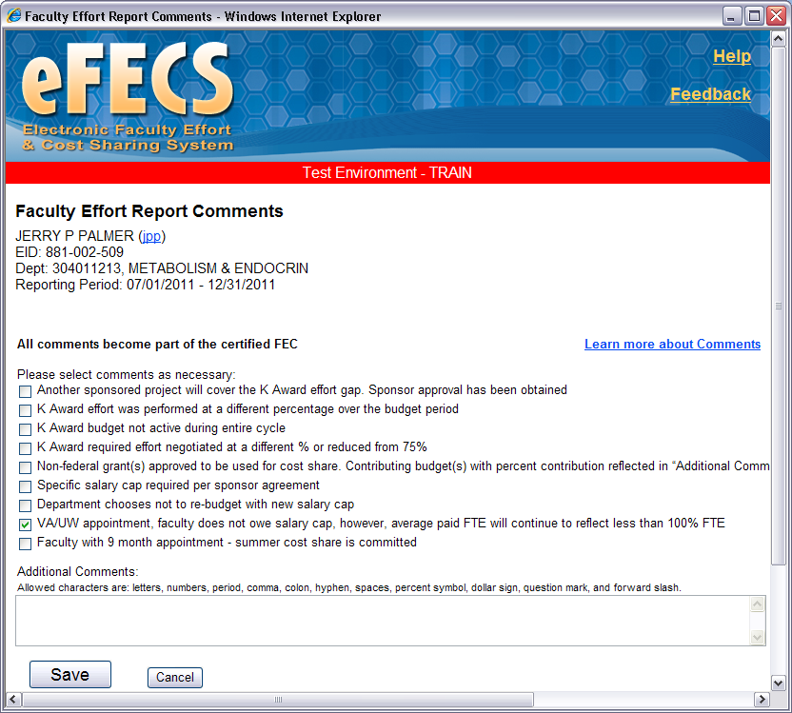

Doing this will document on the FEC why the cost share adjustments were made.

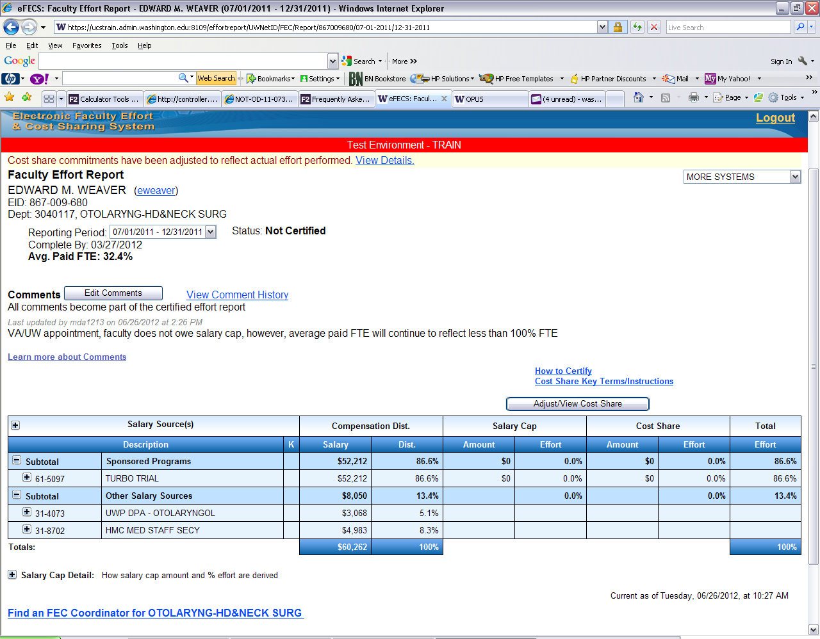

Examples are provided for assistance in determining the correct adjustment calculation to make. On rare occasions a faculty member may have an appointment that is less than 1.0 which will require additional calculations.  Please contact [efecs@uw.edu](mailto:efecs@uw.edu) should you encounter such a situation.