Getting Ready to Use the FASTRANS Spreadsheet

Set up an account on FASTRANS

Send an email to help@uw.edu with subject line of ‘Fastrans: account request’.

Include your full name, UWNetID or employee number, department name, and area code (if known).
The area code is a 2 digit alpha code chosen by the department. It will be automatically added to the invoice number.

Review the FASTRANS process as described at http://www.washington.edu/admin/adminsystems/fastrans/

Determine whether your budget will be issuing Cost Transfer Invoices (CTIs) or Internal Sales Documents (ISDs)
Recharge centers, cost centers and auxiliary enterprises issue ISDs
All other budgets issue CTIs.

Download the FASTRANS Excel spreadsheet at:
http://finance.uw.edu/maa/recharge/templates

*Important* It is extremely important not to open the spreadsheet from your web browser, but to save it to a location.

Minimum System Requirements for spreadsheet
- 10 MB of free disk space

Excel 97 (Excel 98 for Macs) or later version with Visual Basic for Applications installed

How to determine if you have Visual Basic for Applications installed on your computer:
Open new Excel workbook
Click Tools > Macro
Visual Basic for Applications is installed on your computer if the Visual Basic Editor option appears in black.

Macro security set to medium (for Excel 2000 users)

How to set macro security:
Open an Excel workbook
Click Tools > Macro > Security
Change setting to medium

FASTRANS ISD Instructions

Open the template entitled isd_temp.xls.

Click ‘Enable Macros’.

Choose whether this spreadsheet will be and ISD file or a CTI file.

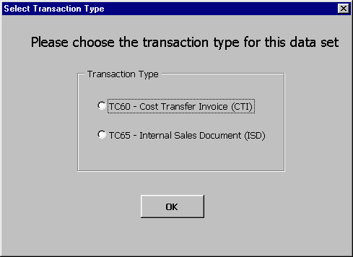

The same template can be used to do both types of transactions, although you can’t do it at the same time. Click ‘OK’ when done.

Choose the accounting month in which the transactions will be posted.

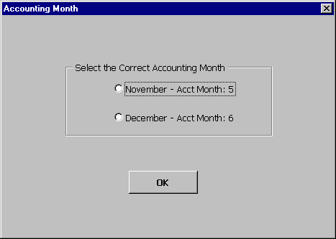

The worksheet automatically displays the previous and current accounting month. This is the month it shows in the accounting system, not the date the service was performed. After choosing the accounting month, click ‘OK’.

Choose file name for the spreadsheet.

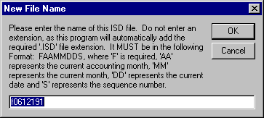
A name is automatically assigned to your worksheet that follows FASTRANS naming conventions. If you do transfer more than one file a day, the sequence number will need to be updated manually when naming the file.

Do not add an extension, as this will be automatically supplied. Click ‘OK’ to choose file name.

You can also type in a user-selected name. We recommend you use a user-selected name only if you need to transfer more than one file in a day. To type in a user-selected name, use the following format:

F – FASTRANS requires all files begin with the letter ‘F’. Enter as a capital letter.
AA – The two-digit current accounting month per FIN. This should be a number between 01 and 24.
MM – The two-digit current calendar month. January equals 01.
DD – The two-digit current date.
S – The one-digit sequence number. This allows you to transfer more than one file a day.

Select the location to save the file.

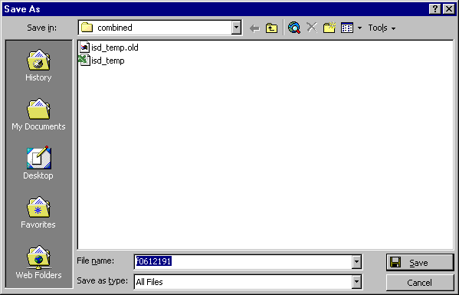
Macros will run slower if files are saved on floppy disks or network drives. Once you have selected a file path, click ‘Save’ to exit dialog box.

Enter ISD information.

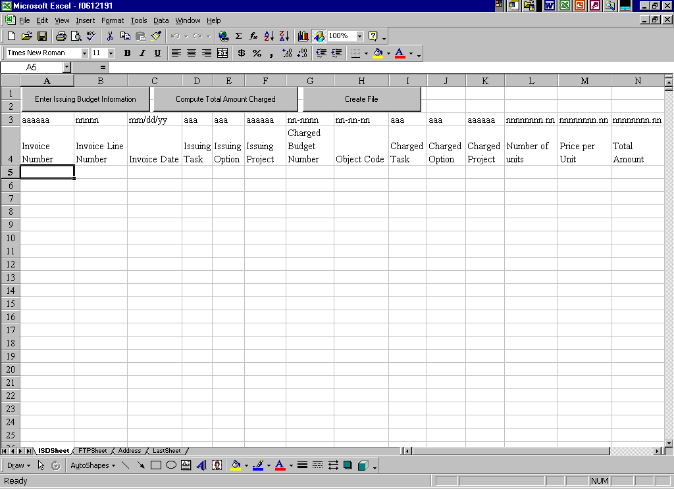
Go to the worksheet labeled ‘ISDSheet’ in the current workbook. Line 3 of the worksheet lists the required formats for each column.

FASTRANS is set up to accept the information in a specific format. If the information is not entered in this format, the file will generate an error message when submitted in FASTRANS.

Do not add or delete any columns, or enter information in any columns other than those labeled.

If you copy and paste information from another spreadsheet, use the ‘Paste-Special’ command for columns A-K and O-Q and copy Values. For columns, L-M, use the regular ‘Paste’ command. Column N contains a calculated function, so will auto-populate with the computed total of column L x M, therefore, DO NOT paste anything into column N. This is required so FASTRANS will accept the formats. Do not leave any labeled column blank. If there is no input into a column, enter an asterisk *.

See the Appendix A for a description of each column and the common entries for recharge and cost center ISDs.

Update issuing budget information.

Each time a new file is created for upload, the general recharge center information should be updated. At the top of the worksheet titled ‘ISDSheet’, click the ‘Enter Issuing Budget Information’ button.

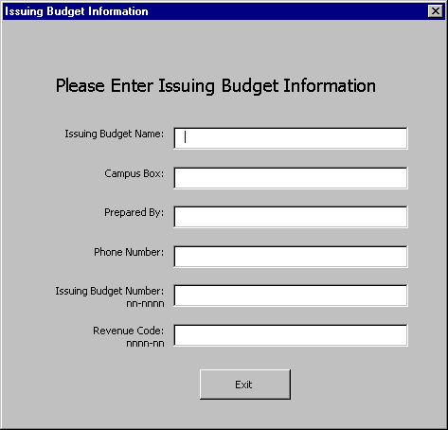
Enter the requested information. Enter the recharge center budget number and the recharge center revenue code in the format listed (including the dash). See Appendix A for commonly used revenue codes. Click ‘Exit’ when done.

Compute total amount charged for this FASTRANS worksheet.

Click on ‘Compute Total Amount Charged’ button at the top of the ‘ISDSheet’.

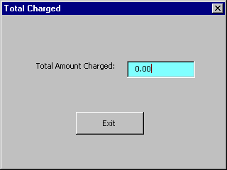
The sum of all entries will be displayed. Verify this check figure with the supporting documentation from the recharge center used to generate the billing. Click ‘Exit’ when done.

Create ISD upload file.

Click on ‘Create File’ button at the top of the ‘ISDSheet’.

The worksheet will automatically create the upload file for FASTRANS (with the designation filename.ISD) and a separate invoice for each budget number charged. Even if you are creating a CTI file, the extension of the upload file will be .ISD.

This could take up to several minutes depending upon the number of entries and the location in which the file was saved. The workbook will automatically close.

Transfer .ISD file to fastrans.u.washington.edu.

The file that should be transferred will end with .ISD.
Open up your file transfer (Secure FTP for PCs, Secure Fetch for Macs) program and connect to fastrans.u.washington.edu.
Transfer the file to fastrans.u.washington.edu. Make sure that the file type is an ASCII file.

Upload the file to the Financial Accounting System (FAS).

Follow the procedure for submission at: http://www.washington.edu/admin/adminsystems/fastrans/submit.html

Check the “Batch Control Report” at: https://edw.washington.edu/Reports/Pages/Report.aspx?ItemPath=/Financial/FAS+Batch+Summary+Report

Review the Batch Control Report to verify that all transactions posted correctly. If any transactions failed, you will need to re-submit the erroneous entries only.

Appendix B lists common error messages generated by FASTRANS. Take the appropriate action to correct the problem entries.

Update invoice information for each budget number.

Open the Excel workbook saved under the filename you entered in Step 4 (with the format FAAMMDDS). Do not open the workbook with the extension .ISD.

Go to the each sheet named as a budget number. After the colon, enter in the Recipient’s Budget Name, Recipient’s Box Number, and a Description of Services Provided.

Once this information has been input for all worksheets, print the invoices. Save and close the workbook when done.

If a box pops up asking to ‘Save any changes’, click ‘Yes’. This message is generated as a result of a macro that compresses the file to about 200 kilobytes. If ‘No’ is selected, then the file takes up considerably more space.

For further help with:
 | Contact | E-mail or online resources | Phone
Account setup on FASTRANS | UW-IT | help@uw.edu | 221-5000
CTI formats |  | http://www.washington.edu/admin/adminsystems/fastrans/tc60_sdf.html
ISD formats |  | http://www.washington.edu/admin/adminsystems/fastrans/tc65_sdf.html
FASTRANS application | Heidi Berrysmith | hbsmith@uw.edu  http://www.washington.edu/admin/adminsystems/fastrans/ | 685-1326
FASTRANS spreadsheet | Service & Recharge Center Team | recharge@uw.edu  http://finance.uw.edu/maa/recharge | 897-1617
Secure FTP software | UW-IT or local IT support | help@uw.edu  http://www.washington.edu/itconnect/security/tools/#sftp | 221-5000

Appendix A: FASTRANS ISD Fields

For more information on the specific formats for each column, consult the FASTRANS guide on the web.

Note: If there is no input into a column, enter an asterisk (*).

 | Field Name | Description | Format | Sample Entry
 | Transaction Code | For ISDs, the code is 65  For CTIs, the code is 60 | NN | Entered automatically
A | Invoice Number | Used to track and identify each charge in the Financial System | AAAAAA | 123456  X12345
B | Invoice Line Number | Used in conjunction with the Invoice Number to uniquely identify the individual transaction | Up to a 5 digit numeric code | 1  011
C | Invoice Date | Date the service was performed or goods received, not the date the ISD was prepared. Can enter the last day of the month for convenience. | MM/DD/YY  Must enter month and day with a 2 digit format. | 12/18/00  03/31/01
 | Issuing Department’s Budget Number | This is entered only once on the ‘Issuing Budget Information Sheet’ | NN-NNNN (include dash) | 14-0001
 | ISD: Issuing Department’s Revenue Code  CTI: Issuing Department Object Code | This is entered only once on the ‘Issuing Budget Information Sheet’ | ISD: NNNN-NN (include dash)  CTI: 21-NN-NN (include dash) | 9620-77 (sale of services)  9650-77 (sale of goods)  21-39-00 (services)  21-50-00 (goods)
D | Issuing Task | Used in project cost accounting | 3 digit alphanumeric code | Most centers, enter an *
E | Issuing Option | Used in project cost accounting | 3 digit alphanumeric code | Most centers, enter an *
F | Issuing Project | Used in project cost accounting | 6 digit alphanumeric code | Most centers, enter an *
G | Charged Budget Number | Budget number that received goods or services | NN-NNNN (include dash) | 61-0001
H | Charged Expense Account | Charged budget number’s object code | NN-NN-NN (include dashes) | 03-49-00 (other campus services)
I | Charged Task | Used in project cost accounting | 3 digit alphanumeric code | Most centers, enter an *
J | Charged Option | Used in project cost accounting | 3 digit alphanumeric code | Most centers, enter an *
K | Charged Project | Used in project cost accounting | 6 digit alphanumeric code | Most centers, enter an *
L | Number of Units | Number of units provided on which the rate is based | Any numeric entry | 1  5.8
M | Price per Unit | Price on a per unit basis | Any numeric entry. Do not include dollar sign | 25  34.28
N | Amount | Amount to be charged is automatically calculated from the quantity and price per unit | NN.NN | Calculated automatically
O | Requisition Number | Requisition or encumbrance number to be referenced on ISD | AANNNNNN | Most centers, enter an *
 | Issuer’s Phone Number | Contact person’s phone number  (do not enter area code) | Up to10 digit alphanumeric code | 3-0001  543-0001
P | Liquidation Code | To liquidate a requisition referenced in ‘Requisition Number’ field. If the ‘Requisition Number’ field is used, then this field should be used also. | N for Non-Liquidating  C for Completely  Liquidating  P for Partially Liquidating | Most centers, enter an *
Q | Additional Description | Provides a description of each individual line item on the FASTRANS worksheet. This is a voluntary field. This information will not be uploaded into FIN. | Free-form, no set format | Enter user name, subproject information, etc, to help identify transaction.
Format Codes:
A is any alpha-numeric character (A-Z, a-z, any numeric character or special character)
N is any numeric character (0 – 9)
MM is the two-digit month (01 – 12), DD is the two-digit date (01-31), YY is the two digit year (01-99)

Appendix B: Common FASTRANS Error Messages

The most common error messages are in bold.

After the errors have been resolved, it is necessary to re-submit the entries that caused the error to FASTRANS. Use the template to create a new .ISD file with only the corrected entries. Do not submit the entire worksheet again, as this will duplicate entries in FIN.

Error Message | Action
>>>>> A1 BUDGET NUMBER MUST BE NUMERIC. | Check Excel spreadsheet for data entry error in Issuing or Recipient Budget Number fields.
>>>>> C2 REVENUE CODES 9480-XX AND 9481-XX ARE INVALID FOR THIS TRANSACTION CODE | Valid for CTIs. Check Excel spreadsheet that the Cost Transfer Code (on the Issuing Budget Information Sheet) has the format 21-nn-nn.
>>>>> C8 BUDGET NO. NOT OPEN TO EXPENDITURE; BUDGET STATUS NOT 1 (IF CTI, SEE REQ BN) | Budget number that is being charged is not in status 1. Check with recipient department to change status or obtain another budget number.
>>>>> C9 INVALID EXPENDITURE, REVENUE,OR GENERAL LEDGER ACCOUNT CODE; NOT ON 03 INDEX [all] | Check Excel spreadsheet for data entry error in field Issuing Department Revenue Code (on Issuing Budget Information Sheet) or Charged Object Code.
>>>>> D2 AMOUNT FIELD MUST BE ENTERED AND NUMERIC. | Check Excel spreadsheet for data entry error in “Number of Units”, “Price per Unit” or “Total Amount” fields
>>>>> E5 INVALID BUDGET NUMBER; NOT ON 02 INDEX. (REFERS TO REQUESTING B/N IF CTI) | Issuing or Recipient Budget Number is not valid per FIN. Check with recipient department to verify budget number.
>>>>> E6 B/N MUST BE AUTHORIZED TO ISSUE CTI'S TO USE EXPEND CODE 21-XX-XX ON CTI | Budget not authorized to issue CTIs. See: http://www.washington.edu/admin/payables/CTI.html
>>>>> E7 EXPENDITURE ACCOUNT CODE FOR SERVICING BUDGET NUMBER MUST BE 21-XX-XX | Valid for CTIs. Check the Excel Spreadsheet, Cost Transfer Code (on the Issuing Budget Number Information Sheet)
>>>>> F1 EXPENDITURE CODE FOR REQUESTING B/N MUST BE W/IN 03-00-00 TO 89-99-99 RANGE | Valid for ISDs. Check the ISDSheet in the Excel spreadsheet to verify that the charged object code is between 03-00-00 and 89-99-99.
>>>>> G2 ACCT CODE MUST BE WITHIN 00-1000 TO 9999-99 RANGE
>>>>> J1 SUB-SUB OBJECT CODE MUST BE NUMERIC. | Check the ISDSheet in the Excel spreadsheet to verify the charged object code is numeric.
>>>>> H8 CANNOT ENTER REVENUE ACCOUNT CODE FOR THIS TRANSACTION CODE | Valid for CTIs. Check Excel spreadsheet that the Cost Transfer Code (on the Issuing Budget Information Sheet) has the format 21-nn-nn.
>>>>> 02 FUND TYPE MUST = FA OR GA FOR SERVICING BGT ON T/C 65. | Valid for ISDs. Verify issuing budget number is authorized to submit ISDs.
>>>>> 03 BUDGET NOT AUTHORIZED TO ISSUE ISD'S. | Budget not authorized to issue ISDs. See: http://www.washington.edu/admin/payables/ISD.html

