How to certify a project statement in ECC:
Steps on website: https://finance.uw.edu/pafc/certifying_statements
- Open the ECC application, and login (to get into the application you must select an “institution”. There are three options; UWM is only for Harborview certifications, and APL is only for Applied Physics Laboratory certifications. Use UW as your institution if you are not a part of either of those groups.)
- After you login, you will land on the Home Page of ECC on a tab called “Statements Awaiting Certification”
- Your project statements that are “Ready for Certification” will appear in the “Assigned Project Statements” section. Click on the link in the “Status” column (any of the linked text in the other columns work too) to open a project statement.
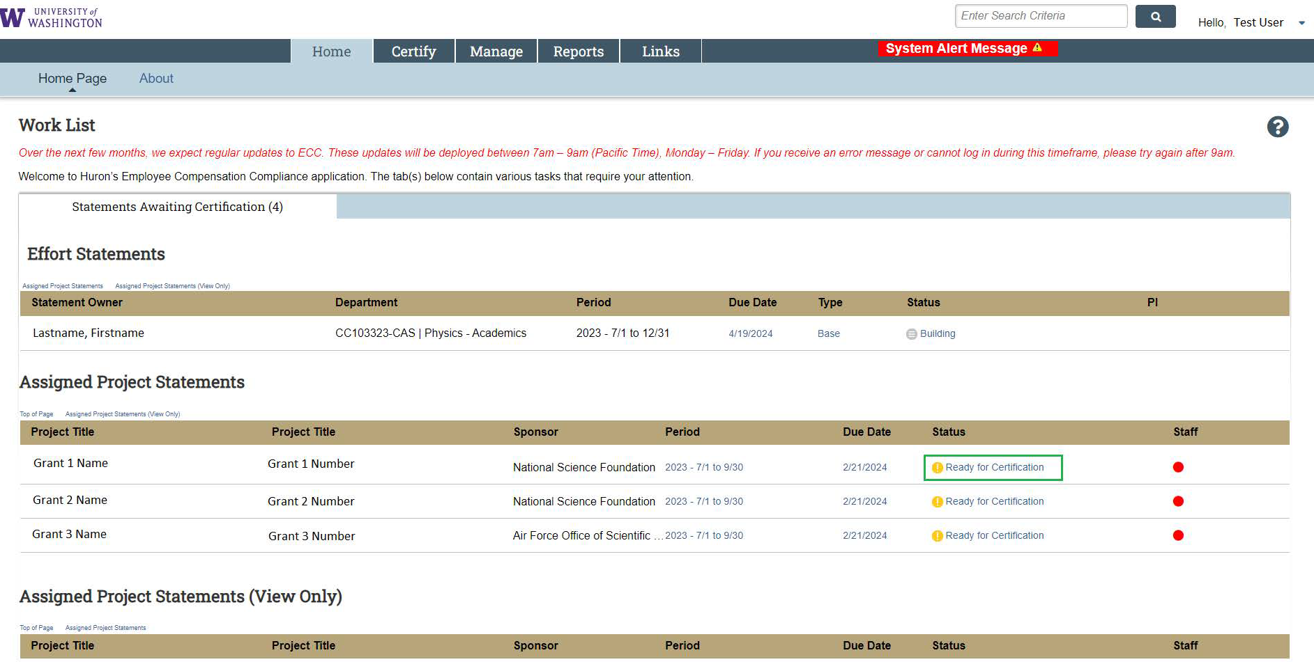
- Review the salary charges for each worker represented on the statement. Percentages on a project statement operate off the following formula:
  - Worker x’s payroll dollars on the grant / worker x’s total salary for the quarter = worker x’s payroll % (percentages for all workers are a function of 100% effort, regardless of their FTE or how many hours they worked during a period)
  - Use the dollar sign symbol () in the “Reports” column to see a specific worker’s pay period detail
  - Use the document symbol () also in the “Reports” column to see a specific worker’s total pay from all their salary sources during the period
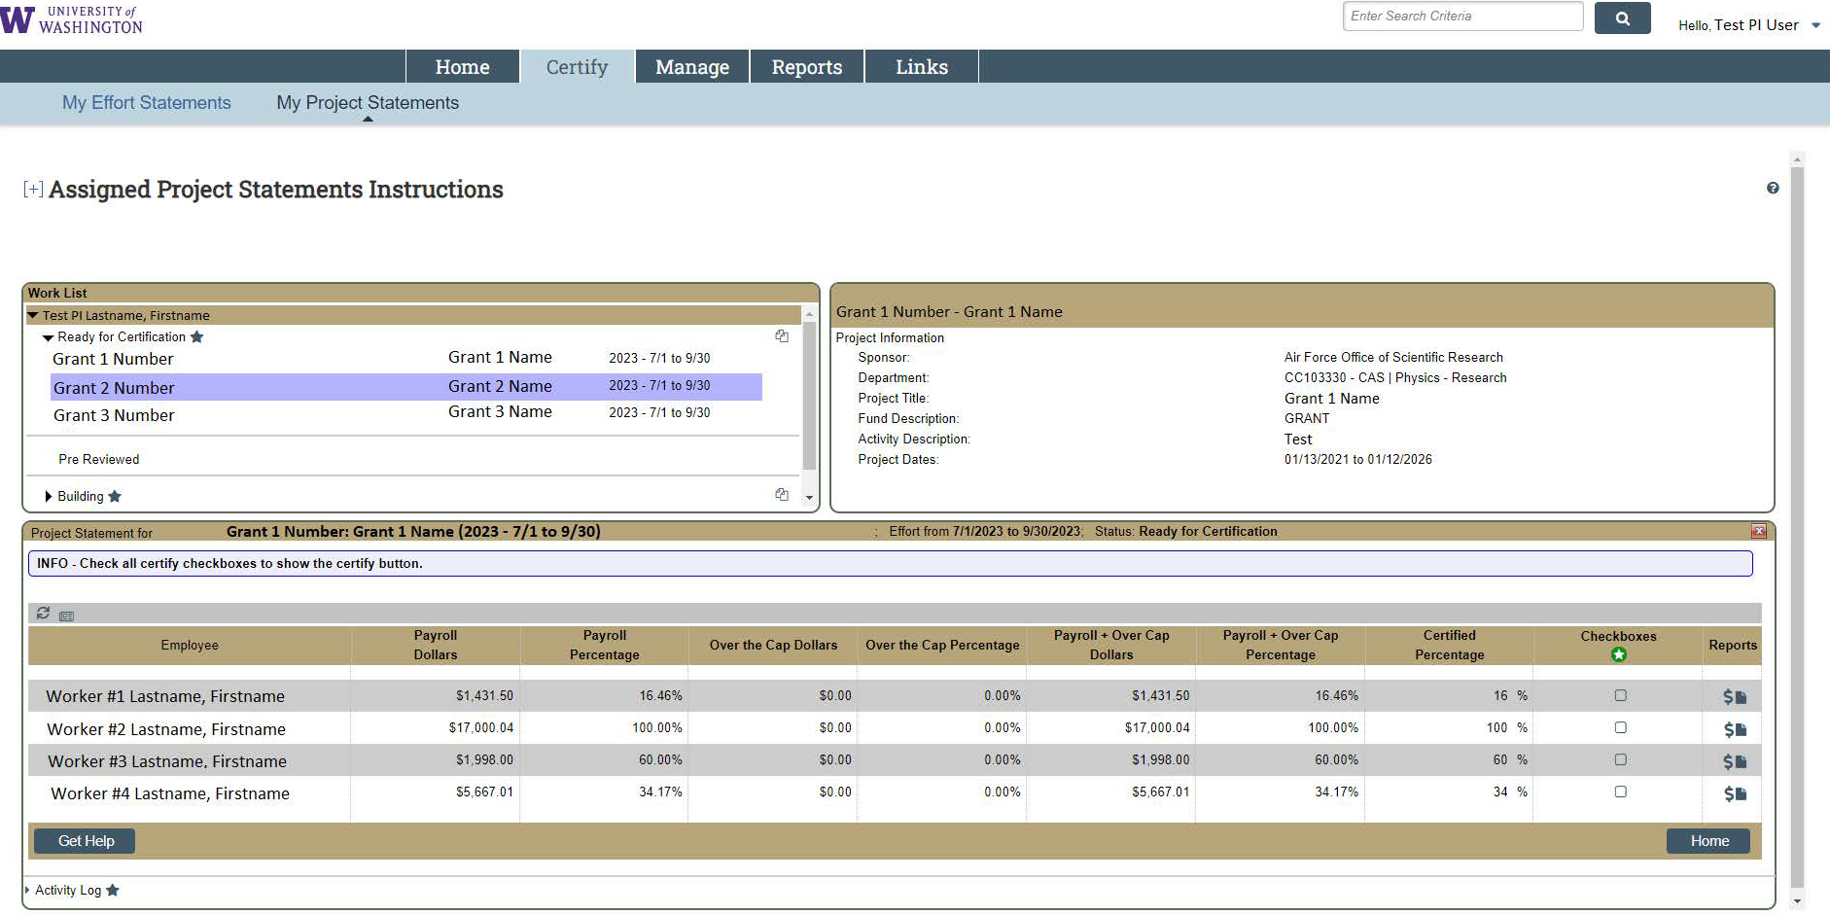
- After you have reviewed the salary charges, check the boxes in the “Checkboxes” column. Use the green circle with a white star icon to check all the boxes at once. After all the boxes are checked, the “Certify” button will appear. Click it.
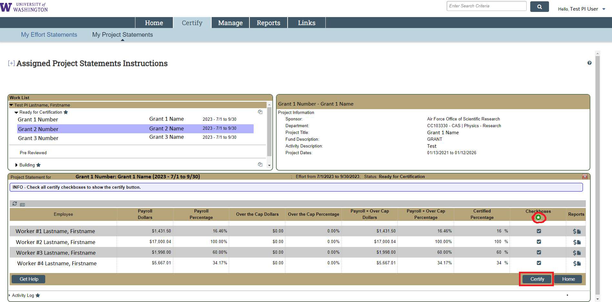
- You will be asked to attest to the reasonable accuracy of the statement. Click “I agree” to finalize the certification.
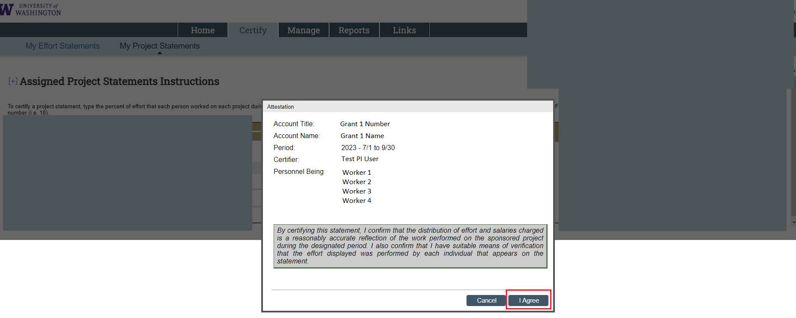
  - If there is an inaccuracy on a statement, press “Cancel”, and notify an administrator in your department. The “Get Help” button on the bottom left portion of the statement screen will open an email to whoever is assigned as the “ECC Coordinator” for your statement(s).
- If you clicked “I Agree”, the statement you selected is now certified. You will be taken to the next report ready for certification if you have one. As of now, the only way to see statements you have certified is to search for the grant number (e.g. GR000001) in the main search bar at the top of the application.
- Alternate between other available statements using the top left box of the project statement’s screen, called “Work List”. Select between the statements that are “Ready for Certification” to view the other statements available to be certified.
