Job Aid – Using the Workday Salary Allocations Calculator
Notes:
Use this tool to calculate the salary allocation into Workday for faculty with REG (X) and Clinical (Y) salary and/or ADS (Administrative Supplement) for when salary cap does and does not apply. By default, the tool operates on monthly periods, this can be adjusted by changing what the salary cap value in column J is adjusting by (currently dividing annual value by 12 to function for monthly)
See example calculations of allocations for different scenarios:
- Only X salary
- X salary with ADS
- X and Y salary (w/ cap and X over cap)
- X and Y salary (w/cap and X under cap)
- X and Y salary (w/out cap)
- X, Y and ADS (w/ cap)
- X, Y and ADS (w/out cap)
Overview of how to use the tool:
- Enter each distinct portion of the individual’s Institutional Base Salary (IBS) into the following sections respectively: X (REG), ADS/ENS, and Y (Clinical). Enter the individual’s actual FTE for the period in cell C11
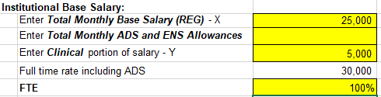
  - Make sure entries for each IBS component (cells C7, C8, C9) are based on actual paid compensation. Using the compensation tab in Workday, you can see the amounts for each of these.
  - If less than 100% FTE, enter the prorated amount(s) that appear in parentheses in Workday:
- Update the salary cap section.
  - Fill in non-EL II salary cap names and annual values if they are applicable for a grant the individual is paid from (NIH/DHHS value in template by default) in purple shaded cells of columns H and I
  - Update the “Monthly” column’s formula if you want to change the tool from functioning monthly to a different length period
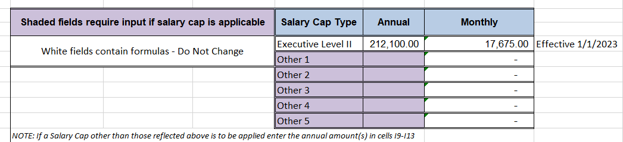
- Enter the grant names/numbers in the highlighted rows of column B with the associated effort commitment for each grant in column C.
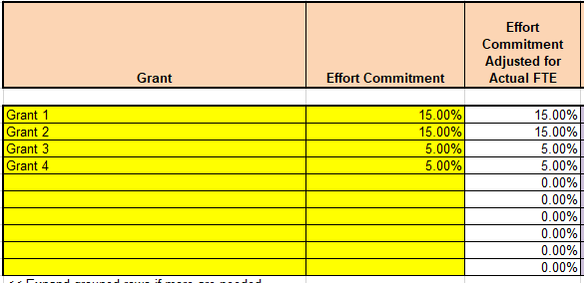
  - Column D, “Effort Commitment Adjusted for Actual FTE” enables the tool to function for when FTE is less than 100%. It adjusts commitments by the ratio of Commitment/FTE
- Enter the salary cap type that applies to the grant (if no cap applies to a given grant, leave the cell blank for that grant) – this will auto-populate the associated monthly cap value in column F.
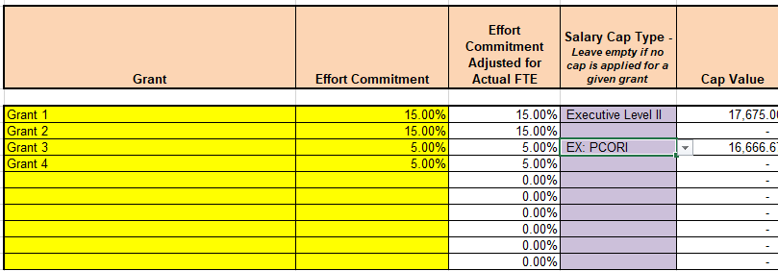
  - Remember, to get unique caps, you must hard code the value in the table at the top of the worksheet:
  - 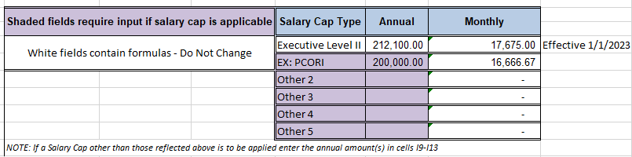
- With the inputs completed, the “Entry Into Workday” column (column I - highlighted green), should now have the appropriate percentage to allocate to each grant in Workday.
  - Notice that, as in the example below, the percentage to enter can differ for grants that have the same committed effort level – this is a result of cap being applied vs. cap not being applied. When salary cap is in place for a certain grant (and the individual has X and Y salary, where the X salary is, by itself, over the cap) the entry into Workday should match the committed effort level, because the maximum allowable direct salary charge to the grant is the adjusted ‘Cap Value’ x ‘Effort Commitment’.
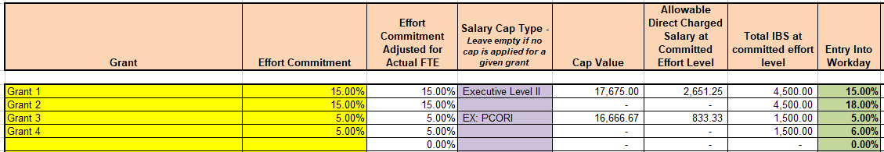
- The tool will calculate the dollar amount that Workday will automatically move to the “Salary Over the Cap” worktag, and display the split of direct charged salary to the grant vs. the over the cap amount
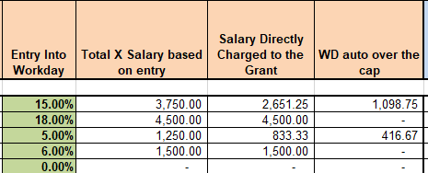
- Columns M and N will display the amount of $ or % that would be needed to shift to the grant in ECC in order for the effort statement to show the original committed level.
  - Shifts will not be necessary when the individual does not have a clinical (Y) salary component.
  - Allocating committed effort in Workday when the individual also has clinical salary will come into ECC at a lower percentage because Workday does not have the clinical salary portion. The calculation of ‘committed effort %’ * ‘REG (X) salary’ leads to a lower total salary attributed to the grant initially (in the example above for 15% effort in the example with and without cap) – this is what makes a funding shift necessary in this circumstance.
  - Viewing the bottom table of the sheet (starting row 54), “What ECC would show”, you can see what would come into the effort statement at the currently calculated Workday allocation.
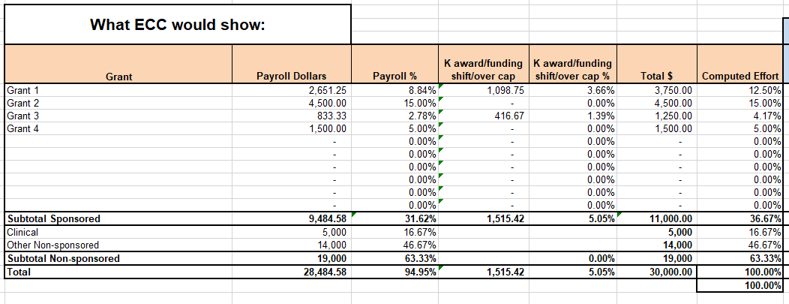
  - Columns I – J of this table (the section with a blue shaded header) will show what action will be needed to be taken in ECC to shift the correct amount of effort in order to increase the effort amount for a grant with salary cap back up to the committed level
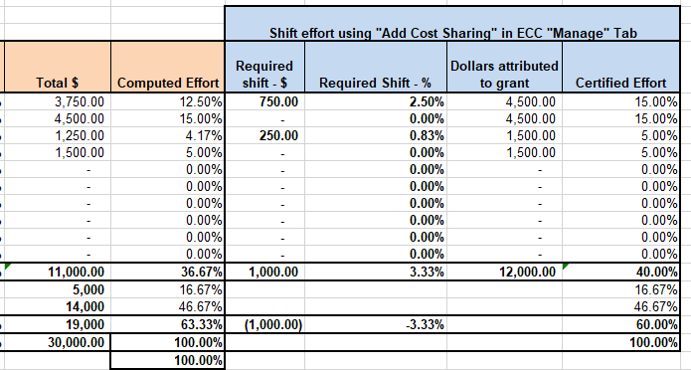
  - Effort shifts are most efficiently completed after the 6-month effort period is complete – if allocations remain stable throughout the 6-month period – the “Required Shift - %” column should be an accurate percentage to input into ECC using the “Add Cost Sharing” function (This process has its own Job Aid here: coming soon) – keep in mind this tool currently operates for a month long period, whereas the effort statement will be for 6-months

Allocation in Different Scenarios:
Only X (REG) Salary:
- EX:
  - X = $25,000, Total IBS = $25,000, Effort Commitment = 15%, FTE = 100%
  - Enter 15% into Workday (whether cap is applicable or not)
X Salary with ADS – when ADS is not charged to grants (same w/ and w/out cap applied):
- EX:
  - X = $25,000; ADS = $1,500; Total IBS = $26,500; Effort Commitment = 15%; FTE = 100%
  - $26,500 * 15% = $3,975 IBS attributed to grant
  - $3,975 / $25,000 = 15.9% Entry into workday
X and Y salary (w/ cap and X over cap):
- EX:
  - X = $20,000; Y = $5,000; Total IBS = $25,000; Effort Commitment = 15%; Monthly Cap = $17,675; FTE = 100%
  - 15% Entry into workday
  - 15% * $20,000 = $3,000 total originally attributed to grant; 15% * $17,675 = $2,651.25 directly charge to the grant per the applied salary cap; $3,000 - $2,651.25 = $348.75 over the cap work tag
  - $25,000 * 15% = $3,750 total needed to attribute to grant for 15% in effort system; $3,750 - $3,000 = $750 (3%) needed to shift to the grant in ECC as salary over the cap
X and Y salary (w/cap and X under cap):
- EX:
  - X = $15,000; Y = $10,000; Total IBS = $25,000; Effort Commitment = 15%; Monthly Cap = $17,675; FTE = 100%
  - $17,675 * 15% = $2,651.25 allowable direct charged salary to the grant
  - $2,651.25 / $15,000 = 17.68% Entry into workday
  - Workday calculates $0 over the cap since the REG (X) portion is below the cap
  - $25,000 * 15% = $3,750
  - $3,750 - $2,651.25 = $1,098.75 (4.40%) necessary shift per month in ECC
X and Y salary (w/out cap):
- EX:
  - X = $20,000; Y = $5,000; Total IBS = $25,000; Effort Commitment = 15%; No Cap; FTE = 100%
  - $25,000 * 15% = $3,750 IBS attributed to grant
  - $3,750 / $20,000 = 18.75% Entry into workday
X, Y and ADS (w/ cap):
- EX:
  - X = $20,000; ADS: $1,500; Y = $5,000; Total IBS = $26,500; Effort Commitment = 15%; Monthly cap = $17,675; FTE = 100%
  - 15% * $21,500 (REG + ADS) = $3,225
  - $3,225 / $20,000 (REG) = 16.125% entry into Workday
  - $26,500 * 15% = $3,975
  - $3,975 - $3,225 = $750 (2.83%) necessary shift per month in ECC
X, Y and ADS (w/out cap)
- EX:
  - X = $20,000; ADS: $1,500; Y = $5,000; Total IBS = $26,500; Effort Commitment = 15%; No Cap; FTE = 100%
  - 15% * $26,500 = $3,975
  - $3,975 / $20,000 = 19.875% entry into Workday

