

CONSOLIDATED BUDGET
FISCAL YEAR 2027
Table of Contents
Introduction 2
Navigating Uncertainty 2
Overview of the University 3
Operating Budget Executive Summary 4
Risk Management & Budget Alignment 7
Academy Operating Budget 7
Core Operating Resources 8
University Auxiliary Activities 13
Other Operating Revenues 14
Grants and Gifts 15
UW Medicine Operating Budget 18
FY26 Performance Summary by Entity 18
Current Financial Performance 19
Looking Ahead: Performance, Budget, Clinical Strategic Planning & Long-Range Planning 20
Capital Budget Executive Summary 24
Introduction 24
Support of Institutional Goals 24
Ongoing Challenges and Funding Strategies 24
FY27 Capital Budget 25
Funding Distribution FY27-FY31 25
Projects Seeking Approval FY27 26
10-Year Capital Look Ahead 28
Capital for the Clinical Enterprise 31
Active/Core Project Overview 32
Priority Issues & Long-Term Strategies 34
Increased Investment in Renewal 34
Seattle Campus Electrical Capacity 35
Institutional Decarbonization Efforts 35
UW Medical Center Expansion & MHSC Replacement 36
UW Information Technology Infrastructure Planning 37
Regulatory Compliance 37
Space Optimization 38
Capital Funding Overview 38
Typical Capital Funding Sources 39

Introduction
This document is the vehicle through which the University of Washington (UW) Board of Regents reviews, and ultimately approves, the University’s operating budget, capital budget, and tuition rates for the next fiscal year. It is published in the interest of promoting a greater understanding of the University’s budgets, with this being the first time our operating budget and capital budget are presented concurrently in the same document.
The University’s operating budget incorporates University-wide expenditures and the revenues that support these expenditures, including state appropriations, tuition and fees, auxiliary/self-sustaining activities, clinical operations, research grants and contracts, and gifts and endowment distributions. The budget is meant to give both the Regents and the public a sense of scale and reach of the University’s annual operations.
The figures contained within the operating budget were the result of a truly “bottom-up” effort from more than a thousand contributors across the Academy and Medicine working in concert with Finance, Planning and Budgeting (FPB). Given the significant shifts occurring in the University’s planning efforts and budget and data systems, efforts are ongoing to resolve data accuracy issues that could affect numbers in this budget document. Therefore, the budget reflects the best information available at a snapshot in time.
The University’s capital budget reflects planned investments in capital projects at the University’s three campuses and research stations. It outlines the challenges the University is facing in maintaining and renewing existing facilities and making strategic growth investments in new capital projects, largely due to capital needs exceeding available resources. Since fall 2021, the Capital Planning Advisory Team (CPAT) has brought an enhanced level of rigor to evaluating capital projects submitted by units through the Campus Architecture and Planning team in UW Facilities. CPAT works to maximize the impact of limited resources by recommending projects to University leadership that best advance the University's mission and strategy.
Projects in the capital budget are organized into several sections including projects likely to seek Board of Regent approval in FY27, a “10-Year Look Ahead” of projects in the pipeline at various stages of development and funding security, and an overview of capital projects for UW Medicine’s clinical enterprise. Other sections outline specific capital budget challenges faced by the University, strategies for addressing those challenges, and information about the different funding sources that enable the capital budget.
The goal in presenting these budgets in a consolidated format is to better convey the interrelatedness of operating and capital budgeting. For example, the operating budget includes annual expenditures for debt service on capital projects and expenditures on maintenance and operations (M&O) for the existing facility inventory. In addition, the University must plan for additional M&O expense on new capital projects and can reduce M&O through removal of square footage. Finally, decarbonization and energy efficiency efforts in the capital budget can create energy savings or cost increases in the operating budget.

Navigating Uncertainty
The University continues to navigate significant uncertainty impacting all aspects of our mission and operations. Since the beginning of calendar year 2025, the University has tracked and responded to a wide range of policy changes and directives from the federal government. In the last year, the University conducted more than $1 billion of federally sponsored research. This high-value and impactful work is at risk of significant contraction, which would result in loss of educational opportunities for students and our ability to conduct innovative, and in many cases, lifesaving, research.
In 2025, the state faced a significant budget deficit ($15+ billion over four years), and the final state budget for the 2025-27 biennium (FY26 and FY27) reduced the University’s state appropriations by over $15 million over the biennium and assumed unsustainable increases to compensation and benefits costs. During the 2026 legislative session, lawmakers passed a supplemental budget that resulted in an additional $1.25 million cut. In comparison, this additional reduction was an improvement over an additional cut of over $19 million proposed by the Governor preceding the legislative session.
Any drops in revenue from grants, the state, or other sources would have significant negative impacts on our students, our patients, our production of novel research, and our economic impact on the state of Washington and beyond. Beyond federal and state funding, other challenges to our operating and capital budgets range from unsustainable and growing deferred maintenance levels, uncertainty surrounding our operating and regulatory environments, demographic shifts, inflationary pressures on wages, goods and services, and challenging social and political questions about the value of higher education.
We will continue focusing on operational efficiencies; improving transparency and resource source/use accountability; strengthening financial management approaches and policies; and identifying our essential priorities and resources for impact. Additionally, we intend to conduct this work in a way that reflects the values of community, collaboration, and commitment to excellence that are central to the UW. As we navigate these and future challenges, we will be guided by our mission of expanding access to an excellent education and to serving the public good, as well as our University’s values. Most importantly, we will continue to prioritize the well-being of our students, patients, faculty and other academic personnel, and staff as we make decisions.
The University’s 2026-30 Strategic Framework has charted a path toward the University’s first comprehensive strategic plan in almost 15 years. The final plan will guide operational decisions and strategy affecting operating and capital budgeting. Included in the strategic plan will be several key initiatives intended to bolster the financial resilience of the University and evolve our enterprise to meet societal challenges and pressures. These efforts are expected to include:
- Operational Excellence: A coordinated effort bringing Together We Thrive with other initiatives like Research Resilience to shift the way we operate and create efficiency across administrative functions of the University.
- Incentive-Based Budgeting (IBB): The University is transitioning from Activity-Based Budgeting (ABB) to a new IBB model, with a goal of creating financial transparency, clarity and long-term sustainability.

Overview of the University
Founded in Seattle in 1861, the University of Washington is a public research university with campuses in Seattle, Tacoma, and Bothell along with a large clinically integrated health system. For more information, please visit the following web pages:
- 2025-26 Fast Facts: a two-page document highlighting frequently used UW data
- About the UW: a one-stop shop for information relating to our University
- Role and Mission of the University: Board of Regents Policy

Operating Budget Executive Summary
This document describes the UW’s operating budget for the period of July 1, 2026, through June 30, 2027, which is known as fiscal year 2027 (FY27).
The focus of this document is on the University’s comprehensive budget, including:
- Our core operating resources, which are predominately utilized to support the academic and public service missions of the University.
- UW Medicine, our comprehensive clinical, research and learning health system in the five-state WWAMI (Washington, Wyoming, Alaska, Montana, Idaho) region.
- Auxiliary resources, which make up a wide variety of mission supporting and mission adjacent activities, ranging from service and recharge centers to non-state supported “fee based” educational programs, housing and dining, transportation, and clinical activities outside of UW Medicine.
- Gift and endowment distribution resources, comprised of current use gifts and current use income derived from gifts contributed for perpetual income purposes.
- The research enterprise, a large, complex landscape dedicated to the advancement of scholarship, knowledge and life-saving treatments supported by externally funded grants and contracts.
Prior year operating budgets for the academy were developed utilizing a hybrid cash-accrual approach, referred to in this document as the “common book”, and UW Medicine operating budgets were developed more akin to a standardized financial statement approach, referred to in this document as “financial book.” As we continue to optimize and align enterprise use of the Workday Financials tools, the FY27 operating budget represents an advancement in institutional planning sophistication necessary to operate in a rapidly changing environment.
The way in which we are displaying current fiscal year information has shifted to a more standardized approach that aligns better with other budgeting and accounting practices across the University. This shift improves clarity and consistency across all UW entities while keeping the budget useful as a management tool for understanding how resources are planned, allocated, and used.
Table 1 reflects the FY27 Operating Budget for all UW entities in a financial book view. Budgeted operating revenues continue to include categories such as Tuition & Fees, State Appropriations, Net Patient Services, Grants & Contracts, Cost Recovery, Sales of Goods and Services, and Gifts. This display also includes Other Operating Revenues such as Investment Income not discreetly reflected in the common book view of “Budgeted Sources” in prior years.
Operating expenses include Salaries, Wages, and Employee Benefits, the primary expense categories reflected in the common book Budgeted Uses. Other Operating Uses from FY26 are now broken out into additional sub-categories such as Scholarships and Fellowships; Supplies and Materials, Purchased Services, and Utilities. The FY27 budget now includes Depreciation & Amortization and Other Operating Expenses, that were not specifically included in prior academy budget planning approaches.
Because this represents a change in budget organization and presentation, the FY27 budget amounts may not be directly comparable to prior-year budgets.

Table 1. FY27 Operating Budget (in millions)¹
 | UW Academy² | UW Medicine^{3,4} | Eliminations⁵ | Enterprise Total
Budgeted Sources/Revenues
Tuition & Fees⁶ | 1,281 |  |  | 1,281
State Capital Funding Shift to Operations⁷ | 43 |  |  | 43
State Appropriations⁸ | 480 | 37 |  | 518
Net Patient Services | 22 | 5,636 |  | 5,658
Grants & Contracts | 1,752 |  |  | 1,752
Facilities & Administrative (F&A) Cost
Recovery
Sales of Goods & Services | 1,952 |  | (725) | 1,226
Overhead & Recovery | 32 |  |  | 32
Gifts & Endowment Distributions | 430 |  |  | 430
Other Operating Revenue | 326 | 404 |  | 730
Total Budgeted Sources/Revenues | 6,317 | 6,077 | (725) | 11,669
Budgeted Uses/Expenditures⁹
Salaries & Wages | 3,071 | 2,500 |  | 5,571
Employee Benefits | 927 | 580 |  | 1,507
Scholarships, Fellowships, & Other  Student Fees | 398 |  |  | 398
Supplies, Materials, Purchased Services &  Utilities¹⁰ | 1,628 | 2,694 | (725) | 3,596
Other Operating Expenses | 243 | 79 |  | 322
Interest Expense | 77 | 33 |  | 110
Total Budgeted Uses/Expenditures | 6,344 | 5,886 | (725) | 11,504
Budgeted Contribution to (Use of) Net Position from Operations | (27) | 192 |  | 165
Depreciation & Amortization | 342 | 159 |  | 501
Budgeted Contribution to (Use of) Net Position from Operations, Depreciation and Amortization, before other Non-Operating Activities¹¹ | (369) | 33 |  | (336)
1. Numbers are rounded to millions and may not total or match exactly to other numbers in the document.
2. Budget includes all UW Academy campuses (Seattle, Tacoma, Bothell), School of Medicine, as well as Portage Bay Insurance, Student Mandatory Fees, and Student Loans.
3. UW Medicine includes UW Medical Center, UW Physicians, Airlift NW, UWM Primary Care Clinics, and Harborview Medical Center.
4. UW Medicine does not include Valley Medical Center or the School of Medicine which is included in the UW Academy totals.
5. Enterprise eliminations (estimated) account for certain flows of funds between the Academy and Medicine related to clinical activities within the School of Medicine and UW Medicine.
6. Tuition and Fees, Net includes Net Operating Fees for Autumn, Winter and Spring Quarters as well as Summer Quarter and Student Non-Tuition Fee revenues.
7. $42.8 million in state appropriated funding via student building fee shift from capital to operating.
8. UWM state appropriations include approximately $2.5M budgeted for FY26 that will be spent in FY27.
9. Expenditures for purposes of conducting UW operations, excluding transfers for major physical plant and equipment.
10. Supplies & Materials includes budget for minor equipment and other purchases that could be capitalized.
11. Other Non-Operating Activities include, but are not limited to, investment income/loss from the Consolidated Endowment Fund, capital gifts, grants and appropriations, permanently endowed gifts and similar items that are non-operating in nature but are included within the University's financial statements.
The FY27 operating budget represents a significant and collective effort across the UW community to respond to ongoing financial pressures while maintaining focus on mission critical priorities. Units have exercised disciplined restraint, made difficult tradeoffs, and applied rigorous financial stewardship to live within available resources and responsibly manage public, clinical, and philanthropic funds. The resulting budget underscores the University’s commitment to long-term financial sustainability and shared accountability and aligns with the Together We Thrive initiative.
The budget includes initial investments to support the UW’s Strategic Framework. As the framework continues to evolve toward a comprehensive plan, units and the University at large will continue to align budget proposals and investment decisions toward stated goals into FY28 and beyond.
Table 2 reflects the FY27 Budget by Resource Group, which is more similar to the common book resource view of prior years. Operating Revenues and Expenses are categorized by Core, Self-Sustaining, Gift & Grant, and Other Resource Groups.
Table 2. FY27 Operating Budget by Resource Hierarchy Group (in millions)¹
 | Total UWA Resources | Core | Self  Sust. | Gift & Grant | Other | UW Medicine | Eliminations | Enterprise Total
Budgeted Sources/Revenues
Tuition & Fees | 1,281 | 876 | 299 | (1) | 107 |  |  | 1,281
State Capital Funding Shift to  Operations | 43 | 43 |  |  |  |  |  | 43
State Appropriations | 480 | 480 |  |  |  | 37 |  | 518
Net Patient Services | 22 |  | 22 |  |  | 5,636 |  | 5,658
Grants & Contracts | 1,752 |  |  | 1,752 |  |  |  | 1,752
Facilities & Administrative (F&A)  Cost Recovery |  | 316 | (1) | (315)
Overhead & Recovery | 32 | 39 | (8) |  |  |  |  | 32
Sales of Goods & Services | 1,952 | 1 | 1,891 | 45 | 14 |  | (725) | 1,226
Gift & Endowment Distributions | 430 |  |  | 430 |  |  |  | 430
Other Operating Revenue | 326 | 62 | 107 | 70 | 86 | 404 |  | 730
Total Budgeted Sources/Revenues | 6,317 | 1,817 | 2,311 | 1,982 | 207 | 6,077 | (725) | 11,669
Budgeted Uses/Expenditures
Salaries & Wages | 3,071 | 1,067 | 1,301 | 681 | 21 | 2,500 |  | 5,571
Employee Benefits | 927 | 314 | 390 | 217 | 7 | 580 |  | 1,507
Scholarships, Fellowships, &  Other Student Fees | 398 | 33 | 38 | 322 | 5 |  |  | 398
Supplies, Materials, Purchased Services & Utilities | 1,628 | 340 | 537 | 736 | 14 | 2,694 | (725) | 3,596
Other Operating Expenses | 243 | 45 | 49 | 89 | 61 | 79 |  | 322
Interest Expense | 77 | 5 | 33 |  | 40 | 33 |  | 110
Total Budgeted Uses/Expenditures | 6,344 | 1,803 | 2,348 | 2,045 | 148 | 5,886 | (725) | 11,504
Budgeted Contribution to (Use of)  Net Position from Operations | (27) | 14 | (38) | (63) | 59 | 192 |  | 165
Depreciation and Amortization | 342 | 48 | 46 | 16 | 232 | 159 |  | 501
Budgeted Contribution to (Use of) Net Position  from Operations, Depreciation and Amortization,  before other Non-Operating Activities | (369) | (34) | (84) | (79) | (172) | 33 |  | (336)
1. Footnotes from Table 1 also apply to Table 2.
Figure 1. FY27 Operating Budget Sources and Uses Diagram (in millions)¹
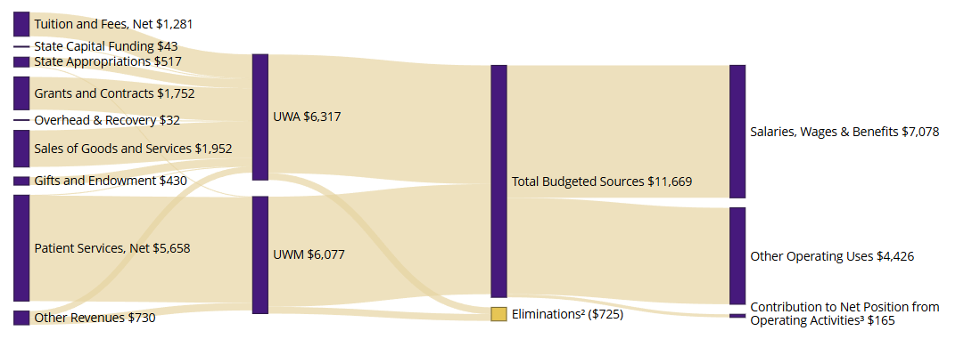
1. Figures reflect all sources and uses for operating purposes and change to net position from operations. Amounts may differ from Table 1 due to rounding.
2. Enterprise eliminations account for certain flows of funds between the Academy and Medicine related to clinical activities within the School of Medicine and UW Medicine. Effect of eliminations in this chart is to display unduplicated budget sources and uses.
3. Excludes the impact of depreciation and amortization, non-cash activity related to capital assets.

Risk Management & Budget Alignment
The University’s Enterprise Risk Management Program (ERM) Program, led by Compliance and Risk Services, provides a report to the Board of Regents annually. The 2026 Risk Management Report covers the foundations of Enterprise Risk Management at UW, previews important annual goals in advancing the program’s maturity, and highlights progress on significant enterprise risk mitigation projects.
In addition to regular reporting benchmarks, in the spring of 2025 the ERM program conducted its biannual risk assessment to update the University’s risk register. As the University continues to adapt to the dynamic risk environment facing higher education and responding to the unique needs of the UW community, the ERM program continues to evolve in tandem to support the needs for effective risk management at all levels of the institution.

Academy Operating Budget
The Academy’s operating budget groups the comprehensive breadth and diversity of activities undertaken by UW academic units and supported by central administrative units into four resource categories generally aligned to the nature of restriction or the degree of discretion available to the university as to their use: Core Operating Resources, Auxiliary Resources, Gift & Grant Resources, and All Other Resources. Figure 2 provides a comparative view of the original FY26 adopted, FY26 restated and FY27 operating budgets.
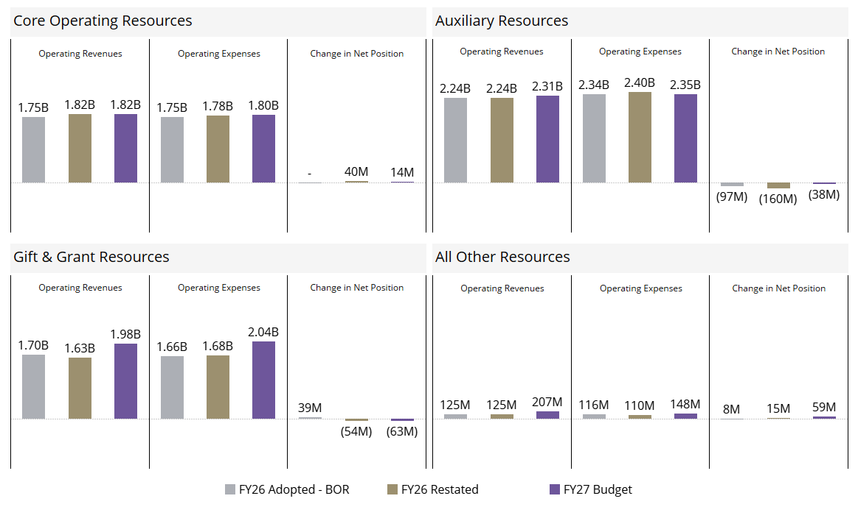
Figure 2. Comparative View of FY26 Budget and FY27 Budget (in millions)^{1,2,3}
1. Grant Resources are shown without Indirect Cost Recovery, which is included in Core Operating Resources. Figures represent all sources and uses for operating purposes and change to net position from operations.
2. FY26 Adopted Budget reflects the original budget as approved, while FY26 Restated uses the same methodology as the FY27 Budget to provide a more relevant comparison.
3. Auxiliary Resources: Operating Expenses variance from FY26 Adopted to FY26 Restated is driven by $93M in “planned transfers for capital purposes” moving from below the line into operating expenses in the new financial book view.

Core Operating Resources
Core Operating Expenses: To ground the FY27 budget in context, we examined expense trends compared to other intensive research institutions. Higher education expenditure trends have long been a focal point nationally and at the UW. As the national conversation prompts local assessment and ongoing monitoring, analyses must consider institutional differences. At the UW, for example, financial statements include our hospital system and expenses are combined for the academy and our hospitals and clinics. In reviewing core operating expenses by function, the areas of research, instruction, and academic support categories have been and continue to be UW's most concentrated areas of expenses and together make up approximately three-quarters of core academy operating expenses. The remaining quarter of the operating expenses fall into broad categories of student services, institutional support, and public service.
Core operating expenses by natural category, such as salaries, benefits, and contractual services, etc., are also monitored according to peer averages and year-over-year growth and contraction. Salary and benefits make up three-quarters of the total core operating expenses. While competitive compensation for our faculty and staff remains a top priority, increases are dependent on state authorizations and funding levels for salary and benefits changes, sufficient incremental auxiliary resources, and other factors. Based on final state budget outcomes, and considering the financial position of the UW, this budget assumes a 2% salary increase for faculty and professional staff in FY27. For classified represented employees, collective bargaining agreements dictate wage changes.
Core Operating Revenues: Core operating resources are derived from state appropriations, net tuition operating fee revenue, indirect cost recovery from grants and contracts, summer quarter tuition, and other local resources. The largest components, state appropriations and net tuition operating fee revenues are detailed below, and indirect cost recovery is discussed within the grants and gifts section.

State Appropriations
In the 2025 state legislative session, the legislature passed a biennial budget that balanced a projected $16 billion budget deficit. In the year since, the Economic Revenue Forecast Council (ERFC) has largely reported steady, modest changes in revenue. Consequently, lawmakers faced a 4-year budget deficit estimated at less than $1 billion, reflecting a better-than-expected revenue outlook entering the 2026 legislative session.
Lawmakers recently approved a 2026 supplemental operating and capital budgets before the end of the legislative session on March 12. The supplemental operating budget adjusts appropriations for FY26 and FY27 that were established in the biennial budget last year. Given the modest deficit, lawmakers balanced the budget with relatively small cuts to agency funding. Governor Ferguson approved the operating budget without major modification.
Total Near General Fund-State (NGF-S) funding in the final compromise budget is $1.0 billion over the 2025-27 biennium, representing a $67.9 million decrease in state funding compared to the enacted 2025-27 biennial budget. Removing a net-neutral shift described below, total operating budget funding would increase by $17.6 million, largely attributed to funding for the Center for Behavioral Health and Learning (CBHL). At a high level:
- The compromise budget would reduce state funding to the University by $85.6 million (GF-S and Workforce Education Investment Account) in FY27 but offset the total amount with UW Building Account funds, which are then backfilled by state bonds. This is a net-neutral shift of funding from the state’s capital budget to the operating budget that reflects the legislature’s creative efforts to avoid additional cuts to the UW’s operating budget. This is a one-time shift in FY27 and is not expected to continue into the next biennium.
- The compromise budget implements a reduction to administrative spending totaling $1.25 million. This represents a reduction in administrative spending of roughly 1.5%.
- The University requested $18.34 million in ongoing funding for the CBHL, consistent with prior agreements among state leaders to fully fund CBHL operations. The compromise budget would provide $15 million in ongoing funding, partially meeting this request.
- The compromise capital budget funds the University’s $47.5 million Climate Commitment Account (CCA) request for the Power Plant Electrification and Campus Hot Water Loop – Phase 1 project. This project is reflected in the Capital Budget portion of this document.
Figure 3 shows the state’s “fund-split” for UW compensation over the past several biennia. The state legislature provides funding for certain compensation items. These include salary, wages, and benefits for represented and non-represented faculty and staff, as well as for central services charged to state agencies. Compensation items are funded on various “fund splits,” with some items receiving a higher proportion of state funding than others. Figure 3 depicts the state and tuition split for all compensation items assumed in state budgets over a five-biennium period.
Figure 3. State "Fund-Split" for Compensation¹

* Due to the COVID-19 pandemic, state funding for some compensation items was suspended for FY22 and FY23 (the 2021-23 biennium). During the 2022 supplemental session, the state restored compensation funding for FY23 at 58%.
Salary increases contemplated in the state budget only apply to positions that are paid for by the combination of state funding and tuition revenue, and account for a small fraction of our employee base. Salary increases for all other employees are funded from other sources of revenue. Combined with proposed cuts to overall state funding and uncertainty with federal funding, the compensation and benefits changes in state budget proposals would be extraordinarily challenging to implement for the University. As a non-cabinet state agency, the University has flexibility to implement increases that differ from authorized levels and must do so as we balance our net adjusted operating income losses with our desire to provide competitive compensation. Table 3 shows the net funding provided in the compromise budget, total cost of salary and benefits changes for state-funded positions, and the effective “fund split” provided by the state.
Table 3. Gap Analysis of FY27 Operating Budget
GF-S and Tuition (in $1,000s)
 |  | FY27
Net State Funding (funding - cuts) |  | 10,667
Total Cost of State Salary & Benefits in Budget |  | 45,644
 |  | Gap | 34,977
 | Effective fund split % state |  | 23%
To put state funding in context with tuition revenue and financial aid (discussed in the following sections), Figure 4 shows state appropriations per FTE and resident undergraduate tuition and fee rates compared to the University’s Association of American Universities (AAU) public peer group. Note that other institutions represented in the figure receive other forms of state support not contemplated here. The UW receives relatively modest state appropriations and maintains comparatively low tuition rates. The combination of low tuition and low state funding means our total resource base supporting instruction is lower than most of our peers. This reality limits our ability to invest in faculty and staff, programs, and student support, potentially affecting educational quality and the long-term sustainability of our institution.
More information regarding state budgets, including a comprehensive summary of budget proposals, can be found in relevant documents on the FPB Briefs webpage. This page includes a summary of the state’s recent final compromise 2026 supplemental operating and capital budgets.
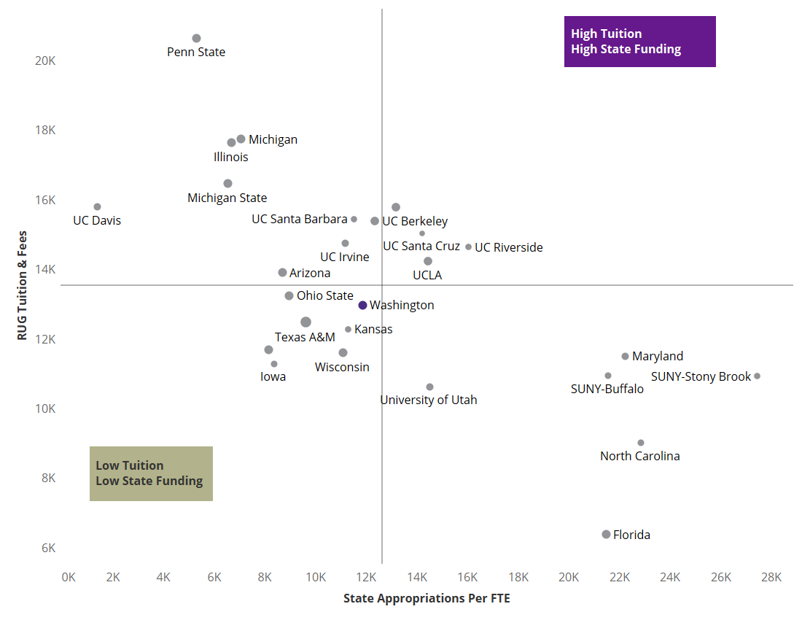
Figure 4. State Appropriations Per Student FTE and Resident Undergraduate Tuition Rates Benchmarking (AAU Public Comparisons, FY25)
Source: AAU Data Exchange
The size of the round circle corresponds to total enrollments.
The dotted lines represent median values.

Tuition & Financial Aid

Tuition & Fees
Current resident undergraduate (RUG) tuition policy (RCW 28B.15.067) allows institutions to increase operating fees by up to the 14-year rolling average of Washington’s median hourly wage as reported by the Bureau of Labor Statistics (BLS). The Board of Regents has the authority to set tuition rates for nonresident undergraduates, and all graduate and professional tuition categories.
The tuition rate recommendations in Attachment 2 are the result of many months of collaboration between chancellors, deans, faculty, students, and staff along with executive and academic leadership. The administration solicited recommendations from deans and chancellors but required that each dean and chancellor consult with students and elected faculty councils. All tuition rate proposals were accompanied by narrative justification, market analysis, enrollment changes, waiver implications, statement of impact to low-income students, and information regarding the use of incremental revenue. Projected tuition revenue—net of building fee, required financial aid set-aside, and waivers—is shown in tables and figures throughout this document as “Tuition Operating Fee Revenue.”
For more information about current tuition and fees, please review our Cost of Attendance and Current Tuition and Fees Dashboards.

Financial Aid
The UW is committed to providing educational access and opportunity, as well as quality educational experiences and academic success for students.
The University’s commitment to financial aid includes programs such as Husky Promise, which guarantees that full tuition and standard fees will be covered by grant or scholarship support for eligible Washington state students. The UW also offers a variety of tuition waivers authorized or required by the state, such as those to veterans and surviving spouses and dependents of fallen police officers and firefighters.
Table 4 shows both the amount of operating fee revenue generated by students and the amount of financial aid funded by tuition. Of the approximately $1.1 billion in gross operating fee charged, approximately $225 million, or 20%, is directed to fund institutional aid to students.
The table outlines the types of aid funded by tuition dollars. A significant portion of aid is also funded by non-tuition dollars, including gifts, UW endowments, federal, and state grants, scholarships, and loans (not shown here). Graduate students also receive support from research grants and contracts, and core operating funds for teaching assistants. Note that Table 4 only displays the projected institutional aid derived from tuition across all three UW campuses.
Table 4: 2026-2027 Net Operating Fee Revenue and Tuition-Based Aid¹ (in $1,000s)
 | Undergraduate |  |  | Graduate/Professional |  |  | Total
 | Resident | Nonresident² | Total | Resident | Nonresident | Total | Total
Full-Time Equivalent (FTE) | 31,257 | 9,676 | 40,933 | 4,869 | 5,201 | 10,070 | 51,003
Gross Operating Fee Revenue | 365,201 | 408,541 | 773,742 | 129,300 | 199,603 | 328,903 | 1,102,645
State-Mandated Aid | (13,627) | (15,972) | (29,599) | (4,417) | (4,036) | (8,453) | (38,052)
UW Institutional Aid | (39,467) | (15,795) | (55,262) | (5,026) | (4,428) | (9,454) | (64,716)
Waivers - Foregone Revenue³ | (9,921) | (4,704) | (14,625) | (13,713) | (94,028) | (107,741) | (122,366)
Faculty and Student Reinves. Pool⁴ | (4,707) | (2,543) | (7,250) | (1,250) | (1,250) | (2,500) | (9,750)
Net Operating Fee Revenue | 297,479 | 369,528 | 667,007 | 104,895 | 95,861 | 200,756 | 867,763
Aid Contributions | 63,015 | 36,471 | 99,486 | 23,156 | 102,492 | 125,648 | 225,134
Aid Allocations | 93,877 | 11,963 | 105,840 | 26,514 | 92,778 | 119,292 | 225,132
Aid as % of Gross | 26% | 3% | 14% | 21% | 46% | 36% | 20%
1. Numbers are rounded to thousands and, therefore, may not match within this table or others in the document.
2. Incremental revenue from past nonresident undergraduate tuition increases has been used to fund aid for domestic nonresident undergraduates.
3. More than 85% of waivers are provided to graduate teaching and research assistants as function of their appointment.
4. Funds held centrally to support faculty compensation (one-time adjustment to the aid budget in FY20).
Financial aid resources correlate to student loan debt. Displayed in Figure 5, the UW’s median loan debt after graduation (undergraduates) is $14,615, well below the peer median of all three peer groups shown.
Figure 5. Median Total Debt
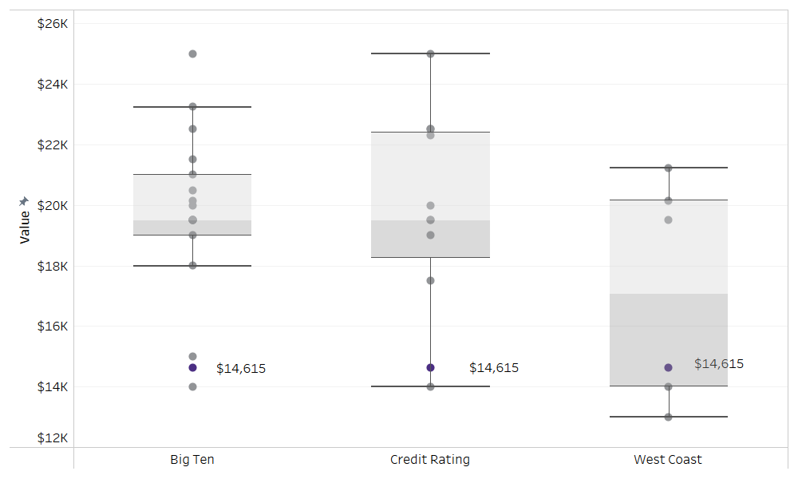

The median cumulative federal debt of undergraduate borrowers who graduated. This figure includes only federal loans originated at the school awarding the credential; it excludes private student loans, Parent PLUS loans, and federal loans originated at previously attended schools.
Note that this value includes federal loan debt for all undergraduate borrowers that completed their program.
Source: NSLDS, FY2024

University Auxiliary Activities
The UW, like many large R1 institutions, operates a broad portfolio of auxiliary business enterprises that exist to support the multipart mission of the institution. These activities are different from those supported by tuition, state appropriations, and federal and state grants or contracts in that they are intended to function sustainably within the revenues generated from internal and external customers. Due to the diverse nature of the portfolio of auxiliary enterprises and, in some cases, the debt covenants associated with their participation in the UW’s Internal Lending Program (ILP), this component of the University’s operations may operate with sizable, accumulated net position.
Many of our schools, colleges, campuses, or administrative units have several types of auxiliary operations, ranging from specialty operations that focus on supporting a specific type of activity to large operations that provide broad support to the University mission.

As has been the case previously, auxiliary activity is concentrated in a handful of units in the FY27 budget. Budgeted revenues are $1.36 billion for School of Medicine (59% of the UW Academy total), $171 million for Housing & Food Services (7% of the UW Academy total), $93 million for Facilities (4% of the UW Academy total), and $105 million for Intercollegiate Athletics (5% of the UW Academy total). The other 34 major organizational units of the UW Academy make up the remaining $579 million, 25% of the total.
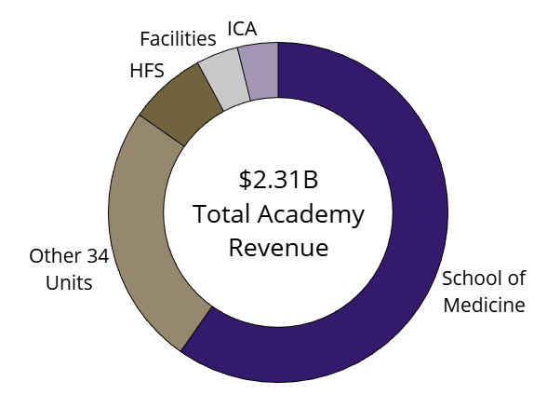
Figure 6. UW Academy Auxiliary Components

The FY27 budget reflects growth in auxiliary operating revenues of +3% and reduction of expenses of (2%) relative to the restated FY26 budget.
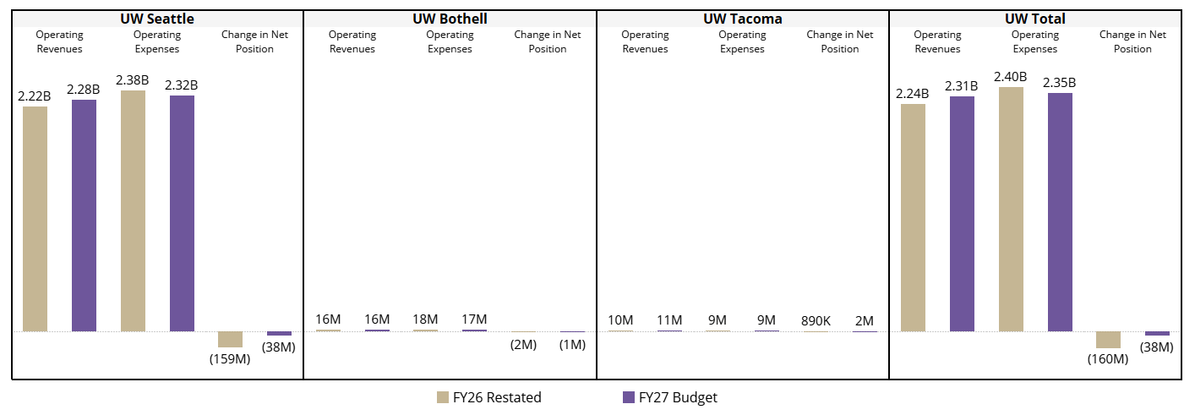
Figure 7. FY26 vs FY27 Auxiliary Operating Revenues & Expenses, by Campus¹
1. FY26 Restated Budget shown here uses the same methodology as the FY27 Budget. Because the methodology has changed, the FY26 Restated Budget will not match last year’s published FY26 Adopted budget materials. See Figure 2 for explanation.

Other Operating Revenues
The Other resources category groups together resources that are not widely used across the University, often limited to use within a single unit or department. These resources are often highly restricted and may have required separation from other funds in the design of our new financial data structure to enable strict monitoring and reporting activities. A primary component of this group ($86 million or 42%) is activity related to Portage Bay Insurance, the University’s captive insurance company. The balance ($121 million or 58%) pertains to Student Mandatory Fees and Sales of Goods and Services.

Grants and Gifts

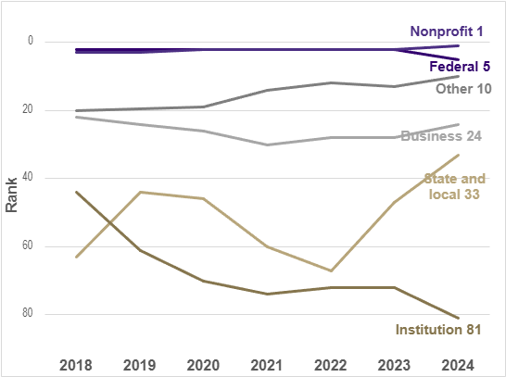
As a leading global research-intensive public institution, UW supports a dynamic philanthropic and research portfolio. The UW has long been a hub for scholarship, discovery, problem-solving, and community engagement. We take pride in our culture of collaboration and innovation, which keeps the UW competitive and our schools, colleges, and campuses at the forefront of significant multi-disciplinary initiatives tackling some of the most persistent issues of our era. Transformative work necessitates substantial collaboration across the University and with partners across the world, supported by a strong network of sponsoring agencies and committed supporters of our mission.
Figure 8. HERD Rankings by Fund Source

National Rankings: According to the Higher Education Research and Development (HERD) survey shown in Figure 8, UW’s rankings for federal research and development (R&D) funding fell from 2nd to 5th in FY24. This can be partially attributed to spending that was delayed during the finance system’s stabilization period. UW’s ranking for foundation and non-profit funding went from 2nd to 1st in FY24. The UW remains highly competitive with public and private universities in funding from a variety of sources.
Global Reach: International collaborator with over 100 universities across 30 countries.
Workforce and Sponsors: Approximately 5,800 full-time employees (FTEs) were supported by awards in FY25 from approximately 1,700 active sponsors.
Awards: In FY25, the University received new awards totaling $1.76 billion, comparable to the final award dollars received in FY24. During FY25 there were more than 8,300 active awards.
Our adopted FY26 operating budget reflected significant declines in research activity based on what had been known and anticipated during the spring of 2025. Throughout FY26 there were multiple federal initiatives ranging from proposed historic reductions in federal research and development funding to overnight changes to longstanding federal indirect cost policy. While our research enterprise has endured many significant impacts due to shifting federal priorities, fortunately, the most extreme scenarios have thus far not come to fruition. Our FY26 projected figures reflect better than anticipated outcomes for the current fiscal year, however, there were substantial impacts associated with delayed award notices and reductions in new award funding that will impact federally funded research at the UW for years to come. FY27 projections reflect those uncertainties. In response, we are continuing our initiatives to foster resilience in the research enterprise and to position UW to be highly competitive for future funding opportunities.

Table 5. Projected Sponsored Research Expenses with Breakout of Indirect Costs (in millions)
 | FY26 Adopted | FY26 Forecasted | FY27  Projected | % Change (Forecasted FY26 to FY27)
Federal¹ | 765 | 1,028 | 956 | (7.0%)
State & local grants² | 132 | 125 | 120 | (4.0%)
Nongovernmental | 346 | 350 | 360 | 2.9%
Indirect Research Expenses | 262 | 333 | 316 | (5.1%)
Total | 1,505 | 1,836 | 1,752 | (5.0%)
1. Excludes Covid-19 relief funding.
2. Includes ~$100M/yr of financial aid that is counted towards sponsored project totals for accounting purposes (not R&D).
Philanthropic support: In FY25, the UW ranked first among public universities in current-use fundraising totals, a metric which includes current-use gifts and current-use private grants, with $584 million on the Council for Advancement and Support in Education (CASE)’s Voluntary Support of Education (VSE) survey.
Figure 9. FY25 Fundraising Peer Rankings (in millions)¹
1. Voluntary Support of Education (VSE) survey from the Council for Advancement and Support in Education (CASE)
Table 6 shows changes between the adopted FY26 budget, revised projections for FY26, and the FY27 projected budget. The gift income figure, defined as current-use support, is a subset of total annual private support, which Advancement projects will be around $761 million in FY26. Gift Income includes only current-use gifts to the University of Washington and the University of Washington Foundation. It does not include income from private grants (approximately $188 million) or new endowment gifts. The decrease in gift income between the adopted and forecasted figures for FY26 is due to a change in forecasting methods. The $246 million FY27 gift income projection reflects continued fundraising for current initiatives and long-term priorities, including support for students, faculty, programs, and key academic facilities. We anticipate a return to growth in line with UW historical trends and sector trends of 3.4% growth.

Table 6. FY27 Annual Gift & Endowment Distributions (in millions)
 | FY26 Adopted | FY26 Forecasted | FY27 Projected | % Change
 |  |  |  | (Forecasted FY26 to FY27)
Gift Income | 269 | 246 | 246 | 0.0%
Endowment Distributions¹ | 159 | 157 | 184 | 17.2%
Total | 428 | 403 | 430 | 6.7%
1. Increase in FY27 Endowment Distribution projections is due to approved increase in CEF spending policy. Effective July 1, 2026, the total spending rate will increase from 4.5% to 4.75%, program distributions will increase to 4.0% and administrative fees will decrease to 0.75%.
Figure 10 shows the UW’s endowment per student FTE, which is approximately $95,000. The University’s endowment places it in the upper-middle tier, above the average of each peer group. The 9% increase in endowment compared to FY24 has improved the University's position amongst Big Ten and other west coast peers on a per-FTE basis, but continue to lag with Credit Rating Peer group.
Figure 10. Endowment Value Per Student FTE
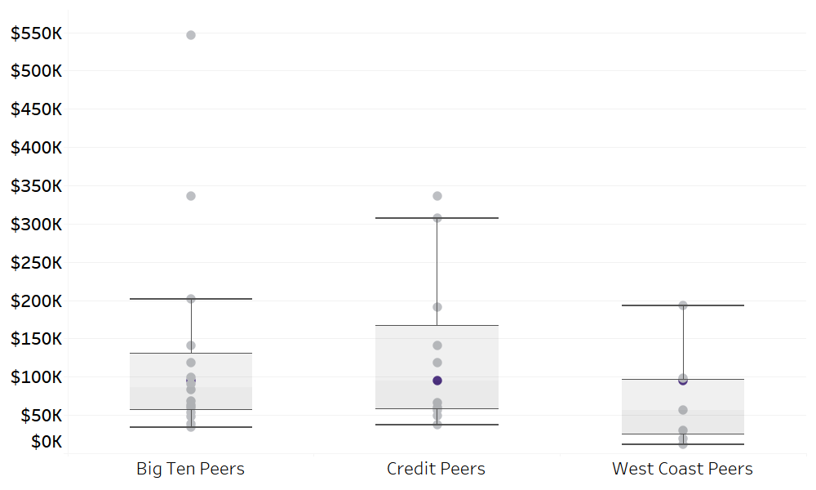

Source: Finance, Planning & Budgeting and UW FY25 Audited Financial Statements
Note: Outlier in Big Ten peers is a private institution.
The UW's endowment is composed of over 5,000 individual endowments, each with its own unique purpose. Of the total, 99% of funds are restricted to donor-directed purposes, and approximately two-thirds directly support students and faculty.

UW Medicine Operating Budget
The clinically integrated parts of UW Medicine consist of the UW School of Medicine (SoM), the two campuses of UW Medical Center at Montlake and Northwest (UWMC), Harborview Medical Center (HMC), UW Physicians (UWP), Airlift Northwest (ALNW), and UW Medicine Primary Care Clinics (UWMPC). Fred Hutchinson Cancer Center (FHCC) serves as UW Medicine’s cancer program and is discreetly presented in the University's audited financial statements (effective April 1, 2022). The budget for UW Medicine also includes UW Medicine Shared Services. UW Medicine is led by the CEO of UW Medicine, who also serves as Executive Vice President for Medical Affairs, and Dean of the School of Medicine, University of Washington. Environmental factors, industry and economic trends, and operating challenges are considered carefully in developing the budget for UW Medicine.
In FY23 and FY24 Mission Forward work increased revenues, reduced costs, and focused investment in key infrastructure while standardizing work across the system. This was extremely beneficial, and we have maintained the recurring benefits of Mission Forward throughout FY25 and FY26. However, capacity challenges, the continued labor market wage and benefit pressure, other inflationary pressures, shifts in payer mix, and a continued need to address higher than desired length of stay including complex discharge continue to challenge significant financial improvement.
Today, we also face rising budgetary concerns at both the federal and state level including ongoing delays and cancellations of grants; reduced eligibility and funding for Medicaid and related supplemental programs that help sustain our ability to care for our Medicaid patients; and caps on reimbursement for providing care to state employees. The FY27 budget includes $153 million for UWMC and $229 million for HMC for the directed payment programs.
Consistent with our mission to improve the health of the public, UW Medicine continues to focus on delivering world-class clinical care, research, education, and training while navigating an evolving and challenging federal and state funding environment.

FY26 Performance Summary by Entity
UWMC is a single hospital with two campuses including the Center for Behavioral Health and Learning on the Northwest campus. Strong volume growth especially in outpatient volumes, continued operational improvements around length of stay, surgical and procedural throughput and expense control contribute to offsetting the continued growth of Medicare and inflation to help achieve the FY26 budgeted net income at UWMC. The outpatient and inpatient directed payment programs provide additional federal funding through a Medicaid supplemental program. These direct payment programs have provided approximately $122.5 million at UWMC in cash received in FY26. As a part of H.R.1 (One Big Beautiful Bill, OBBBA), these directed payment programs will start to decline in FY28. Days of cash on hand in FY25 was 55 days, and cash levels in FY26 have decreased to 53 days at the end of March 2026 including UW Medicine non-interest bearing funding of $53.5 million.
UWMC has significant deferred maintenance which requires capital support. Funding support including timely access to capital and efficient deployment of strategic initiatives will be crucial success drivers in the ability to address deferred maintenance over time while achieving financial targets. Continued volume growth at UWMC is a critical component to achieving the FY26 budget.
UWP works closely with the medical centers during the development of the budget and the long-range plan to ensure the volume and reimbursement assumptions are consistent. UWP has prepared a budget that anticipates growth in key areas, consistent with the prioritized strategies of UW Medicine overall.
UWMPC expects continued growth in outpatient primary care volumes with strong demand for our primary care services. In FY26, primary care and urgent care visits continued to grow over FY25 volumes within the same clinic footprint.
ALNW has experienced a decline in total flights and billable mileage in FY26 YTD as compared with FY25 partially offset by expense control. Mitigating strategies to improve the financial performance of ALNW are being evaluated by leadership.
HMC continues to experience higher than budgeted admissions, outpatient surgical cases and lower than budgeted length of stay offset by lower than budgeted inpatient surgical volumes in FY26 YTD. Some inpatient volume growth is projected and will allow for additional volumes expected to be generated from population growth as well as continued growth in HMC Centers of Emphasis. The opening of four new outpatient operating rooms in January 2026 generates capacity for further growth in FY27. The outpatient and inpatient directed payment programs have provided approximately $174.8 million at HMC in cash received in FY26. Days of cash on hand in FY25 was 106.3 days, and cash levels in FY26 have increased to 118.2 days at the end of March 2026.
For the calendar year 2025 and 2026, HMC property tax has been approved by King County, and the distribution of the tax falls to three buckets: operations, other capital and bond projects. The 2026 calendar year tax is estimated at $48 million for operations, $34 million for other capital, and $42 million for bond projects. For calendar 2026, Medicaid funding of $31 million will be encumbered once certain reporting requirements are submitted to the executive and King County Council. Included in the FY27 budget is $48 million of operational support and $31 million for Medicaid funding from the property tax.
In the fall of 2020, the voters of King County approved a $1.7 billion bond measure to enhance and expand the HMC campus. The multi-year planning process is underway in partnership with King County and UW Medicine. Enhancements are expected to include inpatient, emergency, operating room capacity, replacements to aged infrastructure, and extensive seismic upgrades.
UW Medicine is committed to managing Harborview in a fiscally responsible manner to provide and teach exemplary patient care, to provide health care to a mission population of the underserved as defined by King County, as well as serving patients from all walks of life through the Centers of Emphasis based there.
SoM has a modest surplus YTD FY26 due to better than budgeted philanthropy and clinical volumes. Important programmatic initiatives around medical school accreditation and continued build-out of the 1601 Lind building are on-going.

Current Financial Performance
Table 7 depicts the FY26 margins recorded at all the UW Medicine entities through March 2026 but is preliminary and subject to audit. A subtotal has been incorporated to highlight the results specific to the Select Units (SU). The SU represents the entities that are part of the borrowing unit for UW Medicine, which includes all UW Medicine organizations other than HMC and the SoM. When UW ILP debt requirements are re-established for the SU they will be measured only on the results of the SU.

Table 7. FY25 Financial Results by UW Medicine Entity, as of March 2026 (in $1,000s)
 | YTD Actual³ | YTD Budget | Variance to Budget
UWMC | 4,498 | (2,610) | 7,108
ALNW | (1,821) | 1,153 | (2,974)
UWMPC | 4,911 | (2,803) | 7,714
UWP¹
SUBTOTAL, SU | 7,588 | (4,260) | 11,848
HMC² | 13,093 | 25,585 | (12,492)
TOTAL | 20,681 | 21,325 | (644)
1. Results for UWP are shown after amounts available to the School of Medicine.
2. Harborview recorded $56 million of expense for FY27 and FY28 King County mission population support payments in December 2025.
3. YTD Actual results include $278.7 million for directed payment program year 2026 and as of March 2026.
Figure 11 depicts the month-to-month comparison of actual results to budget.
Figure 11. Combined Monthly Total Income as of March 2026 (in $1,000s)
Note: Excludes FHCC and SoM

Looking Ahead: Performance, Budget, Clinical Strategic Planning & Long-Range Planning
With operational and strategic initiatives, we completed our capital plans and adjustments have been made to reduce or delay our planned capital spending as much as possible to maintain needed days cash on hand. During FY25 and FY26 we have started work on several capital projects that will continue into FY27 and beyond. UW Medicine is planning for a sustained increased level of capital necessary to address delayed maintenance and strategic growth projects.
All the hospital budgets for FY27 were approached with the goal of preserving liquidity given the challenges in financial performance that UW Medicine and our peers are facing. Specifically, at UWMC, work has been done to develop short-term strategies that will provide the runway to establish the initiatives necessary to maintain financial results.
Actual and annualized revenues and total margins for FY25 and FY26 are in Table 8. The FY27 amounts in the table are final. It is important to note that these budget targets were challenging to achieve, especially at UWMC, as our revenue reimbursement declines due to H.R.1 and PEBB/SEBB caps impacted our revenue growth, which is limited due to capacity constraints. Expense inflation is outpacing revenue in both labor and non-labor expenses. The FY27 budgeted margin for UWMC finalized at a loss of $13.2 million or -0.4% and continued necessary investment in capital of $120 million. The FY26 final budget targets for other UW Medicine entities did not change from preliminary targets shared in May.
The UW Medicine FY27 budget does not include FHCC, which will be included in the University’s FY27 financial results as a discreetly presented component unit. The target margins for FY27 are displayed in Table 8.
Table 8. FY25 and FY26 YTD Actual Revenues and Margins and FY27 Budget (in $1,000s)
UW Medicine¹ | FY25 Actual Total Margins | FY26 Budget Revenues² | FY26 March Annualized Revenues | FY26 Forecast Total Margins³ | FY27 Budget Revenues | FY27 Target Margin⁴ | FY27 Target Margin %
UWMC | 131,881 | 3,057,000 | 3,015,961 | 10,000 | 3,236,000 | (13,200) | -0.4%
UWP |  | 716,000 | 723,776 |  | 756,000 |  | 0.0%
Airlift NW | 2,418 | 85,000 | 78,299 | (500) | 86,700 |  | 0.0%
UWMPC | 3,014 | 174,000 | 178,705 | 4,000 | 177,000 | (2,600) | -1.5%
Subtotal SU⁵ | 137,313 | 4,032,000 | 3,996,741 | 13,500 | 4,255,700 | (15,800) | -0.4%
HMC | 133,561 | 1,775,000 | 1,750,123 | 7,000 | 1,785,000 | 48,600 | 2.7%
UW Medicine | 270,874 | 5,807,000 | 5,746,864 | 20,500 | 6,040,700 | 32,800 | 0.5%
1. School of Medicine projections are included within the Auxiliary/Self-Sustaining and Core Operating Budget areas of the University budget, so they are excluded here.
2. The revenue amounts differ slightly from the amounts approved in the FY26 budget due to final budget refinements.
3. Total margins do not include pension and OPEB year-end actuarial adjustments.
4. Total target margin ties to budgeted contribution to net position minus depreciation and amortization in Table 1 and Table 2, which includes state appropriations in revenue.
5. Select Unit subtotals do not include Shared Services, ITS, and eliminating entries in FY25, FY26, or FY27.

Budget Priorities
Achieving sustainable financial performance and liquidity continues to be one of UW Medicine’s top strategic priorities. Pressure on reimbursement from all UW Medicine payers has resulted in less than inflationary increases. The cumulative impacts of inflation, particularly related to labor costs, continue to trend higher than expected overall blended governmental and commercial rate increases. As we move into FY27, our primary clinical goals remain to improve access to high-quality, equitable care for our patients, to provide a safe and inclusive working environment that supports the well-being of our employees, and to focus on our multi-year plan of improving financial performance.
Our FY27 budgets include modest strategic capital investments and assume a planned level of access to capital via the Internal Lending Program. A portion of these investments will be made using operating cash, and anticipated debt service has been included in budgets. Details related to the planned investments are included within the University’s capital budget item that will be brought forward for Regental approval.
UW Medicine’s budget challenges have always existed due to the significant inflationary expense increases that are projected every year that outpace expected revenue growth. Salary and benefit inflation for our workforce, pharmaceutical inflation, and supply inflation are included in the FY27 budgets. Additional cost savings or revenue-producing initiatives as well as sustained recurring benefits from operational efficiencies (historically called Mission Forward) are required to offset these increases.

Clinical Strategic Planning and Long-Range Financial Planning: FY26-FY39
Academic Medical Centers (AMCs) across the country have seen declines in financial performance as the ability to weather the current economic challenges has become further strained. In an April 2024 study, McKinsey & Company reported that across 45 AMCs, median operating margin fell from 3.7% in 2017 to 1.5% in 2022. At the same time, hospitals need to be able to make large capital expenditures to keep current with advances in technology, provide needed access to care, and address delayed maintenance. The industry continues to be in a period of system consolidation and re-stabilization post-COVID-19.
The operating, clinical, and financial aspects of our business will be challenging over the next few years as we navigate our way past significant inflationary cost increases while reimbursement rates continue to decline. The development of additional capacity for profitable growth, network partnerships and strong, public sources of revenue to support UW Medicine’s mission, clinical priorities and hospital operations will be a key focus for our leaders going forward. UW Medicine will continue to focus on the strategic directives of the organization, prioritizing the following:
- Focus on continuing our work on maximizing revenues and lowering costs on a volume adjusted basis
- Expansion of inpatient capacity including:
  - Optimizing existing facilities to convert administrative to clinic, OR and procedural space
  - Planning for South Campus Hospital Expansion
  - Northwest Hospital campus planning and programming
  - Network strategy development
  - Partnerships with other public hospital systems
  - Ambulatory strategic planning, including expansion of geographical access to UW Medicine services
- Strengthening strategic alignment with our clinically integrated partners such as Fred Hutch Cancer Center
- Focus on key service line growth initiatives, including extension of specialty services through telehealth, Transplant, Maternal Fetal Medicine and Heart Institute
- Focus on improving access to high-quality, equitable care for our patients
  - Length of stay and other efficiency improvements
  - Medicare line of business strategic planning and population health initiatives
- Successful stabilization and enhancements of the Workday financial platform
- Investments in infrastructure including
  - Campus renewal at each site
  - Continued enhancement of our investment in a single EHR platform
- Philanthropic support
UW Medicine’s ability to successfully deliver on our mission to improve the health of the public requires that it has strong, effective, and visionary leadership; makes well-informed strategic choices; recruits and retains excellent staff and faculty; implements best practices in all aspects of its business; and strengthens its financial health to be able to invest in the future. UW Medicine overall provided uncompensated care of more than $433 million and $391 million in fiscal 2025 and fiscal 2024, respectively (the most recent years measured), which requires that we continually focus on ways to improve our efficiency while providing high-quality care to all our patients. Continuous improvement and efficiency gains across the care continuum, sustainable growth, maintaining quality, safety, service, and improving access to care for our patients will all be crucial to our financial success and our ability to achieve our goals.

Capital Budget Executive Summary

Introduction
The FY27 Annual Capital Budget reflects the University's upcoming capital investment priorities. The budget totals $3.9 billion of total forecasted project costs, with approximately $2.1 billion projected for expenditure over the next five years ($1.7 billion when excluding Housing and Food Services and certain other partnerships), or roughly $430 million annually.
- Items Requiring Board Action: Initial approval of planned FY27 projects ($1.1 billion) and 10-year look ahead.

Support of Institutional Goals
Capital investments are a primary mechanism through which the University can advance pillars of the draft 2026–2030 Strategic Plan. Pillar 2 calls for investing in advanced infrastructure and leading-edge technology to build flexible research environments that protect existing strengths and accelerate discovery. Pillar 3 identifies technology as an amplifier of knowledge and skills and directs the expansion and modernization of the UW Medical Center – Montlake campus to improve patient experience and elevate care quality. Pillar 4 commits the University to creative revenue solutions, stronger unit finances, and disciplined risk management to sustain future ambitions. While the Strategic Plan is currently under final review, many of the investments outlined in this document make progress toward the goals identified for the next five years.

Ongoing Challenges and Funding Strategies
Building upon sustained investment, the University continues to advance several structural and funding priorities to support strategic capital stewardship:
- Energy infrastructure and decarbonization: Increasing electrical demand on the Seattle campus, driven by expansion, decarbonization goals, and rapid adoption of digital capabilities is a top priority requiring integrated capital and operational planning. State funding from the Climate Commitment Account (CCA) provides a strong foundation, while the University actively pursues complementary funding sources to fully advance these programs.
- Deferred renewal backlog: The deferred renewal backlog represents $3.5 billion, of needed investment with aging facilities and infrastructure systems ready for modernization. The University is actively expanding its funding strategies beyond traditional sources such as the State Capital Bond and UW Building Account to meet growing demand.
- UWMC expansion: UW Medicine sees growing patient demand as an exciting catalyst for campus transformation, as existing infrastructure is updated to meet modern standards of care. Advancing this opportunity calls for a carefully coordinated sequence of initiatives, including the strategic relocation of functions currently housed in the Magnuson Health Sciences Center (MHSC).
- Technology infrastructure modernization and renewal: UW now relies on technology systems for virtually all key functions: including but not limited to those of research, teaching, student life, medicine, human resources, and finance. The deepening of this dependency has occurred faster than the University or the state has been able to adopt corresponding funding structures or plans.
- Regulatory compliance: The University is working collaboratively with the City of Seattle to navigate the Substantial Alteration Code, seeking practical solutions that enable cost-effective building renewal while meeting code compliance. This active partnership is key to stretching renewal investments further and modernizing more facilities across campus.
- Space optimization: The University remains committed to smart, sustainable growth of its facilities, maximizing the value of existing spaces through repurposing and renovation before pursuing new construction.
- Debt capacity: Reflecting the University's growing ambition, institutional debt requests now signal robust demand across strategic priorities, accelerating the need to explore innovative financing solutions.
To address these ongoing challenges and ensure responsible stewardship of institutional resources, the University is working toward a revised strategic framework for capital planning with collaboration among the Capital Planning Advisory Team (CPAT), FPB, UW Facilities, UW Medicine, UW Information Technology (UWIT), and other partners on the University’s campuses. A new framework should support a transition from a largely reactive, request‑driven process to a more strategic, data‑informed, and financially disciplined capital planning environment.
At a high level, the revised framework would emphasize:
- Strengthened front‑end requirements to ensure that only financially viable and strategically aligned proposals advance in the process. These requirements include a formal feasibility study approval process and a matching‑funds expectation for projects seeking state support to reinforce financial realism and readiness at the earliest stages of project development.
- Data-informed approaches to project prioritization that enable the University to strategically address its tri-campus deferred renewal backlog, advance enterprise-wide AI-ready infrastructure, and concentrate renewal investments on the assets that deliver the greatest institutional value in alignment with the University's Strategic Plan.
Together, these changes are intended to better align capital requests with realistic funding pathways, improve project readiness, and focus limited capital resources on the University’s most mission‑critical and feasible priorities, while helping reduce the number of proposals developed in the capital budget process without a viable long‑term funding strategy.

FY27 Capital Budget

Funding Distribution FY27-FY31
The FY27–FY31 capital plan prioritizes renewal at 41% of total funding, underscoring the urgency of the University's $3.5 billion deferred renewal backlog. Clinical investment represents 43%, driven largely by UW Medicine’s renewal and growth needs. Growth and Strategic projects together account for the remaining 16%, reflecting a deliberate constraint on new space consistent with targets in the most recent Long-Term Capital Plan (LTCP).
Figure 12. FY27-FY31 Capital Funding Distribution
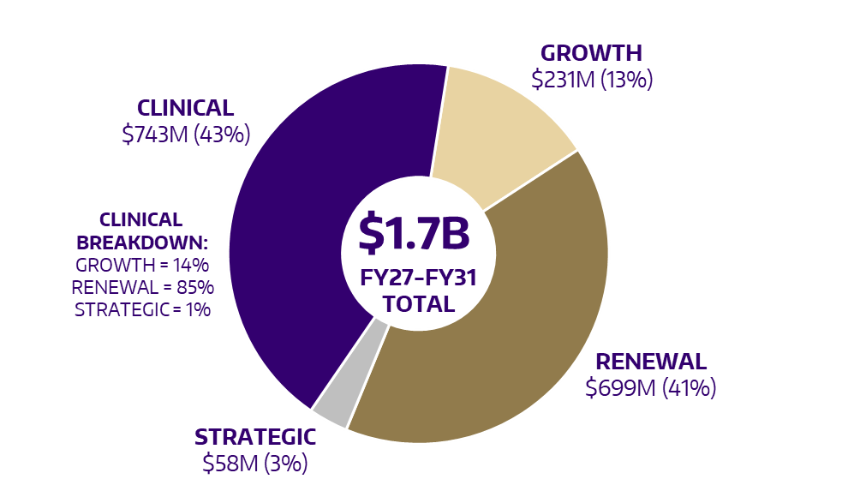
Excludes: Housing & Food Services projects, P3 projects and funding defined as “Other.”

Projects Seeking Approval FY27
The following projects represent just over $1 billion of new investment for FY27. Projects are presented for informational purposes; many are pending resolution of their funding plans or successful state funding requests prior to formal approval by the Board of Regents.
Table 9. Projects Seeking Approval FY27
Category | Project  Name | Sponsoring  Unit | Primary Demand | Estimated Cost | Proposed Funding Source(s) | Notes /  Next Steps
Academic & Institutional Support | UW Tacoma – Student Housing and Food Service | UW Tacoma | Strategic | $150M | $2.5M of UW Tacoma Equity  Remainder - TBD | Dependent upon finance and legal review, successful development of a Public Private Partnership (P3) agreement, and review of potential ongoing costs.
Academic & Institutional Support | McMahon Hall Replacement | Housing & Food Services | Renewal | $280M | $224M – Institutional Debt  $56M – Unit Equity | Requires approval of project plan and debt issuance by Regents.
Education & Research | Bagley Hall Renovation | Arts & Sciences | Renewal | $100M | Central Equity & Debt | Project formation needs to be finalized, follows Chemical Sciences.
Education & Research | Smith Hall 120 Renovation | Student Affairs | Renewal | $8M | TBD | Potential state request as part of reversal of UW Building Account transfer to operating budget for M&O.
Education & Research | UW Bothell - Husky Hall Replacement | UW Bothell | Growth | $93.3M | $73.3M – State 057 Bond Acct.  $20M – Unit Equity | Submit Predesign to OFM by July 1. Plan for 2027-29 state request.
Education & Research | UW Tacoma -Revitalizing the Campus Core | UW Tacoma | Renewal | $74.6M | $67.1M – State 057 Bond Acct.  $7.5M – Unit Equity | Submit Predesign to OFM by July 1. Plan for 2027-29 state request.
System Improvements | Burke Gilman Trail Corridor Renovation - Phase II | UW Facilities | Renewal | $16M | State Transportation Budget  (Two Biennia) | Funding accelerated into 2025-27 biennium through the state’s transportation budget.
System Improvements | Energy Renewal Plan (ERP) - Power Plant Electrification & Hot Water Loop – Phase 1 | UW Facilities | Renewal | $47.5M | CCA | Funding for the project was appropriated in 2026 Supplemental Capital Budget
System Improvements | ERP - New Substation and Energy Efficiency Program  27-29 | UW Facilities | Strategic | $323.1M | $103M – CCA  $67M – Institutional Debt  $153.1M – TBD/Seattle City Light | Agreement needs to be reached with Seattle City Light. Portions of CCA program likely to be submitted for 2027-29 request.

Table 10 captures the projected expenditures by funding source for the Projects Seeking Approval FY27 over the upcoming five-year period.
Table 10. Projects Seeking Approval - Projected Expenditures FY27–FY31 (in millions)
Project Name | Demand  Area | Project  Budget | Prior  Spend | State  Bond | Bldg.  Account | CCA | Debt | Donor | Central  Equity | Unit  Equity | Other | UW Total  27-31 | P3 | Future
UW Tacoma – Student Housing and Food Service | Strategic | 150.0 | 0.4 |  |  |  |  |  |  | 2.1 |  | 2.1 | 147.5
McMahon Hall Replacement | Renewal | 280.0 |  |  |  |  | 224.0 |  |  | 56.0 |  | 280.0
Bagley Hall Renovation | Renewal | 100.0 |  |  |  |  | 78.7 |  | 20.0 |  |  | 98.7 |  | 1.3
Smith Hall 120 Renovation | Renewal | 8.0 |  |  | 8.0 |  |  |  |  |  |  | 8.0
UW Bothell - Husky Hall Replacement | Growth | 93.3 |  | 73.3 |  |  |  |  |  | 20.0 |  | 93.3
UW Tacoma - Revitalizing the Campus Core | Renewal | 74.6 |  | 67.1 |  |  |  |  |  | 7.5 |  | 74.6
Burke Gilman Trail Corridor Renovation - Phase II | Renewal | 16.0 | 0.7 |  |  |  |  |  |  |  | 15.3 | 15.3
ERP - Power Plant Electrification & Hot Water Loop - Phase 1 | Renewal | 47.5 |  |  |  | 47.5 |  |  |  |  |  | 47.5
ERP - New Substation and Energy Efficiency Program  27-29 | Strategic | 323.1 |  |  |  | 56.2 | 67.0 |  |  |  |  | 123.2 | 127.8 | 72.1
 | Totals | 1092.5 | 1.1 | 140.4 | 8.0 | 103.7 | 369.7 |  | 20.0 | 85.6 | 15.3 | 742.7 | 275.3 | 73.4

In addition to the investments above, the Intellectual House - Phase II (noted as an active project in Table 14) will not move forward without additional funding. The current plan is to request an additional $5 million from the state’s 2027-29 capital budget, which in combination with existing state appropriations and anticipated donor funding, would allow the project to move forward.

10-Year Capital Look Ahead
This section captures three categories of longer-horizon projects:
- Projects best positioned to advance over the next several years.
- Proposals in need of further development before they are ready to advance. These will be reviewed in future cycles for potential inclusion in a subsequent Annual Capital Budget.
- Major long-term efforts and emergent needs that require significant coordination over the coming decade, which are currently in early stages of development and may evolve into specific project proposals.

Table 11. 10-Year Capital Look Ahead
Category | Project  Name | Sponsoring  Unit | Primary Demand | Estimated Cost | Proposed Funding Source(s) | Notes /  Next Steps
Projects Best Positioned to Advance | Mechanical Engineering Building (MEB II) | College of Engineering | Renewal/  Growth | $215M | $165M – State 057 Bond Acct. $50M – Unit Equity | Potential 29-31 capital budget request.
Projects Best Positioned to Advance | UWB/CC Activities & Recreation Building Expansion | UW Bothell | Growth | $84M | UW Bothell Student Activities Fees (debt) | Approval of increased student activities fee and approval of debt issuance by regents.
Projects in  Need of  Further Development | Friday Harbor Labs (FHL) Docks Replacement | Friday Harbor Labs | Renewal | $29M | TBD | Requires sufficient funding sources to be identified to move forward. Possible 2028 supplemental capital request.
Projects in  Need of  Further Development | Marine Sciences Tenant Improvement Renovations | College of the Environment | Renewal | $15.9M | TBD | Consider alternatives to state funding.
Projects in  Need of  Further Development | Meany Hall Lighting | Arts & Sciences | Renewal | $3.5M | TBD | Identify alternatives to state funding, consider combining with other needed improvements.
Projects in  Need of  Further Development | Miller Hall Renovation | College of Education | Renewal | $92.1M | State 057 Bond Acct. | Additional discussions required to  identify unit equity or donor funding opportunities.
Projects in  Need of  Further Development | PNW C-14 Accelerator Mass Spectrometer | College of the Environment | Renewal | $3M | TBD | Identify alternatives to state funding. Federal request in process.
Projects in  Need of  Further Development | Radiochemistry Cyclotron Facility | School of Medicine | Renewal | $8M | TBD | Identify alternatives to state funding.
Projects in  Need of  Further Development | UWIT - Digital Asset Protection | UW Information Technology | Strategic | $29.62M | State 057 Bond Acct. | Consider alternatives to state funding.  Complete UWIT Master Plan.
Projects in  Need of  Further Development - Continued | UWIT - Next Generation Wireless | UW Information Technology | Strategic | $26.5M | State 057 Bond Acct. | Same as above.
Projects in  Need of  Further Development - Continued | Libraries Off-Site Storage | UW Libraries | Renewal | $69M | $68.5M – State 057 Bond Acct.  $500K – Program Renewal | Phase project, refine scope, identify partnerships and alternative funding.
Projects in  Need of  Further Development - Continued | Saving Our Special Collections | UW Libraries | Renewal | $38.275M | $37M – State 057 Bond Acct.  $875K – Central Equity  $400K – UW 064 Bldg. Acct. | Same as above.
Projects in  Need of  Further Development - Continued | Student Space Solutions | UW Libraries | Renewal | $21M | TBD | Same as above.
Long-term Efforts and Emergent Needs that Require Significant Coordination | UW Medical Center Expansion & MHSC Replacement | UW Medicine - Executive Office | Strategic | TBD (multibillion) | TBD | TBD
 | Animal Care and Use Program | School of Medicine | Renewal | $30M | TBD | Need to consider as part of other MHSC efforts.
 | Dentistry Predoctoral Clinics | School of Dentistry | Renewal | $4.5M | TBD | Same as above.
 | S1 Parking Capacity Replacement | Transportation Services | Renewal | $150M | TBD | University may consider alternatives to replace capacity as part of other MHSC projects.
 | Power Plant  Decarbonization  (formerly Energy  Renewal Program) | Facilities | Renewal | $1.6B  (2024 Dollars) | TBD  (including CCA) | Dependent on state CCA funding but likely need to identify additional sources.  Anticipated to be multiple phases over multiple biennia.

Capital for the Clinical Enterprise
UW Medicine's capital program represents $743 million of the five-year plan, addressing deferred renewal, infrastructure renewal, technology modernization, and targeted clinical growth across the Montlake and Northwest clinical campuses.
As described in greater detail in the “Institutional Debt Scenarios” section, the University’s forecasted debt capacity totals $625 million over five years. Since the FY21 Capital Budget, UW Medicine has collaborated with FPB to reserve a portion of this capacity (commonly referred to as a capital “debt wedge”) to provide an additional source of funding for clinical projects. Access to this debt is contingent upon comprehensive financial due diligence and risk assessment, including evaluation of the clinical enterprise’s ability to service the debt.
Table 12 presents UW Medicine's project-specific debt projections for FY27 across both campuses. Projects valued at less than $25 million are designated "Small Works" and are approved in the aggregate by the Board of Regents as a separate action item.
Table 12. UWMC FY27 Debt Requests (in millions)
Project Name | Total  Forecast | FY27  Debt | FY27-FY31 Debt
UWMC ML - Kitchen Cafeteria Exp. Renovation | $95.0 | $20.0 | $83.7
UWMC NW - A-Wing Floor 4-5 Renovation | $20.8 | $9.3 | $11.4
UWMC - Small Works Projects | $237.7 | $11.9 | $82.3
Totals | $353.5 | $41.2 | $177.4

Clinical Projects Summary Table
Table 13. Clinical Projects Summary - Projected Expenditures FY27–FY31 (in millions)
Project Name | Demand  Area | Project  Budget | Prior  Spend | State  Bond | Bldg.  Account | CCA | Debt | Donor | Central  Equity | Unit  Equity | Other | UW Total  27-31 | P3 | Future
Individual Regent Projects
UWMC ML - Kitchen Cafeteria Exp. Renovation | Renewal | 95.0 | 7.9 |  |  |  | 83.7 |  |  | 3.4 |  | 87.1
UWMC NW - A Wing Floor 4-5 Renovation | Renewal | 20.8 | 9.3 |  |  |  | 11.4 |  |  |  |  | 11.4
UWMC NW - OPMC OSC OR Expansion | Growth | 49.0 | 2.2 |  |  |  |  |  |  | 46.8 |  | 46.8
UWMC ML - 4NN/ 4EE- 24 IP Bed Expansion | Growth | 35.5 | 0.5 |  |  |  |  |  |  | 35.0 |  | 35.0
Grouped Projects
UWMC - Deferred Maintenance | Renewal | 261.4 | 93.7 |  |  |  | 40.0 |  |  | 127.7 |  | 167.7
UWMC - Strategic Specialty Care and Service Line Expansion | Strategic | 139.1 | 108.8 |  |  |  | 0.9 |  |  | 29.5 |  | 30.4
UWMC - Security | Renewal | 0.5 |  |  |  |  |  |  |  | 0.5 |  | 0.5
UWMC NW - Campus Reconfiguration/Backfill | Renewal | 8.5 | 6.9 |  |  |  |  |  |  | 1.6 |  | 1.6
UWMC - End of Life Equipment | Renewal | 231.4 | 90.2 |  |  |  |  |  |  | 141.2 |  | 141.2
UWMC - Core Capital Construction | Strategic | 237.7 | 16.6 |  |  |  | 82.3 |  |  | 138.8 |  | 221.1
 | Totals | 1078.9 | 336.1 |  |  |  | 218.3 |  |  | 524.5 |  | 742.8

Active/Core Project Overview
These projects have received conditional or full approval from the Board of Regents or are being executed under Delegated Authority (projects under $25 million) and are currently in progress. Collectively, they represent just under half of the total Annual Capital Budget over the next five fiscal years (excludes projects seeking approval).
Table 14. Active/Core Project Overview - Projected Expenditures FY27–FY31 (in millions)
Project Group | Project  Budget | Prior  Spend | State  Bond | Bldg.  Account | CCA | Debt | Donor | Central  Equity | Unit  Equity | Other | UW Total  27-31 | P3 | Future
Active Capital | 991.4 | 462.8 | 130.2 |  |  |  | 113.9 | 30.4 | 151.7 | 2.5 | 428.7 | 99.9
Core Capital | 708.2 | 283.3 |  | 165.4 | 36.1 |  |  | 23.7 |  |  | 225.2 |  | 199.8
 | 1699.6 | 746.1 | 130.2 | 165.4 | 36.1 |  | 113.9 | 54.1 | 151.7 | 2.5 | 653.9 | 99.9 | 199.8

Active Projects Summary Table
Table 15. Active Projects Summary - Projected Expenditures FY27–FY31 (in millions)
Project Name | Demand  Area | Project  Budget | Prior  Spend | State  Bond | Bldg.  Account | CCA | Debt | Donor | Central  Equity | Unit  Equity | Other | UW Total  27-31 | P3 | Future
Intellectual House - Phase 2 | Growth | 16.7 | 0.6 | 13.6 |  |  |  | 2.6 |  |  |  | 16.2
HFS - University Housing Four Properties UH4 | Strategic | 360.5 | 260.6 |  |  |  |  |  |  |  |  |  | 99.9
HFS - Haggett Hall | Renewal | 197.0 | 85.9 |  |  |  |  |  |  | 111.1 |  | 111.1
Welcome Center | Strategic | 60.0 | 7.1 |  |  |  |  | 52.9 |  |  |  | 52.9
College of Education - Early Learning Center, Rainier Valley | Growth | 35.0 | 1.9 |  |  |  |  | 33.1 |  |  |  | 33.1
ASUW Shell House Restoration | Renewal | 21.0 | 13.6 |  |  |  |  | 5.3 |  |  | 2.0 | 7.3
Chemical Sciences Modernization | Growth | 220.6 | 14.4 | 116.6 |  |  |  | 20.0 | 29.6 | 40.0 |  | 206.2
Big Ten Broadcast Control Center | Strategic | 14.6 | 13.8 |  |  |  |  |  | 0.8 |  |  | 0.8
Renewal and Replacement of Magnuson Health Sciences Complex | Renewal | 66.0 | 64.9 |  |  |  |  |  |  | 0.6 | 0.5 | 1.1
 | Totals | 991.4 | 462.8 | 130.2 |  |  |  | 113.9 | 30.4 | 151.7 | 2.5 | 428.7 | 99.9

Core Projects Summary Table
Table 16. Core Projects Summary - Projected Expenditures FY27–FY31 (in millions)
Project Name | Demand  Area | Project  Budget | Prior  Spend | State  Bond | Bldg.  Account | CCA | Debt | Donor | Central  Equity | Unit  Equity | Other | UW Total  27-31 | P3 | Future
Asset Preservation (Minor Works and Major Preservation) | Renewal | 418.3 | 159.0 |  | 96.8 |  |  |  |  |  |  | 96.8 |  | 162.5
Program Renewal (Classroom Modernization Effort) | Renewal | 78.9 | 37.3 |  |  |  |  |  | 21.6 |  |  | 21.6 |  | 20.0
Accessibility Improvements | Renewal | 20.5 | 18.4 |  |  |  |  |  | 2.1 |  |  | 2.1
Seismic Improvements | Renewal | 112.2 | 61.9 |  | 33.1 |  |  |  |  |  |  | 33.1 |  | 17.3
Energy Renewal FY24 | Renewal | 38.9 | 2.8 |  |  | 36.1 |  |  |  |  |  | 36.1
Infrastructure Renewal 25-27 | Renewal | 39.4 | 3.9 |  | 35.5 |  |  |  |  |  |  | 35.5
 | Totals | 708.2 | 283.3 |  | 165.4 | 36.1 |  |  | 23.7 |  |  | 225.2 |  | 199.8

Priority Issues & Long-Term Strategies
Our capital planning and budgeting approach continues to evolve from the most recent University LTCP, balancing renewal investment, growth constraints, and decarbonization commitments. Notwithstanding sustained progress, the University continues to confront persistent structural challenges, resource limitations, and emergent demands in securing the capital investment necessary to protect its facility inventory and advance its institutional mission.
The following sections address the University's most significant long-term capital challenges in detail.

Increased Investment in Renewal
More than half of the Seattle campus was built between 1950 and 2000, in an era that prioritized rapid construction over long-term durability, and in which information technology was in its infancy. These factors contribute to a tri-campus deferred renewal backlog that now exceeds $3.5 billion and grows by well over $100 million annually.
The estimated backlog across the tri-campus inventory and UW Medical Center (Montlake and Northwest) breaks down as follows:
Table 17. Deferred Renewal Backlog
Campus/Unit | Current Backlog | Annual Growth
UW Bothell | $34.9 million | $3.3 million
UW Seattle (E&G) | $2.9 billion | $100 million
UW Tacoma | $82.4 million | $8 million
UW Medical Center | $500 million | TBD
Figure 13 summarizes historical and projected renewal funding levels for Seattle Campus E&G facilities compared to deferred maintenance equilibrium and long-term strategic renewal targets.
Figure 13. Capital Renewal Investment in Seattle E&G Facilities
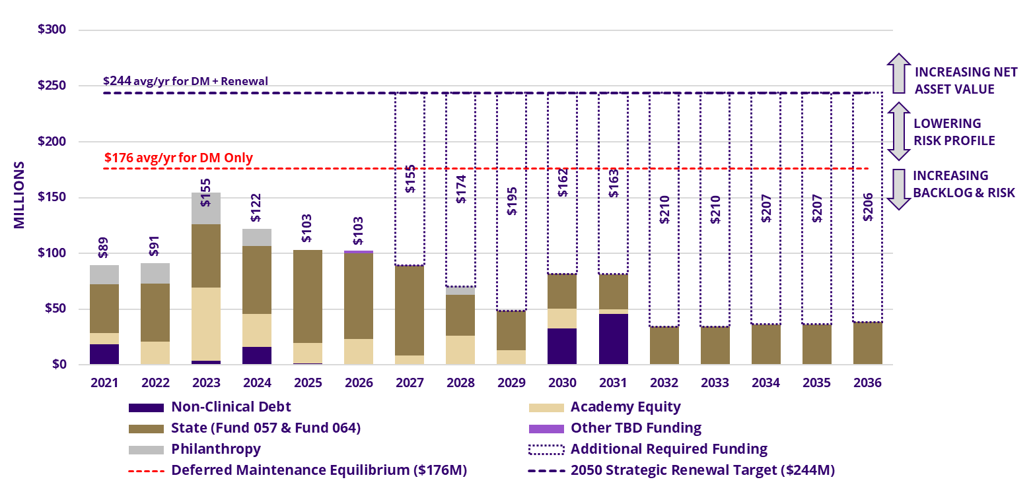
To keep pace with annual deferred maintenance growth, the University's investment in renewal projects needs to double. Persistent underinvestment leads to the gradual but clear degradation of campus facilities and will have increasing impact on the ability to deliver on all aspects of the mission. While the UW Building Account has been deployed effectively, rebalancing State Bond Account allocations toward renewal will be a priority in future capital planning cycles.

Seattle Campus Electrical Capacity
The Seattle campus currently sees electrical demand exceed capacity on the hottest days of each year and is forced to execute standby plans for curtailing use of specific buildings. Decarbonization efforts will require additional electrical capacity to reduce and eventually eliminate natural gas as a heat source. Any potential future campus expansion or energy-intensive use (e.g., data center, hospital expansion, etc.) would further increase the University’s electrical demand on Seattle City Light (SCL) from 52 megawatts (MW) to 90 MW. To meet this increased demand and address the limited remaining service capacity from SCL’s University Substation (driven by increased development in the U-District) the University is pursuing the development of a new 120 MW electrical substation in partnership with SCL to support existing campus needs, new loads related to decarbonization efforts and planned facilities, and future anticipated development.
Optimistically, the new substation is estimated to take six years to come online. Until then, without reducing demand, the UW will continue to face significant curtailment risks to multiple buildings whenever electrical loads exceed system capacity. Recent calculations by Campus Energy, Utilities, and Operations staff within UW Facilities indicate a load reduction of approximately 3.5 MW will be required to maintain safe campus operations and allow critical enabling capital projects for the UW Medical Center Expansion & MHSC Replacement mentioned below. However, the new substation is required to be online before any major expansion is completed.

Institutional Decarbonization Efforts
The University's decarbonization efforts are shaped by two significant pieces of state legislation. In 2019, the state enacted the Clean Buildings Performance Standard (CBPS). The CBPS requires buildings to demonstrate operational energy efficiency at or below a mandated Energy Use Intensity target (EUIt) based on facility type. Buildings that fail to meet this standard are required to implement improvements to eliminate energy waste starting in 2026. Recognizing that building decarbonization is equally essential to the state's climate goals, the Legislature amended the law in 2023 to require decarbonization plans for all state-owned campus District Energy Systems (DES), targeting a 90% reduction in Scope 1 greenhouse gas emissions (GHG)1F by 2040. The University has diligently worked towards achieving compliance with the CBPS and the state’s decarbonization mandates.
In late 2024, Facilities completed the Seattle Campus Energy Renewal Plan (ERP), defining a decade-plus program with estimated project costs of $1.6 billion (2024 dollars) to comply with state mandates. The ERP anticipated that the majority of the funding for this effort would come from appropriations from the state’s Climate Commitment Account (CCA), with the potential for some funding (+/- $30 million) from the Federal Inflation Reduction Act (IRA) of 2022, and two major energy source projects through partnerships. Similar decarbonization issues exist, but at a smaller scale at Bothell, Tacoma, and UWMC Northwest.
The University has received $108.9 million in capital appropriations from the CCA to date to help address decarbonization. Despite recent success in adjusting our approach to requesting CCA funds, it is clear that this funding source alone will not support the execution of the ERP or decarbonization efforts at Bothell, Tacoma, and UWMC Northwest at levels near those originally anticipated. With the projected funding needed to comply with decarbonization mandates for the state’s higher education institutions alone approaching $4 billion, the University is continuing to evaluate different delivery methods (such as partnerships) to determine how to best leverage the limited state funds available to meet this mandate.

UW Medical Center Expansion & MHSC Replacement
UW Medicine must significantly expand its clinical, research, and educational capacity to sustain its long-term mission in support of Pillar 3 of the University’s Strategic Plan and remain financially viable. Projected shortages of 274 inpatient beds by 2040 and 22 operating rooms and 12 procedural spaces by 2050 highlight the urgency of increasing both the quantity and mix of patient care. At the same time, the new strategic plan calls upon the University to leverage technology to improve the patient experience and elevate quality of care.
Although the existing patient tower was expanded in 2012, large portions of the tower and the Warren G. Magnuson Health Sciences Center (MHSC), portions of which were originally constructed in 1949, are aging and increasingly out of alignment with modern standards for care delivery, research, and operational efficiency. Based on recent condition assessments, the MHSC alone accounts for a substantial amount of the identified deferred renewal issues in the Seattle E&G facilities and includes seven of the ten ‘worst’ buildings from a deferred renewal standpoint.
To address these challenges, this initiative envisions the construction of a new south campus patient care tower and the relocation of numerous functions (900,000 Gross Square Feet) from MHSC to Portage Bay Crossing (West Campus), elsewhere in South Campus, or other campus-adjacent properties, guided by a detailed, phased implementation strategy that minimizes disruption to academic, clinical, and business units.
The vast majority of this anticipated multi-billion-dollar project cost will require funding before revenue from the new patient tower is generated, making early identification of financing strategies essential. Funding strategies will need to leverage a blend of institutional debt, partnership-based financing, state and federal support, philanthropy, public-private partnerships, and revenue from real estate ventures. University leadership has confirmed this program as a top institutional priority, and preliminary concept studies and due diligence are beginning.
As a companion initiative, the University is also exploring consolidation of the Institute for Protein Design (IPD) on campus, with potential co-location alongside the Brotman Baty Institute to enhance interdisciplinary research capacity. This and other capital needs could potentially be resolved in the overall plan to relocate activity in MHSC.

UW Information Technology Infrastructure Planning
UWIT, in partnership with Facilities, is developing a five-year capital strategy for digital infrastructure that treats IT systems as essential enterprise infrastructure and fully integrates them with physical facilities planning. Guided by the Together We Thrive program, the plan applies a disciplined, risk-based approach to strengthen financial sustainability, operational efficiency, and long-term institutional resilience.
The strategy proposes a shift in how digital infrastructure is governed and funded, placing networks, data centers, wireless, and cybersecurity systems on par with utilities and life-safety systems. The University’s academic, research, healthcare, and administrative functions depend on reliable and secure digital platforms, and aging systems present growing risks to service continuity, security, compliance, and institutional reputation.
Strategic capital investment in IT is not discretionary modernization, but a stabilization approach that replaces reactive spending with proactive lifecycle investment. Accordingly, IT infrastructure improvements must be more fully integrated into the capital project development process to mitigate risk and capitalize on coordination opportunities.

Regulatory Compliance
A significant barrier to renovation is the City of Seattle’s Substantial Alteration code, originally adopted in 2012. This provision is unique within the Seattle Existing Building Code (SEBC) and requires comprehensive safety and energy upgrades for older buildings when renovation work exceeds defined thresholds. The Seattle provisions are additive to the state building code which sets minimum standards that can be modified by certain jurisdictions. While the Seattle code additions were established with laudable goals such as improving seismic resilience and reducing energy waste, their application creates substantial financial challenges for the University.
When a project is deemed a “substantial alteration,” the city may require the building to be upgraded to current standards across multiple code areas, typically extending far beyond the scope of the originally planned work. In practice, many of the University’s deferred renewal projects trigger this provision, rendering them financially unviable. As a result, maintenance is deferred not because the core renewal work is unaffordable, but because compliance necessitates extensive additional upgrades that fall well outside the intended project scope or funding availability. The University’s extensive portfolio of large and aging facilities exacerbates this challenge compared to most entities subject to these additional code provisions.
Although the city and the University have previously executed Memoranda of Understanding covering the exemptions around unreinforced masonry improvements and converting heating systems from fossil fuels or electric resistance to heat pumps, additional targeted exemptions are still needed. To responsibly steward its public assets, the University is actively engaged with the city to secure further relief that would allow critical renewal and maintenance work to proceed in a fiscally sustainable manner while still improving the efficiency and safety of our building stock.

Space Optimization
As the institution transitions from Activity-Based Budgeting to Incentive-Based Budgeting over the coming years, more accurate space occupancy and utilization data will be required to enable clearer insight into how existing space is assigned and used, directly supporting more efficient and strategically informed capital decisions.
Over the past six years, the University has made excellent progress in minimizing expansion of its E&G facilities’ footprint, consistently remaining well below the 0.5% annual increase target established by the LTCP. Since 2021, the trendline has been steadily decreasing and should approach zero net new square footage growth by the end of the decade based on current planning efforts.
For all new projects, renovation should be evaluated as the primary option before new construction is considered, provided the program's needs can be effectively met in an existing space. Projects must commit to funding future maintenance, operations, and renewal costs prior to receiving approval.

Capital Funding Overview
Since 2021, the Capital Planning Advisory Team (CPAT), which consists of a body of 14 voting members appointed by the President and Provost, has helped support the University's capital planning process by recommending which submitted projects best advance the University’s capital strategy within available funding constraints.
As part of our evolving approach to capital budgeting, we are currently developing a revised strategic framework intended to strengthen front‑end project readiness and improve long‑term capital outcomes. For the first time, we have begun to incorporate enterprise technology funding needs in capital planning conversations. This framework emphasizes financial and strategic screening through feasibility study approvals and matching‑fund expectations for state‑funded projects, while also advancing a more proactive, data‑informed approach to building renewal. Together, these changes are expected to improve project viability, focus scarce resources on institutional priorities, and strengthen stewardship of University capital funds.
At the outset of any capital project, a full range of potential funding sources should be explored and evaluated to maximize investment opportunities and enhance project viability. Recent requests for capital project funding have continued to outpace available traditional sources by billions of dollars, making it essential that funding considerations be integrated from the earliest stages of project ideation. Receiving and analyzing dozens of project requests which face extremely long odds for being funded serves neither the University nor individual units, schools, colleges, or campuses well. Among the available capital funding sources, only two offer consistent and predictable streams: the State Capital Bond Account and the UW Building Account. The majority of remaining sources, while viable, are project-specific in their applicability. Institutional debt presents a broader instrument capable of supporting a range of initiatives; however, debt-service capacity at the unit level constitutes a substantive constraint on its utilization. Additionally, all capital projects must demonstrate a full life cycle funding plan, encompassing maintenance, operating, and renewal costs, prior to seeking Board approval.

Typical Capital Funding Sources
Table 18 shows an overview of typical funding sources available to the University in each biennium:
Table 18. Typical Capital Funding Sources
Funding Source | Access | Biennial Value | Usage Restrictions
State 057 Capital Bond Account | Competitive funding source appropriated by the Legislature | $150M (planned request)  ($129.7M in 25-27) | 25% equity contribution required unless waived by the Executive Office
UW 064 Building Account* | Appropriated by the Legislature. Largely funded by student tuition (building fees). | $97.5M | Used for renewal of existing facilities and based on legislative intent
Climate Commitment Account | Appropriated by the Legislature | Varies  $108.9M of capital appropriations received to date | Decarbonization projects with tangible Greenhouse Gas (GHG) reductions
University Issued Debt | UW Treasury | $250M  ($625M over five years) | Debt component should not exceed 80% of total funding
Academic Equity | Central & Unit Equity | Project Specific  $80M biennial target value | No restrictions
Clinical Equity | UW Medicine | Varies (dependent upon UW Medicine Strategic Plan) | Used as a source for clinical projects and clinical debt service
Philanthropy | Advancement and Units | Project Specific  $80M biennial target value | No restrictions
Partnerships | Varies | Varies | No restrictions (must be approved by Project Finance and Legal (PFAL))
Note: $25.825M of the UW 064 Building Account is currently transferred by legislation to support preventive maintenance operating costs and is not available for capital expenditures. In addition, Metro Tract proceeds deposited in this account will be smaller than in past biennia due to declining revenues.

State 057 Capital Bond Account
Projects seeking support in the form of a state capital budget request (from the State 057 Capital Account) should include a minimum of 25% non-state funding toward the total project budget, sourced from local equity or donor funds. Eligible equity contributions may take various forms, including debt issuance, provided the unit demonstrates sufficient financial capacity to service the loan. This requirement mirrors the funding structure of Program Renewal funding, which calls for units to contribute a minimum of one-third of total project costs through local equity. Projects are strongest candidates for this funding source when they address one or more of the following:
- Advancing high-demand workforce degrees in alignment with University and state goals
- Addressing deferred renewal by updating or replacing aging campus facilities

Institutional Debt
Projects that are not developed by UW Medicine and that utilize institutional debt capacity may finance no more than 80% of total project costs through debt. This limit helps ensure that limited state funding and institutional debt capacity remain available to support the widest possible range of projects. Exceptions to this policy may be granted only by the Executive Office.

Institutional Debt Scenarios FY27–FY31
For the first time in recent history, requests to utilize institutional debt exceed the five-year capacity target. Institutional debt capacity is a management planning target, not a legal limit, as there is no statutory limit on debt issuance. The annual debt capacity model, calculated by Treasury, uses audited institutional results, updated forecasts, the capital plan, and peer performance comparisons to determine the amount of debt the University can issue over the next five years. This analysis includes rating agency metrics for wealth, revenue, and affordability relative to debt. While capacity is calculated at an institutional level, the ability to pay is measured at the unit level. The Capital Budget allocates that capacity to priority projects, and the Regents approve the use of that debt capacity through individual project authorizations.
The current five-year capacity recommended by Treasury is $625 million (approximately $125 million per annum). Increasing debt capacity would require sustained improvement in institutional financial performance, including growth in cash flow, total cash, and investments.
As shown in Table 19, potential five-year debt requests total $671 million, which is approximately $46 million above the $625 million capacity target. This overage underscores the need for careful prioritization and may require revised financing strategies for lower-priority requests.
Table 19. Institutional Debt Requests FY27–FY31 (in millions)*
Project | FY27 | FY28 | FY29 | FY30 | FY31 | Five-Year Total
UWMC Projects | $41.2 | $42.4 | $43.7 | $45.0 | $46.0 | $218.3
McMahon Hall Replacement |  | $28.0 | $149.8 | $46.2 |  | $224.0
Electrical Substation** |  | $6.4 | $38.3 | $22.3 |  | $67.0
UWB/CC Activities |  | $2.5 | $14.7 | $45.9 | $20.3 | $83.4
Bagley Hall Renovation |  |  |  | $32.9 | $45.8 | $78.7
Totals | $41.2 | $79.3 | $246.5 | $192.3 | $112.1 | $671.4
* Values do not include potential debt required for the multi-billion-dollar UWMC Expansion/MHSC Relocation or capacity for any emergent projects.
** It is possible that some portion of this project would be requested from state CCA funding or funded by Seattle City Light, but University debt is assumed to be the backstop.

Includes the Bothell and Tacoma Campuses, Seattle Campus facilities classified as education and general (E&G), and UW Medical Center Montlake and Northwest.
Scope 1 emissions are direct greenhouse gas emissions from sources owned or controlled by an organization.

