Programmatic & Academic Vitality Narratives
- As a result of the global COVID-19 pandemic, have you had to make substantive changes to your unit’s/campus’s strategic plan, budget/resourcing processes or programmatic offerings? Please briefly summarize and provide commentary on anticipated and/or realized impacts on the populations your unit/campus serves. Word Limit: 500
The School of Social Work strategic plan/aspirational aims emphasize effective, culturally dignifying, and sustainable solutions that are rooted in the profession’s social justice mission and are intimately linked to our commitment of equity and impact. Our strategic, aspirational goals include:

- Creation of a culture of equity and inclusion at the School of Social Work;
- Impact Science: strengthening the capacity of our faculty and doctoral students to engage in collaborative impact science by expanding opportunities for community engaged, collaborative, transdisciplinary research that are real-world, scalable, sustainable, and scientifically and culturally appropriate;
- Impact Education: co-creation and transformation of our curricula by providing our students with cutting-edge knowledge, skills, and mentored experiences within diverse settings that allow our students to take on new roles and leadership positions within the field;
- Inclusive Innovation: Identification of new funding streams and opportunities to fuel and accelerate innovation to impact pipelines;
- Social Compacts: expansion and exploration of current partnerships with the State of Washington

While the pandemic has created resource constraints both in time and energy of our most precious resource – our faculty and staff, they have not affected our strategic goals nor budget. The School experienced growth in enrollments overall. Our students and workforce are more diverse than ever. Current initiatives from a reconceptualization of research support for faculty through the Office for Faculty Excellence and Research (OFFER) to the launch of the statewide Behavioral Health Workforce Development Initiative that will transform community behavioral health for students, employers, and patients alike speak directly to our aspirational aims. Further, the pandemic created opportunities to reevaluate modalities of learning and to evaluate what the School values in the workplace to both retain our employees as well as provide a new way to work and learn that keeps pace with our regional workforce. Programmatically, the shift to remote learning and work did require a substantial lift in temporary resources that was well north of $250,000 of funds and lost revenue of over $500,000; however, added costs of pandemic related activities from added technology to temporary faculty and staff to support illnesses were offset both by vacancies and temporary support through federal CARES funds.

While not a direct result of the pandemic, the new realities of the workplace with larger than expected activity in retirement and resignations have been the most disruptive. Vacancies have created more demands on current staffing which affect bandwidth to carry out new initiatives; however, as the UW resumes onsite learning and work opportunities and hires ensue, renewed emphasis on strategic activities will continue.

- Please discuss your campus’s/unit’s ongoing work to support the themes and goals of the UW’s Diversity Blueprint. For example, you may wish to touch on (but are not limited to) areas such as: work stemming from the campus climate reports, education & training, outreach, etc. In your response, include a qualitative summary of the resources your unit utilizes to support the Diversity Blueprint, how you assess impacts of your work, as well as your campus’s/unit’s future plans to continue resourcing this important work.
Note, in future planning cycles, you will be asked to provide and reflect on quantifiable budgetary plans to further the UW’s DEI efforts. Word Limit: 750

The School’s current Diversity, Equity, and Inclusion (DEI) Master Plan was developed through an extensive, inclusive process involving SSW students, staff, and faculty. Initiated in FY2017 and completed in FY2019, the planning process was structured around the goals of the UW Blueprint, as applied to the SSW’s unit-specific objectives, strategies, and activities. While the production of the “public” version of the plan (updated, final-edited, and formatted) has been delayed due to the pandemic, since FY2019 the School’s activities have been guided by the “draft” plan, and many of the priority activities outlined in the SSW DEI Plan have already been achieved. In this section, we highlight a few significant achievements for FY2022.

GOAL 2: Attract, retain, and graduate a diverse and excellent student body: In the past year, SSW’s undergraduate and graduate student bodies continued to be among UW’s most diverse (and most excellent!), and our retention and on-time graduation rates for BIPOC, URM, and students overall remained among the University’s highest. For the past several years and for FY22, the School of Social Work has an overall URM student body rate of 25.6%. This is 37% greater than our closest peer within the UW and over 100% more than the UW Seattle campus broadly. For 1st generation undergraduates, over 57% are 1st generation compared to 30.6% for UW Seattle undergraduates in general. Finally, the School is particularly proud of a 95+% graduation rate among our bachelors and master’s students.

In FY22, the School succeeded in securing funding for three major initiatives that significantly advances our capacity to recruit, support, and graduate a highly diverse student body. In particular, these initiatives will allow the School to reduce the “debt-to-salary” ratio of our graduates—a fundamental educational equity goal to which the School has been committed for over a decade.
- SSW Behavioral Health Workforce Development Initiative: Funded by the Ballmer Group, this ambitious $34.4 million initiative will provide over $21.4 million in generous, two-year scholarship grants to approximately 415 behavioral health graduate students in Washington State broadly over the next five years. The initiative specifically aims to strengthen support to BIPOC students committed to serving the state’s most in need of behavioral health services, and to eliminate or dramatically reduce student debt associated with graduate education. From FY23-FY26, approximately $4.5 million in grants is expected to go to MSW students at UW—approximately $3.4 million to UW-Seattle students and $1.1 million to UW-Tacoma.

- Equity-driven career path in technology for social workers: In FY2022, School of Social Work and formally agreed to partner with Washington state’s Department of Children, Youth & Families (DCYF) to create a new IT educational pathway for a highly diverse cohort of students with IT interests who are also deeply committed to meeting the needs of children and families served by the public child welfare system. We will partner with the ISchool in developing and offering this new program. In a first-of-its-kind innovation, the School and DCYF will tap an existing source of uncapped federal child welfare training funding—Title IV-E of the Social Security Act—to cover $2 million in annual costs for student tuition grants, curriculum development and program costs for the new program. We anticipate the program will include 22 students in its first class, with great potential for increased growth with commensurate federal reimbursement.

The use of IV-E funding will allow us to offer a substantially debt-reduced IT education pathway to students. The program will focus recruitment on highly diverse, capable, and committed students who might otherwise lack access to a high-quality education. The two schools will collaborate to design an innovative, equity-framed IT curriculum that meets the needs of child welfare practitioners and the families they serve. The curriculum will speak to current calls for tech education programs to help students better understand how technology and technology-mediated practice reflect the power asymmetries and inequities of the social systems in which they are embedded—and to teach skills and competencies to develop sociotechnical solutions to existing problems.

- The Alliance for Child Welfare Excellence: In FY2022, the Washington State Department of Children, Youth & Families (DCYF) and the SSW renewed a historic agreement that created the Alliance for Child Welfare Excellence, an innovative partnership led by the UW School of Social Work. The Alliance encompasses all three Master of Social Work (MSW) programs at public universities in the state—UW Seattle, UW Tacoma and Eastern Washington University. The Alliance through our Child Welfare Training Advancement Program provides specialized courses, field education placements, and generous educational grants, totally approximately $3.6 million per year, for approximately 75 SSW MSW students on the Seattle campus and 47 for MSW students on the Tacoma campus.

GOAL 3: Attract and retain a diverse faculty: In FY2020-2021, the School completed one of its most successful faculty hiring periods in is history, welcoming two Indigenous tenure-track professors, three African American tenure track assistant professors, and two Asian American research assistant professors.

Tuition Based Program Rate Recommendations - Narrative Section
Responses to the questions below are required for each tuition category that your unit/campus recommends adjusting. In addition, a new question (#7) is required for any programs for which no tuition increase is requested. If you are recommending changes for multiple tuition categories, please differentiate your responses within each question.
- Please explain why each proposed change is needed and how your unit/campus will use new incremental tuition revenue increases or absorb incremental tuition revenue losses. Word Limit: 500
The School is recommending a 3.5% tuition increase in its MSW incoming tuition category only. This would apply both to resident and non-resident enrollments. The continuing MSW tuition category will not have any increases at all. This plan was part of a larger process implemented Fall 2019 to great student interest to tackle ever growing student debt in a field where pay is low and loans are higher.

For our Tier 2 tuition category for our PhD program we are recommending a 2% increase for residents and non-residents that is in alignment with the School of Medicine.

Planned increases for tuition support the entire school from the ability to add vital services from increased field faculty that impact students’ experiential learning and support in student services to dedicated mental health counseling. Additionally, the increase supports necessary annual faculty, staff, and student employee salary increases required by the University of Washington and needed to maintain a competitive edge with hiring and maintaining the best faculty and staff. Annually, the School must come up with at least $275,000 to support salary increases. Combinations of tuition increases and other revenue generating activities provide this support.
- Explain whether and how each proposed change will affect peer comparisons and/or whether a market analysis was conducted. Word Limit: 500
The School of Social Work performs annual market analysis to determine both the health and affordability of our program compared to our peers across all our programs. As a top ranked School of Social Work nationally, the University of Washington focuses analysis at the MSW ranks as the school recommends its own tuition that aligns with our values and fiscal sustainability. Currently SSW is in the 27th percentile for resident tuition and 22nd percentile for non-resident tuition for MSWs for comparison schools based on OFM, Top 15 and Global Challenge schools though we are 3rd nationally by program. Further, when compared to top 15 Schools of Social Work publicly, the University of Washington is in the 50th percentile for resident and 40th percentile for non-resident tuition. For our PhD program we are in the 33rd percentile for resident/nonresident status. Finally, in our BASW ranks, the School is at the 27th and 61st percentile for resident and non-resident enrollments respectively. Given both our commitment to access and affordability continued incremental increases in both our MSW and PhD programs will not only keep us extremely competitive for tuition with our peers but allows the School to meet its financial obligations.
- Tuition and fee increases have a disproportionate impact on low-income students. Please comment on how each fee change will affect student debt loads, and specifically how the program will offset this impact. Word Limit: 550
Costs of education are not inexpensive nor is the cost of living in Seattle. As an industry, newly hired social workers make an average low-end starting salary of $42,064 annually while the median salary is $59,521¹. Monthly debt from loans is difficult not only to pay off but to keep social workers in the field; therefore, affordability is key. Combinations of expenses that are in alignment or less than prevailing costs of living along with more support for students should help in allowing students to pursue the profession of social work.

Based on forecasted City of Seattle Consumer Price Index projections, the projected CPI annually over the next 4 years is over 2.5%. The anticipated increase for only year 1 cohorts is 3.5% as a onetime increase. Over two years, that increase averages about 1.75% annually which is less than projected City of Seattle CPI. In fact, increases since 2019 have either been in alignment with City of Seattle CPI or under as referenced by the US Bureau of Labor Statistics below.

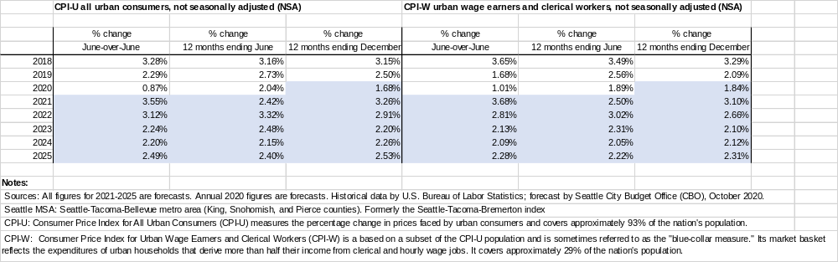

Due to the social justice issues of salary and indebtedness, the School has sought to ameliorate student debt both through low tuition increases and more importantly thru aggressive donor support. As shown in the chart below, the School’s support for student scholarships and stipend supports rose dramatically over the course of the past several years:
- There has been over a 100% increase in the total number of awards distributed with each student averaging over $9,845/MSW student among donor and program supported scholarships & stipends annually between FY14-FY21.
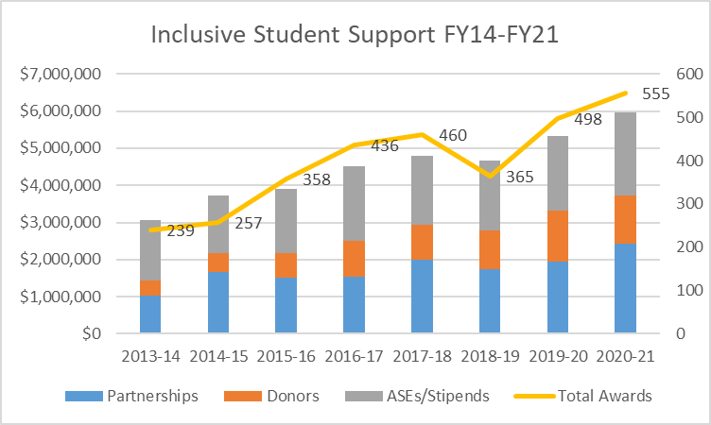
- Private philanthropic support experienced the greatest increase since FY14, increasing over 129% from $.4M to $1.3M annually. This support was made possible in part our success in securing our largest single scholarship gift ($10 million to establish an endowed fund), and private matching funds from UW ($5 million).
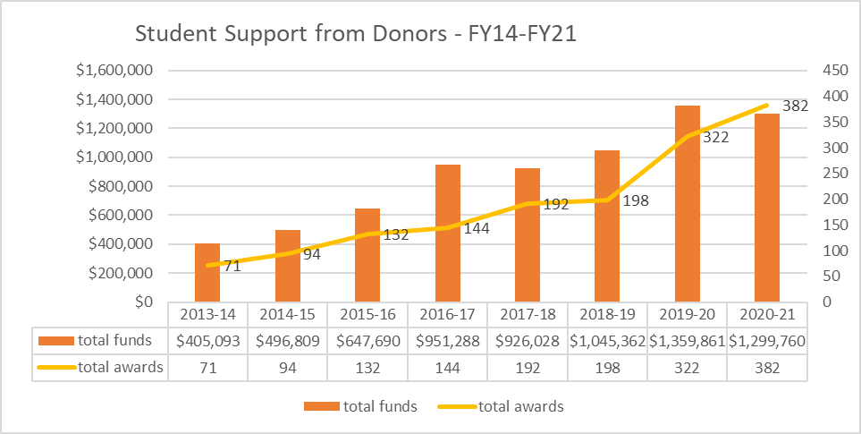

Finally, the School of Social Work received a statewide award from private philanthropy to fund chronic shortfalls in behavioral mental health services in mid-2021. The statewide Behavioral Health Workforce Development Initiative will fund over $21.7M of direct scholarship support to over 400+ students statewide over 5 years. The program launched Fall 2021 and UW students will participate fully Fall 2022. Support averages $51,500 per student over two years which will have a tremendous impact on student debt load over the coming years.

Overall SSW provides quite a bit of support for all our student degree programs:
- In FY21 over $5.9+M of scholarships, fellowships and ASE appointments were allocated to student ranks of BASWs, MSWs, and PhDs
- MSW students received $4.1M of funding from 424 unique awards:
  - Residents:
    - 171 awards averaging $7,886/year – 72% of all resident students
  - Non-Residents:
    - 73 awards averaging $10,642/year – 68% of all non-resident students
  - MSW EDP students:
    - 193 awards averaging $10,057/year– over 89% of all EDP students
Net tuition resulting from student support for recipients:
- Based on the number of awards, average amount of awards and when factoring in average annual tuition & fees, the net tuition for recipients was affected as follows:
 | Total yrs | Annual Tuition/Fees | Total Program Tuition/fees | Ave award | Total support | Net tuition
MSW day-Res | 2 | $21,119 | $42,238 | $7,886 | $15,772 | $26,466
MSW EDP | 3 | $21,724 | $65,172 | $10,057 | $30,171 | $35,001
MSW day-NR | 2 | $35,591 | $71,182 | $10,642 | $21,284 | $49,898

While the push for increased support by scholarships, stipends, and other student centric opportunities never ceases, the School will always work diligently to provide as much support to all ranks of students so that they may choose social work as a profession without pause due to debt burden.

- Describe whether you expect the proposed tuition rate(s) to result in any substantial changes to enrollment (including a change in the resident/nonresident composition) or to the volume of waivers awarded. Word Limit: 250
At this point we do not anticipate any resulting enrollment changes based on our tuition. We are competitive and with stable tuition for the duration of our core population of MSW students, we believe this predictability will better assist students in choosing the UW as their first choice for their MSW degrees. The advent of the newly created Behavioral Health Workforce Development Initiative may impact enrollments in the future. However, more information on capacity and student support is underway to determine whether funding further reduces student debt burden to our current population or increases overall enrollments to meet the ongoing need of behavioral health social workers.
Waivers at the School of Social Work have fluctuated over the years. The volume of waivers at SSW averaged about $440,000 annually over the past 2 fiscal years. Waivers come from a variety of opportunities including ASE and stipend appointments to tuition exemption programs. SSW can only control waivers it assigns via stipends or positions it hires for centrally. Non-SSW waivers are currently beyond our control so while they support students, the ability to predict them is impossible under current circumstances.
The uptick has benefited students; yet, questions of how waivers can and should be assigned is one SSW wishes to pursue more thoughtfully at the UW so the waiver can impact student need while allowing SSW some measure of control to maintain solvency as waivers ultimately are forgone revenue that supports the entire school.
- For each proposed change, please explain what would happen if the change were not implemented (e.g. deficit, loss of staff positions, etc.). If a proposed change is part of a plan to eliminate a current deficit, please indicate that. Word Limit: 250
In the event we were not allowed to increase tuition, we would go into a deficit situation within a year or two as we need to raise approximately $275,000 annually to cover merit at a minimum of 2%. The increases in tuition are not meant to cover a current deficit but to avoid one. In addition, we have a robust fee-based program which is 40% of our current MSW student body. Since it is important to treat both our state and fee-based student equitably, it would not be feasible to raise fees on 40% of our students only. Further, we would not be able to hire any faculty or staff to support our increased enrollments until we became solvent. With merit and the advent of Workday finance, we need to increase our tuition in part to support our programs and provide enhanced supports to students.
- For each tuition category that you have proposed changing, please discuss your unit/campus's overall tuition rate strategy for the next 3-5 years. In your response, please explain whether and how your long-term strategy connects to "market" rates (e.g. where do you want to be, rate wise, compared to peers?) Word Limit: 250
As stated above we have planned on 3.5% tuition increases 1 time for each new MSW class while PhD students have a 2% increase annually. The recommended rates will provide predictability for our students in planning yet allow the School to maintain solvency. With more recent changes in peer tuition, the School has actually moved downward slightly for tuition from its 52nd percentile to the 50th percentile and has held steady at the 40th percentile for resident and non-resident tuition respectively. Our PhD tuition market analysis shows that the UW is on the lower end of peer tuition dropping from the 40th percentile to the 33rd percentile. For a public university that is ranked 3rd in the country and 1st worldwide by the Center for University Rankings, the program is right priced for the value and staying close to the 50th percentile is an important goal for the School. When compared with similarly ranked programs, the UW School of Social Work is affordable; however, understanding that tuition historically is high everywhere the goal is to fund raise and provide opportunities to continue to lower net costs for students as demonstrated above.

- If you are not planning to increase tuition for any program, please respond to the following: Generally, small, inflationary increases (1-2% annually) are preferred over no increase or large increases every few years. Please answer the following questions for each program where no increase is requested. Word Limit: 250
  - Please explain why this program's rate does not warrant an increase by describing the program's financial position, structure, peer comparisons, or other relevant information.
  - What do you currently anticipate annual rate change requests will be for the next two years?
N/A

Communication with Faculty & Student Stakeholders
Communication of your unit's annual review materials, including fiscal vitality data, narrative responses and tuition rate recommendations is an important and necessary component of the University of Washington's Annual Review process. Your responses to the questions below will be documented and included as part of the annual review materials provided to Executive Leadership of the UW.
If the meeting schedules of faculty and student leadership groups present a challenge, please make accommodations to get approval within the necessary time frame. If necessary, you may submit an update to OPB at a later date, after faculty and students have had an opportunity to review.
- Please provide the date that FACULTY leadership within your unit/campus was consulted and provided the opportunity to provide input as part of this budget planning exercise. If, due to scheduling difficulty, you are unable to consult with faculty leadership before the February 1, 2022 submission deadline, please select the date you are scheduled to consult with FACULTY leadership and, immediately after that date, please provide an update to Jed Bradley.

Currently faculty have received a budget update back on December 7th to discuss the School’s overall financial health and to begin strategic discussions of budget as it pertains to the School’s strategic aims and priorities. A deeper dive will commence by February 28th as current recommendations are following approved planning from 2019.
- Please list a point of contact for your FACULTY leadership (name and UW email address).

Mike Spencer: mspence@uw.edu + Cynthia Pearson: pearsonc@uw.edu
- Please provide the date that STUDENT leadership within your unit/campus was consulted and provided the opportunity to provide input as part of this budget planning exercise. If, due to scheduling difficulty, you are unable to consult with student leadership before the February 1, 2022 submission deadline, please select the date you are scheduled to consult with STUDENT leadership and, immediately after that date, please provide an update to Jed Bradley.

Currently the SSW Student Advisory Council launched their first full meeting of the academic year in early January. A discussion of budget will take place on February 7th, 2022. This discussion will provide the background and continued plan for review of recommendations presented in the report.

- Please list a point of contact for your STUDENT leadership (name and UW email address).

Our Student Advisory Council does not have an appointed contact as they act in unison. Lin Murdock is the staff lead that oversees activities of our Student Advisory Council. You can reach her at linm@uw.edu
- Enrolled students affected by tuition rate increases should be consulted on proposed increases before proposals are finalized. Please describe when and how students were consulted and summarize the feedback they provided regarding EACH of your tuition recommendations.
Faculty, staff, and students have and will receive both a presentation about the overall fiscal health of the school via Budget 101 materials. Additionally starting February 2022, the School will embark on sustainable academic business planning that aligns with the school’s stated aspirational aims and will continue through the end of spring quarter to both educate our community while aligning our priorities to budget.

