  - Inventory Taker Quick Reference Guide

Start Inventory
- Log in to MAS Web.
- Click the “Inventories” tab at the top of the screen.
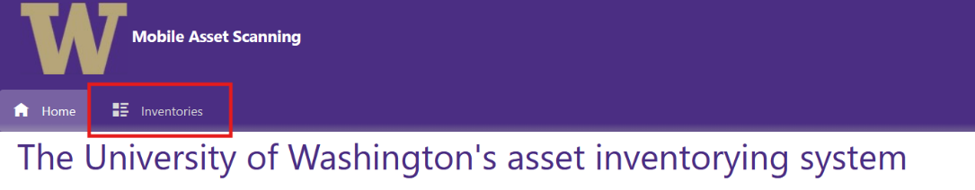
- Open the assigned inventory. Inventory will be in “Pending Start” status.
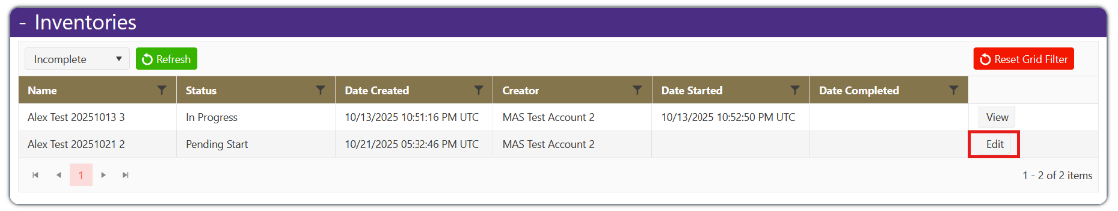
- Click “Assign Department Head.
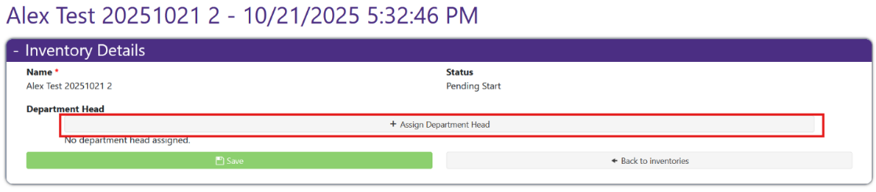
- Search for Department Head and assign.
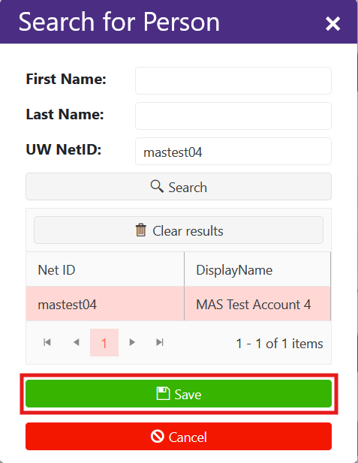
- Save.
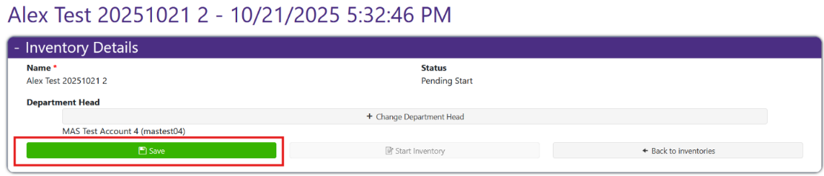
- Click Start Inventory.
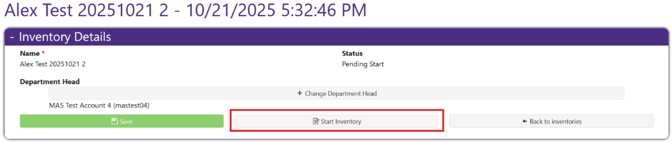
- Confirm status is In Progress.
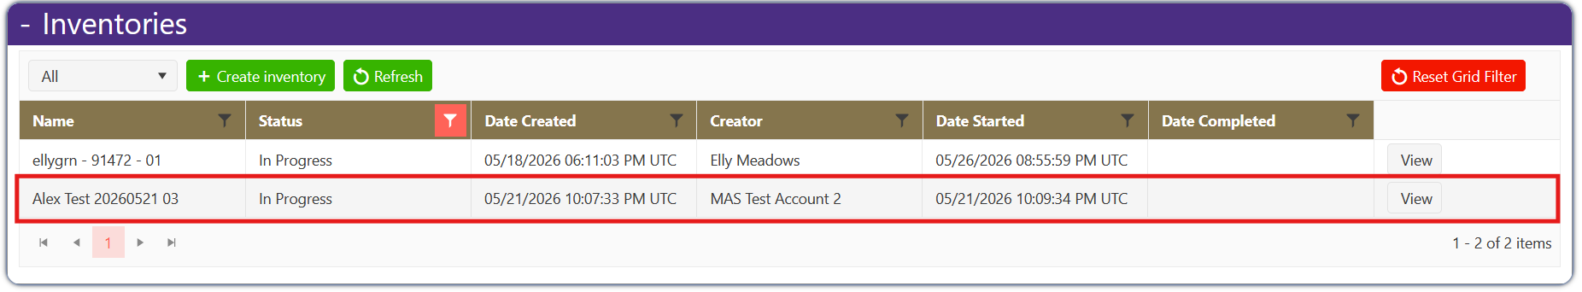

Prepare Mobile Device
- Open MAS Mobile.
- Log in.
- Sync inventories.
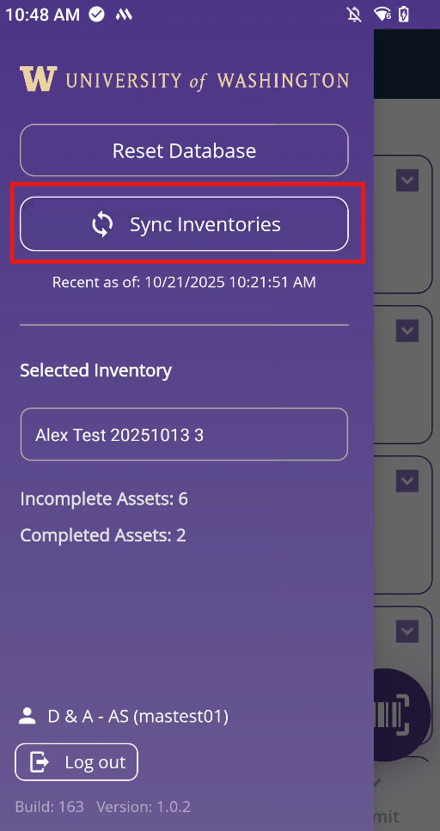
- Select the assigned inventory.
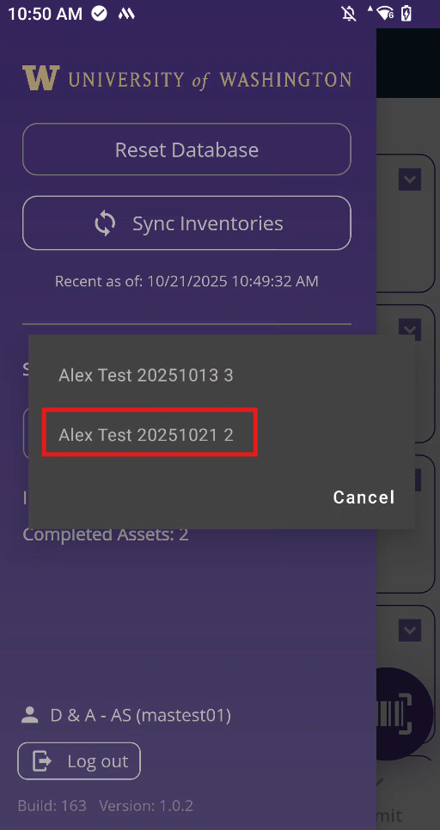
- Confirm the inventory list matches MAS Web.

Scan Asset
- Click scan button.
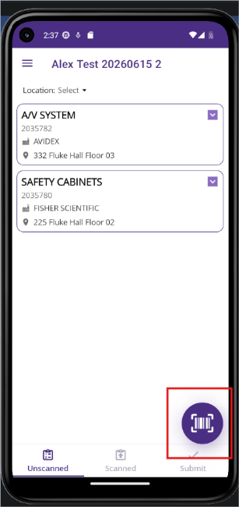
- Point scanner at barcode.
- Scan barcode.
- Review asset detail.
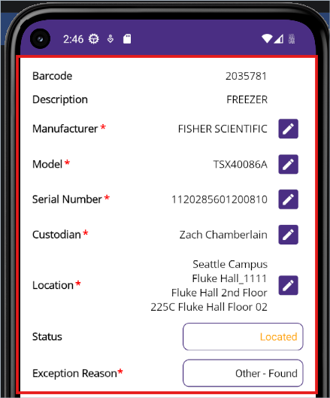
- Add notes if needed.
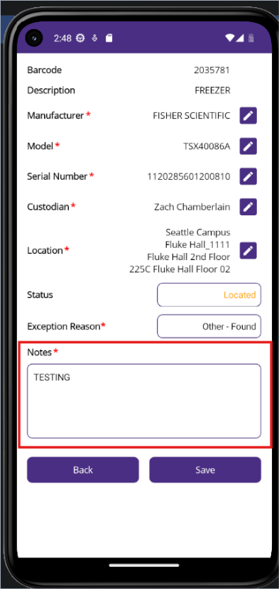
- Save.
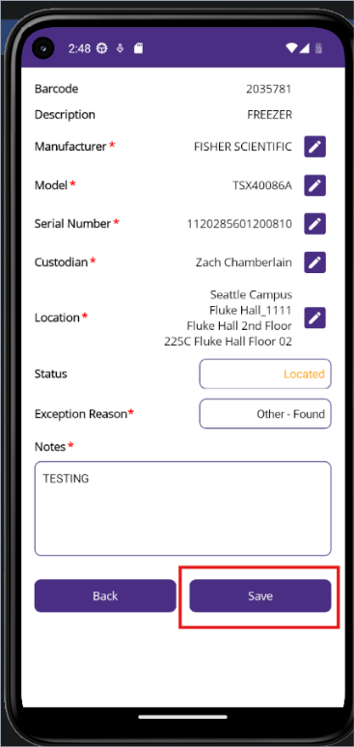
- Submit.
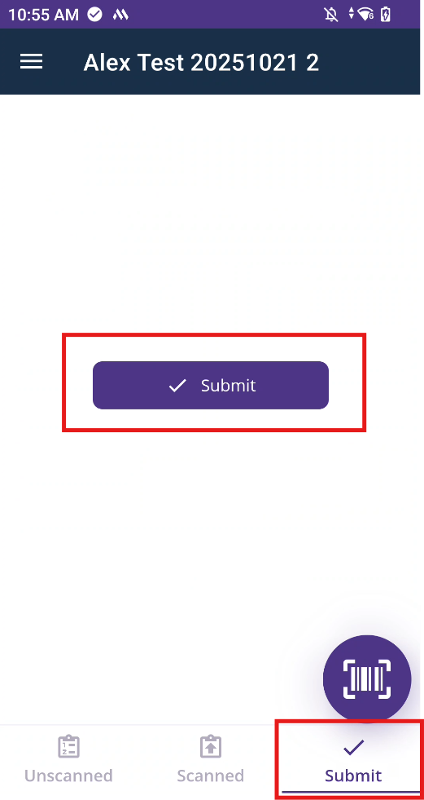

Non-Scannable Asset
- Open asset detail.
- Select “Located” or “Not Located”.
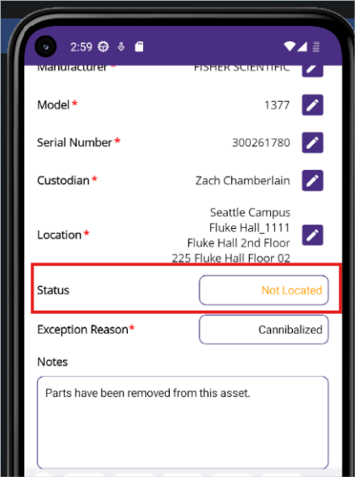
- Select an exception reason
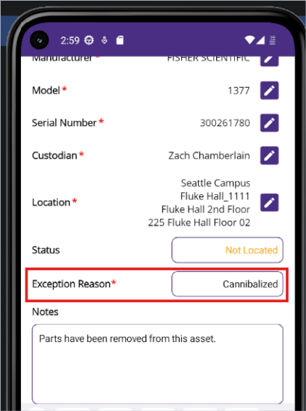
- Add notes if required.
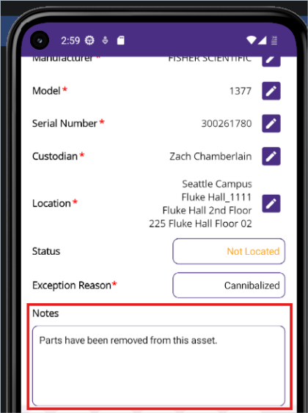
- Save.
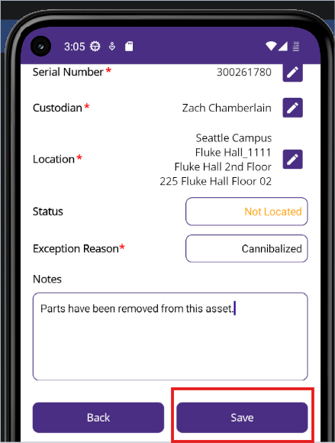
- Submit.
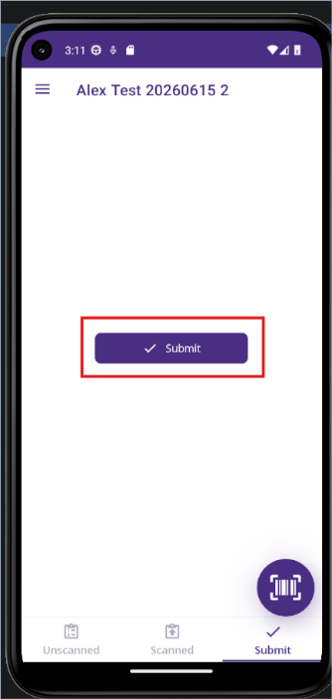

Upload Offline Updates
- Open Completed Assets tab.
- Select Assets to Upload.
- Select asset checkboxes.
- Click Upload.
- Confirm upload completed.

Submit Inventory
- Confirm all assets are complete.
- Confirm pending uploads are complete.
- Open inventory in MAS Web.
- Click Complete Inventory.
- Confirm status is Submitted to Department Head.

Common Issues and Troubleshooting
Issue | Solution
My device won’t turn on. | The device may be low on battery. Charge the device for a couple of hours, then try to turn it on.
My device won’t charge. | If you have been charging your device for over an hour and it does not gain battery life, please check the charging cable and/or the charging brick. If you are trying to charge using your laptop or computer, please try plugging it into a wall instead.
I am getting syncing errors on my mobile device. | Please check that you have a stable internet connection. If you are in a location without connectivity, the device will attempt to sync when connectivity is re-established.  If you are offsite and not connected to a UW network, you will need to use a VPN. Please reach out to EIO for help connecting to a VPN.
My inventory disappeared/I can’t find my inventory. | After you submit/approve an inventory, it will disappear from your inventory list and appear in the next person's list. You will not be able to return to the inventory. This is expected behavior.
Errors when syncing device. | An asset may be in an invalid state (Example: Disposed) in Workday. Contact EIO to report this.
Note: If you are still having issues, please contact EIO for further assistance.

Returning Your Device
Once you have completed and submitted your inventory(ies), you are now ready to return your mobile scanning device. The original package should have included a return mailer and return instructions.
In case the instructions and/or return mailer are lost, please follow these instructions:
- Obtain a padded mailer large enough to fit the device and accessories.
- Place device inside of carrying case and place carrying case in the mailer.
- Place charging cable in the mailer.
- Return mailer to:
  - For campus mail, use box 359561
  - For postal mail, mail to:
4545 15th Ave NE
Box 359561
Seattle, WA 98105

