

Mobile Asset Scanning
  - Inventory Taker User Manual

Table of Contents
Purpose 4
Acronyms and Terms 4
MAS Process Flow 5
High-Level End-to-End Process 5
Inventory Taker 6
Inventory Taker Responsibilities 6
Before You Begin 7
Device Checkout and Return 7
Requesting a Device 7
Receiving the Device 7
Returning the Device 7
Inventory – MAS Web 8
Viewing an Inventory via Web Application 8
Inventory Grid and Fields 9
Sorting and Filtering 11
Assigning Department Head 11
When to Assign a Department Head 11
Assign Department Head 11
Department Head Search Fields and Buttons 13
Starting an Inventory 14
Inventory – MAS Mobile 15
User Access (log in) 15
MAS Mobile Device 15
Navigation, Syncing, and Logging Out 16
Quality Check Before Scanning 16
Recommended Quality Check 17
Locating an Asset 17
Scanning an Asset 18
Scan an Asset 19
Setting Status of Non-Scannable Asset 19
Exception Reasons for Found Assets 20
Exception Reasons for Not Found Assets 20
Manual Status Update 21
Updating Asset Details 21
Inventory Fields 22
Best Practices for Updating Details 23
Updating Assets When Offline 23
Working Offline 23
Manual Upload Steps 23
Submitting Inventories – MAS Web 24
Before Submitting 24
Submit 24
After Submission 24
What Happens Next 25
Rejected Inventory 25
Making Corrections 25
Troubleshooting 25
Revision History 27

  - Inventory Taker User Manual

Purpose
This document provides an overview of the Mobile Asset Scanning (MAS) inventory process and detailed instructions for users whose role in the inventory process is Inventory Taker.
Inventory Takers use MAS Web and MAS Mobile to review assigned inventories, assign a Department Head reviewer, start inventories, scan or manually update assets, upload completed asset records, and submit inventories for approval.
Business rule: Workday is the official source of truth for Workday-managed data at the University.
Workday provides asset information to MAS through an integrated data feed. MAS uses the asset information to facilitate and complete the inventory process, then sends approved updates back to Workday through integration.

Acronyms and Terms
Acronym / Term | Description
Administrator | The user group responsible for technical support.
Cannibalized | Consumed/Cannibalized is one of 11 disposal types in Workday. It is used for an asset that is no longer in use in the form it was acquired, but some of its parts are retained for use in another form or in conjunction with other parts to serve a function. For MAS purposes, an asset record that is disposed of with disposal type consumed/cannibalized would be excluded from future physical inventories.
Department Head | The user assigned by the Inventory Taker to perform first-level review and approval of the completed inventory.
EIO | Equipment Inventory Office. EIO is responsible for inventory oversight and final approval activities.
Inventory Manager | The user group responsible for creating inventories and providing final approval.
Inventory Taker | The user group responsible for performing departmental asset inventories. Most Inventory Taker work is completed on a mobile scanning device.
MAS | Mobile Asset Scanning. MAS is an application used to support asset inventory work for the University of Washington.
Mobile App | The MAS mobile application is used by Inventory Takers to perform inventory duties on a mobile scanning device.
Scanner | A handheld mobile scanning device used to access the MAS Mobile App and perform asset inventory duties.
WD | Workday. Workday is the system of record and source of truth for asset data.
Web App | The MAS website application where asset inventories are created, managed, started, and submitted.

MAS Process Flow
There are four user groups within MAS:
- Inventory Managers - Responsible for creation and final approval of departmental asset inventories.
- Inventory Takers - Responsible for performing departmental asset inventories.
- Department Heads - Assigned by Inventory Takers for first-level inventory approval.
- Administrators - Responsible for technical support.

End-to-End Process
- Workday sends asset data to MAS.
- Inventory Manager/EIO creates an inventory in MAS.
Inventory Manager assigns one or more Inventory Takers.
- Inventory Taker opens the assigned inventory in MAS Web.
Inventory Taker assigns a Department Head reviewer.
Inventory Taker starts the inventory.
Inventory Taker performs inventory work in MAS Mobile.
Inventory Taker scans assets or manually updates non-scannable assets.
Inventory Taker uploads any locally saved or pending updates.
Inventory Taker submits the inventory to the Department Head.
- Department Head approves or rejects the inventory.
If approved, the inventory moves to Inventory Manager / EIO final review.
If approved by Inventory Manager / EIO, MAS sends updates to Workday.
- Workday processes updates and returns confirmation to MAS.
- The inventory status changes to Completed.
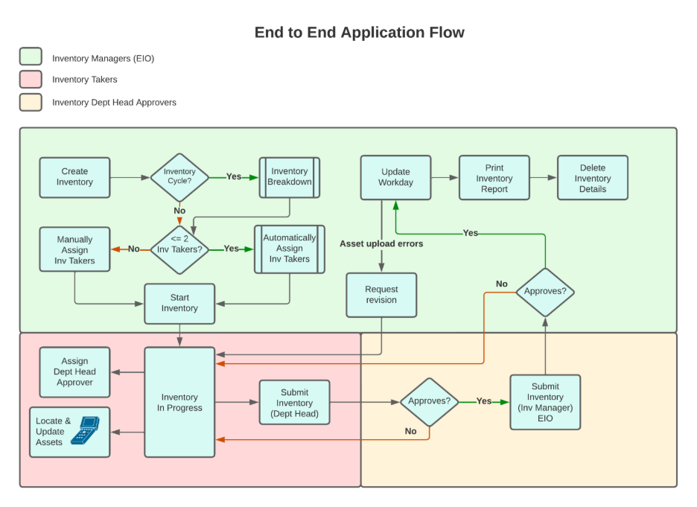
Figure 1 – End-to-End Application Flow

Process improvement: Inventory Takers should assign the Department Head before beginning physical inventory work, even if MAS allows the inventory to be started before the Department Head is assigned. Assigning the Department Head early helps avoid submission delays.

Inventory Taker
The Inventory Taker is responsible for completing the inventory work accurately and submitting it for review.

Inventory Taker Responsibilities
- Confirm assigned inventory is visible on MAS Web.
- Request and check out a mobile scanning device.
- Assign Department Head.
- Start inventory.
Log in to MAS Mobile.
Synchronize inventories on the mobile device.
Verify that the asset list on the mobile device matches the inventory in MAS Web.
Scan asset barcodes whenever possible.
Search for and manually update assets when scanning is not possible.
Update editable asset fields when needed.
Select accurate status and exception reasons for non-scannable assets.
Add notes when required or helpful.
Upload local/offline updates.
- Submit completed inventory to Department Head.
- Respond to rejection or revision requests if inventory is returned.

Before You Begin
Before starting an inventory, complete the following readiness checks.
Readiness Item | What to Confirm
Inventory Assignment | Confirm that the inventory appears in MAS Web under the Inventories page.
Access | Confirm that you can log in to MAS Web and MAS Mobile.
Mobile Device | Confirm that you have checked out or requested a mobile scanning device.
Network Access | Confirm the device can connect to the UW network, network login, or VPN as required.
Department Head | Confirm who should review and approve the inventory after submission.
Inventory Locations | Review the locations where the assigned assets are expected to be found.
Important: If you do not see your assigned inventory, contact EIO or the appropriate support team. Your inventory assignment or Workday-related role setup may need review.

Device Checkout and Return
Inventory Takers use a handheld scanner or mobile scanning device to perform asset inventories in MAS Mobile. Devices are generally managed as a shared pool and are checked out for inventory work.

Requesting a Device
- Open the Mobile Asset Scanning Device Chec k-Out form.
  - Complete the required information.
- Enter the estimated return date.
- Submit the request.
- The checkout request creates a ticket in UW Connect and is routed to Service Center or help desk.

Receiving the Device
Depending on location and availability, the device may be provided through campus mail, USPS, UPS, or another approved fulfillment process.

Returning the Device
Return the device as soon as inventory work is complete so it can be made available to other Inventory Takers.
Best practice: Request the device before the inventory start date and provide a realistic, estimated return date.

Inventory – MAS Web
Inventory Takers use MAS Web to view assigned inventories, assign the Department Head, and start or submit an inventory.

Viewing an Inventory via Web Application
- Open MAS Web.
- Log in using your authorized credentials.
- Select the Inventories page.
- Locate the inventory assigned to you.
- Use the View or Edit option to open the inventory details page.
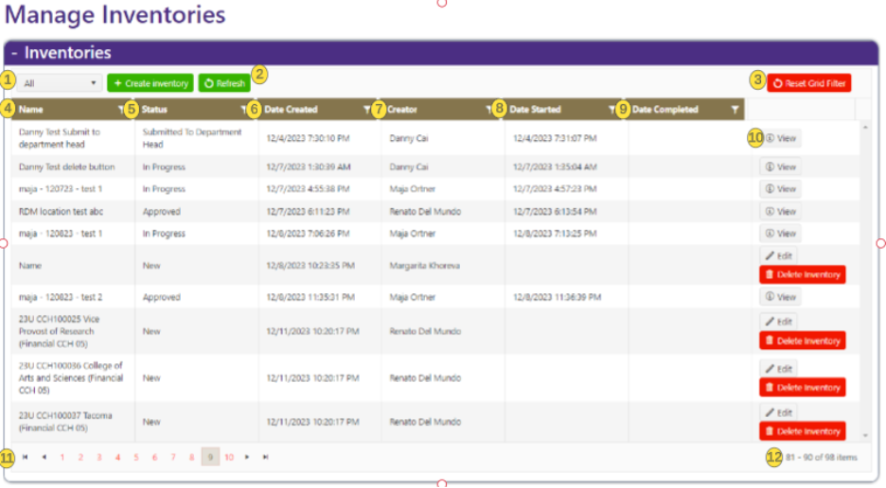
Figure 2 – Manage Inventories

Inventory Grid and Fields
The Inventories grid shows the inventories available to the user and provides status information about each inventory.

Inventories Grid
Item # | Field or Button | Description
1 | Grid Completed Filter | Filters the inventories to show All, Incomplete, or Complete inventories. This filters only the inventories that are not yet completed.
2 | Refresh Button | Refreshes the inventory grid. Use this if the displayed data appears stale or if an expected inventory does not appear.
3 | Reset Grid Filter Button | Clears filters applied to grid columns.
4 | Name Field | Shows the name assigned to the inventory.
5 | Status Field | Shows the inventory's current status.  - New – Inventory has been created, but there are no inventory takers assigned.  - Pending Start – Inventory has at least one inventory taker assigned.  - In Progress – Inventory has been started, and inventorying of assets is in progress.  - Submitted to Department Head – Waiting on DH review and approval/rejection.  - Rejected by Department Head – Sent back to Inventory Takers for updates and resubmission.  - Submitted to EIO – Approved by DH and waiting on EIO Inventory Manager to Approve/Reject.  - Rejected by EIO – Sent back to Inventory Takers for updates and resubmission.  - Revision Requested – Sent back to Inventory Takers for updates and resubmission.  - Approved – Approved by EIO and waiting for upload and update confirmation in Workday.  - Completed – Confirmation of all asset updates in Workday has been done
6 | Date Created | Shows when the inventory was created.
7 | Creator | Shows the user who created the inventory.
8 | Date Started | Shows when the inventory entered In Progress status.
9 | Date Completed | Shows when the inventory entered Completed status.
10 | View Button | Opens the inventory details page. This is where the inventory taker can assign the department head to approve the inventory.
11 | Record Paging Navigation | Used to navigate through pages of inventories.
12 | Record Count | Shows the current record numbers and total record count.

Inventory Statuses
Status | Description | Inventory Taker Action
New | Inventory has been created, but no Inventory Takers have been assigned. | No action unless assigned later.
Pending Start | An Inventory has at least one Inventory Taker assigned but can have more than one. EIO adds the Inventory Takers to an Inventory. | Open inventory, assign Department Head, and start inventory.
In Progress | Asset inventory has started (in progress). | Perform scanning or manual updates.
Submitted to Department Head | Inventory is waiting for Department Head review and approval or rejection. | No action unless rejected or returned.
Rejected by Department Head | Inventory has been sent back to Inventory Takers for updates and resubmission. | Review notes, correct issues, and resubmit.
Submitted to EIO | Approved by Department Head and waiting for Inventory Manager / EIO approval or rejection. | No action unless returned.
Rejected by EIO | Inventory has been sent back to Inventory Takers for updates and resubmission. | Review notes, correct issues, and resubmit.
Revision Requested | Inventory has been sent back to Inventory Takers for updates and resubmission. | Review requested revisions and resubmit.
Approved | Approved by EIO and waiting for upload/update confirmation into Workday. | No action required.
Completed | Confirmation that all asset updates in Workday have been completed. | No action required.

Sorting and Filtering
The Inventories grid supports sorting and filtering.
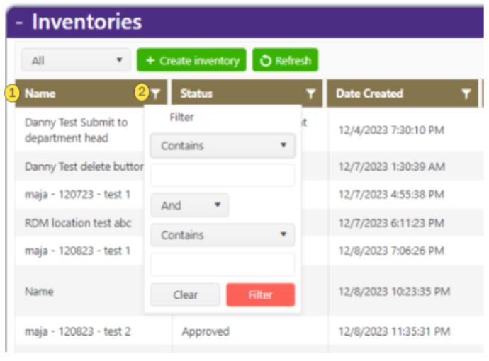
Figure 3 – Sorting and Filtering Inventories

Sorting and Filtering
Item # | Function | Description
1 | Sorting | Click a column name to sort the inventory grid by that column. By default, the grid sorts in ascending order. Click again to sort descending.
2 | Filtering | Click the filter icon on a column to open a filter input. Enter criteria to filter the inventories shown in the grid.

Assigning Department Head
The Department Head is responsible for the first-level review and approval of the inventory after the Inventory Taker submits it.
Important: The original MAS guide indicates that a Department Head assignment is required to submit an inventory. As a process improvement, assign the Department Head before beginning physical scanning work.

When to Assign a Department Head
The inventory status must be either Pending Start or In Progress to assign or change a Department Head.

Assign Department Head
- Open the assigned inventory in MAS Web.
- Click the Assign Department Head button.
  - Search for the Department Head by first name, last name, or UW NetID.
  - Review the search results.
  - Select the correct person.
- Click Save in the search window.
- Confirm that the selected Department Head appears on the inventory details page.
- Click the inventory-level Save button to commit the change.
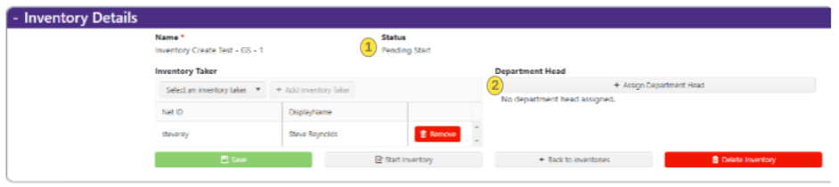

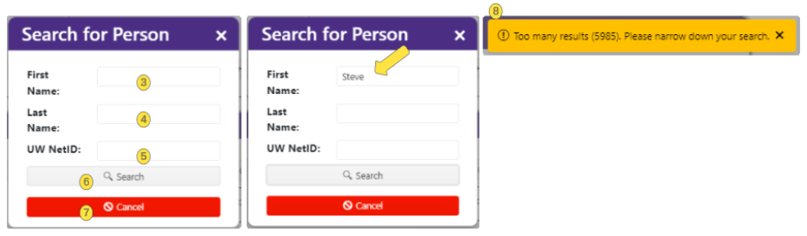

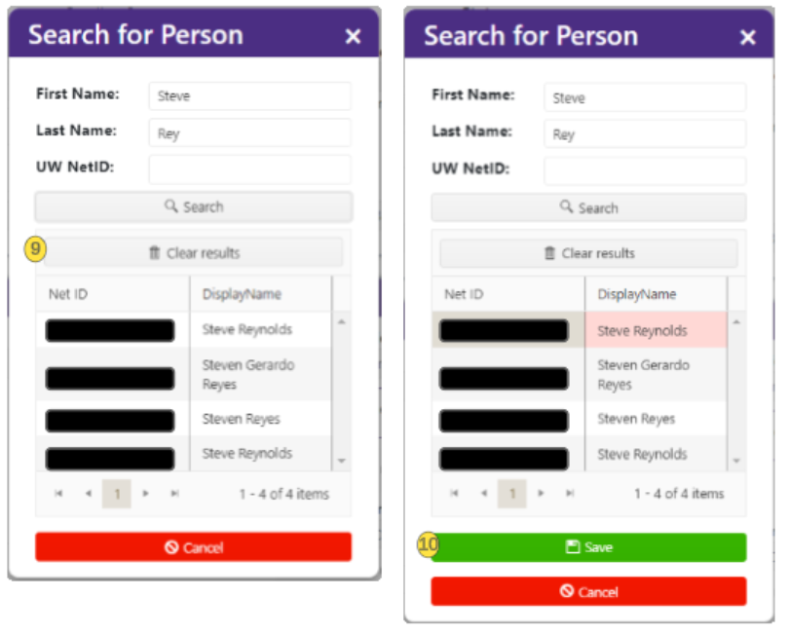
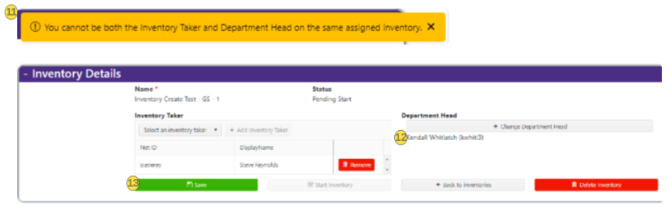
Figure 4 – Assigning Department Head

Department Head Search Fields and Buttons
Item # | Item | Description
1 | Status | Status needs to be either “Pending Start” or “In Progress” to assign a department head. A department head assignment is not required to start an inventory, but it is required to submit it.
2 | Assign Department Head | Click this button to assign a department head to an inventory. The Inventory Taker can add or change the Department Head until the inventory is ready to be submitted.
3 | First Name | Enter the first name of the person you are looking up. Search uses a “Starts With” condition, so partial names can be used when spelling is uncertain.
4 | Last Name | Enter the last name of the person you are looking up. Search uses a “Starts With” condition.
5 | UW NetID | Enter the full UW NetID if known. Search uses an exact match for UW NetID.
6 | Search Button | Initiates a search using the entered lookup details.
7 | Cancel Button | Cancels the Department Head lookup and assignment.
8 | Too Many Results Error | If search criteria return too many results, narrow the search using additional criteria.
9 | Clear Results Button | Clears the search results.
10 | Save | Adds the selected person as Department Head and closes the search window.
11 | Invalid Department Head Error | You cannot select someone as Department Head if they are already assigned as Inventory Taker for the same inventory.
12 | Assigned Department Head | The assigned department head will show on the inventory details page just under the Assign Department Head button once one has been selected. This assignment will not be saved until the inventory has been saved.
13 | Save | To commit the department head assignment to the inventory, click Save.
Important: You cannot be both the Inventory Taker and Department Head on the same assigned inventory.

Starting an Inventory
Important: Please do not initiate any changes to the asset in Workday during the duration of the inventory. Doing so may cause failures in the Inventory integration with Workday.

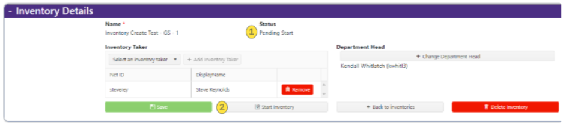
Figure 5 – Starting an Inventory

Starting an Inventory
Item # | Item | Description
1 | Status | Set the status to “Pending Start” to initiate the inventory process.
2 | Start Inventory | Starts the inventory, changes the status to In Progress, and locks the filtered asset list from further changes.

After opening the assigned inventory, select the Department Head and begin the inventory from MAS Web.
- Confirm that the inventory status is Pending Start.
- Confirm that the Department Head has been assigned and saved.
- Click the Start Inventory button.
- Confirm that the inventory status changes to In Progress.
Important: Starting the inventory applies the inventory filter to the asset list. From this point on, the assets in the inventory are fixed and cannot be changed by adjusting the filter.

Inventory – MAS Mobile

User Access (log in)
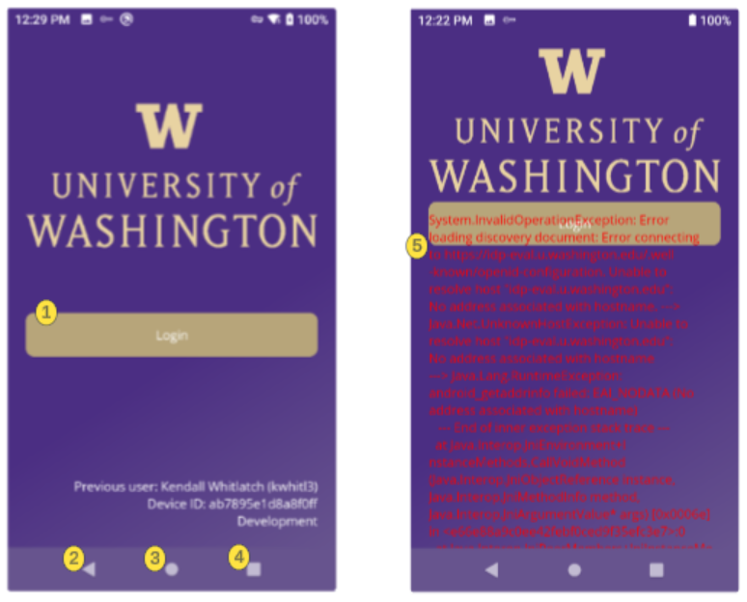
Figure 6 – Log in to MAS Mobile Device
Use the MAS Mobile App on the scanner to perform asset inventory work.

Login Screen Buttons and Messages
Item # | Item # | Description
1 | Login | Takes the user to the web browser login page to connect to MAS back-end services and data. After signing in, the user is returned to the application, which automatically loads their default inventory.
2 | Back | Returns you to the last MAS mobile application location accessed. In other areas of the application, it works like a browser's Back button and navigates to the previous page.
3 | Home | Returns user to mobile device’s home screen.
4 | Error Messaging | If this error appears, verify that you are connected to the UW network through a network login or VPN before contacting the Help Desk.

MAS Mobile Device
- Turn on the mobile scanning device.
- Open the MAS Mobile App.
- Click the Login button.
- Complete the web browser login process.
- After logging in, return to the MAS Mobile App.

Navigation, Syncing, and Logging Out
MAS Mobile includes a main inventory screen, navigation menu, sync option, and logout option.
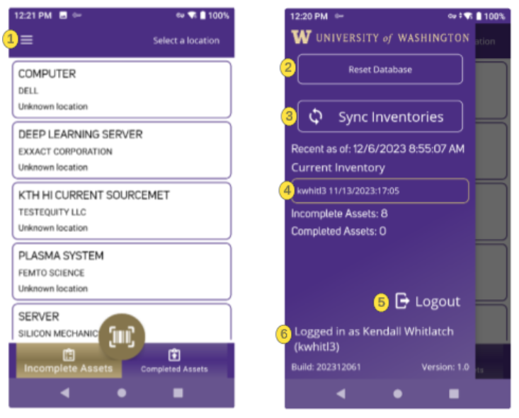
Figure 7 – MAS Mobile Main Inventory Screen

Inventory Screen
Item # | Item | Description
1 | Hamburger Menu | Opens the main application menu.
2 | Reset Database | Debugging tool that clears stagnant changes from the device’s local copy of the inventory database.
3 | Sync Inventories | Pulls down assigned inventories and any updated inventory data since the last login or sync.
4 | Current Inventory | Shows the inventory currently being worked on. Selecting it displays the list of assigned inventories.
5 | Logout Button | Logs the user out of MAS Mobile.
6 | User Name and NetID | Shows the person currently logged into the app.
Caution: Use Reset Database only when instructed by support or when documented troubleshooting steps require it. Resetting local data may affect unsynced changes.

Quality Check Before Scanning
Before scanning, verify that the inventory displayed on the mobile device matches the inventory shown in MAS Web.

Recommended Quality Check
- Open the inventory in MAS Web.
- Open the same inventory in MAS Mobile.
- Compare the inventory name.
- Compare the visible asset list or asset count, if available.
- Confirm that the mobile device is showing the correct assigned inventory.
- Sync inventories if the expected inventory or assets do not appear.
Best practice: Do not begin scanning until you confirm that the mobile device inventory list matches the MAS Web inventory.

Locating an Asset
The main inventory screen displays assets in the inventory that are unscanned or incomplete. You can use location filtering to narrow the asset list by campus, building, floor, and room.
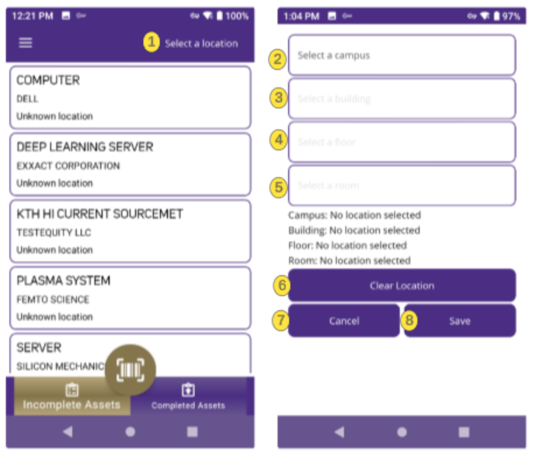
Figure 8 – Main Inventory Screen

Main Inventory Screen
Item # | Item | Description
N/A | Main Inventory Screen | Displays assets in the inventory that are unscanned or incomplete.
1 | Select a Location Link | Opens the location filtering page.
2 | Select a Campus | Current campus options shown in the manual include Bothell, Seattle, Tacoma, Seattle Non-Campus, and Out of State.
3 | Select a Building | Displays buildings associated with the selected campus.
4 | Select a Floor | Displays floors associated with the selected building.
5 | Select a Room | Displays rooms associated with the selected floor.
6 | Clear Location Button | Clears all selected location filters.
7 | Cancel Button | Cancels location selection and returns to the Main Inventory Screen.
8 | Save Button | Saves the location selection, filters the asset list, and returns to the Main Inventory Screen.
Location Note: One asset can have only one location. However, a single inventory can include assets from multiple locations.

Scanning an Asset
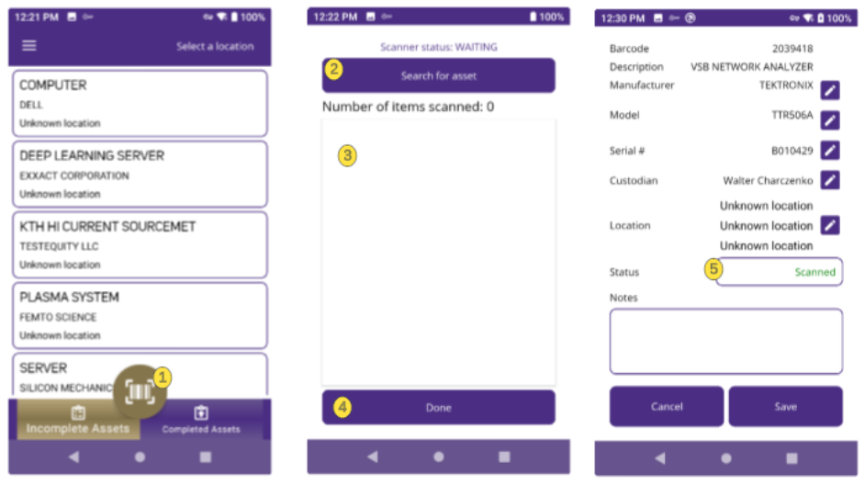
Figure 9 – Scanning Page

Scanning Page
Item # | Item | Description
1 | Enable Scan Button | Opens the scanning page.
2 | Search for Assets | Allows searching by product name, manufacturer name, or partial barcode.
3 | List of Items Scanned | Shows scanned items and indicates the app is ready to scan a barcode.
4 | Done Button | Returns to the Main Inventory Screen.
5 | Asset Detail Page | Displays asset details after scan. The status should change to Scanned. Save the asset before it updates the MAS back end.
Important: The original manual states that the only way to set status to Scanned is to use the scanner itself. Do not manually set an asset to Scanned.

Scan an Asset
- From the Main Inventory Screen, click the scan button.
- After the scanning page opens, point the top of the device at the asset barcode.
- Use one of the device scan buttons to scan the barcode.
  - Confirm that the asset detail page opens.
  - Confirm that the asset status changes to Scanned.
  - Review the asset details.
  - Add notes if needed.
- Click Save to update MAS.

Setting Status of Non-Scannable Asset
Use this process when an asset cannot be scanned or cannot be located.
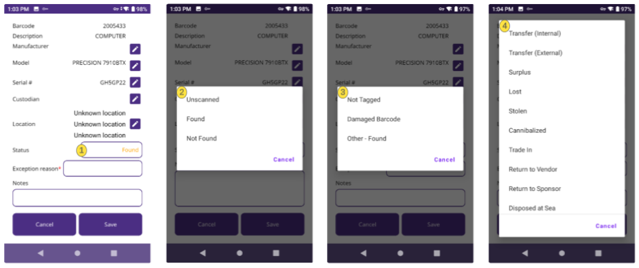
Figure 10 – Non-Scannable Asset

Non-Scannable Asset
Item # | Description
1,2 | Select an asset to open the Asset Detail page, where you can change its status to Unscanned, Found, or Not Found. To mark an asset as Scanned, use the scanner.
3 | Selecting Found requires an Exception Reason: Not Tagged, Damaged Barcode, or Other – Found. Choosing Other also requires a note describing the situation.
4 | Selecting Not Found requires an Exception Reason. If you choose Other, you must also enter a note explaining the situation.

Status Options
Status | Use When
Unscanned | The asset has not been scanned or updated yet.
Found | The asset was found, but the barcode could not be scanned, or another non-scanned condition applies.
Not Found | The asset could not be located.

Exception Reasons for Found Assets
Choosing Found requires an exception reason. If Other or a similar option is available, use notes to describe the specific situation.

Exception Reasons (Found)
Item # | Exception Reason | Use When | Notes Requirement
1 | Not Tagged | The asset is present but has no tag or barcode. | Add notes if helpful.
2 | Damaged Barcode | The asset is present, but the barcode is damaged or unreadable. | Add notes if helpful.
3 | Other – Found | The asset is present, but the reason does not fit another option. | Notes are required.

Exception Reasons for Not Found Assets
Choosing Not Found requires an exception reason. Options include:

Exception Reasons (Not Found)
Exception Reason | Notes Requirement
Transfer – Internal | Add notes if helpful.
Transfer – External | Add notes if helpful.
Surplus | Add notes if helpful.
Lost | Add notes if helpful.
Stolen | Add notes if helpful.
Cannibalized | Add notes if helpful.
Trade In | Add notes if helpful.
Return to Vendor | Add notes if helpful.
Return to Sponsor | Add notes if helpful.
Disposed at Sea | Add notes if helpful.
Important: Select the most accurate exception reason. Exception reasons are reviewed during approval and may require follow-up.

Manual Status Update
- Search for the asset or select it from the incomplete asset list.
- Open the Asset Detail page.
- Select the appropriate status: Found or Not Found.
- Select the required exception reason.
- Add notes if required or helpful.
- Click Save.

Updating Asset Details
Some asset detail fields can be edited in MAS Mobile. 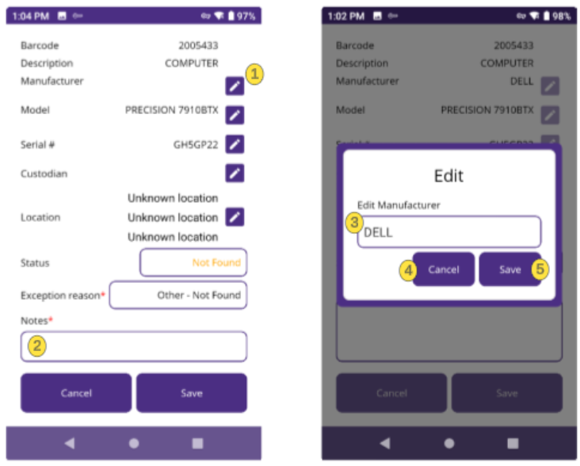
Figure 11 – Asset Details in MAS Mobile

Asset Detail Fields
Item # | Item | Description
1 | Pencil Icon | Any asset detail with a pencil icon next to it is editable.
2 | Notes Field | The Notes field is always editable.
3 | Edit Pop-Up | Clicking the pencil icon opens the field in an edit pop-up.
4 | Cancel | Discards changes and returns to the Asset Detail page.
5 | Save | Saves changes to the field and returns to the Asset Detail page.

Inventory Fields

Editable Fields
Field | Type
Manufacturer | Text
Model | Text
Serial number | Text
Custodian | Searchable picker by name or NetID
Location | Searchable picker by location name, etc. (Campus, building, floor, or room)
Status | Predefined picker: when manually editing, status can be set to:  - Not Scanned  - Located/Found  - Not Located/Not Found
Exception reason | Predefined list/dropdown (required when the status is Located/Found or Not/Located/Not Found
Notes | Text (required when the Exception Reason is “Other – Found” or “Other – Not Found”

Non-Editable Fields
Field | Type
Barcode | Read-only
Description | Read-only

Best Practices for Updating Details
- Only update information that you can verify.
- Use notes to explain unusual changes.
- Verify location changes carefully.
- Verify custodian changes carefully.
- Save changes before leaving the asset detail page.

Updating Assets When Offline
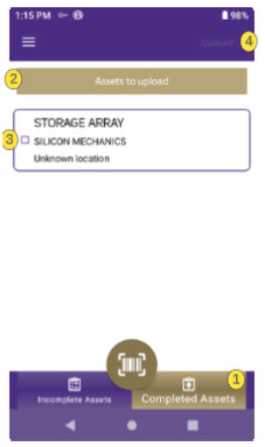
Figure 12 – Updating Assets When Offline

Working Offline
If you are offline and scan or update an asset, MAS Mobile saves the asset locally on the device. Local assets appear on the Completed Assets tab and are uploaded automatically when the device reconnects to the UW network and you confirm the upload. If an asset is not uploaded automatically, you can upload it manually as described below.
Important: If you exit MAS or restart your device without first syncing, you will lose any changes to your inventory.

Manual Upload Steps
- Go to the Completed Assets tab.
- Confirm the gold bar header says Assets to upload. If not, select the box and change it.
- Select the checkboxes next to the assets you want to upload.
- Click the Upload button in the upper right of the screen.
- Confirm the assets are removed from the upload list after successful upload.
Best practice: Before submitting the inventory, confirm there are no pending local/offline updates remaining on the device.

Submitting Inventories – MAS Web
After scanning or updating all assets, submit the inventory in MAS Web.
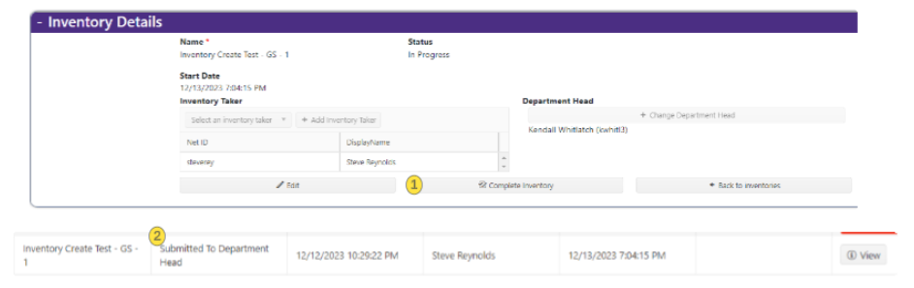
Figure 13 – Submit Inventory in MAS Web

Submit Inventory
Item # | Item | Description
1 | Complete Inventory Button | Submits the inventory to the assigned Department Head for approval.
2 | Status Field | After submission, the inventory status changes to Submitted to Department Head.

Before Submitting
Confirm the following before submitting:
- All required assets have been scanned or manually updated.
- No incomplete assets remain.
- Any offline or local updates have been uploaded.
- Required notes have been entered.
- The Department Head is assigned.
- The inventory is ready for first-level review.

Submit
- Open the inventory in MAS Web.
- Confirm the inventory status is In Progress.
- Click the Complete Inventory button.
- Confirm that the inventory status changes to Submitted to Department Head.
Important: Do not submit the inventory until all asset updates are complete and all pending mobile updates have been uploaded.

After Submission
After the Inventory Taker submits the inventory, it moves to the assigned Department Head for review.
Important: At this point, the inventory is removed from the Inventory Taker's view and is no longer accessible.

What Happens Next
- The Department Head reviews changes, notes, and exception reasons.
- The Department Head approves or rejects the inventory.
- If approved, the inventory moves to Inventory Manager / EIO final review.
- If rejected, the inventory is returned to the Inventory Taker for corrections.
- After final approval, MAS sends updates to Workday through integration.
- After Workday processing is complete, the inventory status changes to Completed.
Possible limitation: After submission, the inventory may no longer appear in the Inventory Taker’s active list. If read-only tracking is not available, track submitted inventories outside MAS.

Rejected Inventory
If the Department Head or Inventory Manager rejects or requests revision to an inventory, it is returned to the Inventory Taker for updates and resubmission.

Making Corrections
- Open the returned inventory in MAS Web.
- Review rejection or revision notes.
- Open MAS Mobile if asset-level updates are required.
  - Correct the identified asset records.
  - Add or update notes if needed.
  - Upload pending changes from the mobile device.
- Resubmit the inventory.
Best practice: If rejection notes are unclear, contact the reviewer before resubmitting.

Troubleshooting
Issue | Possible Cause | Recommended Action
Assigned inventory does not appear in MAS Web. | Inventory may not be assigned to you, or access may not be configured correctly. | Contact EIO or support to confirm assignment and access.
Department Head search returns too many results. | Search criteria are too broad. | Add last name or UW NetID to narrow the search.
Cannot assign selected Department Head. | The selected person may also be assigned as Inventory Taker on the same inventory. | Select a different Department Head.
Device login shows an error. | The device may not have a valid UW network or VPN connection. | Confirm network connection, network login, or VPN before contacting support.
Inventory does not appear on mobile device. | Device may not have synced after assignment. | Use Sync Inventories from the mobile menu.
Asset list on mobile device does not match MAS Web. | Device may need to sync, or the wrong inventory may be selected. | Sync inventories and confirm the current inventory.
Barcode will not scan. | Barcode may be damaged, missing, or unreadable. | Set status to Found and select Damaged Barcode, Not Tagged, or Other - Found as appropriate.
Asset cannot be found. | Asset may have moved, been transferred, gone to surplus, been lost, or otherwise be unavailable. | Set status to Not Found and select the appropriate exception reason.
Notes are required. | An “Other” exception reason was selected. | Enter clear notes explaining the situation.
Updates do not appear in MAS Web. | Updates may still be stored locally on the device. | Upload pending assets from the Completed Assets / Assets to Upload page.
Inventory cannot be submitted. | Department Head may not be assigned, assets may be incomplete, or pending uploads may remain. | Confirm Department Head, complete assets, and upload pending changes.
Errors when syncing device. | An asset may be in an invalid state (Example: Disposed) in Workday. | Contact EIO to report error.
Workday does not reflect changes immediately. | Updates are sent to Workday only after approvals and scheduled integration. | Wait for the scheduled integration cycle. Confirm timing with EIO or support.

Revision History
Date | Revision | Description
03/15/2024 | 1.0 | Initial Release
05/30/2024 | 2.0 | Final Release
09/03/2024 | 2.1 | New feature: revision requests
08/17/2026 | 2.2 Draft | Updated Inventory Taker draft with clarified MAS terminology, Workday integration context, device checkout guidance, pre-scan quality check, post-submission guidance, rejection workflow, troubleshooting, and items to verify.
08/24/2026 | 3.0 | Updated Release

