WORKDAY CAPITAL EQUIPMENT REQUISITION TYPES & TRACKABLE SPEND CATEGORIES (UWA)
A supplemental guide for creating and submitting requisitions in Workday for Capital Equipment in UW Academy
Workday Job Aid – Work Instructions

WORKDAY CAPITAL EQUIPMENT REQUISITION TYPES & TRACKABLE SPEND CATEGORIES (UWA)
A supplemental guide for creating and submitting requisitions in Workday for Capital Equipment in UW Academy

Purpose
The purpose of this guide is to help Requisitioners determine the correct capital equipment requisition type and trackable spend category to use for capital equipment purchases.

Key Terms:
Capital Equipment: Capital equipment is defined as equipment having a useful life greater than one year and a total cost >= $5,000 (including ancillary costs.) Per UW policy, capital equipment must be tracked in Workday. Additionally, all weapons and accessories, regardless of cost must be tracked in Workday. A Trackable Spend Category must be used to requisition Capital Equipment.
Trackable Spend Category: Trackable spend categories were created specifically to identify equipment purchases that will result in the creation of an asset record.
- A Requisitioner Guide to Trackable Spend Categories has been created to assist in the selection of the correct trackable spend category.
- Requisitions that include a trackable spend category will include routing to a Business Asset Tracking Specialist for approval. When the equipment is physically received, the Workday ‘Create receipt’ task will kick off the asset registration process if the goods line used a trackable spend category.
Capital Equipment Requisition types:
- Capital Asset Request- You will use this requisition type for your capital equipment purchases unless they meet the definition of a multi-component capital asset.
- Multi-Component Capital Asset Request – Choose this requisition type only when multiple components must be combined to create one functioning piece of equipment with one useful life. [this requisition type will be rarely used]

This document will cover:
- How to Create a Capital Asset Request (for Non-Catalog equipment)
- How to Create a Multi-Component Capital Asset Request (for Non-Catalog equipment)

Create a Capital Asset Request (for Non-Catalog Capital Equipment)

Steps
  - Type Create Requisition in the Search bar
1

  - Select the Create Requisition task from the search results
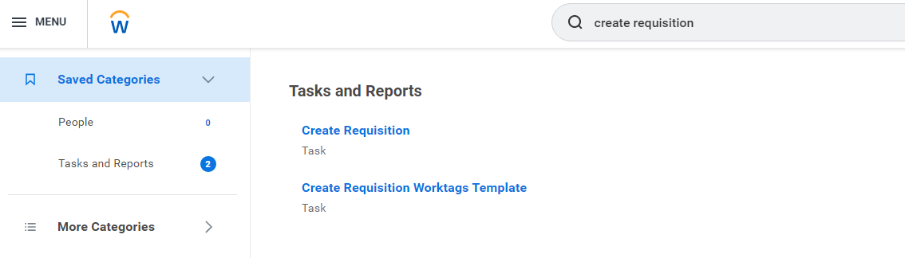
2

  - On the Create Requisition page, select Capital Asset Request from the available options. Then enter the Worktags for the purchase, the correct Deliver-To and Ship-To addresses, and other mandatory fields. Click OK
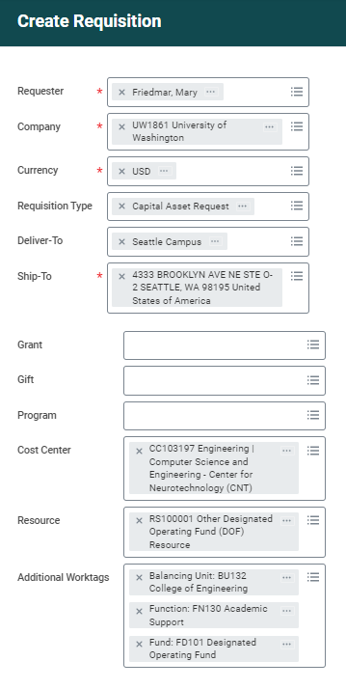
Note: If the requisition is on a Grant, the grant worktag will populate all other required worktags.
If the requisition is on a Cost Center, as shown here, entering the Cost Center will populate the Balancing Unit and Function worktags. You must then enter a Resource Worktag which will populate the Fund Worktag.
3

  - Select Request Non-Catalog Items
4
  - Complete the Goods Requests Details section, choosing a Trackable Spend Category for the item. It is helpful to include the Supplier Item Identifier (supplier catalog or part number) and Supplier if known.
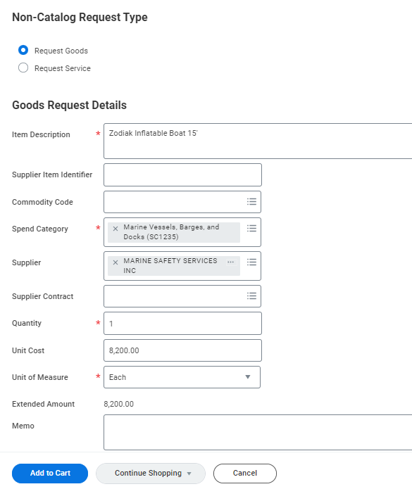
Note: You can search the Requisitioner Guide to Trackable Spend Categories on a keyword, e.g., “Boat” to determine that SC1235 is the correct trackable spend category for the item.
If you were to enter a Non-Trackable Spend Category with one of the two Capital Equipment requisition types a warning message will advise you to select a Trackable Spend Category.
5

  - Select Add to Cart

  - Click the shopping cart
  - Click Checkout
  - Submit the requisition
</end>

Create a Multi-Component Capital Asset Request (for Non-Catalog equipment)

Steps

Type Create Requisition in the Search bar
1

Select the Create Requisition task from the search results
2

On the Create Requisition page, select Multi-Component Capital Asset Request from the available options. Then enter the Worktags for the purchase, the correct Deliver-To and Ship-To addresses, and other mandatory fields. Click OK
3
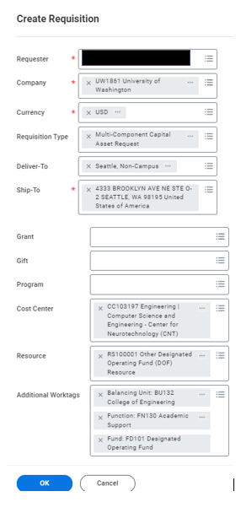
Note: Multi-Component Capital Asset Request is used when multiple parts must be combined to make up a system, or where parts need to be combined for the asset to work.
An example would be:
- a server $7,2000
- a Network switch $3200
- and a server rack $2,000
where the combined items will be registered as one asset with a total cost of $12,400.00, one date in service, and one useful life. When the asset is later disposed, it will be disposed as one unit.
Since the total cost of the combined parts is >= $5,000, we will use a Trackable spend category for each line item. In this example the same trackable spend category (SC1231 Information Technology equipment) applies to each line item

- Select Request Non-Catalog Items
4
- Complete the Request Non-Catalog Items form, for the first component, the Server, choosing Trackable Spend Category SC1231 Information Technology equipment.
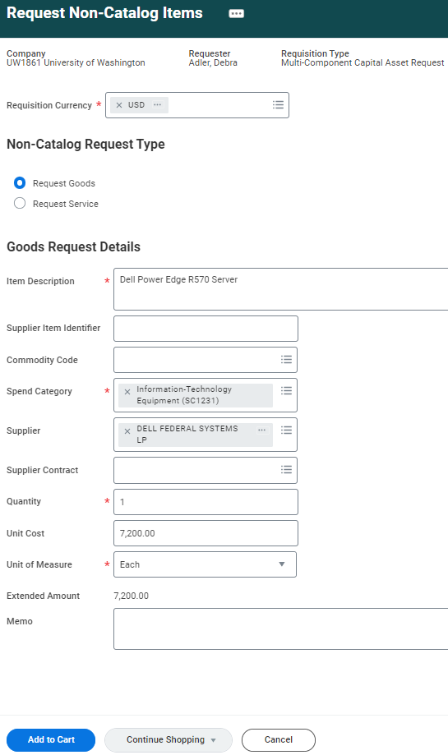
- Select Add to Cart

- Complete the form, for the 2nd component, the Network Switch, choosing Trackable Spend Category SC1231 Information Technology equipment.
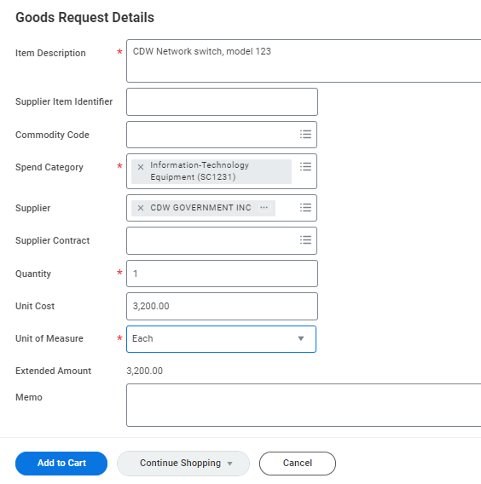
Note: This item is < $5,000, but since the requisition type is Multi-Component Capital Asset Request, a trackable spend category is used because this item is part of the composite asset.
- Select Add to Cart
- Complete the form, for the 3rd and final component, the Server Rack, choosing Trackable Spend Category SC1231 Information Technology equipment.
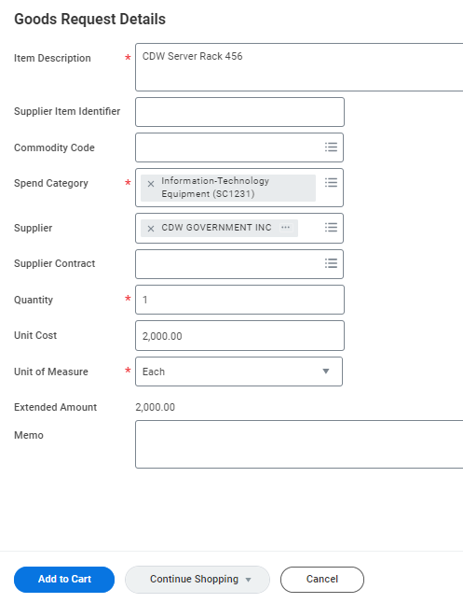
Note: This item is < $5,000, but since the requisition type is Multi-Component Capital Asset Request, a trackable spend category is used because this item is part of the composite asset.
- Select Add to Cart
- Click the shopping cart
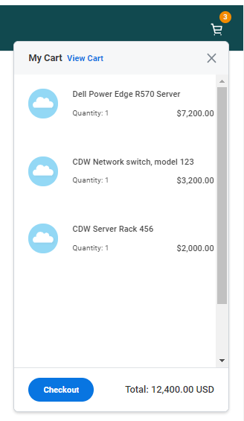
- Click Checkout
- Submit the requisition
</end>

