AA2R Oasis Data Conversion to Workday QUICK REFERENCE GUIDE (QRG)
Reference guide on how legacy assets will be converted to Workday
Workday Job Aid – Quick Reference Guide

Purpose
The purpose of this Quick Reference Guide (QRG) is to explain how Oasis data was converted to Workday.

Audience
- Business Asset Accountant
- Business Asset Tracking Specialist
- Unit Asset Coordinator​

Which Oasis Records are being converted into Workday?
Oasis assets in statuses:
- “A” Approved
- “P” Pending

Which Oasis data groupings are being converted?
- Oasis “Snapshot” data:
  - all fields will convert into a WD delivered field or a Custom object field. Exception: UWM Dept ID field was deemed not needed as WD Cost Center will replace this information
- Oasis Miscellaneous Data section:
  - Fields that our AA2R SME deemed required have been converted into a WD delivered field or a Custom object field.
Which Oasis data groupings are not being converted?
- Oasis “Expenditure” data
- Oasis History data
- Oasis Notes Information
Note: Users will have access to a "Read only" Oasis data copy that will be made available after cutover should they need to review Oasis data fields or groupings that were not converted.
Oasis CONVERSION MAPPING
Oasis snapshot data
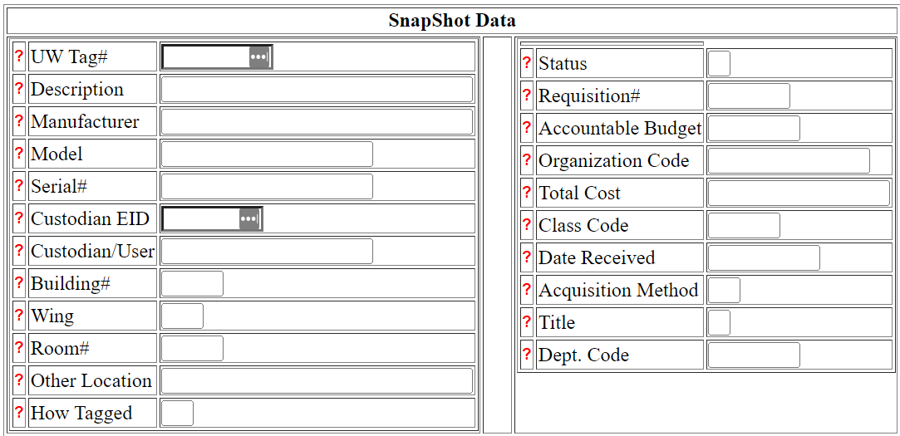
UWM will track location at the building level only. Academy will track location at the room level.
Current Future State mapping, SnapShot Data:
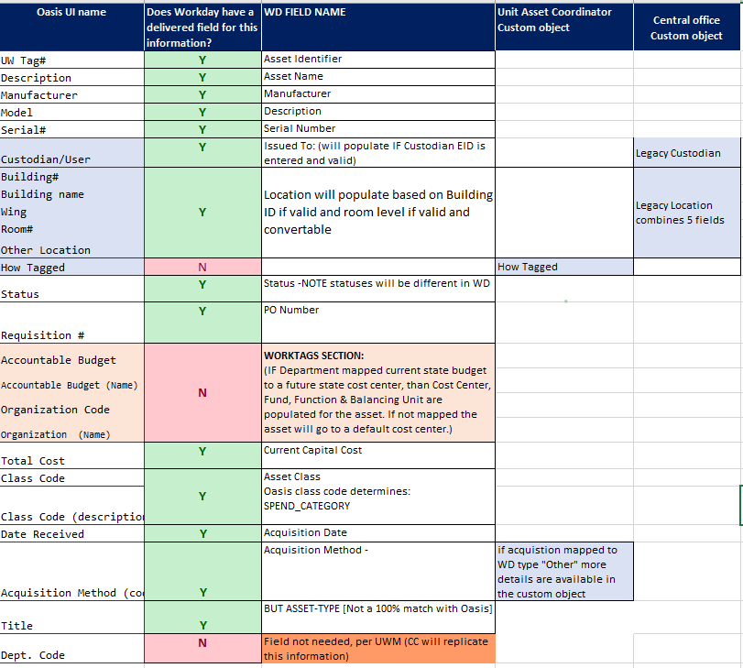
Custom fields were created to hold data when the Oasis data was required for conversion (per AA2R SMEs) but either Workday did not offer a delivered field for the data, or the data in the source system could not reliably be converted into the Workday field.
Oasis Miscellaneous data
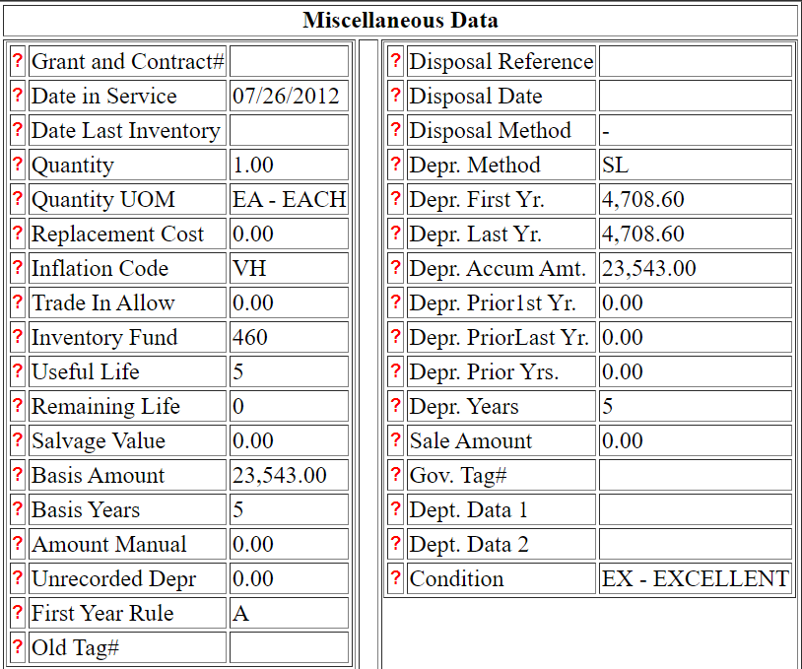

Current Future State mapping, Miscellaneous Data, Left-hand side fields:
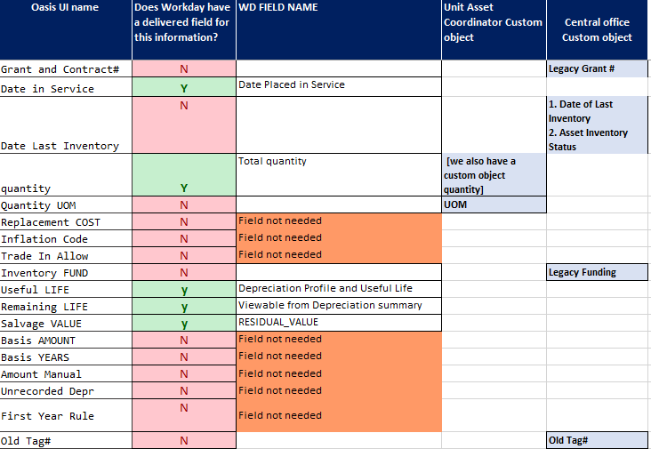
Current Future State mapping, Miscellaneous Data, Right-hand side fields: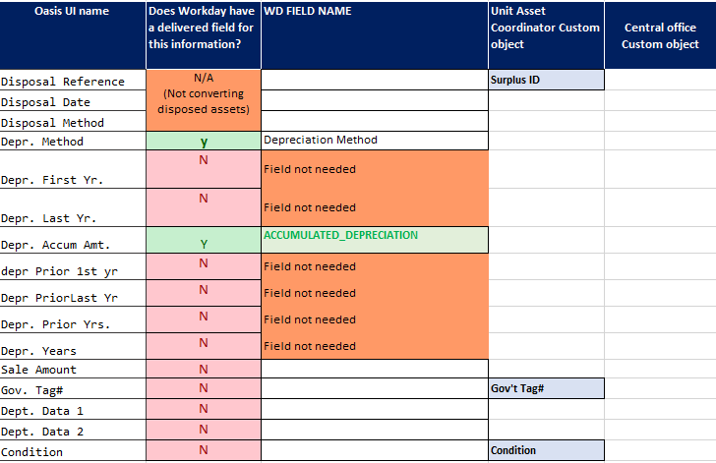
Workday Delivered fields show in the General Information section of an asset record or one of the Asset Tabs:
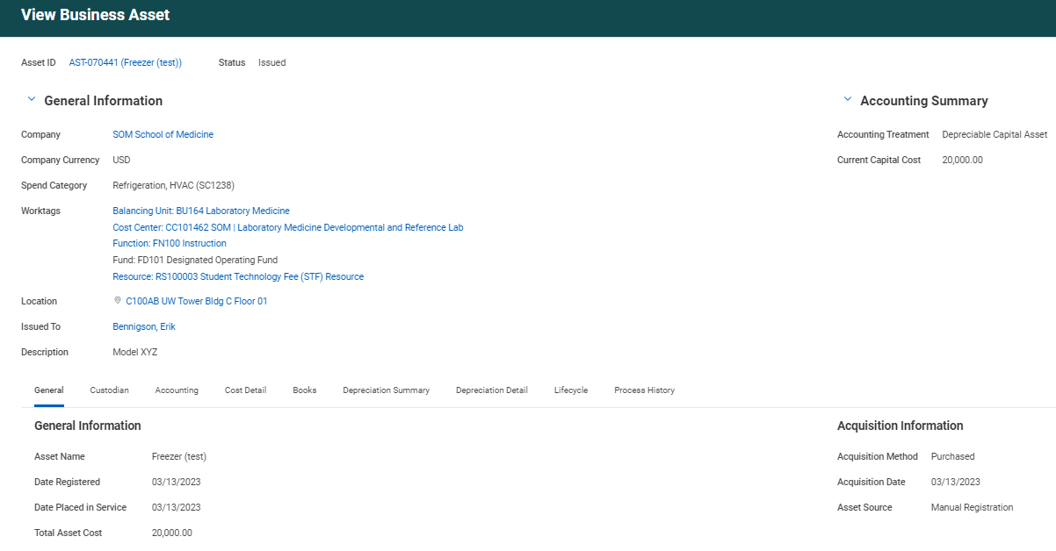
Custom field data can be viewed from Reports, or from the asset record:

- View from Reports: You can view custom field data from The Find Office Unit Asset Coordinator or the Find Assets Central Office reports:
e.g., the report columns below are all custom fields:
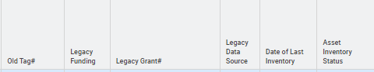
- View from an Asset Record: From the Asset ID, go to the related actions, select Additional Data, then View All
