JOB AID

Interim Cost Share Report

as a Source for Cost Sharing Sharing

UNIVERSITY OF WASHINGTON MANAGEMENT ACCOUNTING AND ANALYSIS

Finance and Facilities

W

**What is an Interim Cost Share Report?**

* The Interim Cost Share Report provides certified documentation of cost share performed by faculty when a Faculty Effort Certification Report (FEC) is not available for certifying the cost shared effort.

**When is an Interim Cost Share Report completed?**

* The sponsor requires periodic/final invoicing/reporting outside FEC cycle dates.
* GCA needs to submit reports to the sponsor before the FEC for the cost share period is released.
  + Example: Grant A expires January 31 and the FEC which will provide certification of the cost share will not be released until late July. The financial report is due to the sponsor by April 30th.

**Where Can I find the Interim Cost Share Report Template?**

* The template is on the Management Accounting and Analysis (MAA), Faculty Effort Certification (FEC) website: <http://f2.washington.edu/fm/maa/fec/fectools>

**What is the Process for Completing an Interim Cost Share Report?**

* Download either the Academic or Calendar Interim Cost Share Report
  + Choose the Academic report if the faculty member does FEC reporting on the Academic cycle.
  + Choose the Calendar report if the faculty member does FEC reporting on the Calendar cycle.
* Scan and email completed certified (signed) report to efecs@uw.edu two weeks before it is required by GCA.
* MAA creates a spreadsheet based on information documented on the Interim Cost Share Report and uploads it to Grant Tracker.
* GCA completes either invoicing or reporting using information from the MAA spreadsheet.

**What do departments need to know about completing the report?**

* Check the appropriate box at the top left of the form to indicate if the Interim Cost Share Report is being completed for invoicing or for reporting purposes. This helps GCA expedite review.
* Fields marked in yellow require department input.
  + *Clinical Salary:* For Calendar reports provide the dollar amount for any clinical salary paid during the cycle.
  + *% of actual cost shared effort*: Normally this will be the committed percent of cost shared effort.
    - Please the actual percent of cost shared effort performed (not prorated) in this field.
    - This may be the amount committed or it may be more or less than the commitment.
  + *Begin and end date of cost shared effort being reported*: this will be a partial FEC period, include the begin date of the FEC cycle and the last date the cost share was provided or the cut-off date for the invoice/report.
  + *Begin and end date of full FEC cycle*: put the entire FEC cycle dates in this field
  + *# pay periods cost share was active*:
    - Academic: indicate how many pay periods the cost share was performed in each of the two quarters in the FEC cycle.
    - Calendar: indicate how many pay periods the cost share was performed during the entire FEC cycle.
  + Have the faculty member certify (sign) and date the report.

Note: this cost share will not be reflected on the Cost Share Summary until the FEC for the cycle is certified.

Faculty Cost Share: <http://f2.washington.edu/fm/maa/fec/costshare> Questions: [efecs@u.washington.edu](mailto:efecs@u.washington.edu)

[efecs@u.washington.edu](mailto:efecs@u.washington.edu)

[efecs@u.washington.edu](mailto:efecs@u.washington.edu)

[efecs@u.washington.edu](mailto:efecs@u.washington.edu)

[efecs@u.washington.edu](mailto:efecs@u.washington.edu)

Academic

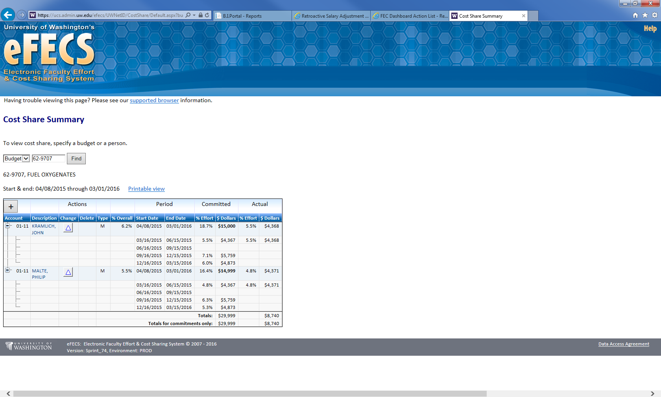

Amount to enter as “% of actual cost shared effort”, as this represents a complete 3 month quarter.

Amount to enter as “% of actual cost shared effort”, as this represents a complete 3 month quarter.

Dr. M:

Calculation copied from Interim Cost Sharing Report:



Dr. K:

Calculation copied from Interim Cost Sharing Report:



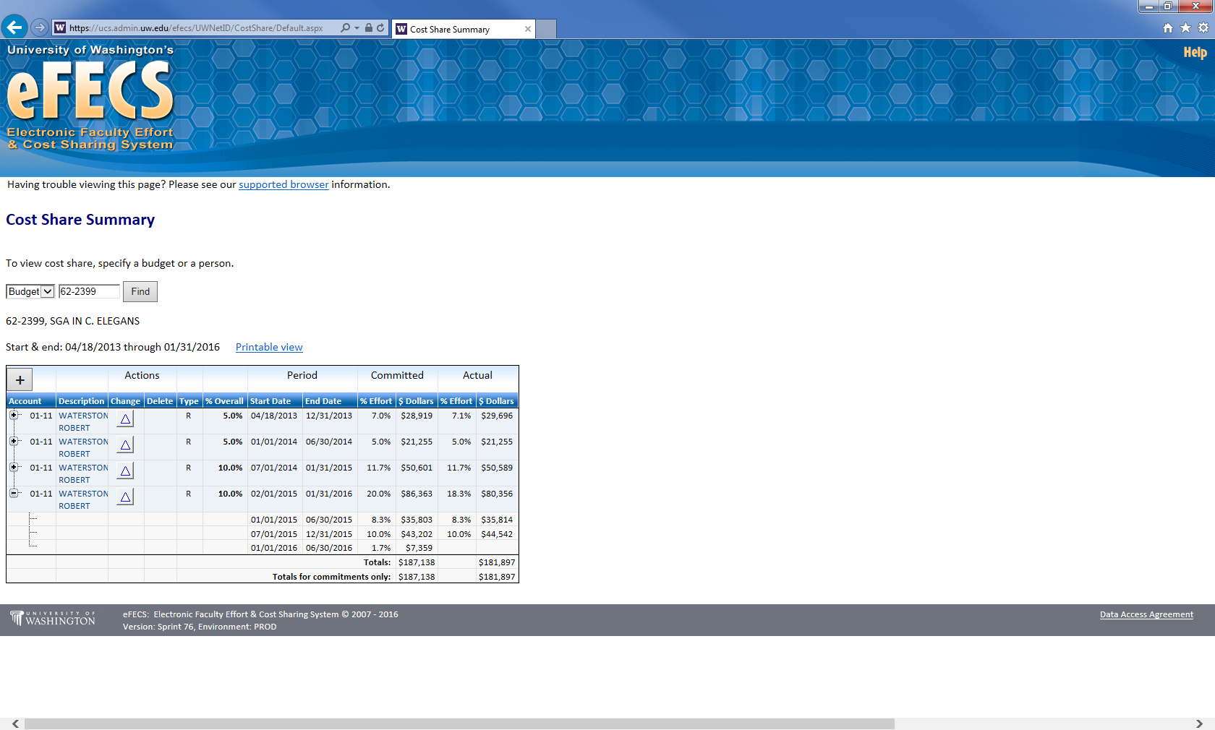

Calendar

Amount to enter as “% of actual cost shared effort”, as this represents a complete 6 month cycle.

Calculation copied from Interim Cost Sharing Report:

