FAQ – Summer 2021 Forum

- When does GCA record the Record Retention Trigger Date?

The Record Retention Trigger Date will show up in Grant Tracker once we have entered a completion date for the final financial report. If no report is due, then the trigger date will appear after we complete the final closing reconciliation.
FAQ: https://finance.uw.edu/gca/faq/what-record-retention-trigger-date-rrtd
- Do the Org Code Reports include the final action dates?

The following Org Code Reports include a column for the Final Action Date:

- Budgets with Final Action or End Dates In Next 90 days
- All Budgets

- Should we always wait to be contacted by GCA around the final action date to close the budget; or do you recommend ever doing it sooner, if you know there won’t be any more transactions between the end of the grant and the final action date?

GCA will only contact your department around/after the Final Action Date (FAD) if there are outstanding issues preventing us from closing the budget or if we need additional information/assistance to complete a final financial report and/or or invoice. To prevent closeout issues, we recommend completing a final reconciliation prior to the FAD. If you know expenditures are final prior to the FAD, you may request that GCA place your budget in status 3 (pre-close) to reduce the risk of additional charges posting. Budgets are closed to status 4 after the Final Action Date has passed and all financial requirements have been met.

- For invoicing, is there a way to generate invoices for items that are not automatically paid? Example, salaries are billed separately, so is there a way we can use Grant Tracker to generate this invoice to send to the vendor?

There is currently no way to generate invoices for different types of costs on a single budget. Our invoicing system bills all transactions for a given billing period (usually one month), and the same period cannot be billed twice. If salary needs to be billed separately, the best thing to do would be to request a sub budget specifically for salary expenditures and ask that GCA invoice the sub budget separately from the parent.

- Any tips on how to communicate special invoice instructions, such as specific email subject lines, email address changes, etc.?

We suggest communicating any special invoice requirements via Grant Tracker, as soon as possible. The earlier GCA can make the necessary process updates, the less likely prior invoices will need to be revised. Please submit a new Grant Tracker request, and our Grant Analyst team will ensure the information gets to our invoicing specialists.

- What happens at GCA's end when campus has created a Grant Tracker note for “email invoice to sponsor”?

A new note will be created in Grant Tracker, confirming that the invoice has been emailed to the sponsor. No additional action will be taken by GCA. See screenshots below for added clarification.

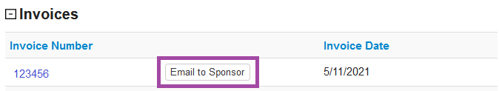
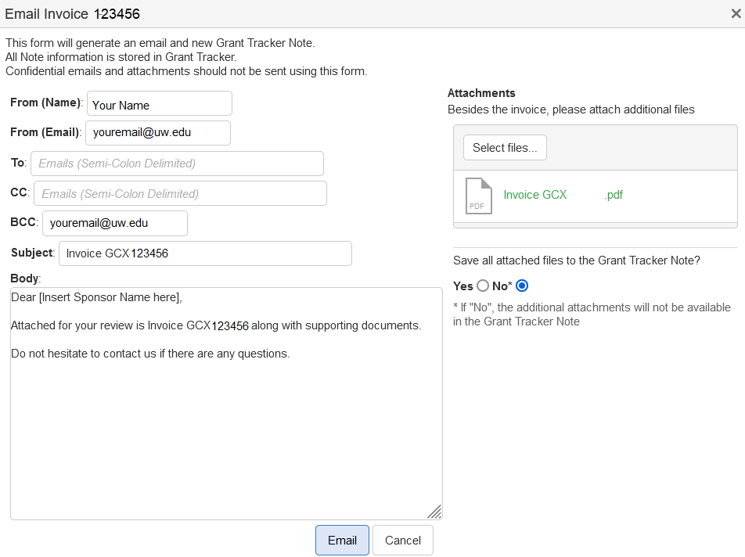

- Is there any way to generate a report that includes directs awarded, separate from indirects? Perhaps by org code? Michelle

Unfortunately, this feature isn’t available through Grant Tracker. You might find the “Budget Summary by OrgCode" report in the BI portal helpful.

- Clarification: What do we do about items posted in MyFD that did not populate on the invoice?

If an invoice appears to be missing a MyFD transaction from its billing period, please contact GCA via Grant Tracker, and we will review the issue. Note, however, that if the missing transaction was a late-posting charge for the month of June, it will most likely appear on our July invoice. To meet sponsor deadlines, we generally must issue interim invoices for June before the fiscal year or biennium has closed in the UW financial system, leading to a small number of MyFD June charges being treated as July expenditures for interim invoicing (and reporting) purposes.

- Would you please explain which budgets have automatic IDC checks, and which need to be watched?

If a budget has outgoing subcontracts or if Grant Control Flag 11 is activated in its MyFD budget profile, GCA will review and manually adjust its F&A expenses. If you manage such a budget, we recommend regular review, both to ensure F&A is ultimately posted correctly and to have an estimate of pending F&A charges for planning purposes.

- Is there anywhere in Grant Tracker we can find the actual award document with specific data for the specific grant or not? I know there is an eGC1 number and connection to SAGE, but because I don’t have access, so I can’t see it. Patrick

There is no place in Grant Tracker to see the complete award document.

If you need access to an eGC1 please contact your ASTRA coordinator. You can find more information about accessing the SAGE system here:

https://www.washington.edu/research/tools/sage/guide/sage-overview/accessing-sage/

