Instructions to complete IRS Form 8233
Please keep in mind that the IRS Form 8233 must be submitted every calendar year. It is only valid from January to December of the year it is submitted.
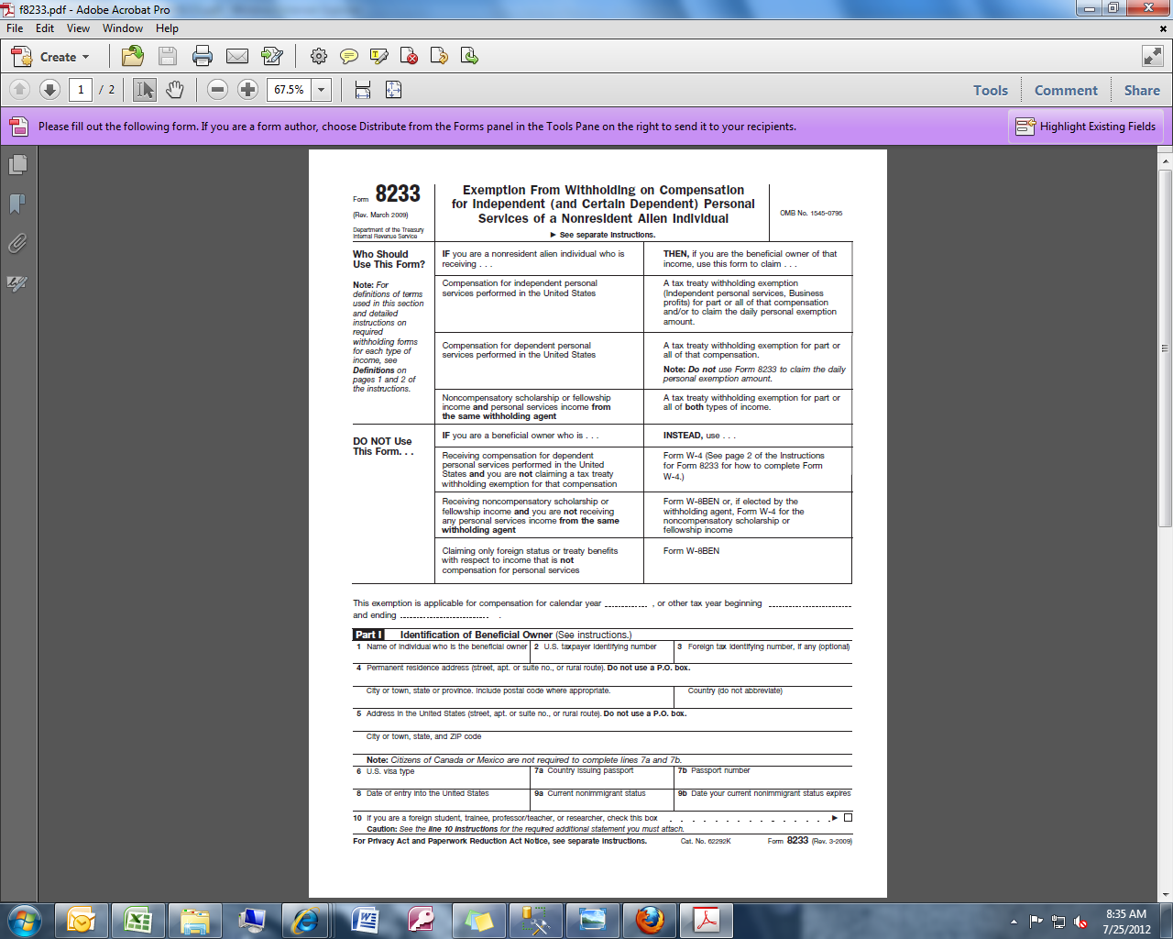

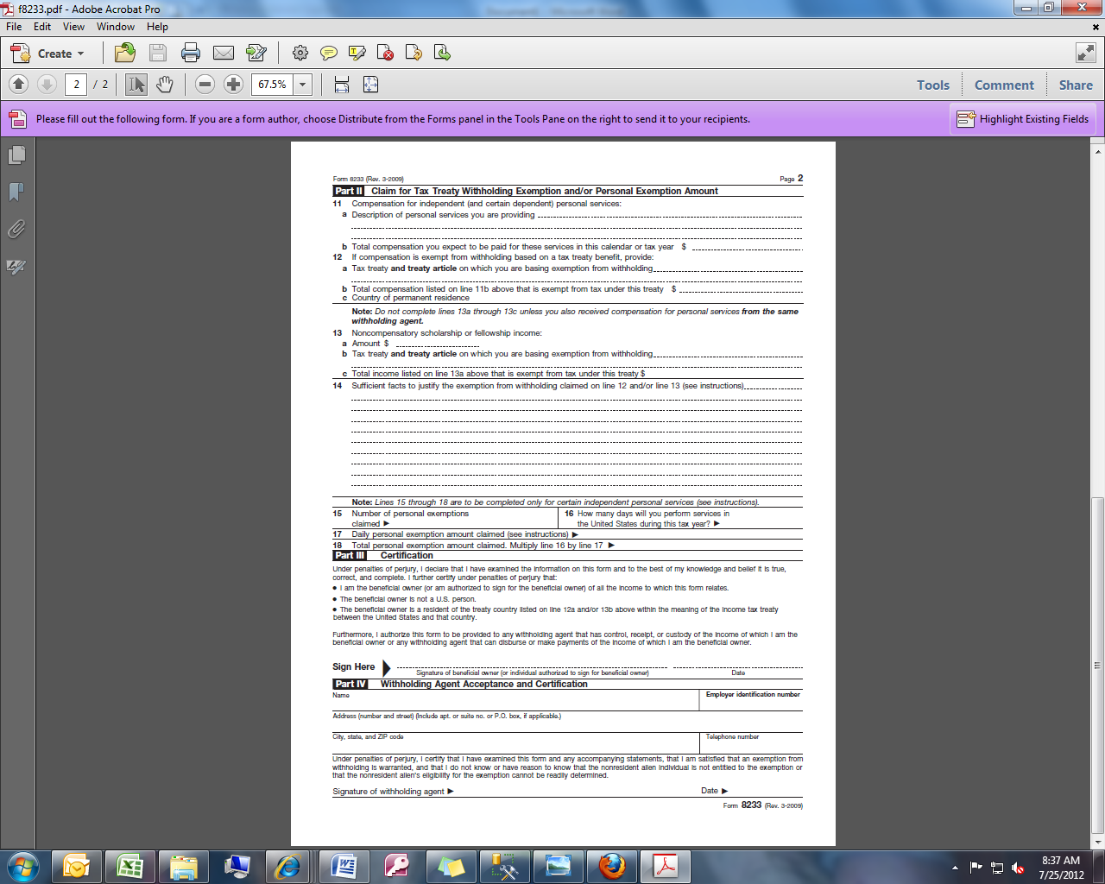
A
1
4a
4b
5
5a
6
7a
7b
8
9a
9b
10
B
2
3
4

11a
12a
11b
12c
12b

13b
13a
13c
14

16
17
15
18

19
19

A. Enter the appropriate calendar year. This form needs to be completed each calendar year if you wish to claim an exemption.
1. Enter your last name, first name as exactly shown on your social security card. Note: You must have a Social Security number (SSN) to claim tax treaty benefits on wages.
2. Enter your U.S. social security number.
3. Enter your foreign tax identifying number, if any (optional). For example, if you are a resident of Canada, enter your Canadian Social Insurance Number.
4. Enter your permanent foreign address in your country of legal residence (street, apt. or suite no., or rural route). Do not use a P.O. Box.
4a. Enter city or town, province (state) and include postal code.
4b. Enter the name of country (do not abbreviate).
5. Enter the address while living in the U.S. (street, apt. or suite no., or rural route). Do not use a P.O. Box.
5a. Enter city or town, state and zip code.
6. Enter your visa type listed on your Form I-94, Departure Record. For example, foreign students are usually granted an "F-1" visa. Foreign professors, teachers, or researchers are usually granted a "J-1" visa.
Note: Citizens of Canada or Mexico are not required to complete lines 7a and 7b.
7a. Enter the country that issued your passport.
7b. Enter your passport number.
8. Enter your date of original entry into the United States that pertains to your current nonimmigrant status.
9a. Enter your current nonimmigrant status. For example, enter student, trainee, professor/teacher, or researcher.
9b. Enter the date your current nonimmigrant status expires which is shown on your current DHS Form I-94, Departure Record.
10. Check this box if you are a foreign student, trainee, professor/teacher, or researcher.
11a. Describe briefly the services for which you are being compensated. For examples: research assistant, working in the library, or course instructor.
11b. Enter your anticipated compensation from the UW for the current calendar year.
12a. Enter the tax treaty and article number you are claiming. For example: U.S./France tax treaty, Article 21
Link to tax treaty articles is below:
- http://f2.washington.edu/fm/payroll/foreign-nationals/tax-treaty

12b. Enter the amount of compensation that is exempt from tax under your tax treaty article claimed. For example, the U.S./Korean tax treaty exempts $2000 of wages of students, so $2000 would be entered on line 12b.
12c. Enter your country of permanent residence.
13a. Leave blank.
13b. Leave blank.
13c. Leave blank.
14. Leave blank.
15. Leave blank.
16. Leave blank.
17. Leave blank.
18. Leave blank.
19. Sign and date the form.
B. Attach and complete the appropriate attachment for the tax treaty provision you are claiming.
- Return the IRS Form 8233 with attachment to Payroll, Box 359555.
- For more information, see IRS Instructions.
- IRS Form W-4 is for wages that are not eligible for tax treaty exemption
- Do not submit both W-4 and IRS Form 8233. See Foreign Nationals webpage Federal Withholding Taxes and Tax Treaties
- IRS Form 8233 with attachment will be submitted to the IRS for review

