How to find late GCCR transactions using BI Portal and filtering:
You can run the expense transfer report from here: https://edw.washington.edu/reports/report/Financial/Expense%20and%20Revenue%20Transfer%20Report
This report displays posted Expense and Revenue Journal Entries (Transaction Code 35) and Salary Expense Transfers (Transaction Code 70) for selected Org Codes for a selected date range. It is similar to the MyFinancial.desktop “Posted Expense Transfer” query template, but also includes Journal Entries initiated in other applications - e.g. FASTRANS. Grant Budgets are defined in this context as those with a Budget Type of "05".
You will need to fill in the required information based on your circumstance.
Transaction Posting Start Date- Typically the month “closes” after the tenth so I would choose the 10th of the month following the GCCR period you are looking at
Transaction Posting End date- Today
Budget Type- Grant Budgets
Journal Entry or Transfer Type- Salary Only
OrgCodes- Select the OrgCode level for the GCCRs you maintain
Grouping- No Grouping is fine
Example:
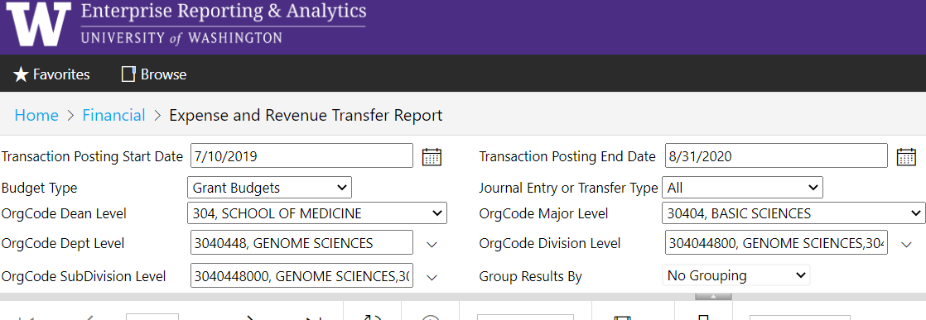

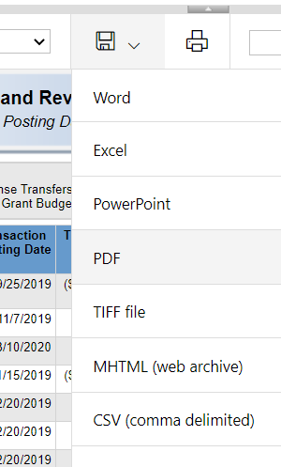
This is going to give you every single transfer done for the period selected but this is much more than what you will need so we need to filter it down. Export the report to CSV using the drop down on the disk icon. You can open this file in excel. Column M OrigTranPayDate is showing the date of the transaction that is being updated by the transfer. You can sort or filter by column M OrigTranPayDate so that you have only the transactions that were from the dates of the GCCR period you are looking at. You already ran the report to look at transfers that happened after that GCCR period finished, so now you should only be viewing “late” transactions. Of these late transactions we are only interested in those for Non-Faculty. Column P Object_SubObject will allow you to see what object code the salary posted in. Typically Non-Faculty transactions are from only 01-20, 01-30, 01-40, 01-60, or 01-70. There are some Non-Faculty such as employees in the Academic Personnel-Academic staff job family or under certain job profiles designated as non-faculty, and they may be paid under 01-10. In this case you will want to use the TranDesc which will give you the name and you can check to see it they are faculty or non-faculty employees.
Now that you have a list of late transfers you can begin updating your GCCRs following the instructions here: https://finance.uw.edu/maa/gccr/change

