ECC STATUS REPORTS Job Aid
Table of Contents
Purpose 1
Audience 1
Overview 1
Coordinator/Department Relationships 1
Generate a Certification Status Report 2
Generate a Project Status Report 4
Common Report Parameters 6
Addendum: ECC Statement Statuses 7

Purpose
The purpose of this job aid is to provide step-by-step instructions to create a status report in the Employee Compensation Compliance (ECC) system.

Audience
This job aid is intended for individuals who are interested in, or responsible for, monitoring the progress of Effort Statements and Project Statements in ECC for a particular unit, department, cost center(s), school or college. The ECC Coordinator role is required to generate these reports.

Overview
ECC provides user the opportunity to create two reports, one for Effort Statements (“Certification Status Report”) and one for Project Statements (“Project Status Report”). The Certification Status Report displays a list of all Effort Statements that have a specified status at the time the report is run. The Project Status Report displays a list of all Project Statements that have a specified status at the time the report is run.

Both reports use similar parameters but are covered in two sections in this job aid.

Coordinator/Department Relationships
To generate these reports for a particular cost center (CC), an individual must have the Effort Coordinator role in ECC and be assigned to that cost center in ECC.

Generating these reports for a Cost Center Hierarchy (CCH) depends on how an individual’s “Coordinator/Department Relationships” are set up in ECC. If the individual is not assigned at the CCH level for their unit, they will only be able to generate reports by individual cost center (CC), which requires knowledge about which specific cost center(s) the statements are within.

Contact the Post Award Fiscal Compliance Effort Reporting Team at effortreporting@uw.edu with questions about relationships within ECC.

Generate a Certification Status Report
- From the ECC Homepage, click on the “Reports” menu.

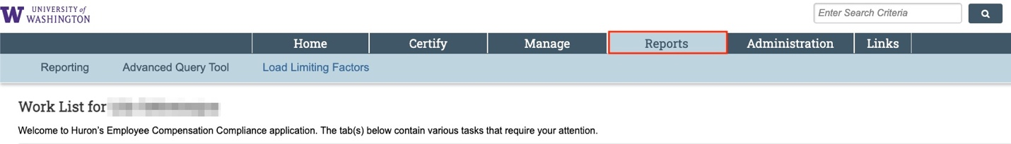

- Click on the “Reporting” submenu.

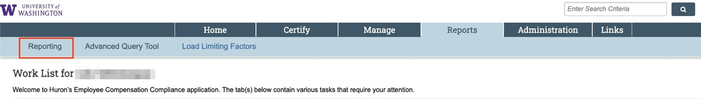

- Select the “Management” category.

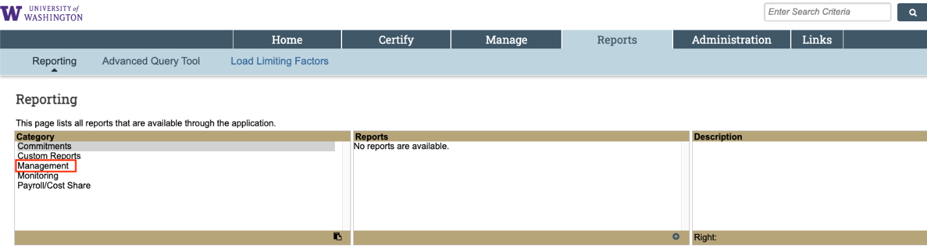

- Select “Certification Status Report”.

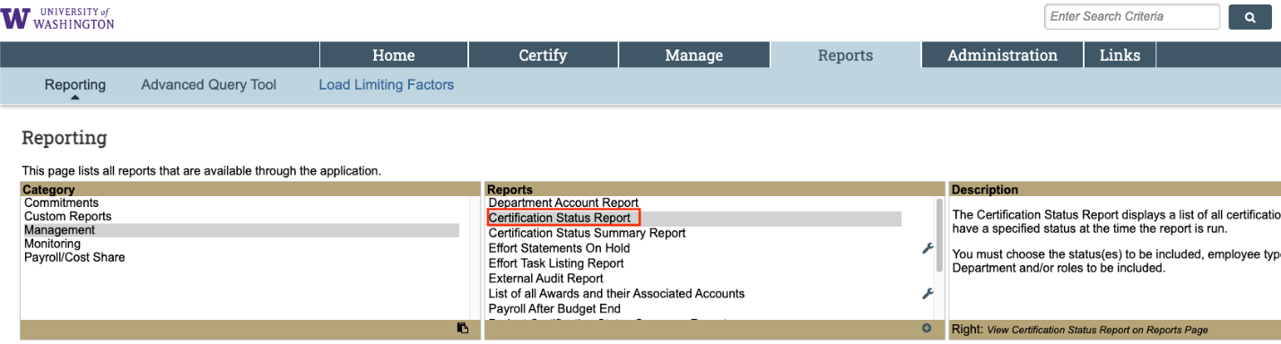

- Scroll down to the “Parameters” tab to select your report parameters.

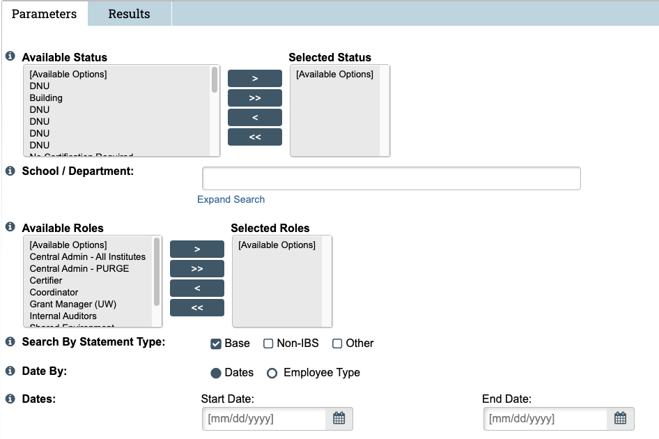

  - Available Status – Select the status or statuses that you are interested in seeing in the report. Refer to the Addendum for a full list of statuses and definitions.
  - School/Department – Enter the name of the unit or the cost center associated with the grant worktag.
    - The “Expand Search” function allows you to narrow the results to a sub department based on what was selected in Step 5b.
  - Available Roles - You do not need to select any “Available Roles” to run this report.
  - Search by Statement Type – Select “Base” payroll to return all statement types.
  - Date By – Select the “Dates” toggle to enter a date range in the “Dates” fields. Select the “Employee Type” toggle to select an Employee Type (UW or UWP) and a specific effort reporting period of performance.
  - Dates – Enter the date range to limit the results shown in the report.

- Click “Run Report”. The report can then be exported to Excel.

Generate a Project Status Report
This report shows the status of all accounts or awards that require a project certification.

- From the ECC Homepage, click on the “Reports” menu.

- Click on the “Reporting” submenu.

- Select the “Management” category.

- Select “Project Status Report”.

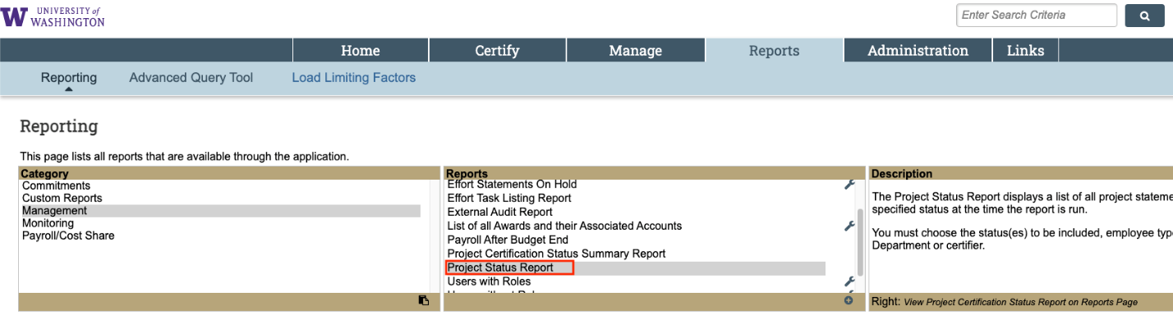

- Scroll down to the “Parameters” tab to select your report parameters.

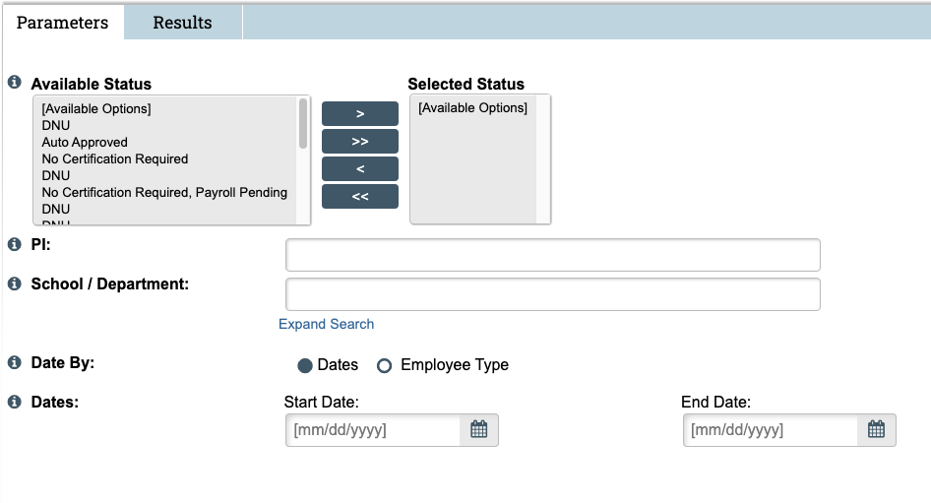

  - Available Status – Select the status or statuses that you are interested in seeing in the report. Refer to the Addendum for a full list of statuses and definitions.
  - PI – Enter the first three letters of the last name of the Principal Investigator.
  - School/Department – Enter the name of the unit or the cost center associated with the grant worktag.
    - The “Expand Search” function allows you to narrow the results to a sub department based on what was selected in Step 5b.
  - Date By – Select the “Dates” toggle to enter a date range in the “Dates” fields. Select the “Employee Type” toggle to select an Employee Type (UW or UWP) and a specific effort reporting period of performance.
  - Dates – Enter the date range to limit the results shown in the report.

- Click “Run Report”. The report can then be exported to Excel.

Common Report Parameters
A common use of these reports is to look for Effort Statements that are outstanding through the last reporting period. To run this report, enter these parameters:
- Selected Status: “Ready for Pre Review” and “Ready for Certification”
- School/Department: Enter the relevant cost center or cost center hierarchy
- Date By: Leave “Dates” selected
- Dates:
  - Start Date: Enter 7/1/2023
  - End Date: Enter the end of the reporting period you’re interested in. Refer to Effort Reporting Schedules for specific dates.

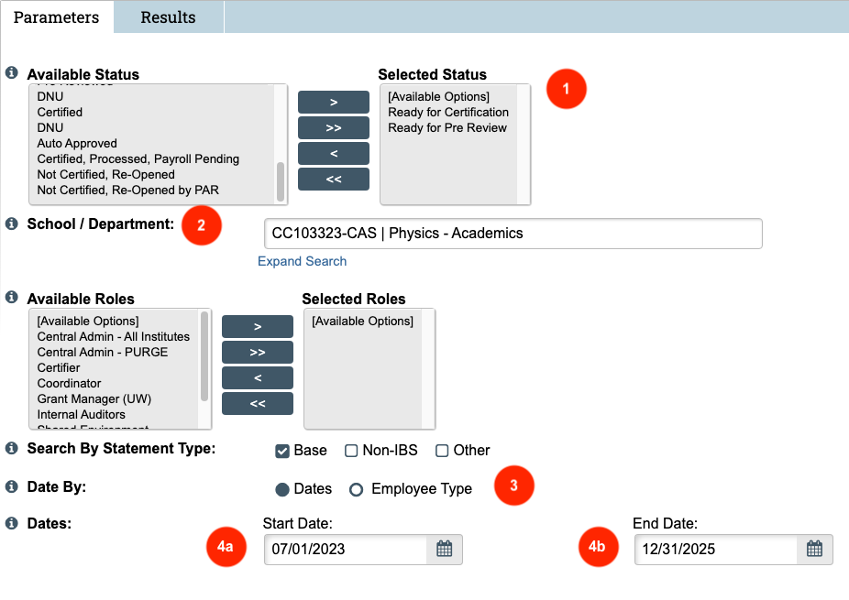

Addendum: ECC Statement Statuses
The following table provides a list of statement statuses and related definitions. A flow chart about the effort reporting process is available on the PAFC Effort Reporting webpage.

ECC Statement Status | Definition
Building | ECC is still generating the statement and loading payroll/effort data. The statement is not yet ready for Pre Review or Certification.
Auto Approved | ECC automatically closed the statement without certification because no sponsored activity requiring certification was identified.
No Certification Required | The statement contains no effort requiring certification, so PAFC has manually moved the statement to this status. No action is needed from the ECC Certifier or ECC Coordinator.
Ready for Pre Review | The Pre Review period has started, and the statement is ready for the ECC Coordinator to review.
Pre Reviewed | The ECC Coordinator completed the Pre Review process during the Pre Review period. Once the Certification period starts, the status will change to Ready for Certification. If the Certification period has already begun when the Pre Review process is completed, the statement remains in “Pre Reviewed” status for up to 24 hours after the completion of the Pre Review process before moving to “Ready for Certification”.
Ready for Certification | The ECC Coordinator has completed the Pre Review process, and the Certification period has started. The statement is now available for the ECC Certifier to review and certify.
Certified | The ECC Certifier has completed certification and attested that the salary/effort reasonably reflects work performed during the reporting period.
Certified, Payroll Pending | The statement was certified, but subsequent payroll changes materially impacted the certified effort amounts, necessitating a recertification. A Payroll Adjustment Reconciliation (PAR) Task will be available for a ECC Coordinator to process.
No Certification Required, Payroll Pending | Payroll data loaded to a statement that PAFC had marked “No Certification Required”. PAFC needs to review.
Not Certified, Re-Opened | A previously certified statement was re-opened because payroll changes, adjustments, or corrections affected the statement after certification. The prior certification is no longer valid until recertification occurs.
Not Certified, Re-Opened by PAR | The statement was re-opened specifically because of a Payroll Adjustment Reconciliation (PAR). The ECC Certifier must review and recertify the updated statement.

