PRE-REVIEW EFFORT AND PROJECT STATEMENTS JOB AID
Table of Contents
Purpose 1
Audience 1
Overview 1
Additional Resources 2
Effort Statement Pre-Review 2
Undo the Pre-Review 5
Project Statement Pre-Review 6
Undo the Pre-Review 8

Purpose
The purpose of this job aid to provide step-by-step instructions for the effort statement and project statement pre-review process.

Audience
This job aid is intended for Effort Coordinators. The ECC Effort Coordinator role is required for this process.

Overview
The main task for effort coordinators is to complete the pre-review process in the Employee Compensation Compliance system (ECC). The pre-review process begins after an effort or project statement period ends and before the statements are ready to be certified by the PI or faculty member. During this period, effort coordinators need to review their assigned statements and “Pre-Review” each statement if it is accurate.
All effort and project statements must be pre-reviewed before they are available to be certified by the certifier. The pre-review process enables any individual statement to be moved to the “Ready for Certification” status. This reduces the likelihood that statements will be certified before they reflect pending changes or adjustments, in turn reducing the cases of recertification. See the Effort Reporting Schedules for the expected start dates for pre-review periods.
This job aid references the “worklist” and the “assigned project statements” on the home page of ECC. For Project Statements specifically, these views are only available to “Primary” effort coordinators for a specific cost center. Those not designated as the Primary coordinators of departments (“Non-primary”) will have to navigate through the “Department Dashboard” section to see the project statements under their assigned departments (refer to “Department Dashboard Overview” user guide). All effort statements should appear on each coordinator’s home page in the “Assigned Effort Statements” section.

Additional Resources
For more information on primary and non-primary coordinators and how to optimize your department’s assignments, refer to the Managing ECC Coordinator Assignments & Authorizations job aid.

Effort Statement Pre-Review
- Go to ECC and select your institution (select UW unless you are affiliated with APL or Harborview Medical Center - aka “UWM” institution in ECC), then click “Continue”.
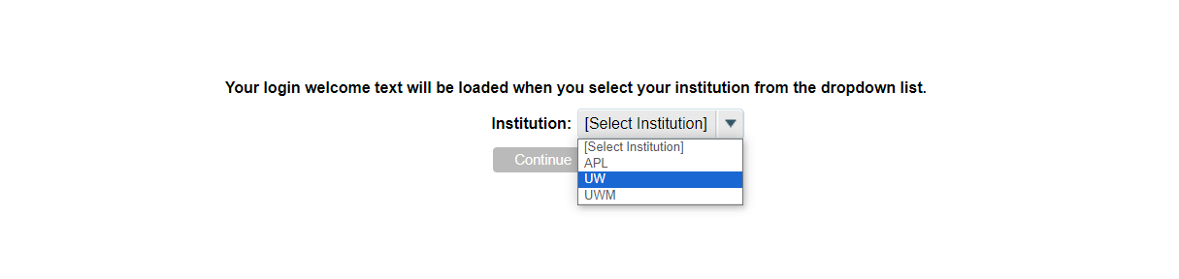

- On the “Home” page, select the “Assigned Effort Statements” subtab.
  - Here you will see your list of assigned certifiers that have a statement that is “Ready for Pre Review”.
  - In the “Statement Owner” column, select the name of a certifier whose statement you want to pre-review.
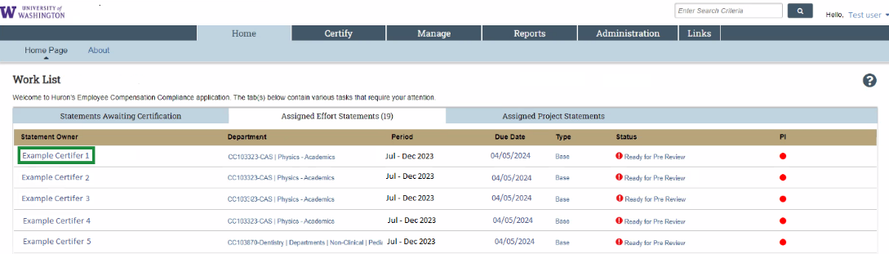
  - After clicking on a “Statement Owner” (or a “Status”), you will arrive at that worker’s statement.
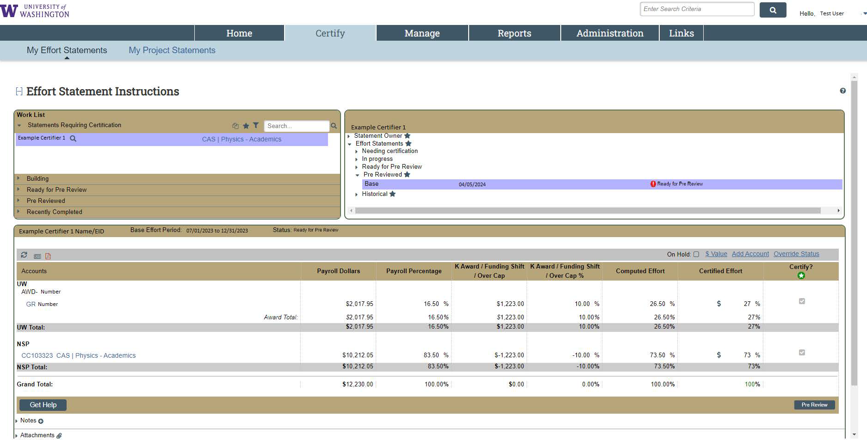
  - There is another method of getting to statements that will enable you to go through multiple statements more efficiently. Go to the “Certify” menu tab and select “My Effort Statements”.
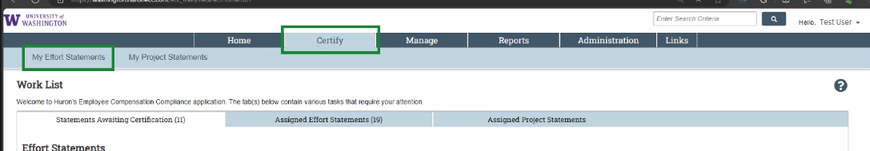
  - Now, you can toggle between different statements from the same screen. You will see this in your “Work List” (highlighted certifier represents which statement is currently being viewed).
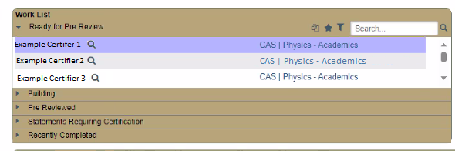
  - Compared to this from the first method of going to a single statement:
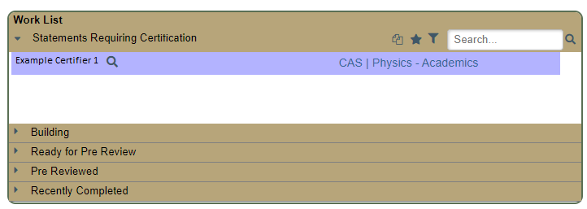
- Review the statement for an accurate reflection of the salary charges to each source during the period.
  - You can breakdown to period-by-period payroll and pay components by clicking the “$” icon in the “Certified Effort” column in each row:
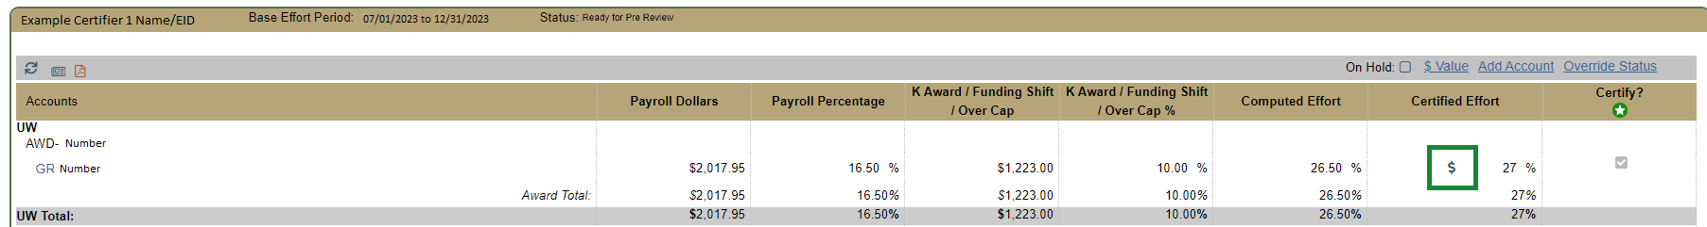
  - This opens a new browser window and shows the period detail:
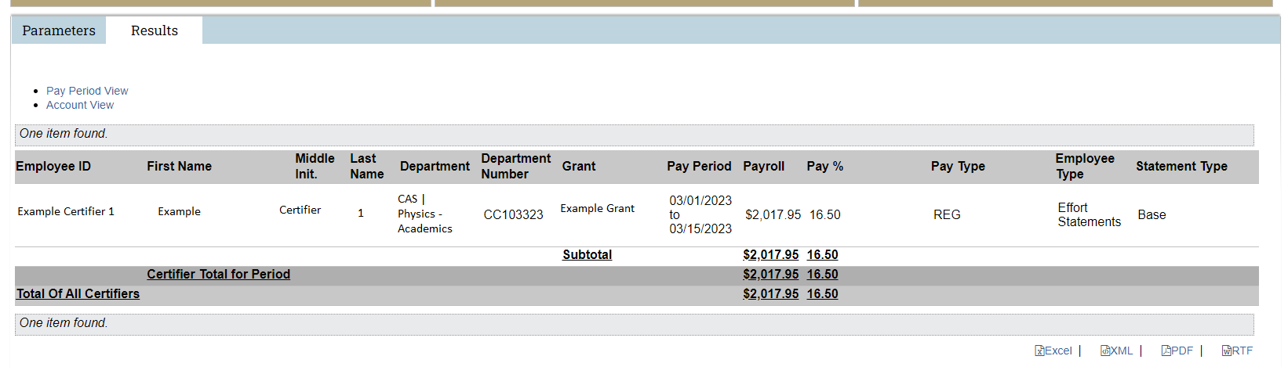
  - You can see this level of detail for each salary source in one report by clicking the newspaper icon in the top left of the statement and selecting “Payroll Report”.
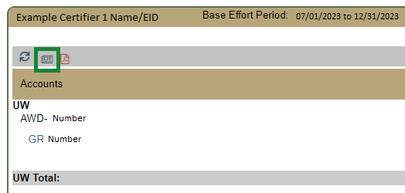
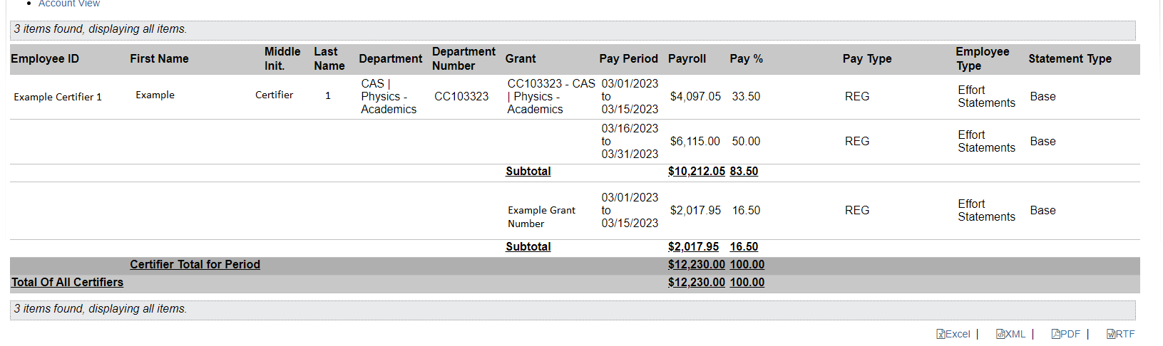
  - If changes need to be made to a statement, do not pre-review the statement. Instead, refer to Making Changes to a Statement to facilitate for next steps.
- If the report is accurate to your knowledge, click “Pre Review” located in the bottom right portion of the screen.
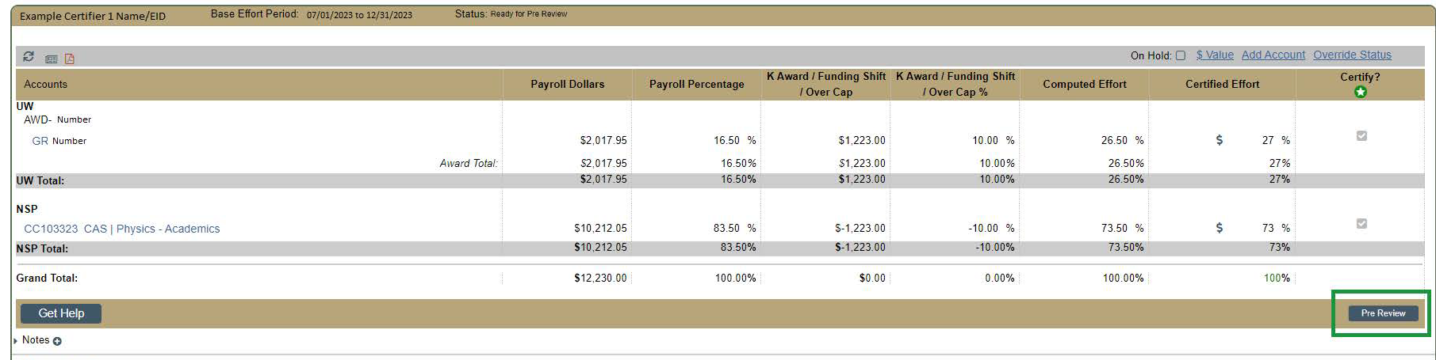
- The effort statement status will change from “Ready for Pre Review” to “Pre Reviewed”.
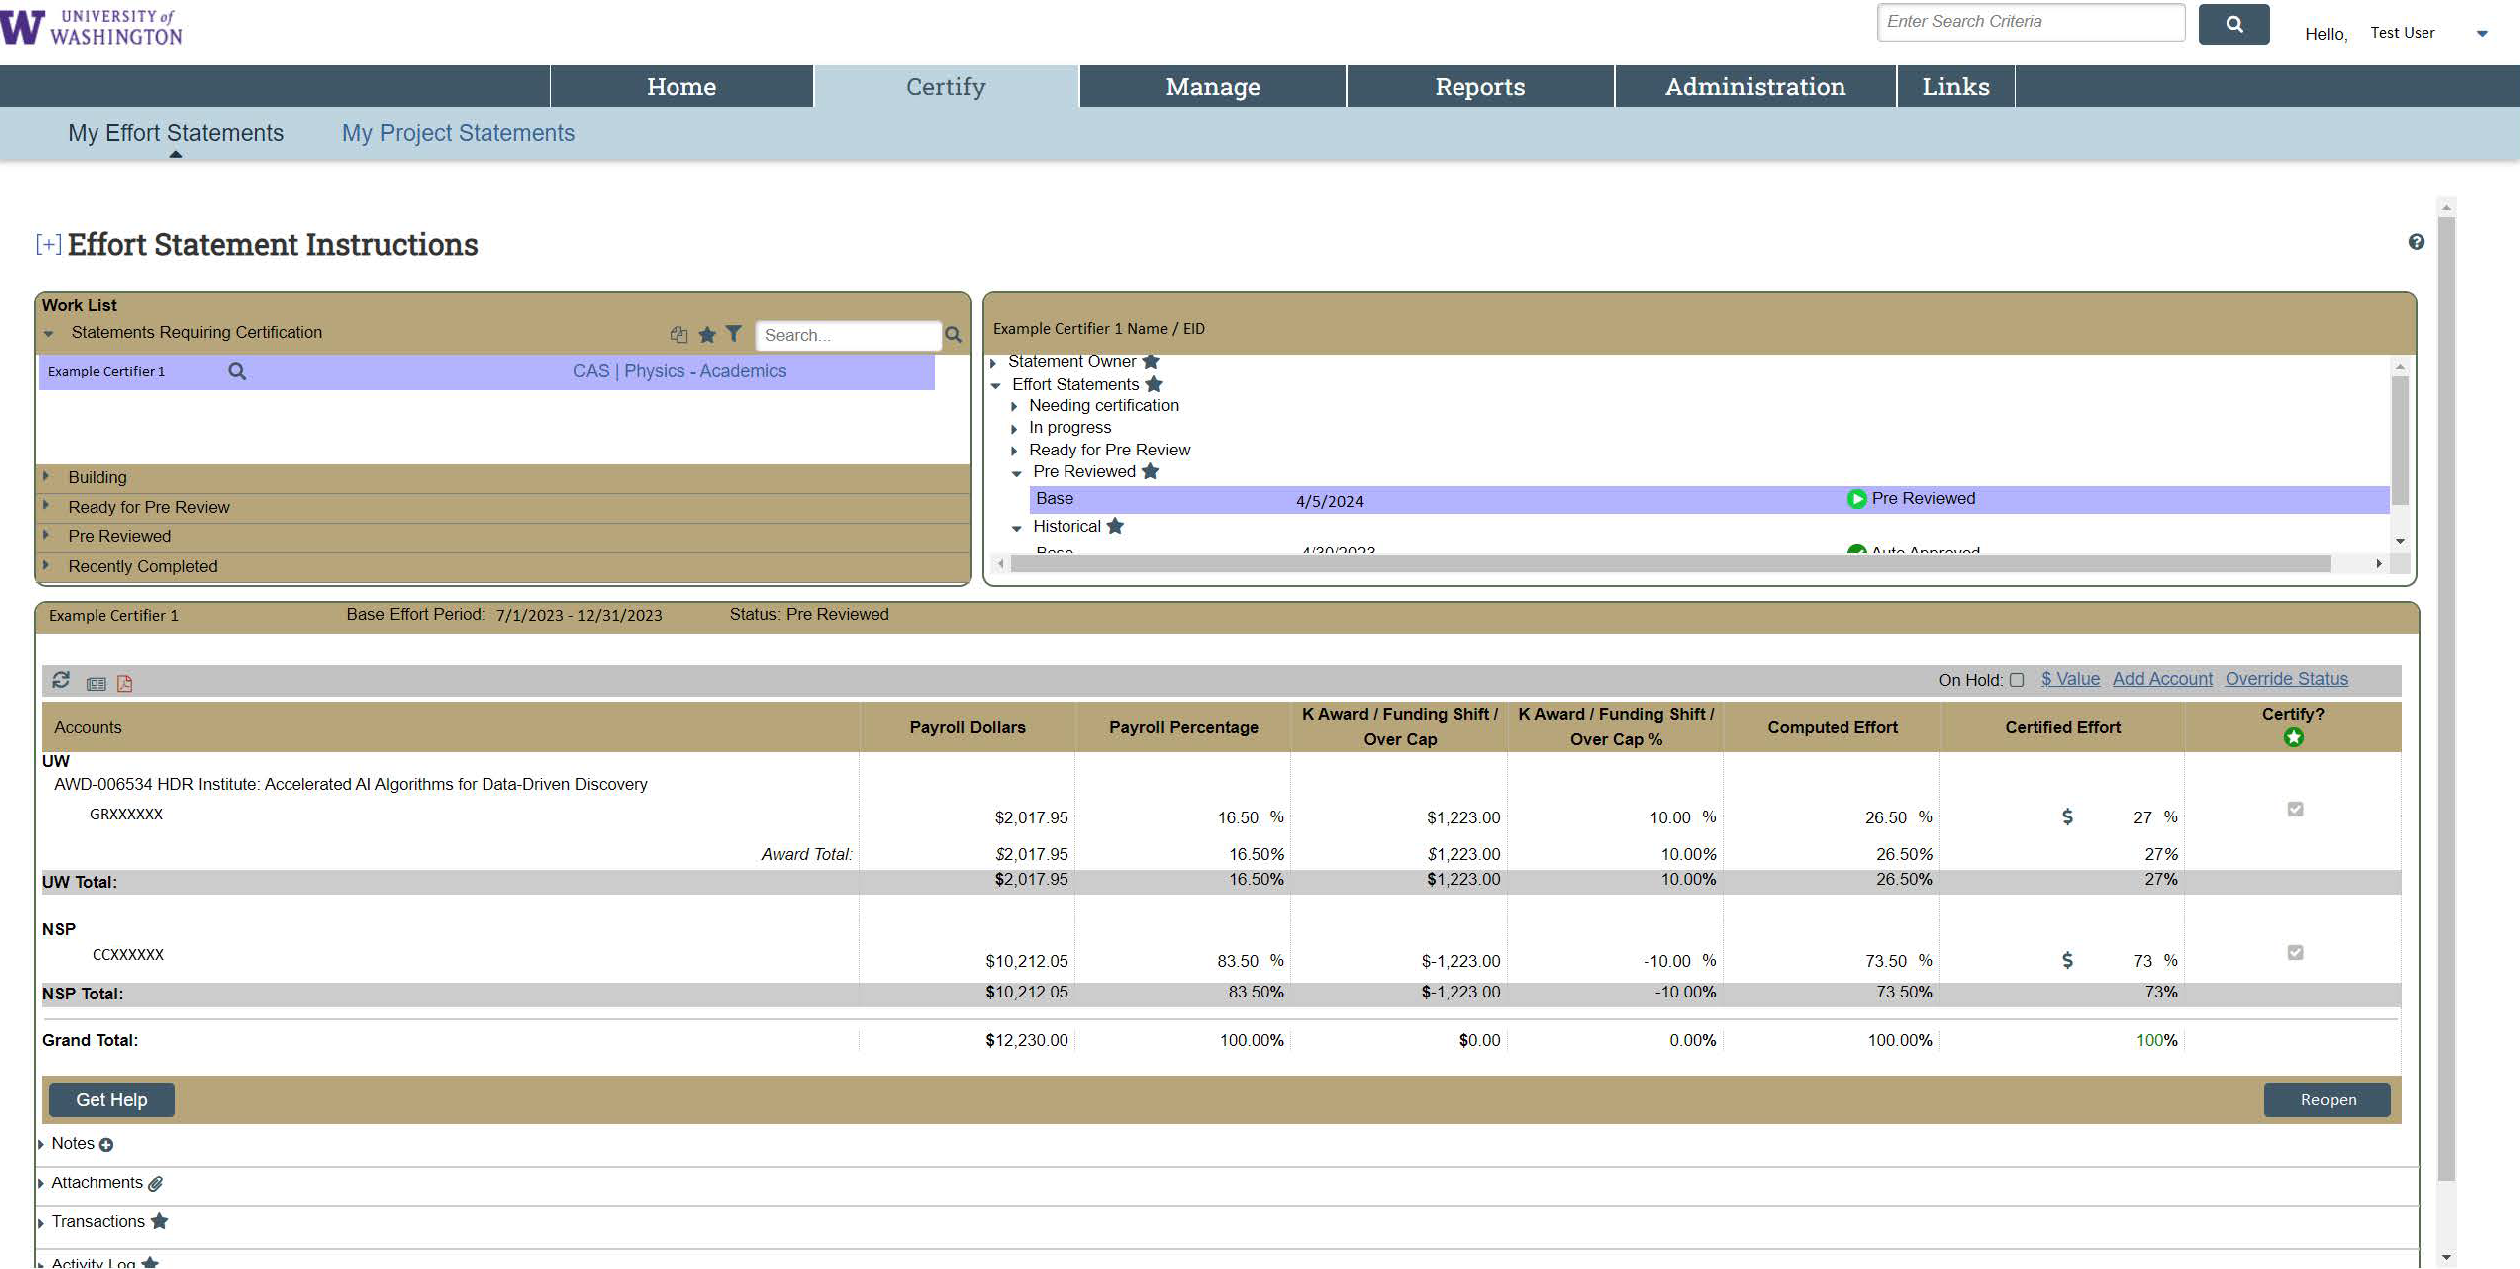

Undo the Pre-Review
If you want to “undo” your pre-review, click the “Reopen” button to return the statement to “Ready for Pre Review” status. This means that the statement will have to be pre-reviewed again. You may want to do this if you pre-reviewed a statement that has pending PAAs that have not been loaded into ECC yet.
The “Reopen” button is only available when the statement is in “Pre Reviewed” status. After the Certification period starts, the statement status changes to “Ready for Certification” (which is either the next time the clock hits 11:45am if the certification period had begun, or per the Effort Reporting Schedules if before the certification start date). At this point, the “Reopen” button will not appear.
Contact Post-Award Fiscal Compliance at effortreporting@uw.edu if you need to move a statement back to “Ready for Pre Review” status after it has already changed to “Ready for Certification”.

Project Statement Pre-Review
Note: Each grant has its own project statement that requires individual pre-review if there was staff payroll charged to it during the period.
- Go to ECC and select your institution (select UW unless you are affiliated with APL or Harborview Medical Center - aka “UWM” institution in ECC), then click “Continue”.
- On the “Home” page, select the “Assigned Project Statements” subtab.
  - Here you will see your list of assigned PIs that have statement(s) that are “Ready for Pre Review”.
  - Select the PI’s name or one of the links in the “Status” column to access a project statement.
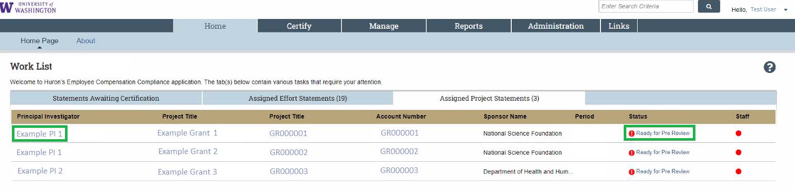
  - There is another method of getting to statements that will enable you to go through project statements for multiple PIs more efficiently. Go to the “Certify” menu tab and select “My Project Statements” (this is only functional for primary coordinators). This will populate the upper left “Work list” box with all your assigned PIs, rather than just one that you select from the home page view.
- Review each statement to ensure it is an accurate reflection of the salary charges to each grant for the period.
  - You can breakdown to period-by-period payroll and pay components for each worker by clicking the “$” icon in the “Reports” column in each row:
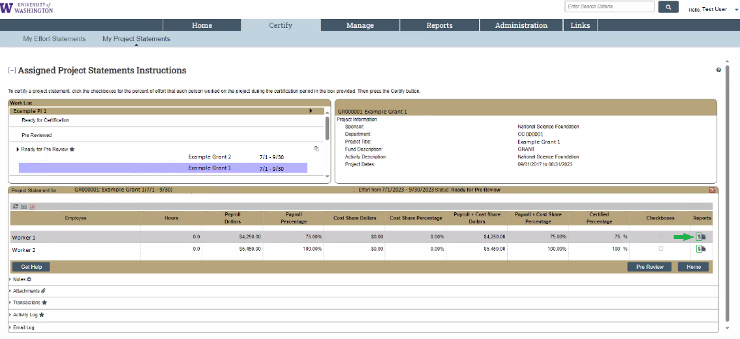
  - This opens a new browser window and shows the period detail:
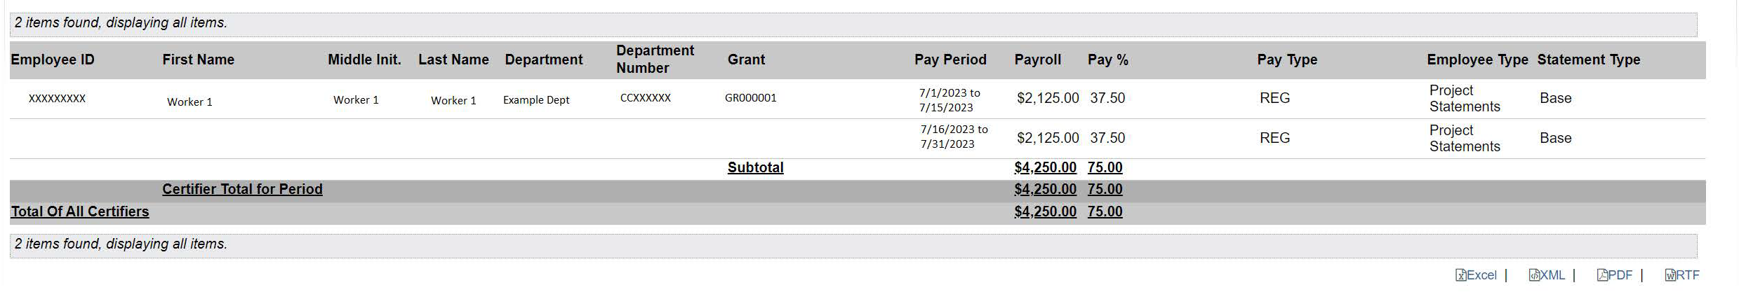
  - The icon that looks like a piece of paper with a folded corner runs a report to show all the payroll for that specific worker to all the sources they had salary charged to during the period.
  - If changes need to be made to a project statement, PAAs must be completed in Workday (UW Connect Resources on PAAs). PAA lines posted in Workday will be loaded into ECC the following week on Monday evening (Tuesday evening for UWM (Harborview), and Wednesday evening for APL).
- If a project report is accurate to your knowledge, click on the “Pre-review” button located in the bottom right portion of the screen.
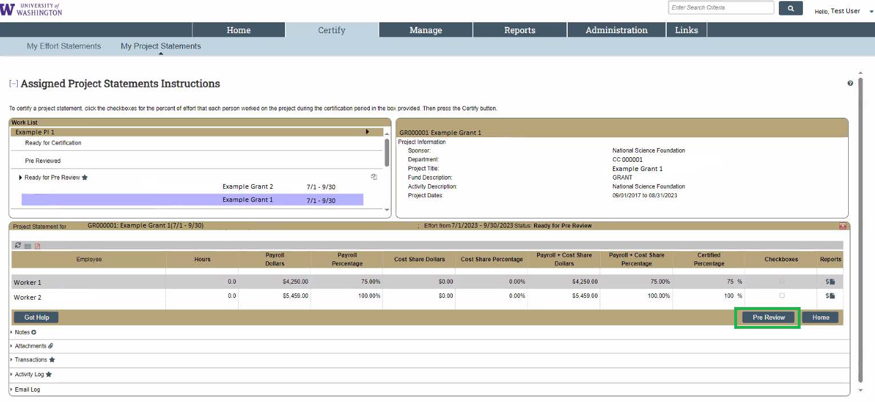
- The screen may change to the next Project statement that needs to be pre-reviewed for a given PI, but the Project statement for the first grant should now be marked as “pre-reviewed”. This can be checked in the “Pre Review” section in the upper left “Work list” to navigate back to the previous statement if your screen changed.

Undo the Pre-Review
If you want to “undo” your pre-review, click the “Reopen” button to return the statement to “Ready for Pre Review” status. This means that the statement will have to be pre-reviewed again. You may want to do this if you pre-reviewed a statement that has pending PAAs that have not been loaded into ECC yet.
The “Reopen” button is only available when the statement is in “Pre Reviewed” status. After the Certification period starts, the statement status changes to “Ready for Certification” (which is either the next time the clock hits 11:45am if the certification period had begun or per the Effort Reporting Schedules if before the certification start date). At this point, the “Reopen” button will not appear.
Contact Post-Award Fiscal Compliance at effortreporting@uw.edu if you need to move a statement back to “Ready for Pre Review” status after it has already changed to “Ready for Certification”.

