Complete a Shift in Effort JOB AID
Table of Contents
Purpose 1
Audience 1
Overview 1
When to Complete a Shift 1
When Not to Complete a Shift 2
Complete a Shift in Effort 2
View or Edit a Shift in Effort 8
Delete a Shift in Effort 10

Purpose
The purpose of this job aid is to provide step-by-step instructions to document a shift in effort in the Employee Compensation Compliance system (ECC).

Audience
This job aid is intended for Effort Coordinators. The ECC Coordinator role is required for this process.

Overview
Effort Shift or Shift in Funding Source (“shift”) is a process to represent effort on a grant that is not charged to or paid by the grant. These shifts are not true transactions and are not traced back to Workday. They are only for documenting a higher total effort level on a sponsored program award than was directly charged.

When to Complete a Shift
- Completing a shift may be required when a faculty member’s Institutional Base Salary (IBS) is over the Salary Over the Cap (SoC) threshold, and they have a clinical practice plan salary component (UWP or CUMG). In this situation, a shift would be required if the necessary SoC amount is not achieved with a PAA in Workday.
- To bring total effort on a K Award up to 75%
- When the faculty contributes voluntary uncommitted cost share to a grant. Voluntary uncommitted cost share is volunteered in a proposal submission and occurs when the faculty has elected to dedicate a certain amount of effort to a grant, but to not actually have the commensurate salary of that effort level, charged to the grant.

When Not to Complete a Shift
Shifts are not required for documenting Salary Over the Cap (SoC) in standard circumstances. Under normal circumstances, Workday’s automatic SoC calculation will apply the “Salary Over the Cap Type” and “Salary over the Cap Basis” worktags to the grant, which allows those pay results to be automatically captured in the “K Award/Funding Shift/Over Cap” column of ECC.

Complete a Shift in Effort
To complete a shift in effort, follow these steps:

- Log into ECC and click on the “Assigned Effort Statement” tab in the “Work List” section of the home page.

- Click on the name the faculty member you need to complete the shift for or the statement status on the “Assigned Eﬀort Statement” tab of the home page. You can also search by the faculty member’s last name or Employee Identification Number (EID) in the main search bar of the application at the top right of the screen.

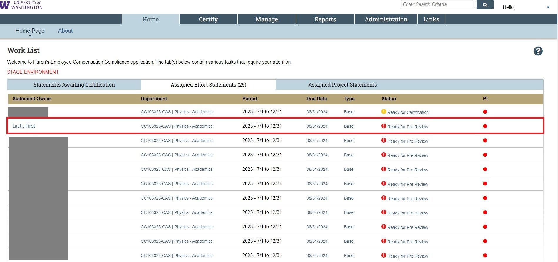

- Determine the grant(s) that need more eﬀort shifted to them and by how much (dollars or percent). The eventual shift will be attributed to the “K Award/Funding Shift/Over Cap” column and contribute to the “Computed Eﬀort” and “Certiﬁed Eﬀort” totals for each row.

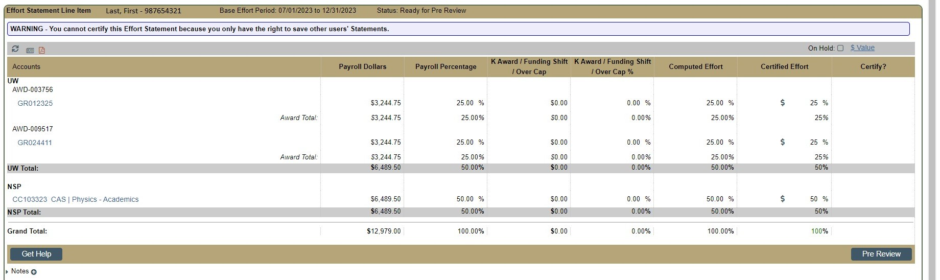

- Keep the statement page open. On another browser tab, open the form to complete the effort shift by clicking on the “Manage” tab then on “Add Cost Sharing” (you may have to expand the subtab menu by clicking the three dots icon - ).

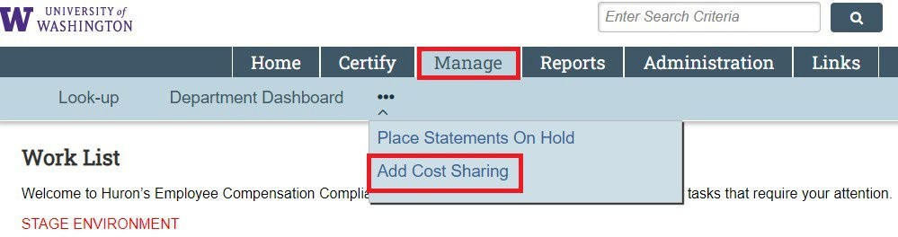

- Enter the last name *space* ﬁrst name (or EID) in the “Employee” ﬁeld and select the faculty from the dropdown list that appears.

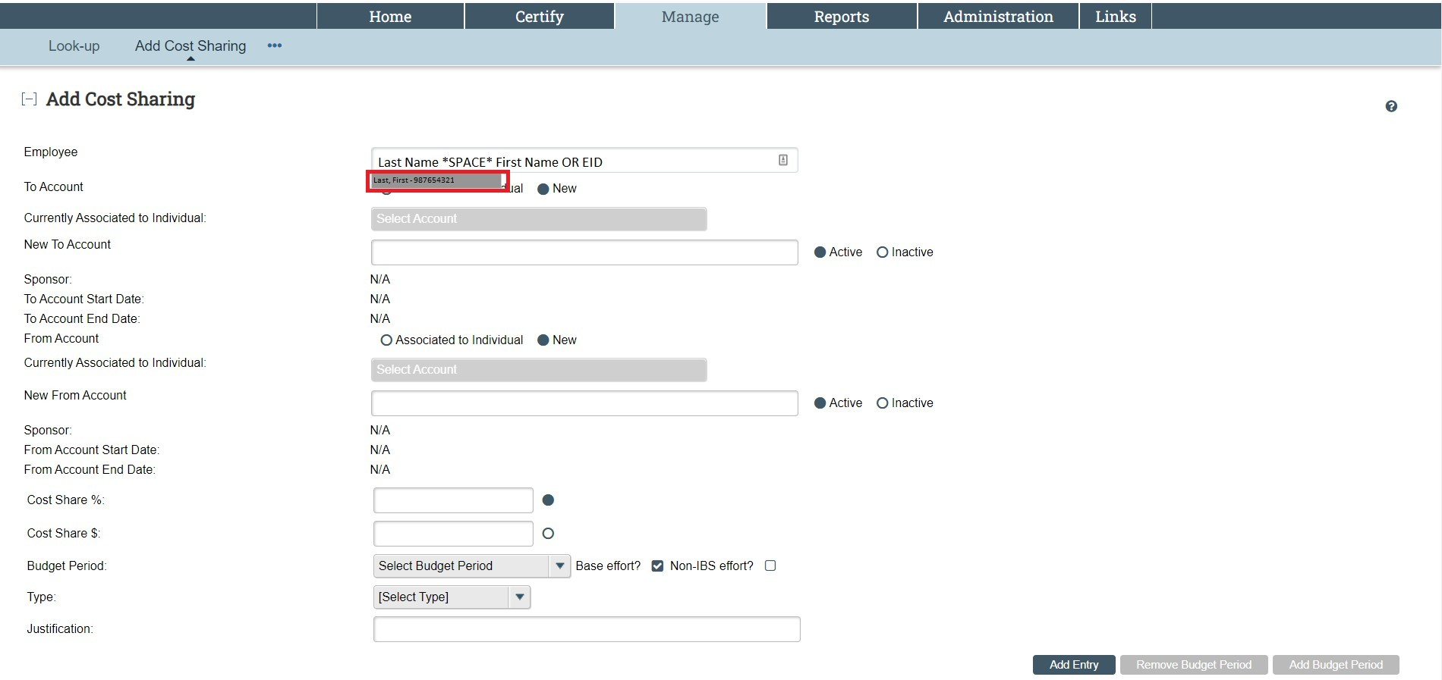

- If shifting to a worktag that the faculty member has already had payroll charged to (most common), click the radio button to the left of “Associated to Individual,” then select the desired worktag from the dropdown menu. Only select an individual grant worktag; do not select an award number even if one appears.

- If the shift in effort is going to a worktag that the faculty member has never had payroll charged to in any period, use the “New” radio button, then type in the grant worktag into the “New To Account” ﬁeld.

  - If the grant’s end date is in the past, you must select the “Inactive” radio button to the right of this ﬁeld. Once a grant worktag’s award period ends, the status changes from “Active” to “Inactive”.

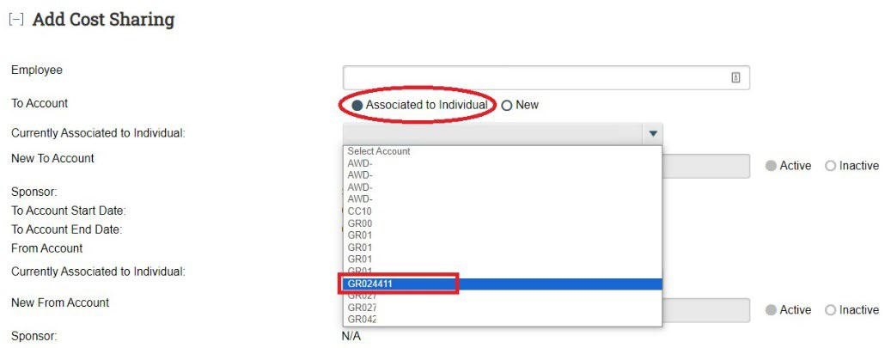

- For the “From Account” you must use the “Associated to Individual” radio button. Click on a non-sponsored source from the dropdown list (the “From Account” cannot be a grant in nearly every situation).

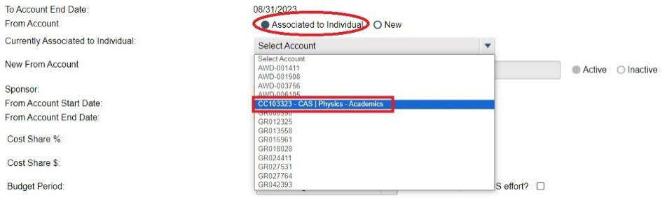

- Enter an amount to shift based on percent effort or dollars. To activate each entry field, select the associated radio button (circled in red).

For percent-based:
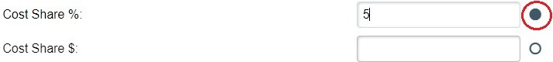

For dollar-based:
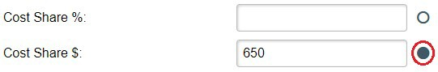

- Select the period you are shifting for from the “Budget Period” drop-down menu. Do not adjust “Base Effort?” and “Non-IBS effort?” checkboxes.

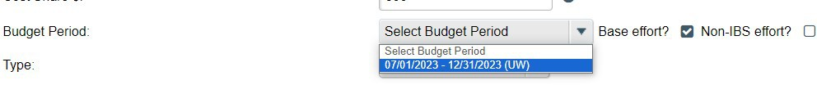

- Select the type of shift from the “Type” dropdown menu. A justification of the shift is not required. Notes may be made on the statement itself after you complete the shift to explain any specific circumstances.

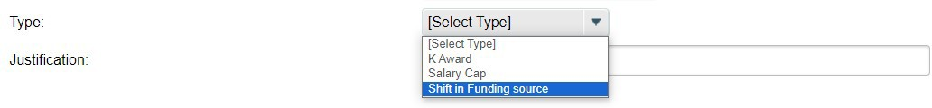

- Click “Add Entry.”
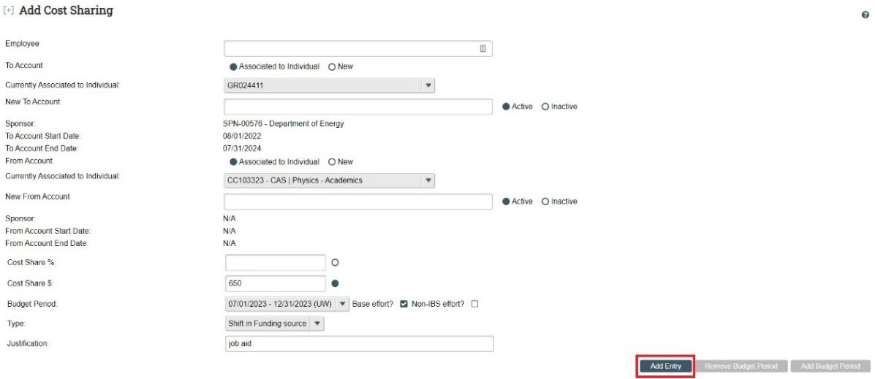

- Review the information that appears on the following summary screen. If you need to make a change, click “Revise Entry” to adjust the entry or “Cancel” to abandon the process. Otherwise, click “Add Entry” to finalize the process.

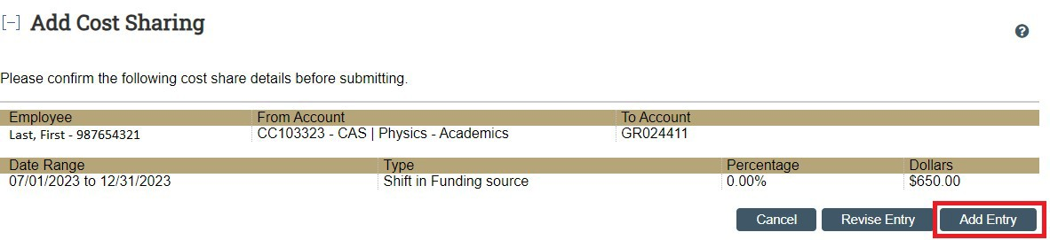

- After clicking “Add Entry,” a message at the top of the screen in green text appears to let you know that the process is complete.

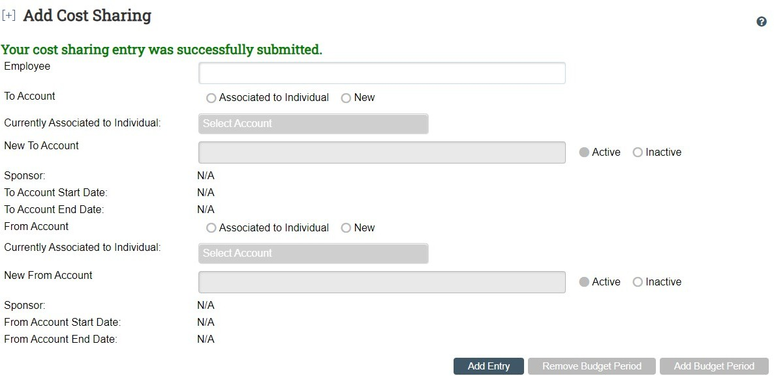

- Return to the browser tab you had the faculty member’s effort statement open in and refresh the page. You should see the amount you shifted appear in the “K award/Funding shift/Over Cap” columns, and the total effort fields updated to include the shifted amount.

Before Shift
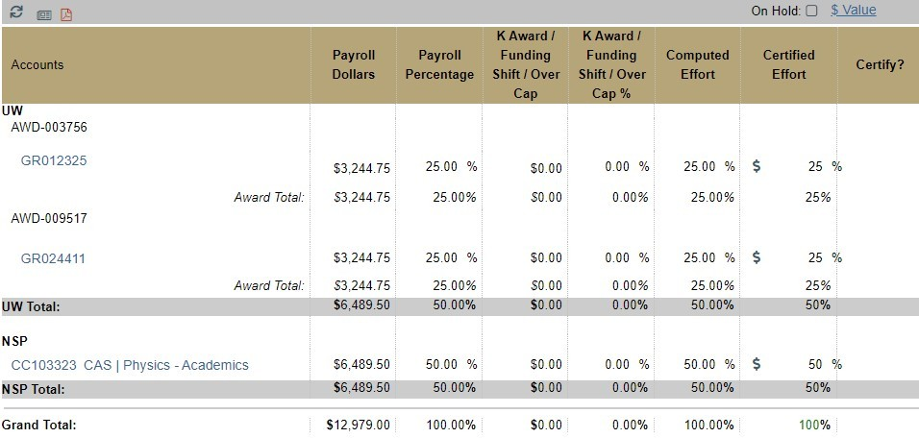

After Shift
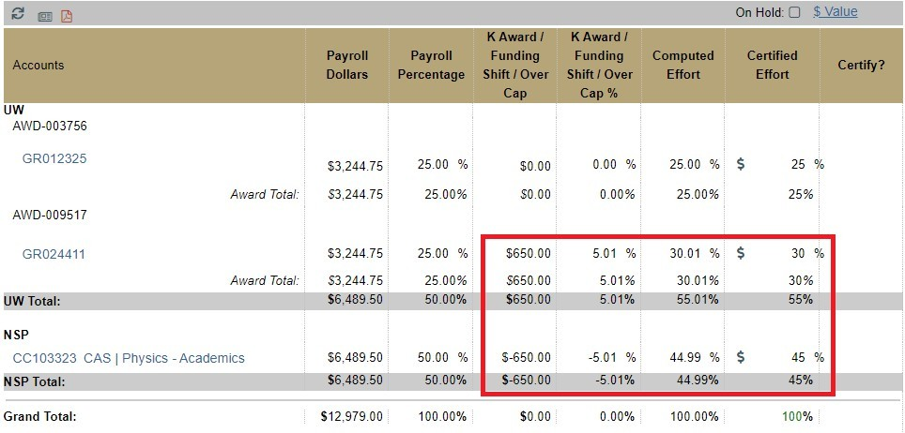

- Check the “Certified Effort” column to make sure it has been updated. If the amount in the “Certified Effort” column does not match the “Computed Effort” column, click the “Statement Reset” icon to allow the fields to recalculate ().

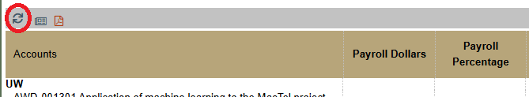

You may need to refresh the browser window to update the statement.

View or Edit a Shift in Effort
To view or edit a previously completed shift in effort, follow these steps:

- Log into ECC and click on the “Assigned Effort Statement” tab in the “Work List” section of the home page.

- Click on the name the faculty member you need to complete the shift for or the statement status on the “Assigned Eﬀort Statement” tab of the home page. You can also search by the faculty member’s last name or Employee Identification Number (EID) in the main search bar of the application at the top right of the screen.

- Click on the newspaper icon in the top left corner of the statement and click “Cost Share Report.”

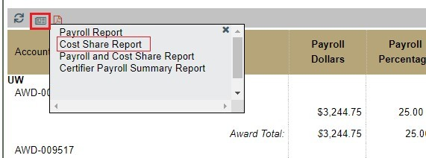

- There may be pre-existing values in the “K Award / Funding Shift / Over Cap” column because of SoC so scroll to the top of the “Cost Share Report” results and adjust the parameters to limit the results just to your completed shifts in effort.

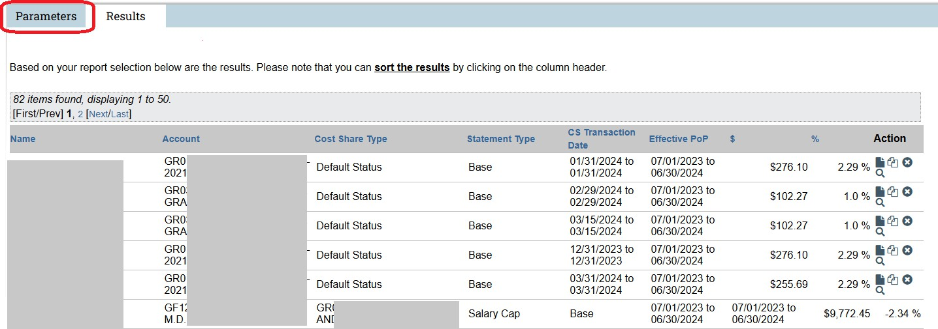

- In the “Cost Share Type” field, select “Type” in the drop-down menu you chose in the shift(s) you want to edit/copy/view.

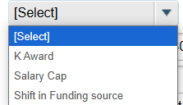

- Select the period that you are adjusting shifts for in the “Period” drop-down menu.

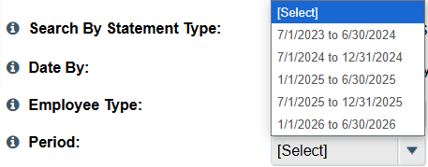

- Since the “Employee” field is auto filled when accessing the report from an effort statement, these are the only fields required. Click “Run Report.”

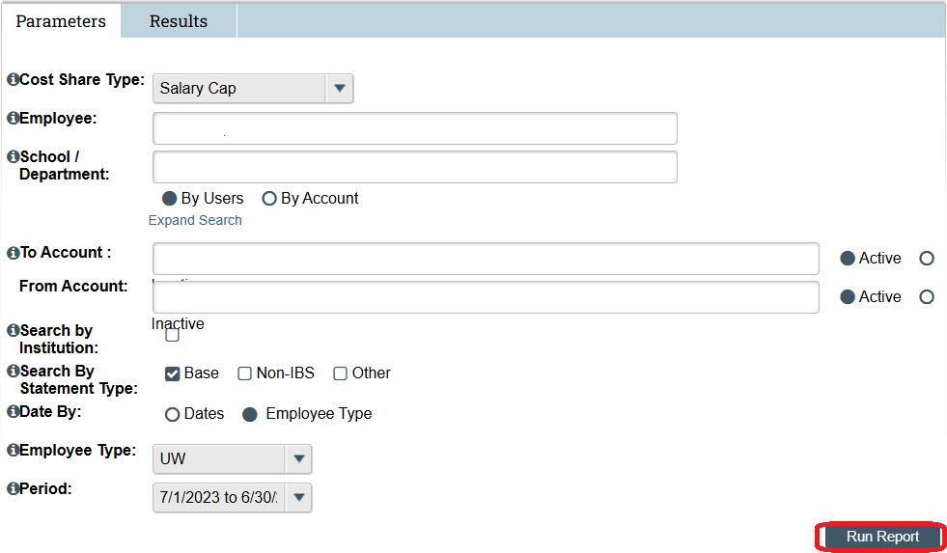

- To edit the shift entry, go to the “Action” column and click on the “Edit” icon () to re-open the shift form and adjust.

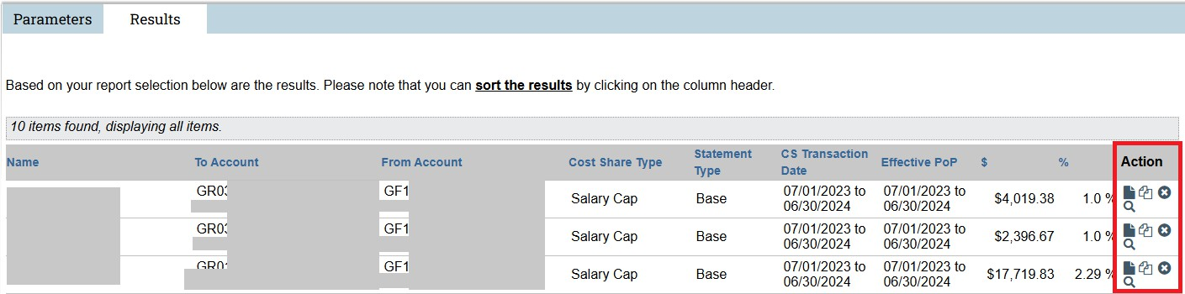

- Go to Step 5 of Complete a Shift in Effort for the next steps.

Delete a Shift in Effort
The ECC Coordinator role cannot delete a shift in effort from ECC. If you need to delete a shift, please contact the PAFC Effort Reporting team at effortreporting@uw.edu. Provide the faculty member’s full name, EID, and the grant(s) that need shifts removed. PAFC will delete the entry in ECC and notify you once it has been completed.

