Manage ECC Certifier and Grant Manager Assignments Job Aid
Table of Contents
Purpose 1
Audience 1
Manage PI/Certifier Assignments 1
Assign a “Grant Manager Override” to an Individual Grant Worktag 4

Purpose
The purpose of this job aid is to provide step-by-step instructions to manage Certifier and Grant Manager assignments in the Employee Compensation Compliance system (ECC).

Audience
This job aid is intended for Effort Coordinators. The ECC Effort Coordinator role is required for this process.

Manage PI/Certifier Assignments

Note: By default, the Primary Coordinator for a given cost center is assigned to all the PIs in that cost center. This lets them see those PIs’ project statements on their home page when they are "Ready for Pre Review". Coordinators not assigned as the Primary will not see the project statements on their home page, unless they are given a “Grant Manager” assignment with certain PIs in ECC (this section shows how to add these assignments).

- Log into ECC and click on “Department Dashboard” in the “Manage” tab.

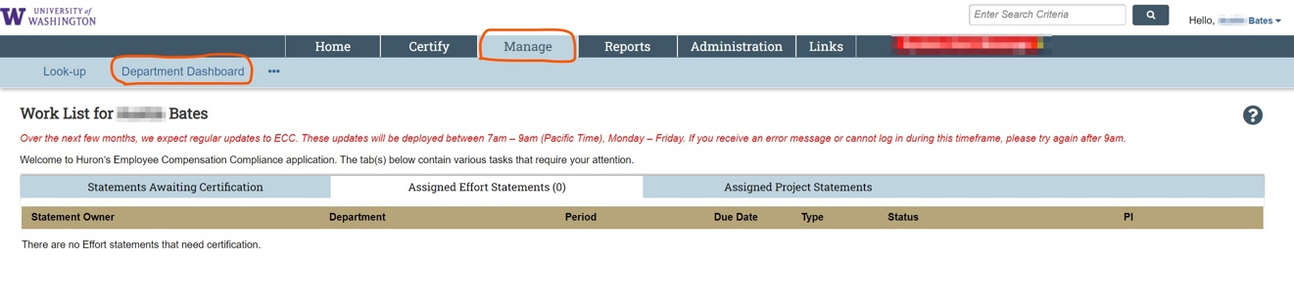

- Enter the cost center where you want to manage coordinators from the drop-down menu and click the “Choose” button.



- Select the “Department Information” section of the page.

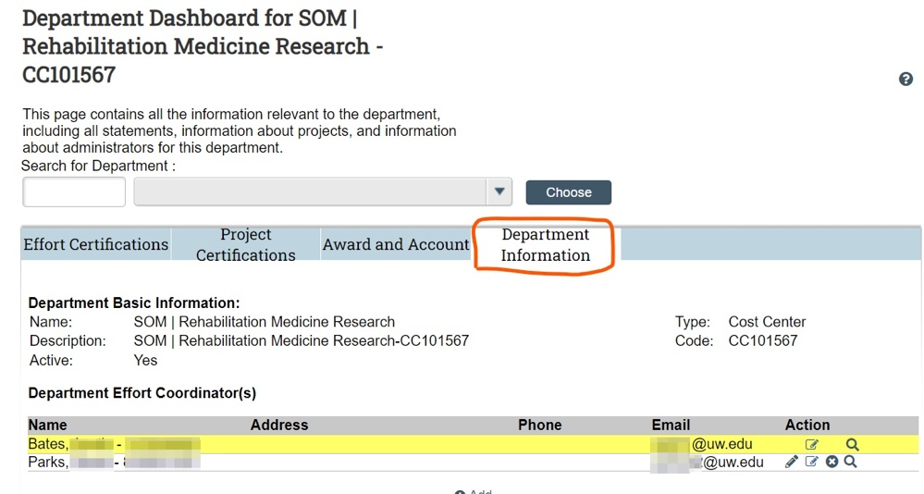

- Click the notepad with a pencil ( ) icon on the Coordinator’s row to manage their list of PIs they are assigned. Note: You can also do this for yourself.

- Select a PI from the left box list (“Unassigned PI/Certifier List”) and click the single arrow (pointed right >) to move them to the “Assigned PI/Certifier List” box to the right.

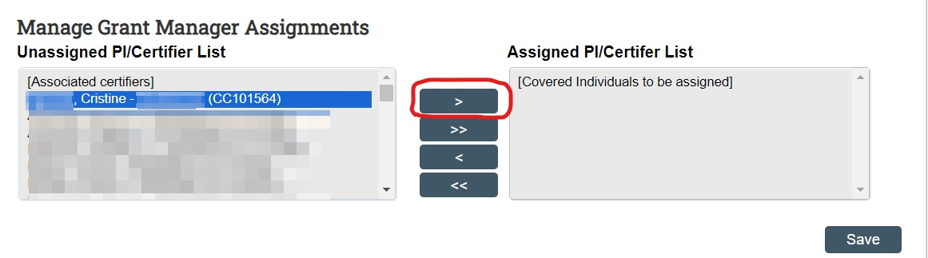

- Move as many PIs as necessary to the “Assigned” section, then click “Save.”

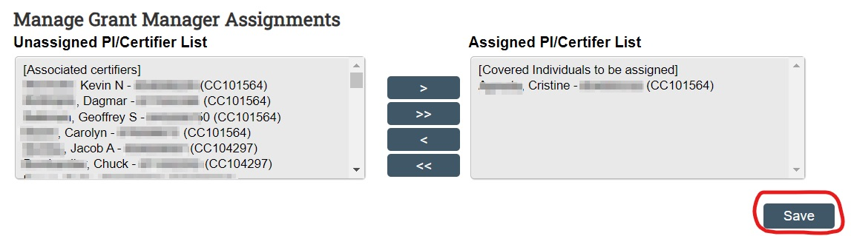

This will make the selected Coordinator, the ECC “Grant Manager” for all the selected PIs’ projects in ECC. This assignment will override the Primary Coordinator assignment of the cost center for these PIs. This means the Coordinator given these assignments will now get automated system emails about statements being “Ready for Pre Review” and will see their assigned PI(s) statements on their home page.

The PI/Certifier assignments span across cost centers, so if a particular PI has projects under multiple different departments, where the coordinator for those accounts should be different,
use the “Grant Manager Override” functionality instead of the PI assignments (see next section of this job aid) to assign coordinators to specific grant worktags.

Assign a “Grant Manager Override” to an Individual Grant Worktag

Note: The individual must be associated to the cost center as a Coordinator on the “Department Information” tab. Instructions on adding a Coordinator are available on Add a New Coordinator to a Cost Center.

- Navigate to the “Manage” menu tab > “Department Dashboard” section.

- Select whichever cost center you want to manage coordinators for from the drop-down menu and click the “Choose” button.

- Select the “Project Certifications” section.

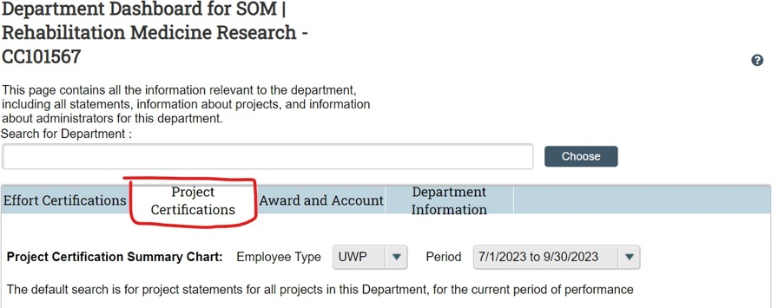

- Click the plus icon on the same row of the grant you want to assign a “Grant Manager Override” to.

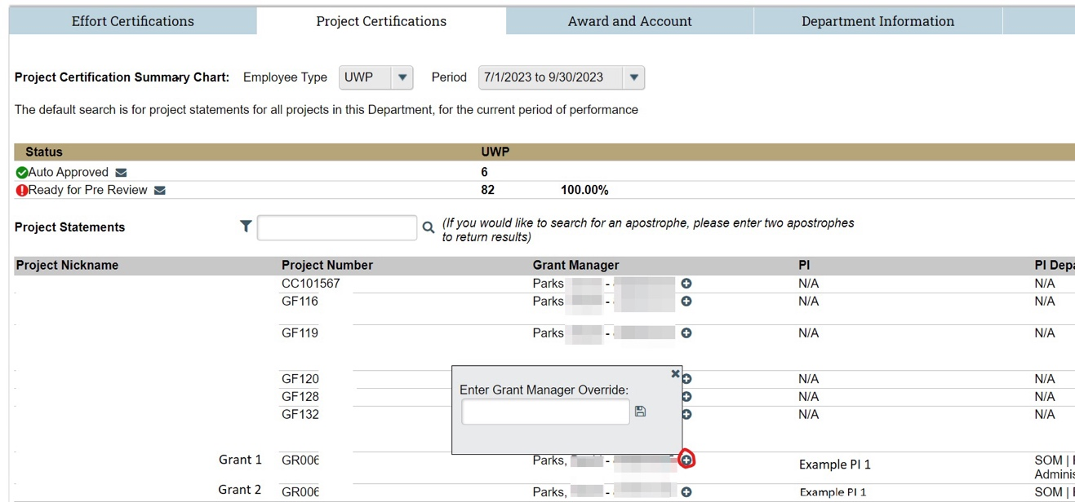

- Enter the person’s name you want to add as the override, last name *space* first name, or EID, and select them from the results that appear below the search bar.

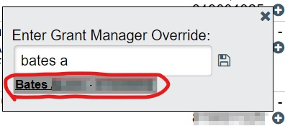

- Then click the “Save” icon.

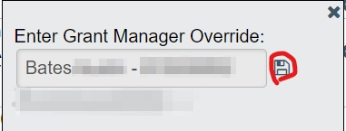

The Grant Manager Override is complete, and the new individual is added. The new Grant Manager will see the project statements for this grant on their home page and will receive an email notification when a project statement is ready for pre review.

- To remove the override, click the red minus symbol (-).



