Add a Proxy in ECC job aid
Table of Contents
Purpose 1
Audience 1
Overview 1
Add a Proxy 1

Purpose
The purpose of this job aid is to provide step-by-step instructions to add a proxy in the Employee Compensation Compliance system (ECC).

Audience
This job aid is intended for Effort Coordinators. The ECC Effort Coordinator role is required for this process.

Overview
When a faculty member is unable to certify their own eﬀort statement (e.g., terminated, on extended leave) necessitate a proxy assignment in ECC, so the statement can be certiﬁed on their behalf. A person with suitable knowledge of the work performed over the course of the period can be added as the proxy in these situations (e.g. Dean/Director/Chair/Division Head).

This process should not be used as substitute for the faculty certifying themselves if they are available.

Add a Proxy

- Use the main search bar of the application and enter the last name *space* ﬁrst name, or Employee Identification Number (EID of the faculty member who is unable to certify. This will take you to their current effort statement.

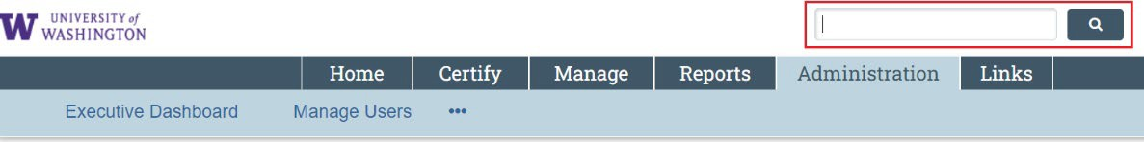

- Click the magnifying glass icon next to the faculty’s name in the “Work List” section of the statement page.

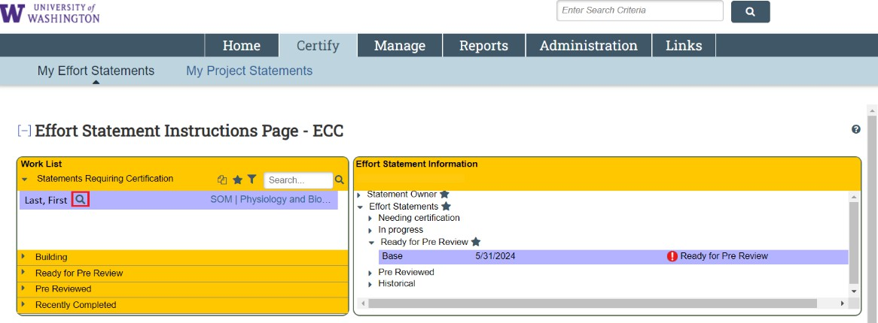

- Click on the “Assignments” subtab.

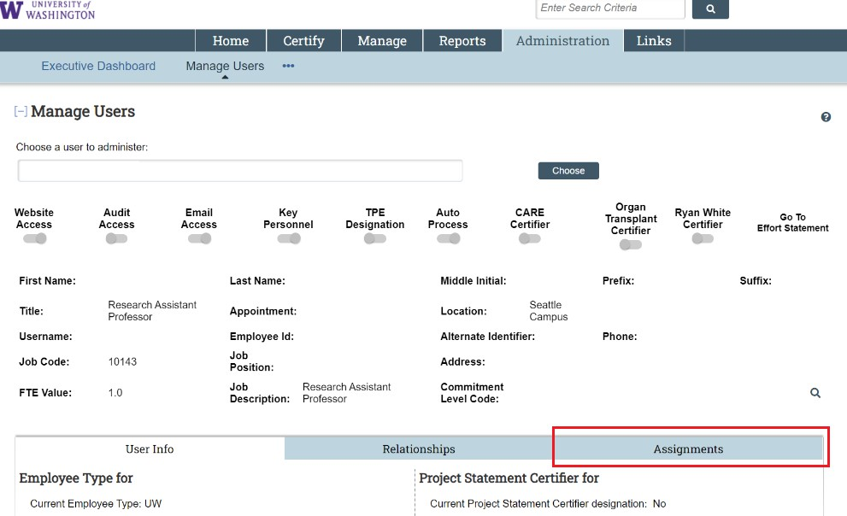

- Scroll down to the section of the page titled “Proxy for faculty’s name – EID”

- In the “Proxy” search bar, enter the last name *space* ﬁrst name or Employee Identification Number (EID) of the person you are adding as a proxy, and select them from the drop-down menu.

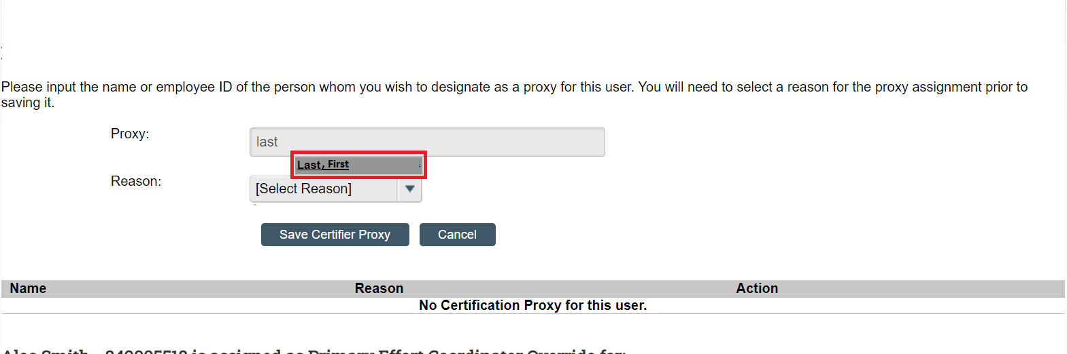

- Select a reason from the “Reason” drop-down menu, then click the “Save Certiﬁer Proxy” button.

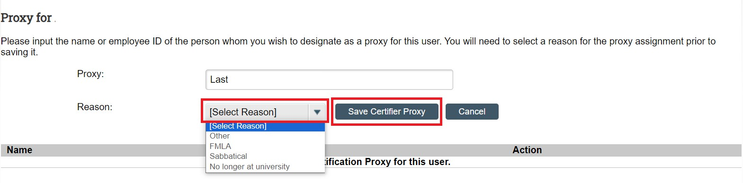

The individual that is added as a proxy must also have the Certiﬁer role in ECC before being able to complete the certiﬁcation. Contact the PAFC Effort Reporting team at effortreporting@uw.edu to add this role. Provide the full name and EID of the faculty member who cannot certify and the full name and EID of the individual who will be the proxy. PAFC will update ECC and notify you once it has been completed.

