Assign a Designee to a Project Statement Job Aid
Table of Contents
Purpose 1
Audience 1
Overview 1
Adding a Designee – Search Bar Method 1
Adding a Designee – Department Dashboard Method 3

Purpose
The purpose of this job aid to provide step-by-step instructions to add a designee to a project statement in the Employee Compensation Compliance system (ECC).

Audience
This job aid is intended for Effort Coordinators. The ECC Effort Coordinator role is required for this process.

Overview
Circumstances where a PI is unable to certify a project statement (for a reason such as terminated, extended leave, etc.) necessitate a designee assignment in ECC, so statements can be certified on their behalf. A person with suitable knowledge of the work performed over the course of the period can be added as the designee in these situations. This can be a department Dean/Director/Chair/Division Head.

If there is a new PI for a grant, and they should be the one certifying the project statements, this process can be used to allow them to certify temporarily. Long term, Workday should be updated to reflect the new PI, after which ECC’s data will get updated too, and future project statements for that grant worktag will be associated with the new PI (contact GCA to request the PI to be updated). The existing designee assignment should be removed after the new PI is reflected as the PI in ECC.

Designees must be added to project statements on an individual basis. Meaning, if the PI who is unable to certify has multiple statements for a period, the following process will have to be done for each one of those statements.

Adding a Designee – Search Bar Method

- Use the main search bar of ECC, and type in the GR number of the statement you want to add a designee to.

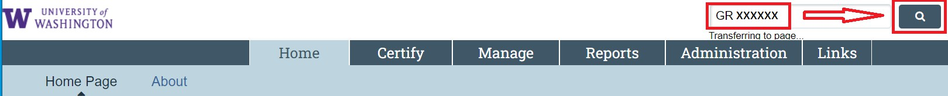

- From the “Account Summary” page that opens, select the “Manage Account Designee” subtab.

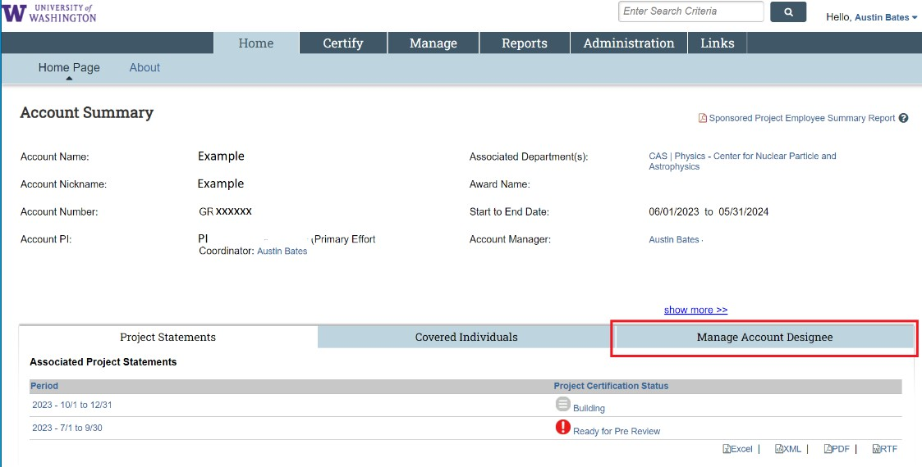

- Type the name of the person you are adding as the designee's last name *space* first name (or EID) and select them from the dropdown menu.

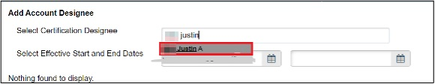

- Enter effective start and end dates.
- Important: the start date of the designee must be within the period of the earliest report the designee is certifying for. For example, if the designee is certifying a report for 7/1/2024 - 9/30/2024, the effective start date must be within 7/1/2024 – 9/30/2024 for the designee to be able to certify.

- Ensure the end date you enter is far enough in the future for the designee to log in and certify the report. Then click “Add Designee.”
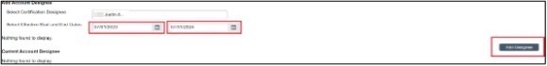

- After this, the designee is added. If you need to delete or adjust the designee assignment, use the icons in the “Action” or “Delete Designee” columns.

The individual that is added as a designee will also need the “Certifier” role in ECC to complete the certification of the project statement(s). Contact the PAFC Effort Reporting team at effortreporting@uw.edu to add this role. Provide the full name and EID of the faculty member who cannot certify and individual who will be the designee. PAFC will update ECC and notify you once it is finished.

Adding a Designee – Department Dashboard Method

- Navigate to the “Manage” menu tab, then select “Department Dashboard.”

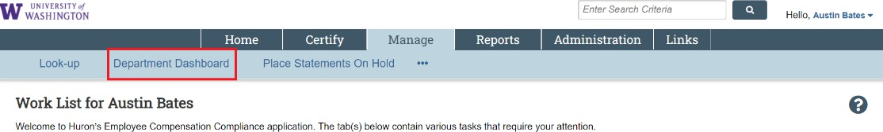

- Select the cost center that has the project statement(s) that you want to add a designee for from the dropdown list.

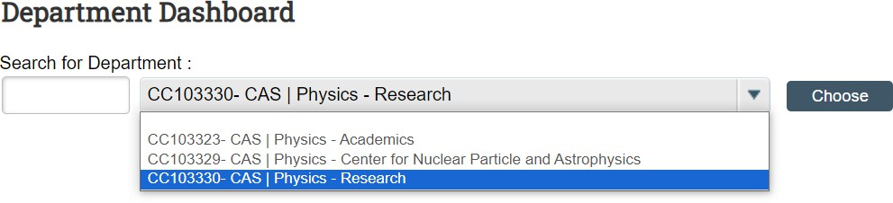

- Click “Choose”.

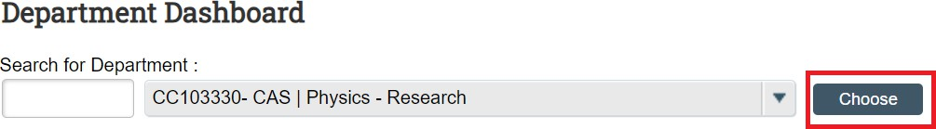

- Go to the “Project Certifications” tab and select a period from the period drop-down.

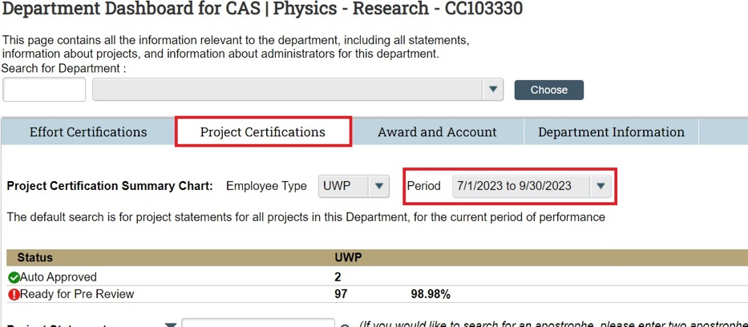

- For the row of the grant worktag you need to add a designee to, click the document icon
- under the “Action” column.

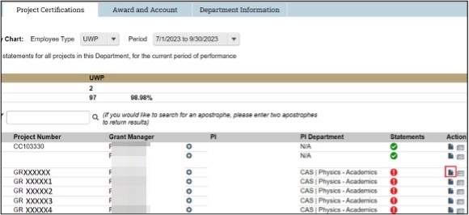

- From the “Account Summary” page that opens, select the “Manage Account Designee” subtab.

- Type the name of the person you are adding as the designee last name *space* first name (or EID) and select them from the dropdown menu.

- Enter effective start and end dates.
  - Important: The start date of the designee must be within the period of the earliest report the designee is certifying for. For example, if the designee is certifying a report for 7/1/2024 - 9/30/2024, the Effective Start Date must be within 7/1/2024 – 9/30/2024 for the designee to be able to certify.

- Ensure the end date you enter is far enough in the future for the designee to log in and certify the report. Then click “Add Designee”.

- The designee is now added. If you need to delete or adjust the designee assignment, use the icons in the “Action” or “Delete Designee” columns.

The individual that is added as a designee will also need the “Certifier” role in ECC to complete the certification of the project statement(s). Contact the PAFC Effort Reporting team at effortreporting@uw.edu to add this role. Provide the full name and EID of the faculty member who cannot certify and individual who will be the designee. PAFC will update ECC and notify you once it is finished.

