Payroll Adjustment Reconciliation (PAR) and Project Payroll Reconciliation (PPR) Tasks Job Aid
Table of Contents
Purpose 1
Audience 1
Overview 1
Complete a PAR/PPR Task 2

Purpose
The purpose of this job aid is to provide step-by-step instructions to complete a Payroll Adjustment Reconciliation task (PAR) or a Project Payroll Reconciliation (PPR) task in the Employee Compensation Compliance (ECC) system.

Audience
This job aid is intended for Effort Coordinators. The ECC Coordinator role is required for this process.

Overview
Payroll Adjustment Reconciliation (PAR) tasks and Project Payroll Reconciliation (PPR) tasks are automatically prompted within ECC when a Payroll Accounting Adjustment (PAA) or retroactive pay (“retro pay”) loads to a previously certified effort or project statement. PAR tasks apply to effort statements, and PPR tasks apply to project statements.

Both tasks support the recertification process for each statement type. Recertification is the process of correcting a previously certified effort statement or project statement. It ensures the most up-to-date and accurate payroll amounts and effort distributions are certified by faculty and Principal Investigators (PIs).

Completing the PAR/PPR task is the first step of the two-step recertification process. The first step is for the ECC Coordinator to complete the PAR/PPR Task in ECC (covered in this job aid). The second step is for the ECC Certifier (faculty/PI) associated with the statement review and recertify the impacted statement. The ECC Certifier will receive an email notification that they have a statement to recertify.

If a Payroll Accounting Adjustment (PAA) or retroactive pay (retro pay) post to a statement that has not yet been certified, the statement will automatically update and not require user intervention.

Complete a PAR/PPR Task
When a PAR/PPR task needs to be completed, ECC will automatically send an email notification to the Primary Coordinator for the department if it is related to an effort statement or to the ECC Grant Manager for the grant worktag if it is related to a project statement.

- After receiving the email notification, login to ECC.

- Click on the “Effort Tasks” tab on the ECC home page.

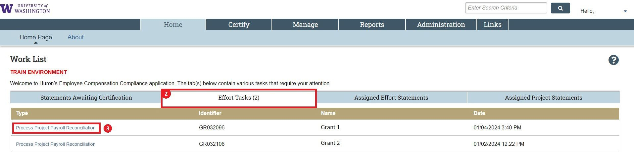

- There will be a list of tasks based on the number of certified statements that have new payroll loads added to them. Click on the linked text in the “Type” column in the first row. This field identifies if the task is a PAR or PPR.

- Review the summarized transfer. It is easier to review the changes on a dollar basis. Click the $ Value button in the top right corner of the summarized table to enable the dollar view.

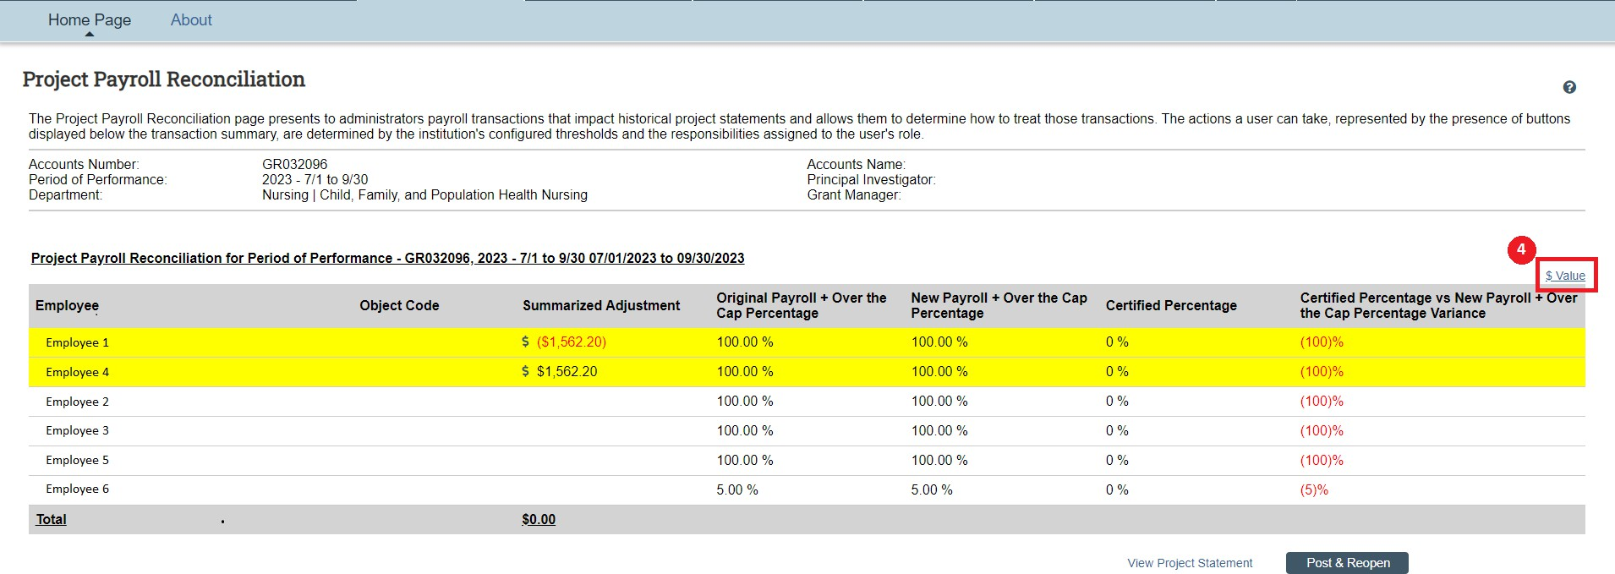

- After you have reviewed the changes, click the “Post & Reopen” button.

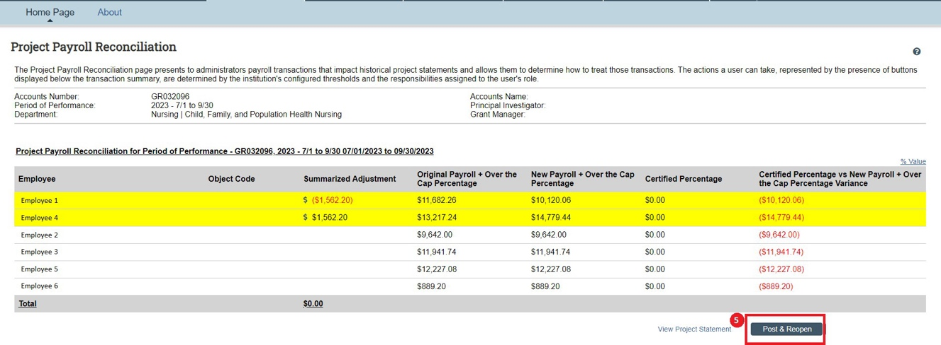

- The values shown on the statement will automatically update and the Status will change from “Recertification Task Pending” to “Ready for Recertification”. This will be the new status for both effort and project statements.

Before
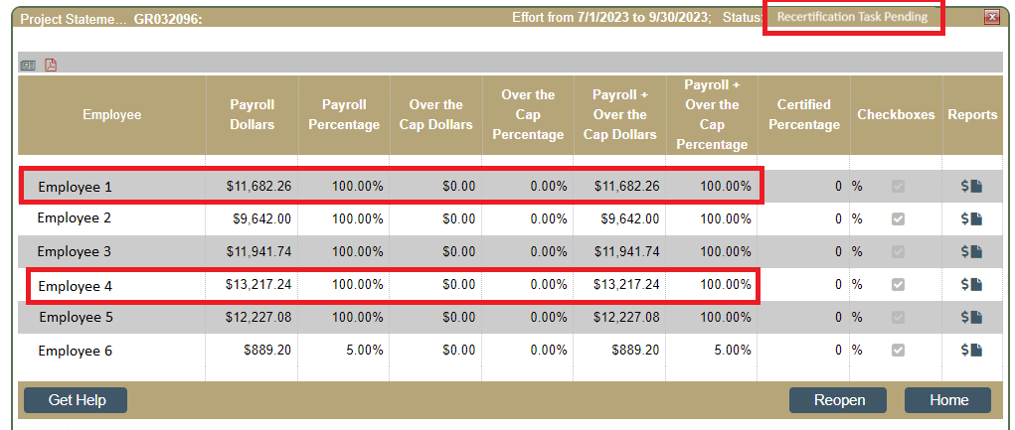

After

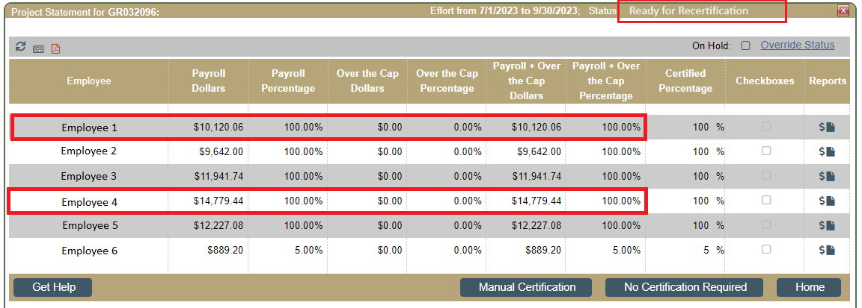

- ECC will automatically send an email notification to the Effort Certifier of the re-opened statement within 24 hours of the completion of the PAR/PPR task, informing them that they have a statement to re-certify.
- Add a note on the statement justifying the reason for the recertification
  - Access the statement from either the home page, or by searching for the faculty’s last name (effort statements) or GR number (project statements)
  - Below the statement body, add a note by clicking on the (+) icon next to “Notes”:
