ECC External Audit Report Job Aid
Table of Contents
Purpose 1
Audience 1
Overview 1
Reporting Periods Before 7/1/2023 1
Generate the ECC External Audit Report 3
Report Parameters for Common Audit Requests 7
Statements By Faculty/Principal Investigator 7
Statements By Grant Worktag 10

Purpose
The purpose of this job aid is to provide step-by-step instructions to run the external audit report in the Employee Compensation Compliance system (ECC).

Audience
This job aid is intended for ECC Coordinators, however, all ECC users can run this report.

Overview
The University of Washington may be contacted to provide effort reporting documentation for an audit. If you receive a notification from a sponsor of an audit, send an email to UW Internal Audit at iaudit@uw.edu. If you have questions regarding what is being requested, the scope of the request, or how to access the necessary documentation, please consult with UW Internal Audit or Post Award Fiscal Compliance (effortreporting@uw.edu).

The ECC External Audit Report is the appropriate way to respond to an effort reporting audit or documentation request. This report provides a list of a historical certification statements by
certifier or project effective 7/1/2023.

Reporting Periods Before 7/1/2023
Faculty Effort Certifications (FECs) are the legacy version of ECC Effort Statements and were in use for periods prior to 7/1/2023. To request copies, send an email to the Post Award Fisal Compliance Effort Team effortreporting@uw.edu. Please include the faculty member’s name and the period of the reports that you need.

Grant and Contract Certification Reports (GCCRs) are the legacy versions of ECC Project Statements. They are retained at the departmental level, so certified reports should be available within your unit’s document retention process.

Generate the ECC External Audit Report
- Login to ECC, click on the “Reports” menu tab, then the “Reporting” subtab.

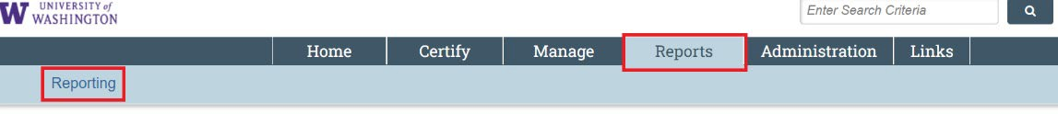

- Select “Management” in the Category column then “External Audit Report” in the Reports column:
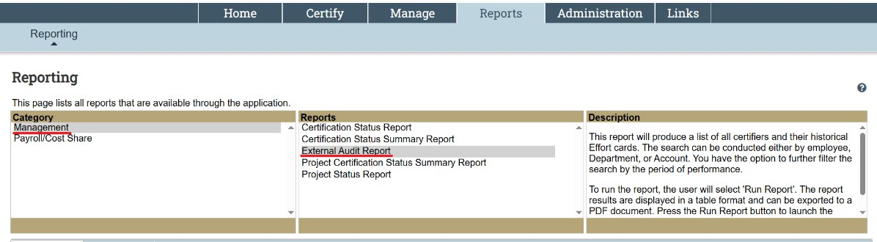

Note: Depending on the ECC statements that you need to retrieve, the following parameter entries may vary. The rest of the steps in this ‘step-by-step’ section will go over each field in the parameter entry in detail, and outline quirks entering the parameters. If you want a summarized view of how to enter the parameters for a specific scenario, jump to the Report Parameters for Common Audit Requests.

- In the “Parameters” tab, the “Statement Type” field allows you to select effort statements, project statements, or both types of statements are included in the report.

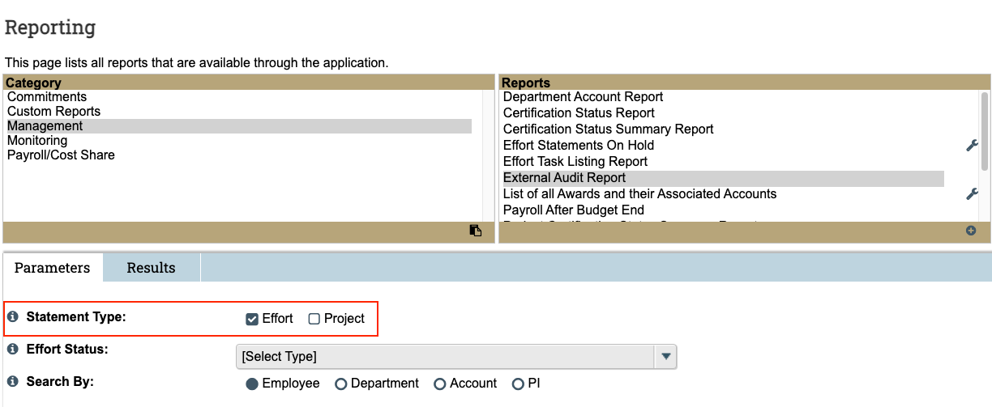
- Using either the “Effort Status” or “Project Status” entries is not recommended, as they do not function as expected to reduce the results only statements in that status. Leave “Status” field(s) as is, with “[Select Type]” instead of any individual status:

- You can find the statement by searching by Employee, Department, Account, or PI.
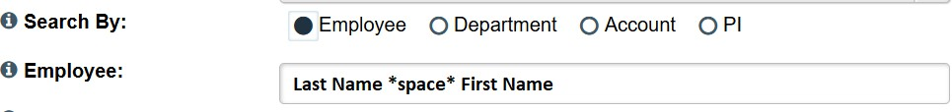
  - Employee – Search for effort and/or project statements associated with a particular faculty/PI

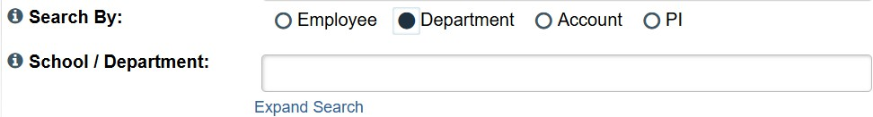
  - Department – Search for statements by cost center. This search parameter is not recommended because it returns results for statements that do not have sponsored payroll (auto approved project/effort statements).

  - Account – Search for grant worktag. The worktag must be a grant worktag. The Search field will populate based on award period associated with the worktag.
    - If today’s date is during the award period, use “Active” selection.
    - If today’s date is after the award period end date, select the “Inactive” toggle before entering grant number – otherwise you will get ‘No Data.’

  - PI – Search for project statements associated with a selected PI. Note: This search parameter is not recommended. We recommend using the “Employee” search (Step 5a) because it returns the same results but also shows effort statements for the selected individual if you select both “Effort” and “Project” in the Statement Type field (See Step 3).

- The following are the standard selection for the next three report parameters:
  - “Show Notes” - Yes
  - “Show Transaction History” - No
  - “Search By Statement Type” – Base

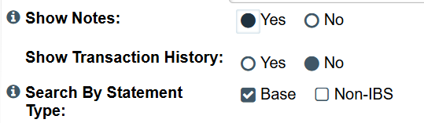

- In the “Date By” field, select “Employee Type” if you only want statements of one type, and for a single ECC period (semi-annual effort, or quarterly project). Otherwise, leave the selection as “Dates.”
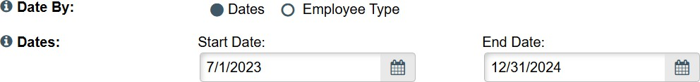
  - If using “Dates” enter the date range of the reports you require. Tip: It is easier to type in “MM/DD/YYYY” rather than use ECC’s date picker.

  - If using “Employee Type,” use ‘UW’ for effort statements, and ‘UWP’ for project statements, then select a single ECC period from the period dropdown. (“UWP” refers to project statements and non-faculty employees, not UW Physicians.)
    - Effort Statements
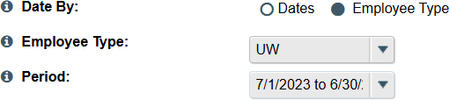
    - Project Statements
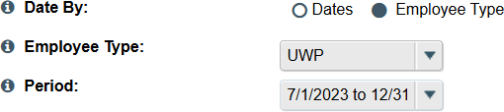
- Click “Run Report” to execute based on your chosen parameters.

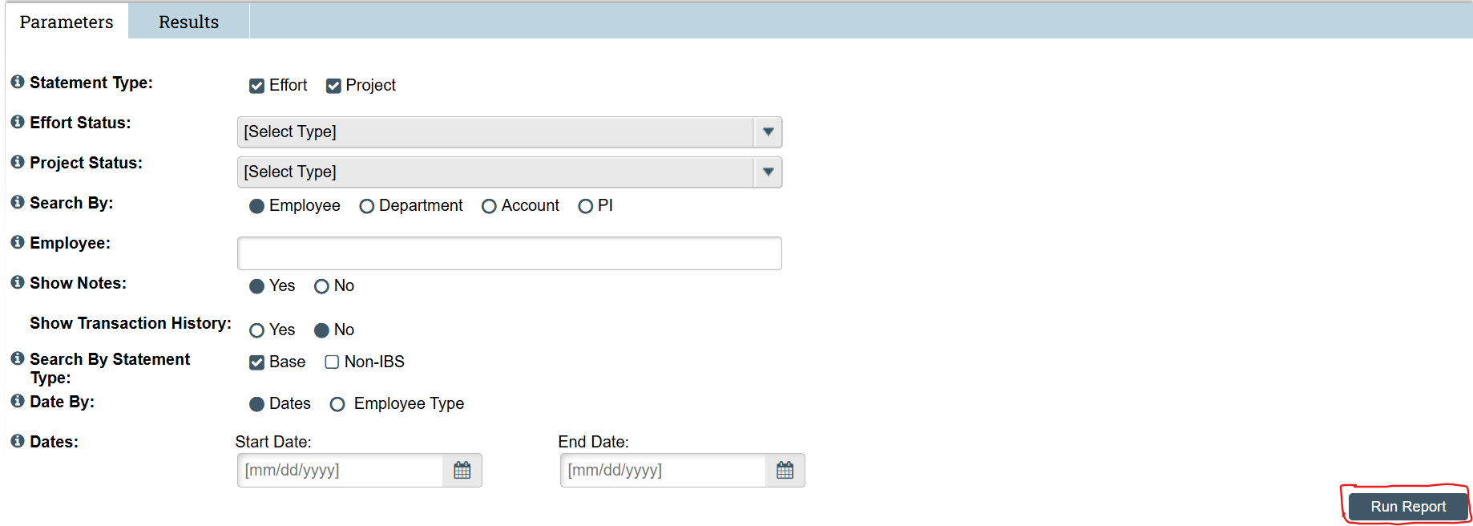

- Click the linked text “Effort PDF Report” and/or “Project PDF Report” (red outlined in screenshot). This will begin the process of generating a PDF of the statements you have selected.

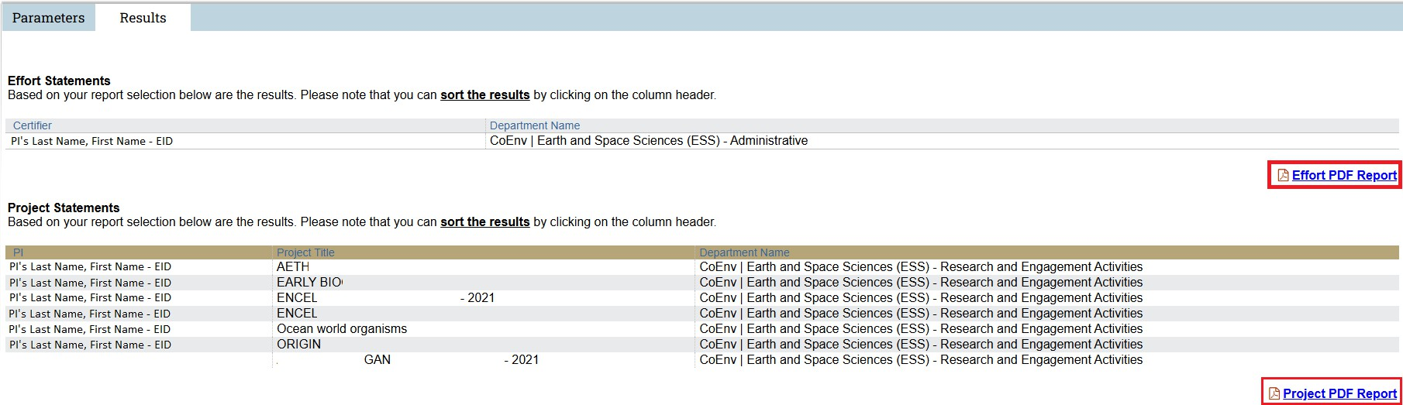

- Download the PDF(s) that ECC generates.

- Review the reports to make sure that all the included effort and project statements are in a “Certified” status. If there are statements in other statuses (e.g. “Ready for Pre Review”, “Ready for Certification”, “Certified, Payroll Pending”, or “Not Certified, Reopened by PAR”), you must facilitate for them to be certified before they can be sent to the sponsor/auditor as effort reporting documentation. Visit Effort Reporting Compliance for additional information.

Report Parameters for Common Audit Requests
The following examples are common external audit requests and the related report parameters. Once the parameters outlined below are entered, return to Step 8 to generate the desired reports.

Effort and Project Statements for Faculty/PI
Effort Statements for a Faculty/PI
Project Statements for an Employee (PI)
Effort and Project Statements for a Grant Worktag
Effort Statements for a Grant Worktag
Project Statements for a Grant Worktag

Statements By Faculty/Principal Investigator
Retrieve effort and project statements for a faculty/PI for a given date range:

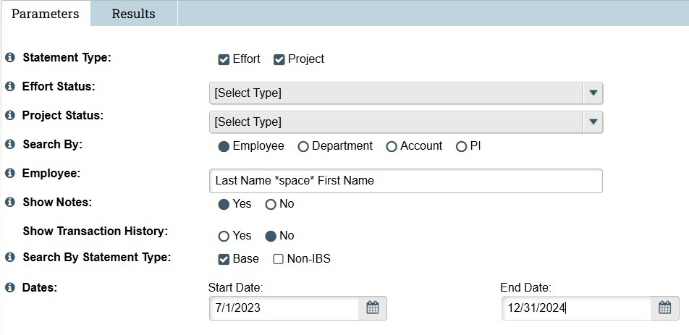

Retrieve all effort statements for a faculty member for a given date range:

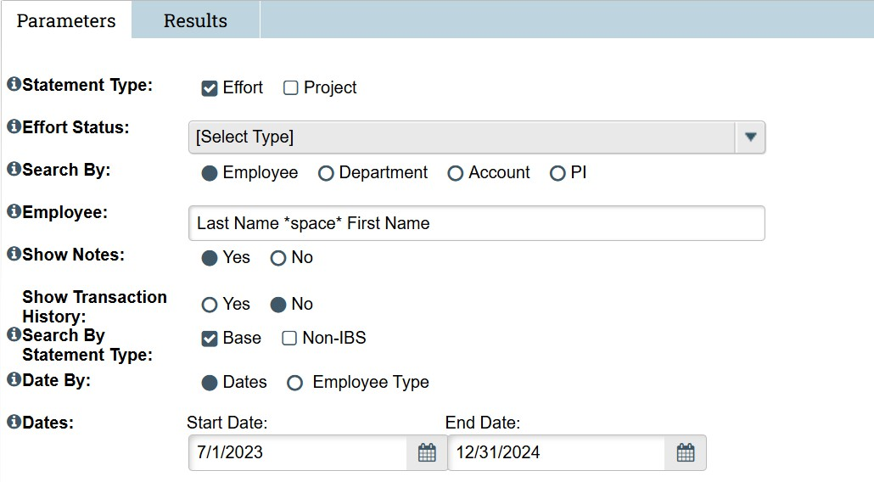

Retrieve all effort statements for a faculty member for a specific ECC Period:

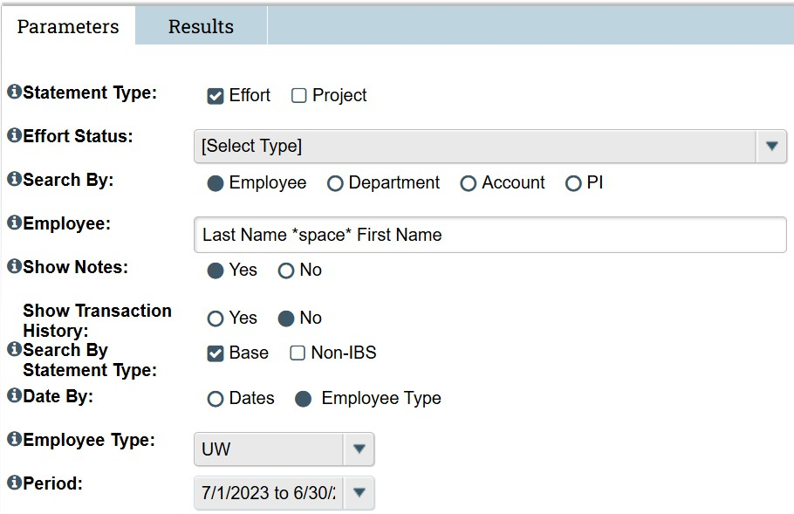

Retrieve all project statements for a PI for a given date range:

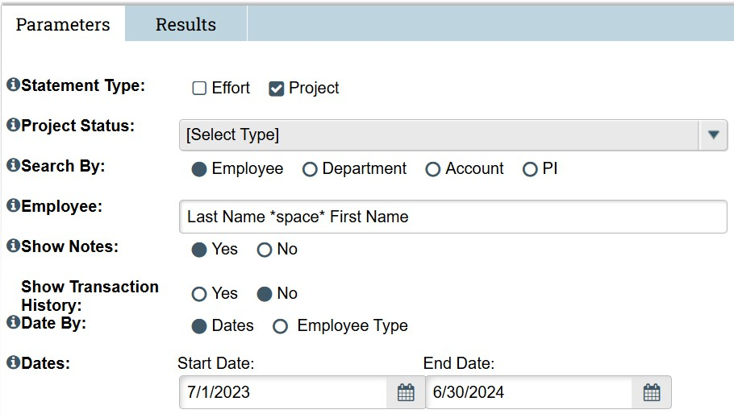

Retrieve project statements for a PI for a given ECC Period:

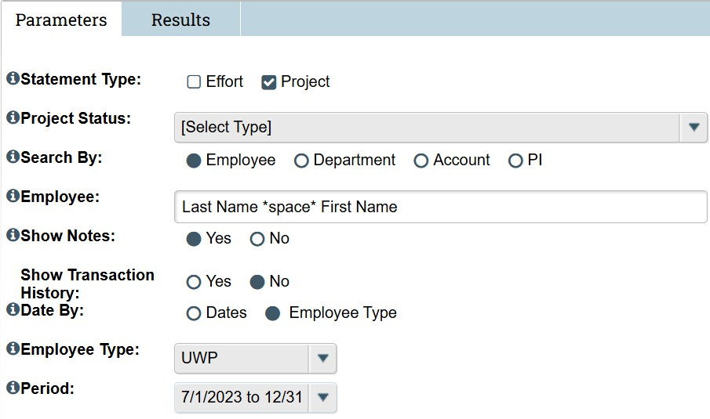

Statements By Grant Worktag

Retrieve effort and project statements for an “Account” (grant worktag) during the award period of the grant:

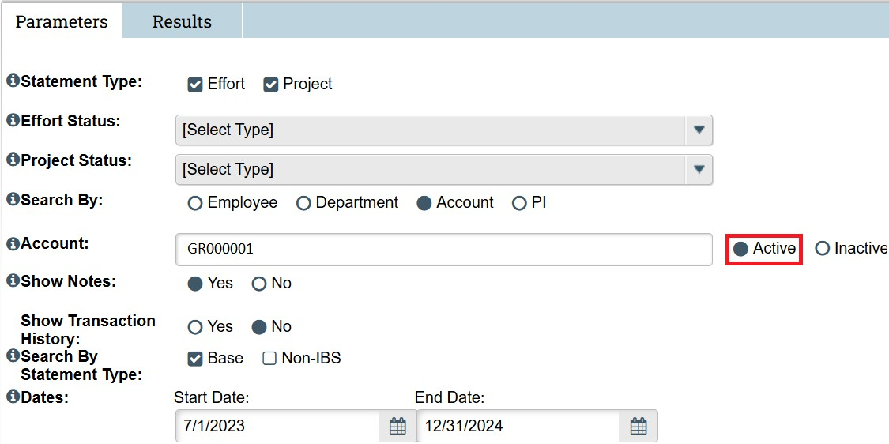

Retrieve effort and project statements for an “Account” (grant worktag) after the award period of the grant:

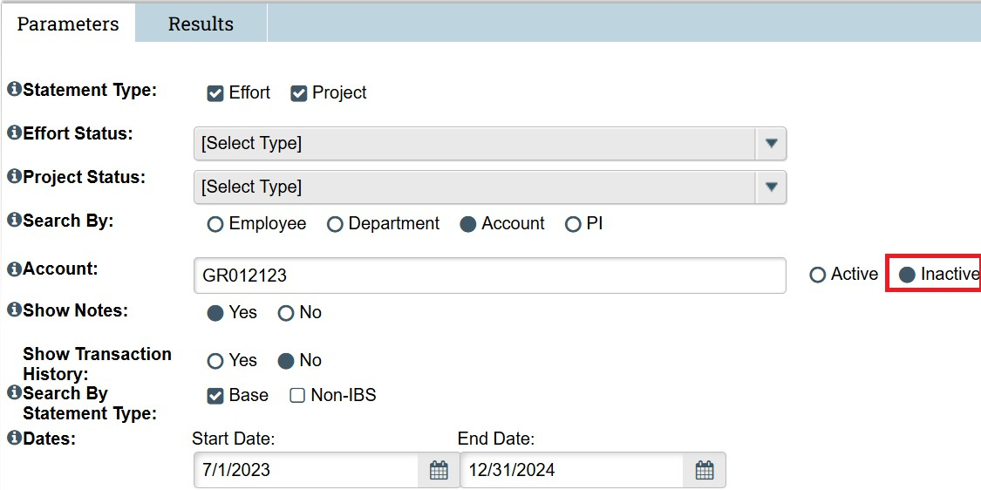

Retrieve effort statements an “Account” (grant worktag) is on during the award period of the grant:

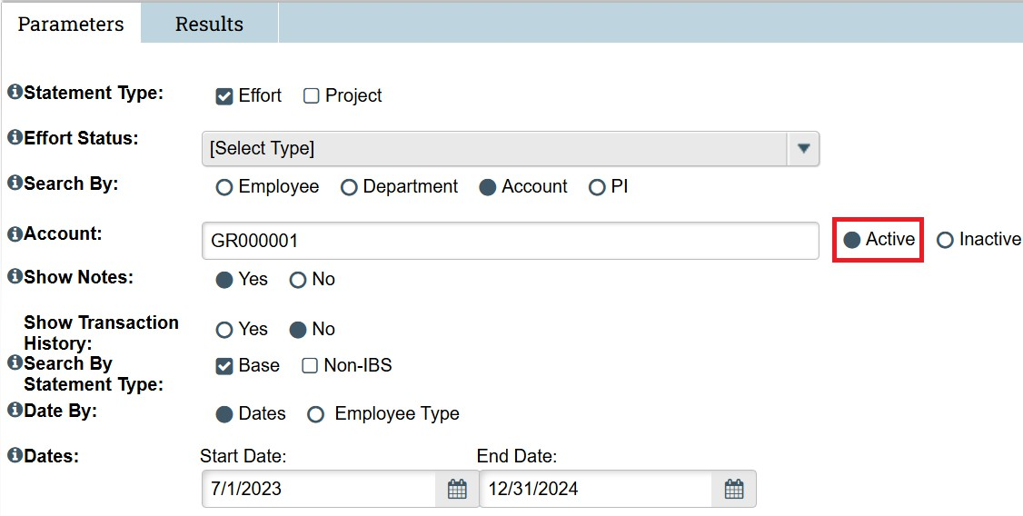

Retrieve effort statements an “Account” (grant worktag) is on after the award period of the grant:

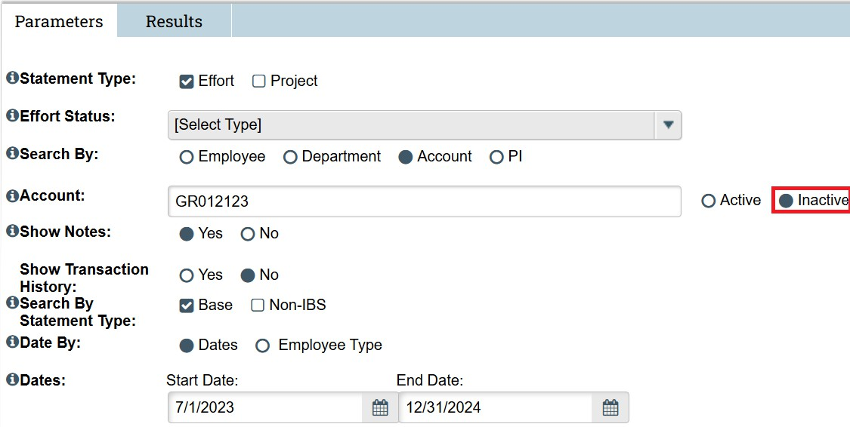

Retrieve project statements for an “Account” (grant worktag) during the award period of the grant:

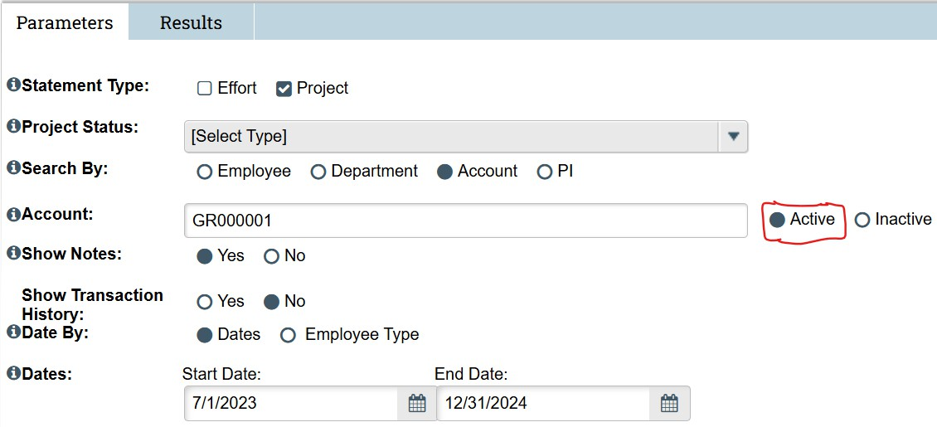

Retrieve project statements for an “Account” (grant worktag) after the award period of the grant:

