ECC Department Dashboard User Guide
Table of Contents
Purpose 1
Audience 1
Overview 1
Navigate to the Department Dashboard 1
Effort Certifications Tab 2
Project Certifications Tab 3
Award and Account Tab 3
Department Information Tab 4

Purpose
The purpose of this job aid is to provide step-by-step instructions on how to use the Department Dashboard in the Employee Compensation Compliance system (ECC).

Audience
This job aid is intended for ECC Coordinators and UW Internal Audit staff.

Overview
The ECC Department Dashboard displays a list of all effort and project statements associated with a specific cost center, as well as all the awards, grant worktags, and non-grant worktags associated with that cost center. This is also where coordinator department assignments can be made and managed.

Navigate to the Department Dashboard

- Login to ECC and select the “Manage” tab.

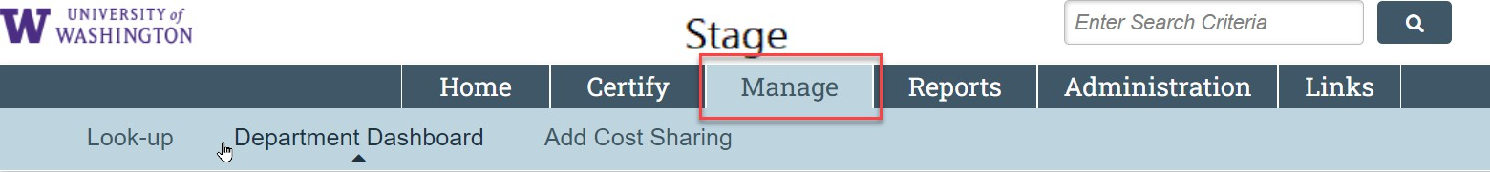

- Select “Department Dashboard.”

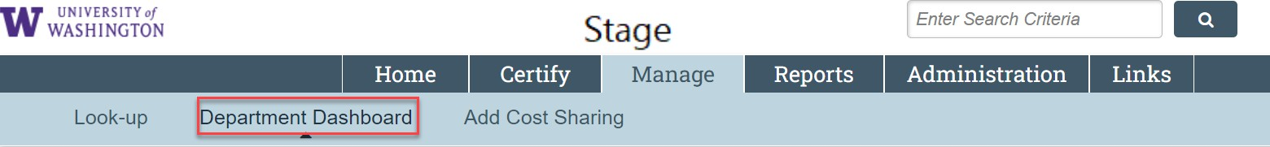

- Enter the cost center you are assigned to in the drop-down menu and click the “Choose” button.

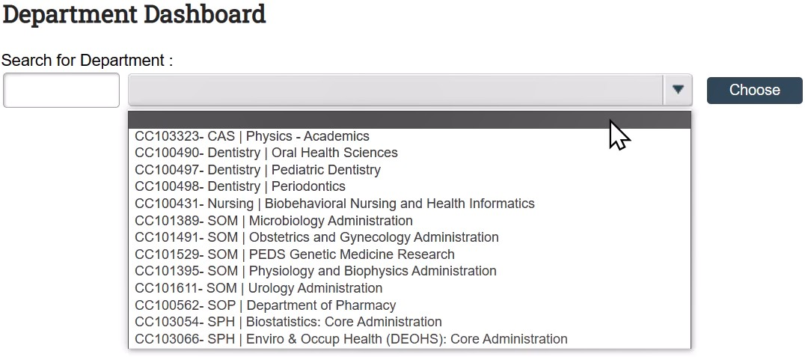

If no cost centers appear, you are not assigned to any as an ECC Coordinator. Contact Post Award Fiscal Compliance Effort Team at effortreporting@uw.edu for assistance. Provide your full name, EID, and the cost center.

You can also ask a colleague in your unit that has access to add you to the cost centers you need. Refer to Manage ECC Coordinator Assignments.

Effort Certifications Tab

- To access an effort statement from the Department Dashboard, click on the “Effort Certifications” subtab.
  - Use the “Period” dropdown menu and select the period you want to view.
  - Identify an individual’s effort statement that you want to view in the “Sponsored” section.
  - Select the icon in the “Statements” column in the same row to access that statement.

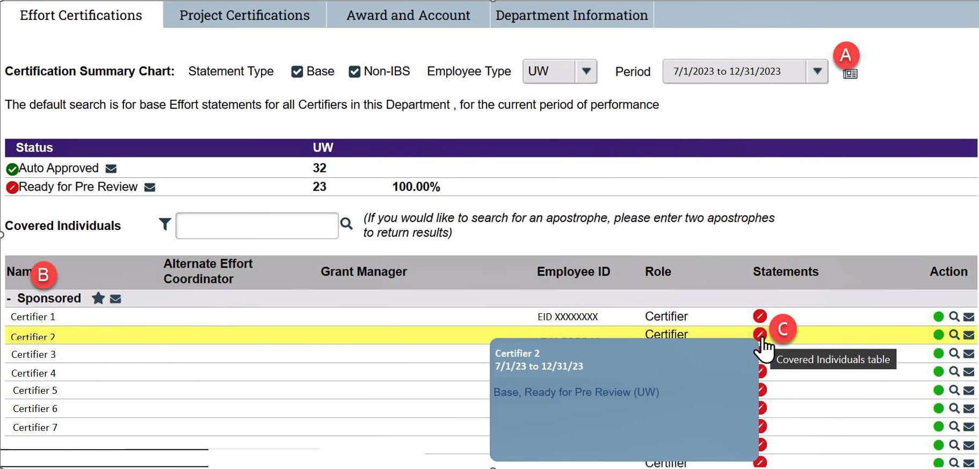

Project Certifications Tab
To access a Project Statement from this page, click on the “Project Certifications” subtab.
  - Use the “Period” dropdown menu and select a period you want to view.
  - Identify a project statement that you want to view in the in the
  - Select the icon in the “Statements” column in the same row to access that statement.

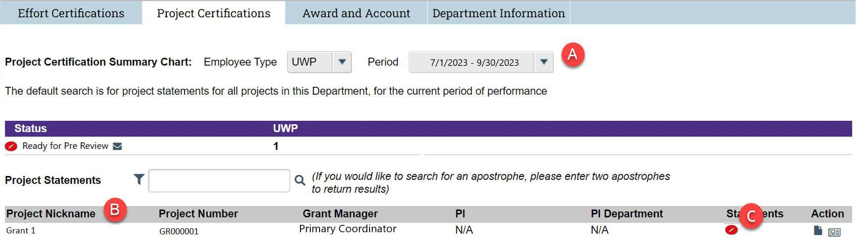

- It is expected that certain cost centers could only have effort statements or only have project statements. All the data ECC has comes from Workday and effort statements are located under the cost center that is the home department for the certifier themselves, whereas the project statements are located under the cost center that the grant is within.

Award and Account Tab
Click on the “Award and Account” tab to access a list of all the accounts (e.g. gift worktags) associated with the selected cost center. This list is derived from the data integrations from Workday to ECC. This section is for informational use only. Not all worktags will appear in this section; only the worktags that are recognized by ECC.

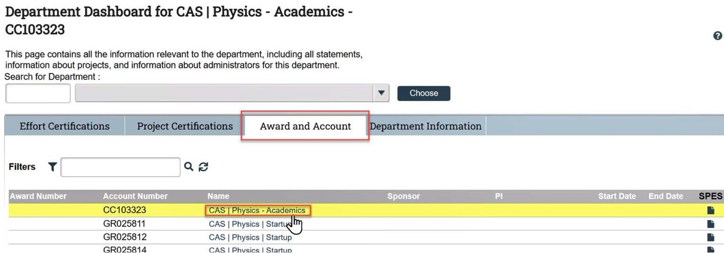

Department Information Tab
- Click on the “Department Information” tab to view individuals assigned as Coordinators for the department.

- The yellow highlighting indicates the Primary Coordinator. As a Coordinator, you can add and remove other coordinators to the department. You can change the Primary Effort Coordinator and configure more role setup for your cost centers. To learn more about managing roles and cost center assignments in ECC, refer to Manage ECC Effort Coordinator Assignments.

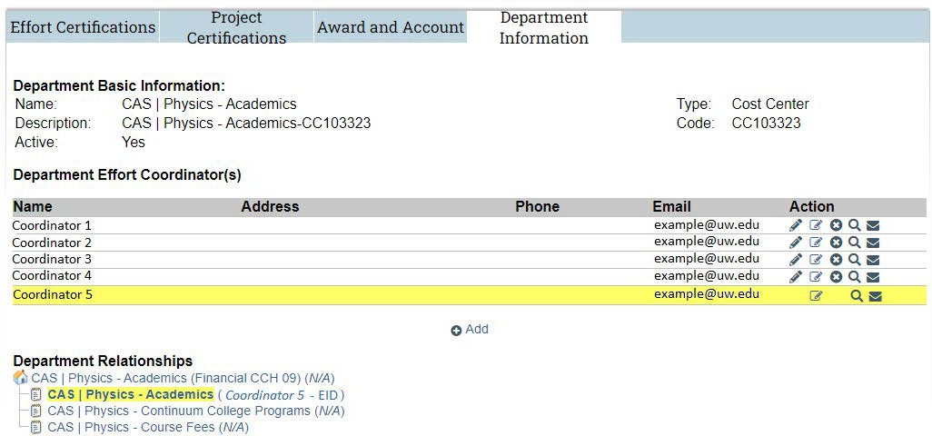

- The "Department Relationships" section shows the cost center hierarchy ECC gets from Workday. Not all cost centers will have statements within them in ECC, so you will only need ECC access to those that have sponsored program activity.

