Job Aid: Coordinator Pre-Review
Contents:
- Overview
- Effort Statement Pre-Review
- Project Statement Pre-Review
Overview:
“Pre-Review” is the main functional task coordinators need to complete in ECC (Employee Compensation Compliance). It is a process after an effort or project period has ended and before statements are ready to be certified where coordinators will review their assigned statements, and “Pre-Review” each statement if it is accurate. All Effort and Project statements must be “pre-reviewed" before they are available to be certified by the certifier. The pre review itself enables any individual statement to be moved to the “Ready for Certification” status. This is to reduce the likelihood that statements will be certified before they reflect pending changes or adjustments, in turn reducing the cases of recertification. See the effort report schedule for the expected start dates for effort and project pre-review periods.
This job aid references the “worklist” and the “assigned project statements” on the home page of ECC. For Project Statements specifically, these views are only available to “Primary” effort coordinators for a specific cost center. Those not designated as the Primary coordinators of departments (“Non-primary”) will have to navigate through the “Department Dashboard” section to see the project statements under their assigned departments (refer to “Department Dashboard Overview” user guide). All effort statements should appear on each coordinator’s home page in the “Assigned Effort Statements” section.
For more info on primary vs. non-primary coordinators and how to optimize your departments’ assignments, refer to the “Managing ECC Coordinator Assignments & Authorizations” job aid, also located on the job aids webpage.
Steps for Effort Statement Pre-review:
- Go to ECC and select your institution (select UW unless you are affiliated with APL or Harborview Medical Center - aka “UWM” institution in ECC), then click “Continue”.


- On the “Home” page, select the “Assigned Effort Statements” subtab.
  - Here you will see your list of assigned certifiers that have a statement that is “Ready for Pre Review”.
  - In the “Statement Owner” column, select the name of a certifier whose statement you want to pre-review.
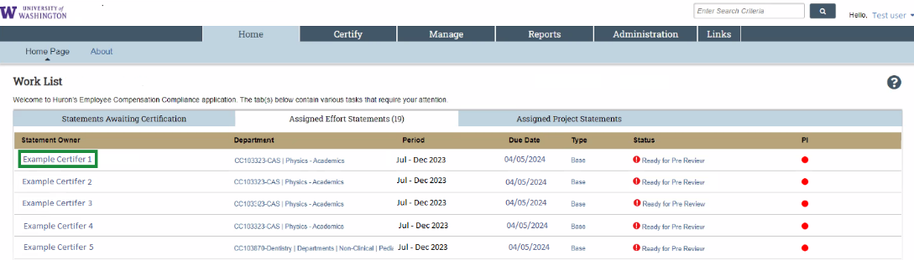
  - After clicking on a “Statement Owner” (or a “Status”), you will arrive at that worker’s statement.
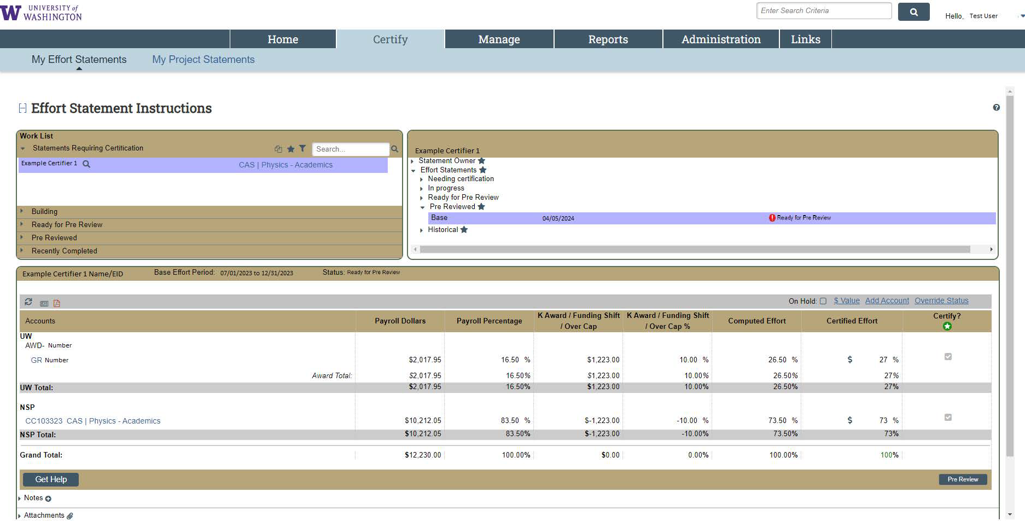
  - There is another method of getting to statements that will enable you to go through multiple statements more efficiently. Go to the “Certify” menu tab and select “My Effort Statements”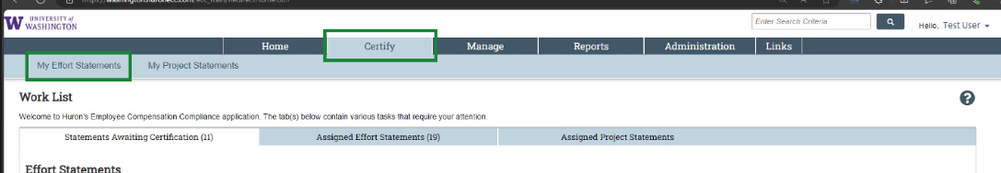
  - This way you can switch between multiple different statements from the same screen. You will see this in your “Work List” (highlighted certifier represents which statement is currently being viewed):
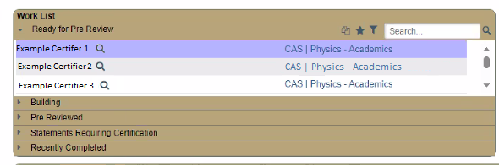
  - Compared to this from the first method of going to a single statement:
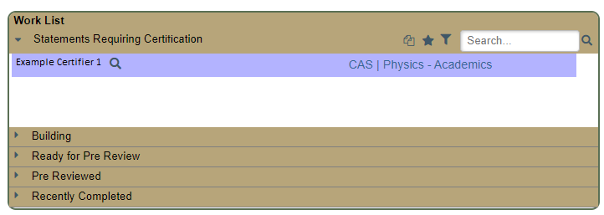
- Review the statement for an accurate reflection of the salary charges to each source during the period.
  - You can breakdown to period-by-period payroll and pay components by clicking the “$” icon in the “Certified Effort” column in each row:
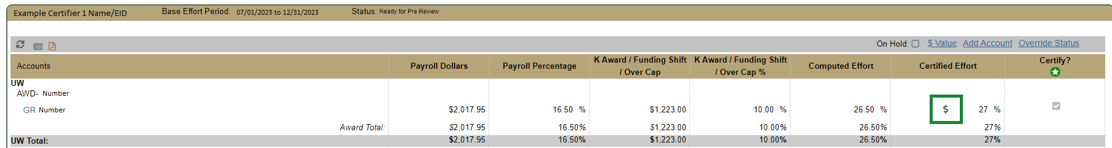
  - This opens a new browser window, and shows the period detail:
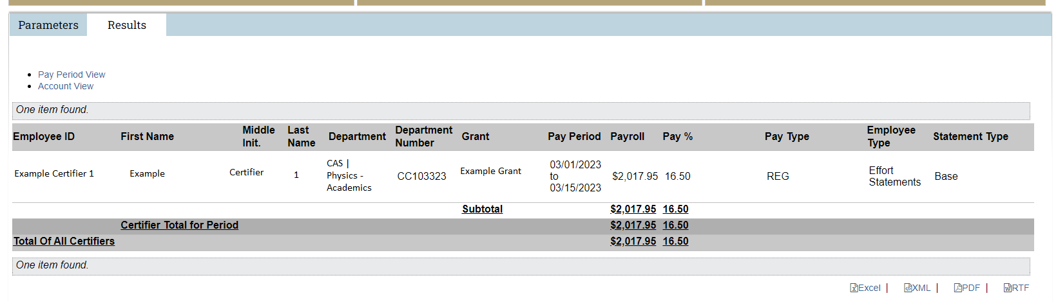
  - You can see this level of detail for each salary source in one report by clicking the newspaper icon in the top left of the statement and selecting “Payroll Report”.
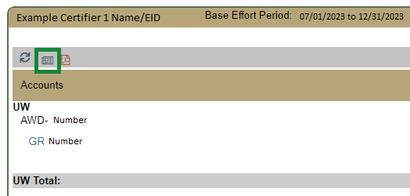
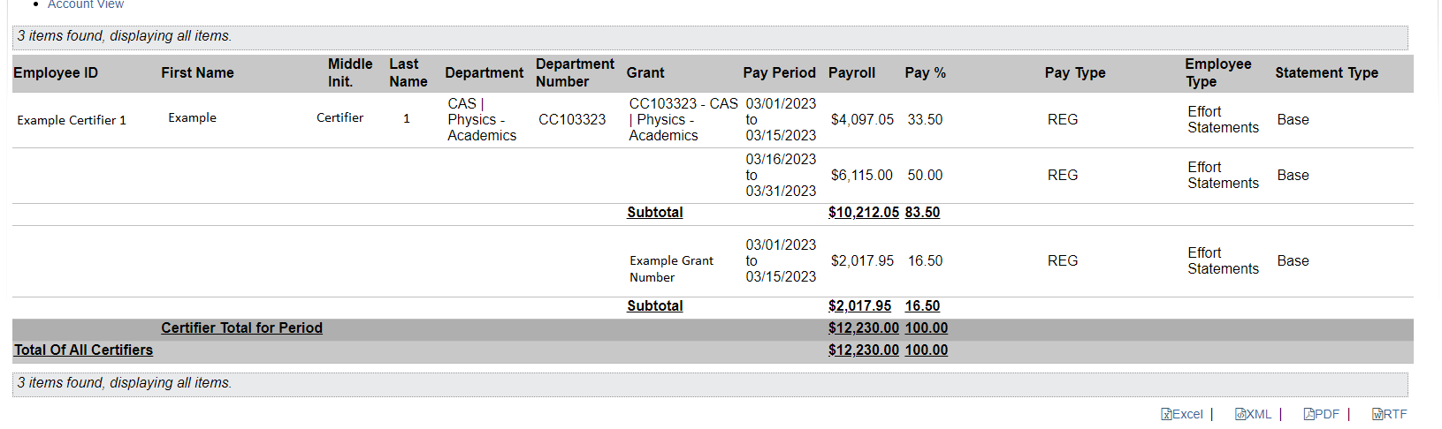
  - If changes need to be made to a statement, do not pre review the statement, refer to this webpage to facilitate for the necessary changes to be made.
- If the report is accurate to your knowledge, click on the “Pre-review” button located in the bottom right portion of the screen.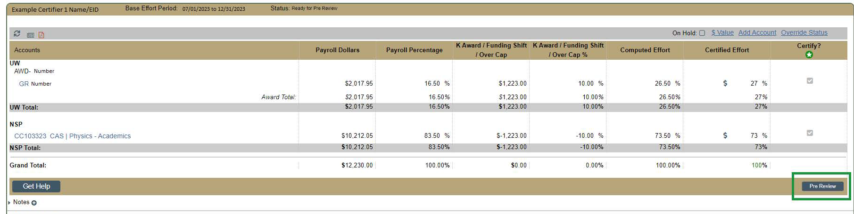
- The Effort statement should now be marked as “pre-reviewed”.
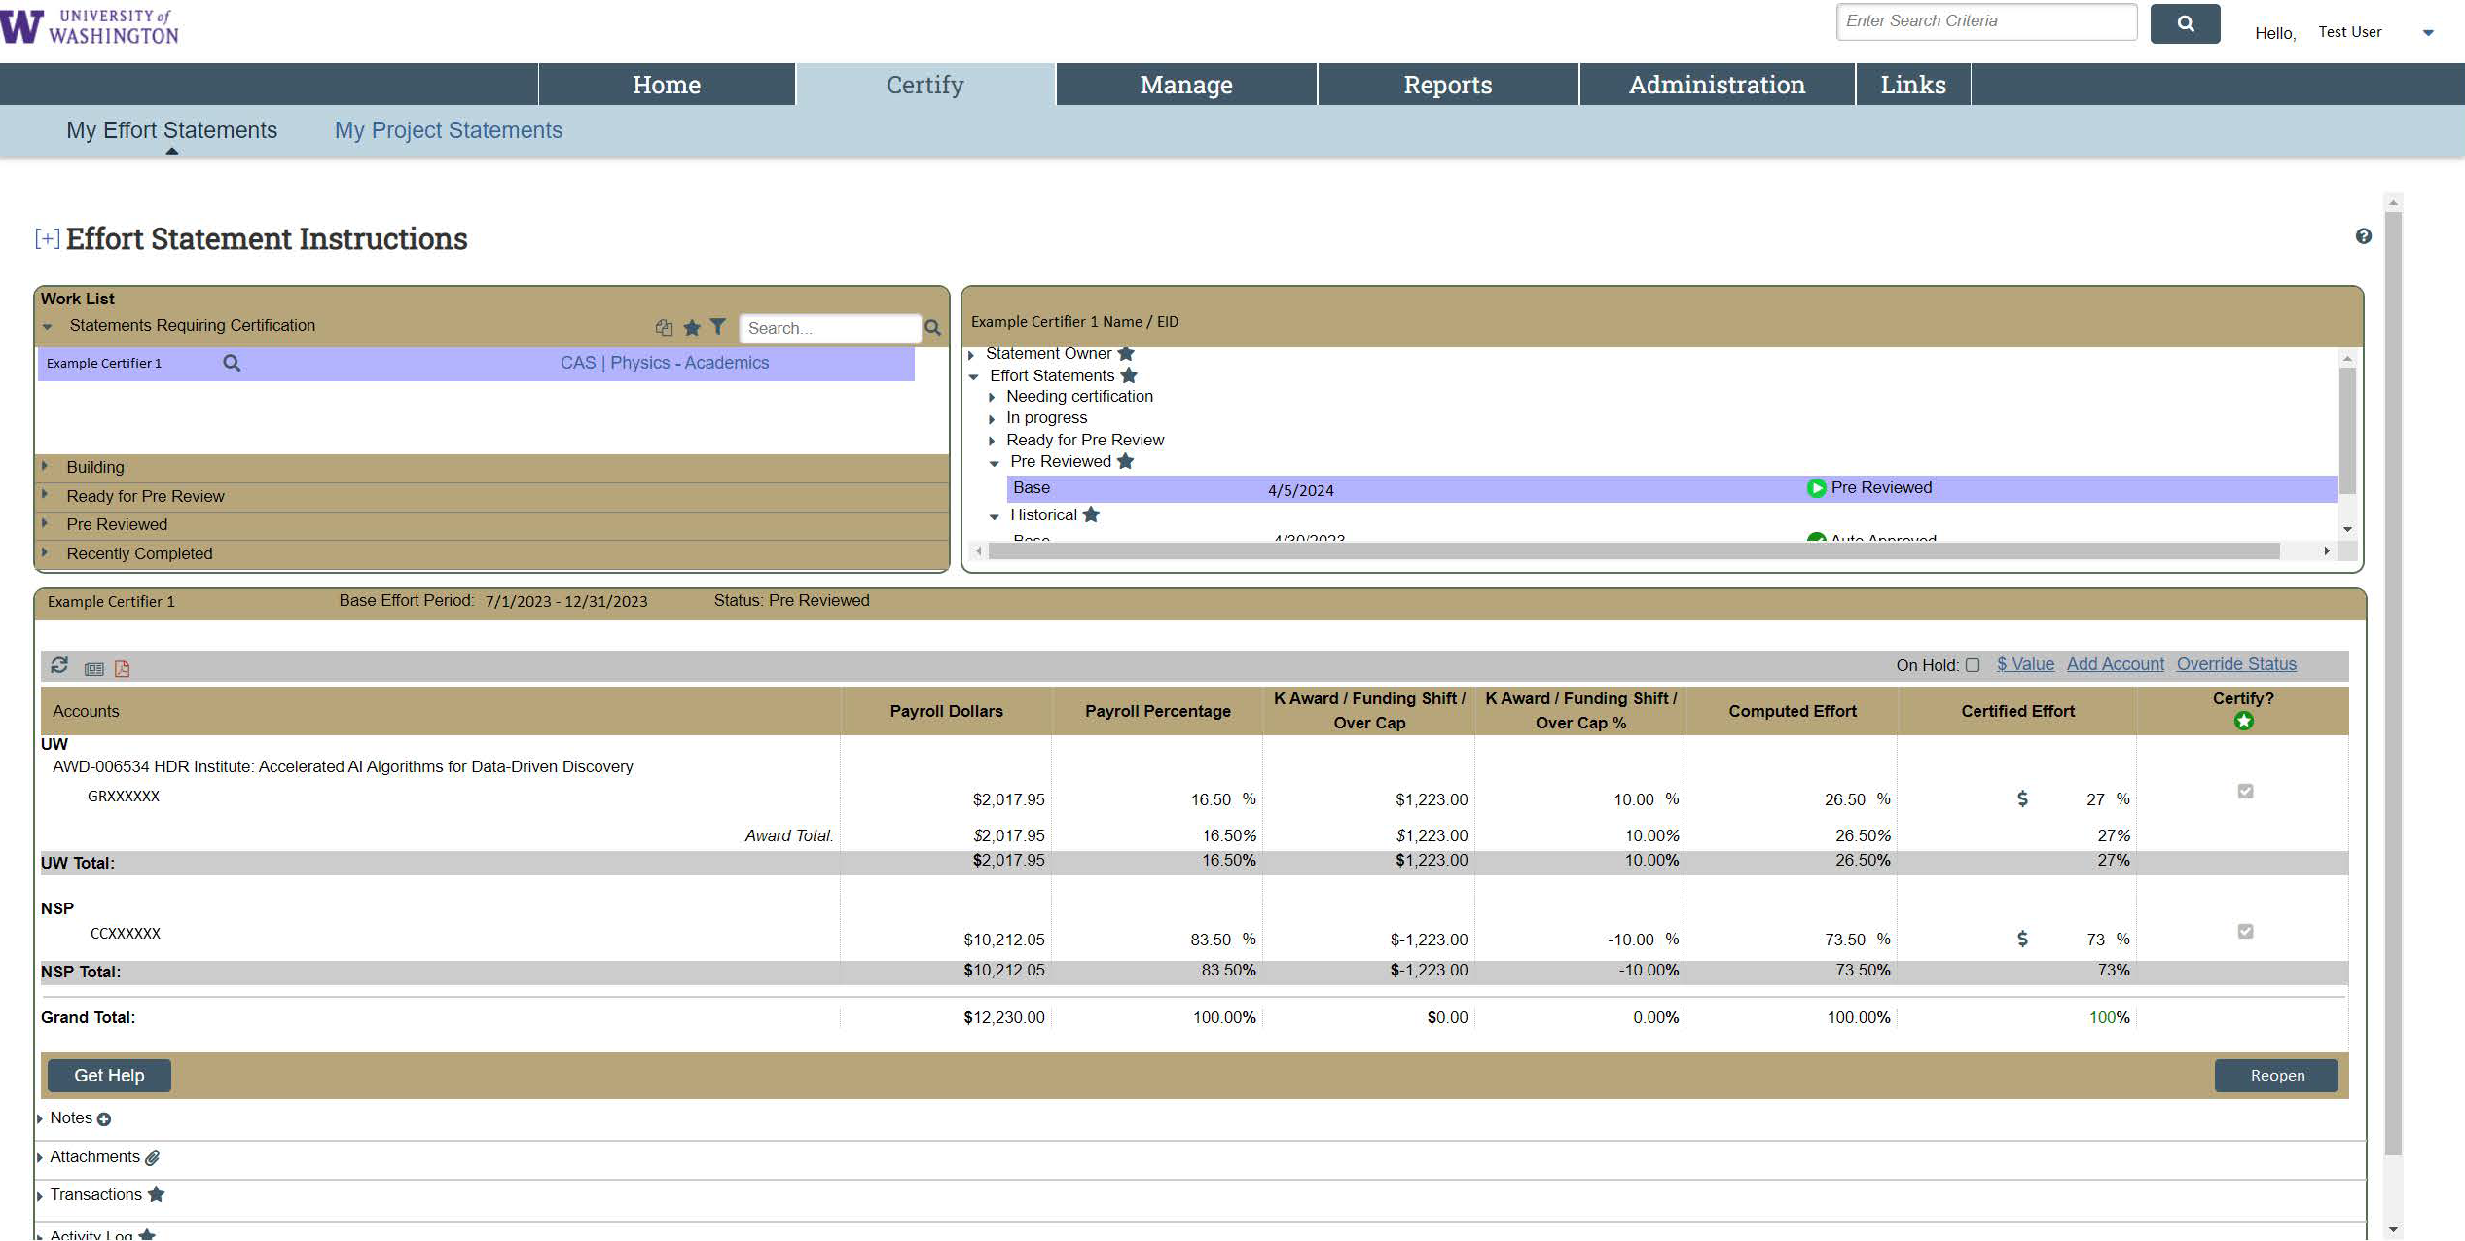
- If you want to “undo” your pre-review, the “Reopen” button in place of where the “Pre Review” button was will return the statement to “Ready for Pre Review”, meaning that it will have to be pre reviewed again. You may want to do this if you pre reviewed a statement that has pending PAAs that have not been loaded into ECC yet.
  - Note: This “Reopen” button will only be available while the statement is in “Pre Reviewed” status. After the statement transitions to “Ready for Certification” (which is either the next time the clock hits 11:45am if the certification period had begun, or per the effort report schedule if before the certification start date). If you need to move a statement back to “Ready for Pre Review” status after it has already moved to “Ready for Certification”, please reach out to effortreporting@uw.edu
Steps for Project Statement Pre-review:
Note: Each grant has its own project statement that requires individual pre-review if there was staff payroll charged to it during the period
- Go to ECC and select your institution (select UW unless you are affiliated with APL or Harborview Medical Center - aka “UWM” institution in ECC), then click “Continue”.
- On the “Home” page, select the “Assigned Project Statements” subtab.
  - Here you will see your list of assigned PIs that have statement(s) that are “Ready for Pre Review”.
  - Select the PI’s name or one of the links in the “Status” column to access a project statement.
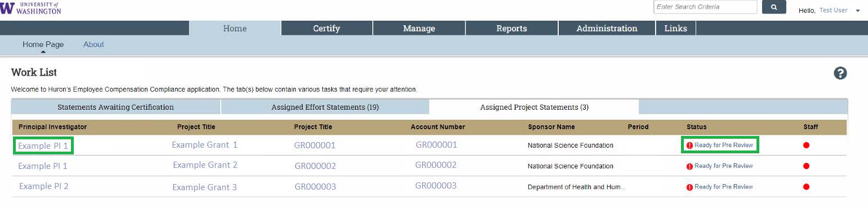
  - There is another method of getting to statements that will enable you to go through project statements for multiple PIs more efficiently. Go to the “Certify” menu tab and select “My Project Statements” (this is only functional for primary coordinators). This will populate the upper left “Work list” box with all your assigned PIs, rather than just one that you select from the home page view.
- One-by-one, review the statements for an accurate reflection of the salary charges to each grant for the period.
  - You can breakdown to period-by-period payroll and pay components for each worker by clicking the “$” icon in the “Reports” column in each row:
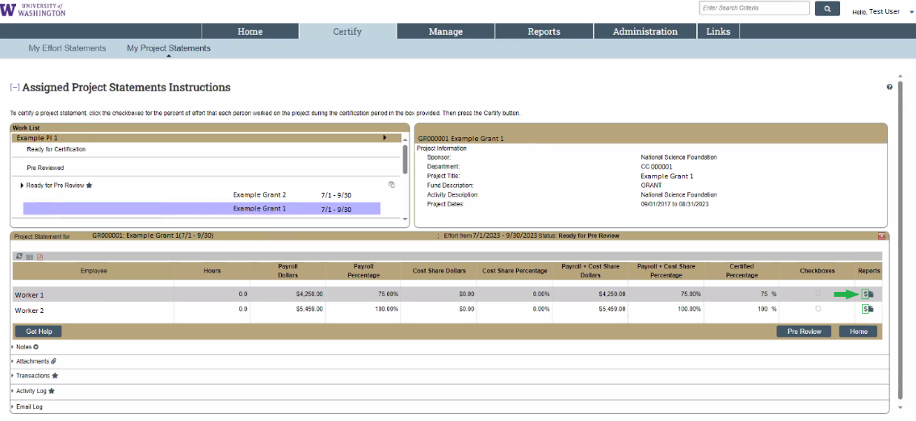

  - This opens a new browser window, and shows the period detail:
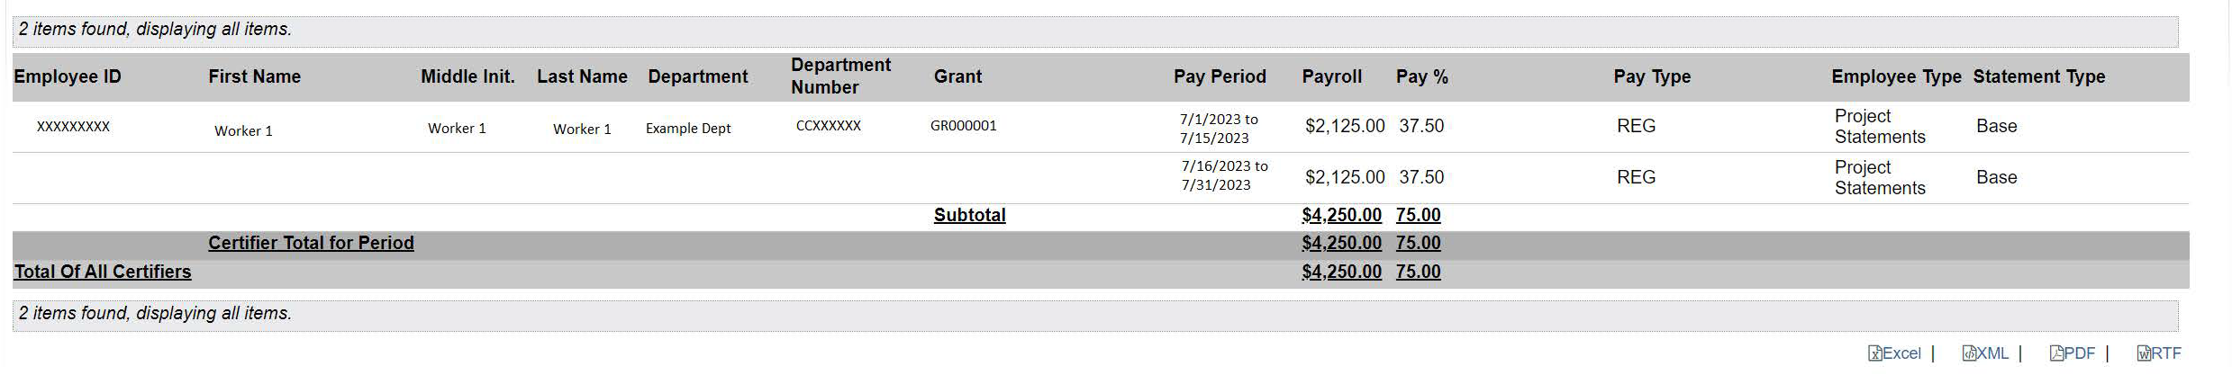
  - The icon that looks like a piece of paper with a folded corner runs a report to show all the payroll for that specific worker to all the sources they had salary charged to during the period.
  - If changes need to be made to a project statement, PAAs must be completed in Workday (UW Connect Resources on PAAs). PAA lines posted in Workday will be loaded into ECC the following week on Monday evening (Tuesday evening for UWM (Harborview), and Wednesday evening for APL)
- If a project report is accurate to your knowledge, click on the “Pre-review” button located in the bottom right portion of the screen.
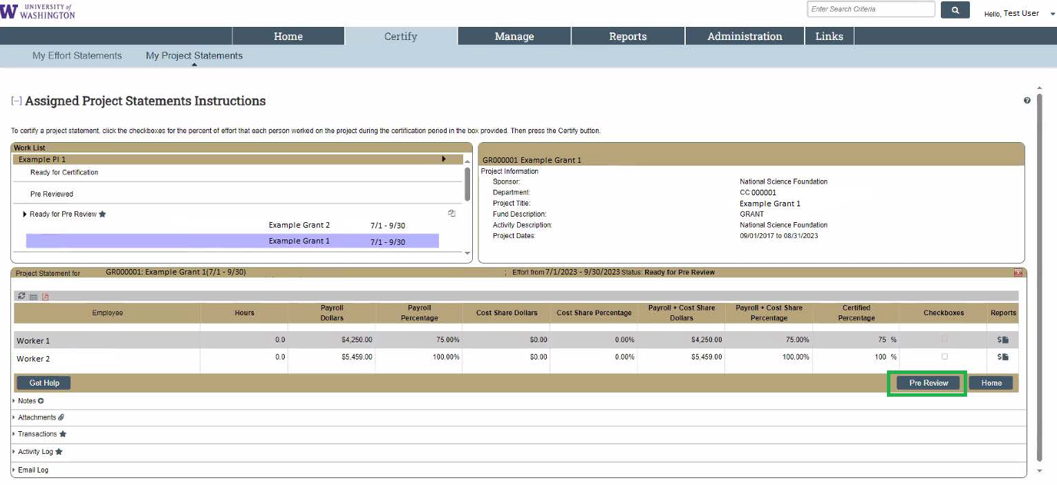
- The screen may change to the next Project statement that needs to be pre reviewed for a given PI, but the Project statement for the first grant should now be marked as “pre-reviewed”. This can be checked in the “Pre Review” section in the upper left “Work list” to navigate back to the previous statement if your screen changed.
- If you want to “undo” your pre-review, the “Reopen” button in place of where the “Pre Review” button was will return the statement to “Ready for Pre Review”, meaning that it will have to be pre reviewed again. You may want to do this if you pre reviewed a statement that has pending PAAs that have not been loaded into ECC yet.
  - Note: This “Reopen” button will only be available while the statement is in “Pre Reviewed” status. After the statement transitions to “Ready for Certification” (which is either the next time the clock hits 11:45am if the certification period had begun, or per the effort report schedule if before the certification start date). If you need to move a statement back to “Ready for Pre Review” status after it has already moved to “Ready for Certification”, please reach out to effortreporting@uw.edu

