HOW TO CERTIFY AN EFFORT STATEMENT Job Aid
Table of Contents
Purpose 1
Audience 1
Overview 1
Certify an Effort Statement 1

Purpose
The purpose of this job aid is to provide step-by-step instructions on how to certify an Effort Statement in the Employee Compensation Compliance (ECC) system.

Audience
This job aid is intended for faculty members and Principal Investigators. The ECC Certifier role is required for this process.

Overview
The Effort Statement certification process is required to comply with federal and UW policies. Effort Statement periods are six months in length: January 1 – June 30 and July 1 – December 31. ECC Coordinators must complete a pre review of the Effort Statement before the statement can be certified. ECC Certifiers will receive an email when an Effort Statement is ready for review. Deadlines for Effort Statement certification are available on the PAFC website.

Certify an Effort Statement
- Open the ECC application and login.
  - To login you must select an “institution”, there are three options: UW, UWM and APL. UWM is only for Harborview Medical Center certifications, and APL is only for Applied Physics Laboratory certifications. Use UW as your institution if your home department is not part of either of these organizations.

- After you login, you should land on the ECC Home Page on a tab called “Statements Awaiting Certification”. If you do not land on this page, click the “Home” tab, then “Home Page” subtab.

- Your Effort Statement(s) will appear in the “Effort Statements” section. Click on the link in the “Status” column to open an Effort Statement.
  - Note: The statement status will be “Ready for Certification” only if your statement is able to be certified. If the statement has a status of “Ready for Pre Review”, an ECC Coordinator must first complete the “Pre Review” process.

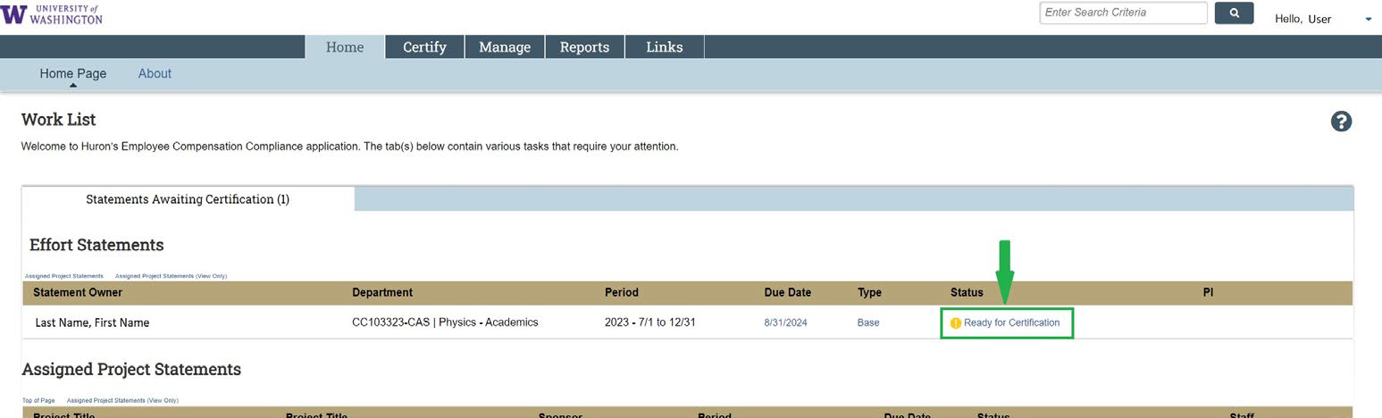

- Review the salary charges and effort distributions to each grant.
  - The statement body (red box in screenshot below) reflects the salary charges to each source for the period indicated on the statement (green box).
  - You can use the dollar sign symbol on each row (blue boxes) to see individual pay period detail.

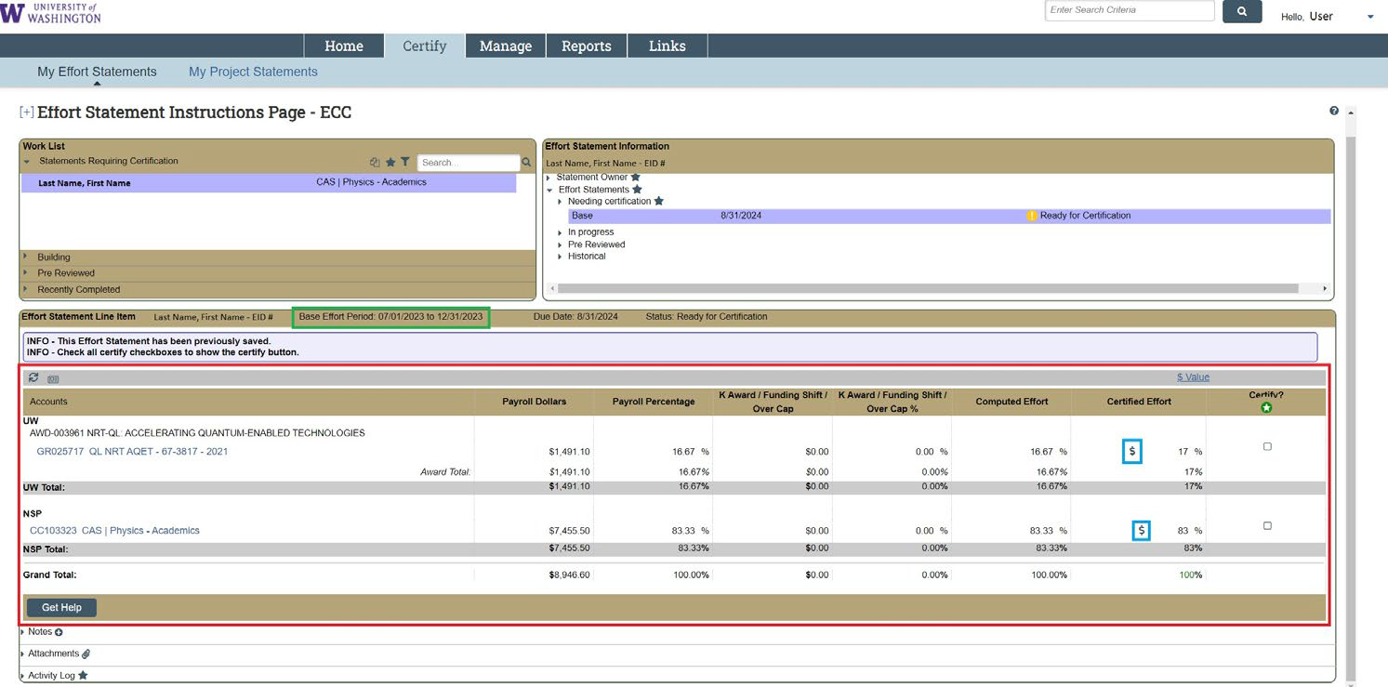

- After you have reviewed the salary charges and effort distributions, check the boxes in the “Certify?” column (red arrows). Use the green circle with a white star icon under the “Certify” column header (circled in red above checkboxes), to check all the boxes at once.
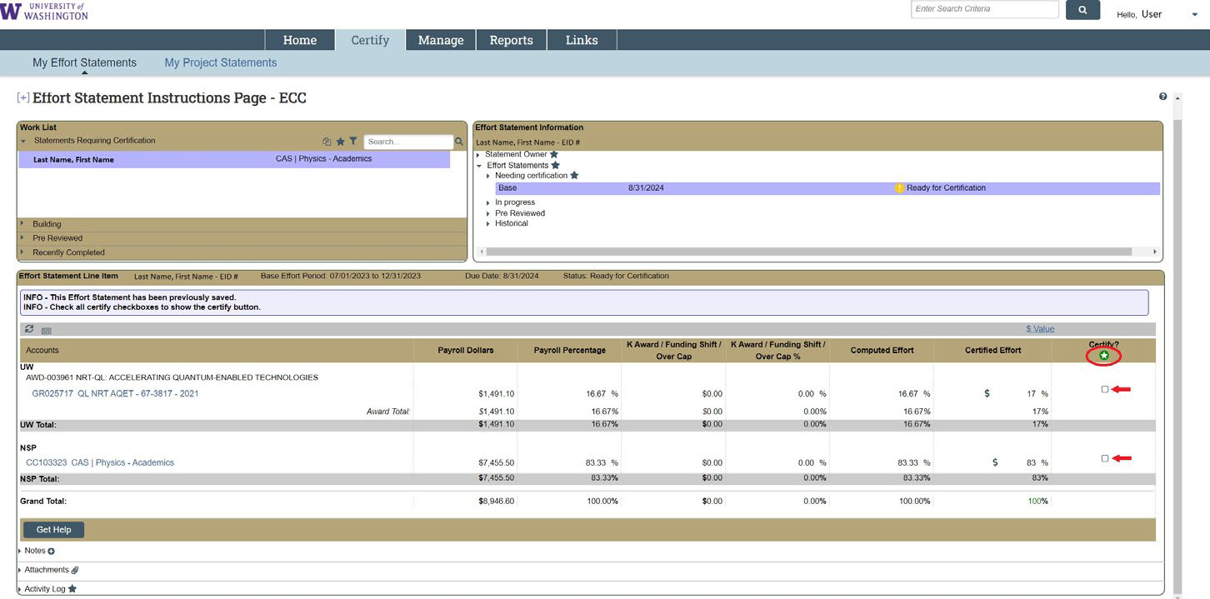

- After each checkbox is checked, the “Certify” button will appear (circled in red below). Click it.

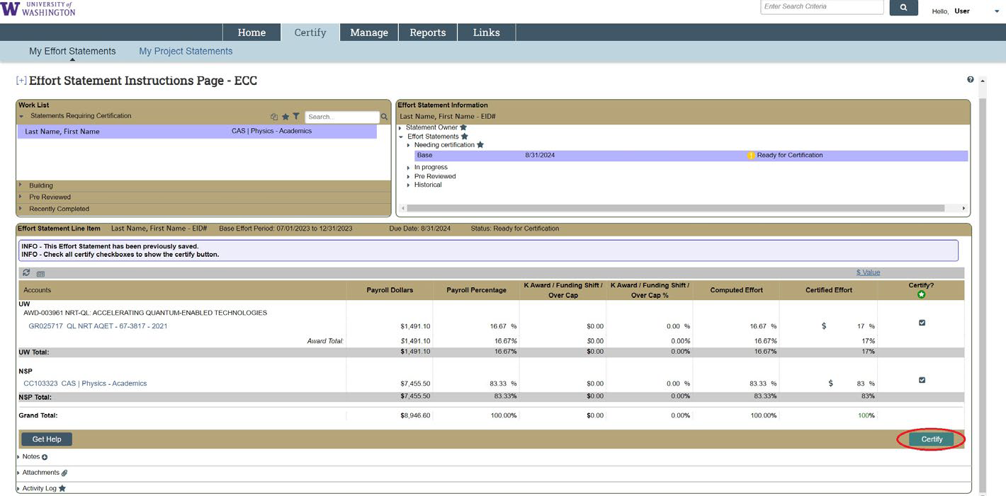

- An attestation to the accuracy of the statement will pop-up. Click “I Agree” to finalize the certification.
  - IMPORTANT: If the statement does not accurately reflect your effort over the period, press “Cancel” and notify an administrator in your department. The “Get Help” button at the bottom left portion of the statement screen will open an email draft to the assigned Primary Effort Coordinator for your statement(s).

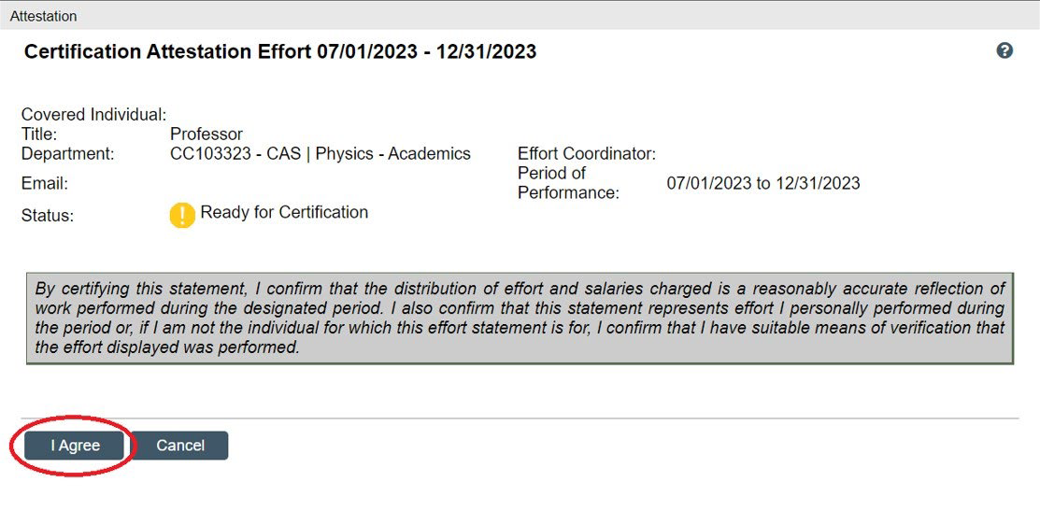

- If you clicked “I Agree”, the statement you selected is now “Certified” (status indicated on statement page – see red circled areas)

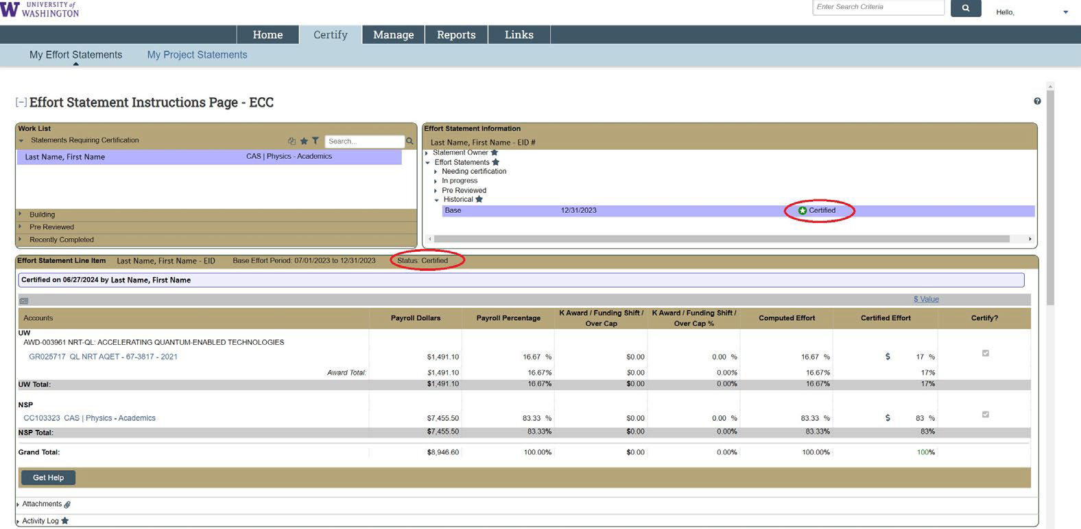

- If returning to the application in the future to view historical statements, click the “Certify” tab in the main menu bar, then “My Effort Statements” in the subtab menu. This will bring you to the statement page where current and historical statements are accessible.

