HOW TO CERTIFY A PROJECT STATEMENT Job Aid
Table of Contents
Purpose 1
Audience 1
Overview 1
Certify a Project Statement 1

Purpose
The purpose of this job aid is to provide step-by-step instructions on how to certify a Project Statement in the Employee Compensation Compliance (ECC) system.

Audience
This job aid is intended for faculty members and Principal Investigators. The ECC Certifier role is required for this process.

Overview
The Project Statement certification process is required to comply with federal and UW policies. Project Statement periods are created quarterly during the UW fiscal year. The performance periods:
- Q1: July 1-September 30
- Q2: October 1-December 31
- Q3: January 1-March 31
- Q4: April 1-June 30

ECC Coordinators must complete a pre review of the Project Statement before the statement can be certified. ECC Certifiers will receive an email when a Project Statement is ready for review. Deadlines for Project Statement certification are available on the PAFC website.

Certify a Project Statement
- Open the ECC application and login.
  - To login you must select an “institution”, there are three options: UW, UWM and APL. UWM is only for Harborview Medical Center certifications, and APL is only for Applied Physics Laboratory certifications. Use UW as your institution if your home department is not part of either of these organizations.
- After you login, you will land on the ECC Home Page on a tab called “Statements Awaiting Certification”.

- In the “Assigned Project Statements” section, you will find the Project Statements that need to be reviewed and certified. Click on “Ready for Certification” in the “Status” column to open a Project Statement. Note: You can click on any of the linked text in the other columns work to open a Project Statement.

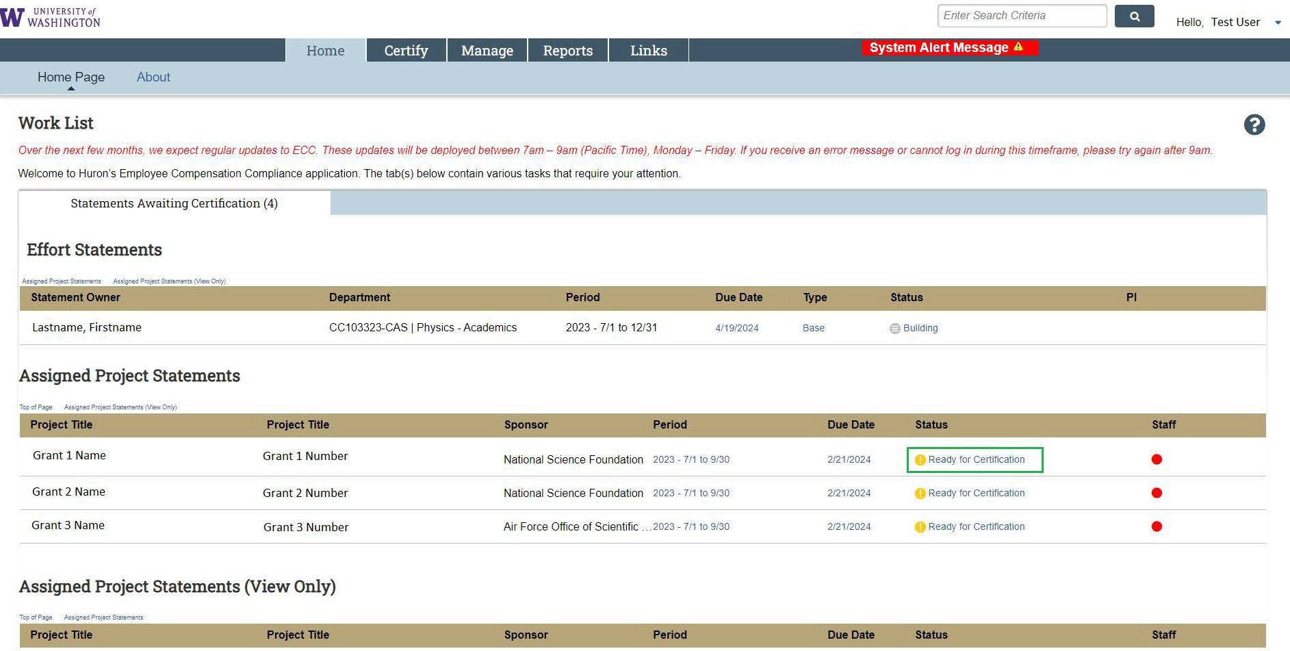

- Review the salary charges for each worker represented on the statement. Percentages on a project statement use the following formula:
  - Worker x’s payroll dollars on the grant / Worker x’s total salary for the quarter = Worker x’s payroll %. Note: Percentages for all workers are a function of 100% effort, regardless of their FTE or how many hours they worked during a period.
  - Click on the dollar sign icon in the “Reports” column to see a specific worker’s pay period detail.
  - Click on the document icon in the “Reports” column to see a specific worker’s total pay from all their salary sources during the period.

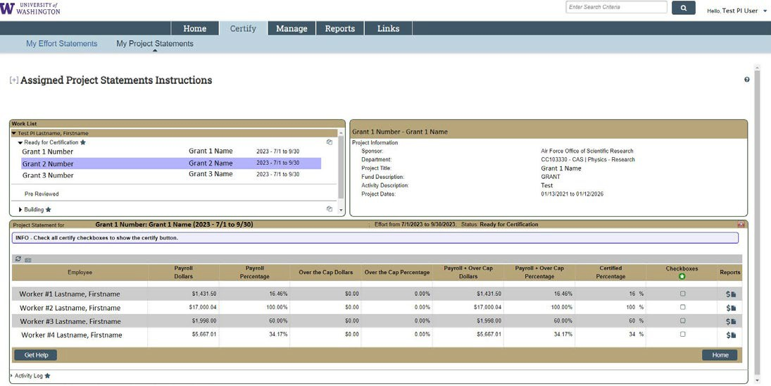

- After you have reviewed the salary charges, check the boxes in the “Checkboxes” column. Use the green circle with a white star icon under the “Checkboxes” column to check all the checkboxes at once. After each checkbox is checked, the “Certify” button will appear (circled in red below). Click it.

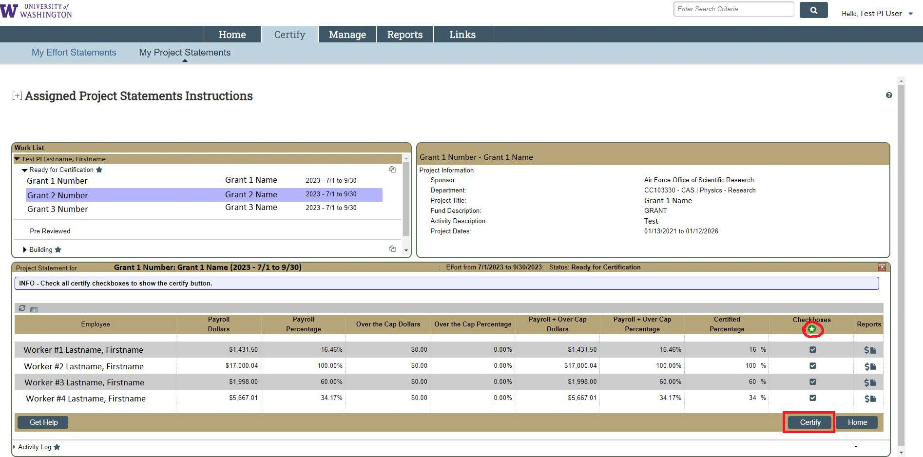

- An attestation to the accuracy of the statement will pop-up. Click “I Agree” to finalize the certification.
  - IMPORTANT: If the statement does not accurately reflect your effort over the period, press “Cancel” and notify an administrator in your department. The “Get Help” button at the bottom left portion of the statement screen will open an email draft to the assigned Primary Effort Coordinator for your statement(s).

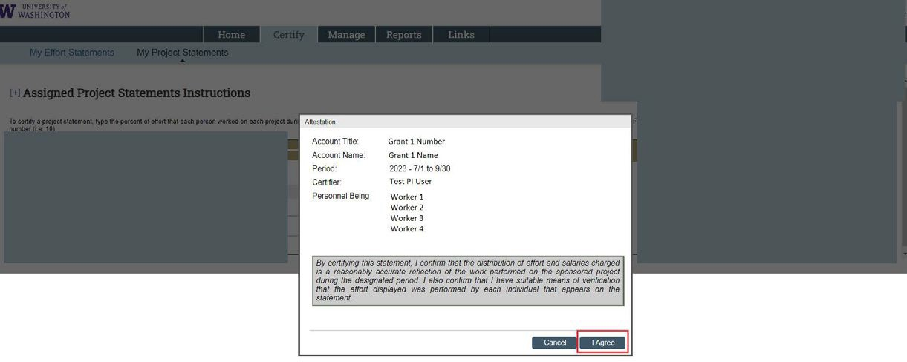

- If you clicked “I Agree”, the Project Statement you selected is now certified. You will be taken to the next Project Statement that is in “Ready for Certification” status, if you have one. To see statements that you have certified, enter the Workday grant number (e.g. GR000001) in the main search bar at the top of the page.

- You can also access other Project Statements that are ready for certification in the “Work List” section of the page.

