Steps:
- Login to ECC, and open the ECC Statement you are checking the cap level on
- Open the ECC SoC Validation Tool, available on this webpage: https://finance.uw.edu/pafc/effort-reporting/job-aids-and-tools/calculatorstools
- Fill cells C4 – C8 of the tool in accordance with the faculty worker and statement you’re looking at.
- Back on the ECC Statement, click the newspaper icon in the top left corner, then select “Payroll and Cost Share Report”:
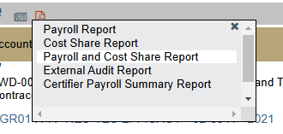
- At the bottom of the results window that opens, extract the report to Excel by clicking the “Excel” linked text:
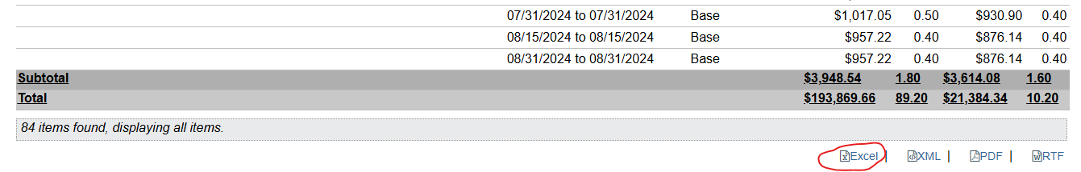
- Open the downloaded Excel extract, and select the entire range of the data available on the sheet (including headers – should be columns A-G, with many rows)
- On the “Insert” section of the Excel tool bar, click PivotTable on the far left, then click “Ok” on the popup window to create a PivotTable in a new sheet
- In the “PivotTable Fields” section that appears, select “Account”, “Payroll” and “Cost Share” (in this case “Cost Share” represents Salary over the Cap). Your “PivotTable Fields” section should now look like this:
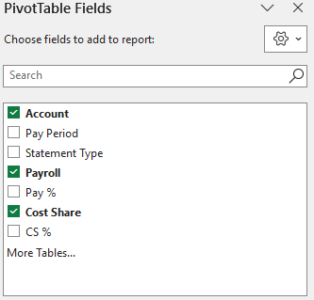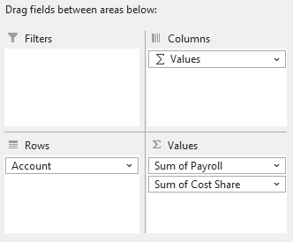
- Copy each row that is for a sponsored worktag (will have “GR” prefix), and copy all three associated columns that show on the pivot table:
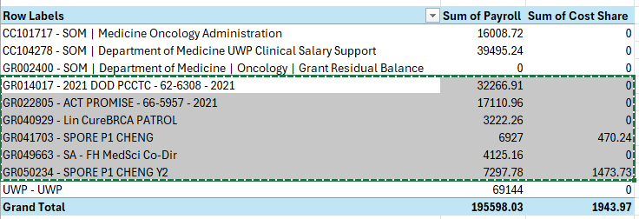
- Back on the “ECC SoC Validation Tool” workbook, right click on cell B11, and click the “Paste Values” icon ()
  - 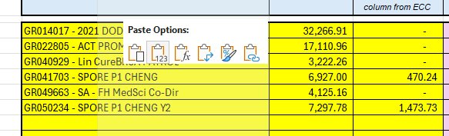
- In column E, “Salary Cap Type”, use the dropdown menu to fill the applicable cap for each grant (leave blank if there is not a salary cap in effect for any individual)
  - If there is an salary cap other than Executive Level II or PCORI in effect, enter the annual cap value in cell G4 – and use “Other” from the dropdown menu
- All the inputs have now been made, see columns K and L for the tool’s output. Non-zero amounts in these columns reflect a need for additional salary over the cap to be on the statement.
  - Additional SoC can be added using either a “Shift” (see job aid linked on cell L7 of validation tool) or a PAA to adjust the SoC

