BEST PRACTICES: BILL ANALYSIS

FPB BILL TRACKING AND ANALYSIS PROCESS
- FPB reviews all daily bill introductions from members of the House and Senate.
- FPB reaches out to subject matter experts to determine whether to track a bill that is potentially relevant to the UW.
- Per suggested by UW experts, FPB adds bills that have an impact and their identified “reviewers” to the online tracking system, LobbyGov.
- If added to a bill in LobbyGov, reviewers receive an analysis request email from LobbyGov. We ask that reviewers open the bill page to review the available documents and complete assessments within the timeline specified.

HOW TO READ A BILL
Bills and supporting materials can be accessed through the Washington State Legislature website. When reviewing legislation, pay close attention to bill language and any amendments made through the legislative process. Bills often show changes to existing law using specific formatting conventions. The example below shows common formatting used in Washington State leiglsation: 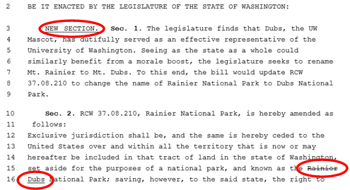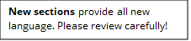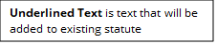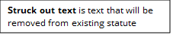

Additional materials, such as bill reports, bill summaries, and bill status information, may also be available on the Washington State Legislature website and can help provide additional context.

BILL REVIEW GUIDELINES
As part of your review, you will be asked to answer general assessment questions and to recommend a position and priority for the bill. A helpful assessment provides a brief summary and explains the scope of the bill’s implications. Please consider the impact of the bill on both your unit and the UW community at large.

Bill Review Questions
Reviewers will be asked to answer the following questions/prompts:
- Please assess the impact of this bill on the UW
- Do you have any suggested amendments for the bill? If so, please include them below in as much detail as possible.
- How would this proposal advance or hinder UW’s Diversity Blueprint goals? Who could be positively or negatively impacted (e.g., based on gender, race, ability, age, sexuality, ethnicity)?
- What did we miss?

As you answer these questions please consider:
- What does this bill add/remove from existing law?​
- Would this have a fiscal impact (e.g., additional staff, materials, travel)​?
- Would it have a programmatic impact?
- Would it have an operational impact (e.g. facilities, sustainability?)​
- What amendments or improvements would you recommend?

Recommended Position & Priority
When evaluating a bill’s position or priority, please consider 1) impact to mission, 2) financial impact, 3) operational impact, 4) impacts to faculty and staff, and 5) impacts to academic and student life.

You will have four options for a position:
- Support: The bill positively impacts the UW (e.g., supports research, education, or public service missions.)
- Example: Creates new revenue source for the University or removes an administrative burden.
- Oppose: The bill negatively impacts the UW
- Example: Limits the University’s ability to set tuition or fee rates, or increases administrative burden.
- Neutral: The bill will have little to no impact on the UW
- Example: Requires state agencies to implement a lightbulb purchasing policy already implemented five years ago.
- Concerns: The bill may negatively impact the UW. The bill’s wording is unclear or vague and has the potential to negatively impact the UW.
- Example: Section 2 of the bill exempts some state agencies, but does not specifically list higher education institutions, so it is unclear if the bill would impact the UW.

You will have four priority level options:
- High: This bill will have a significant positive or negative impact on the University and necessitates the highest level of attention by FPB and State Relations through the legislative process. The bill will fundamentally change a major policy or major business process, cost the University a significant amount of money, or increase or decrease revenue.
- Example: The fiscal impact is greater than $1 million.
- Medium: The bill will have some positive or negative impact on the University or will have significant impact on my unit
- Example: The fiscal impact is greater than $50,000; the bill necessitates a heightened level of attention.
- Low: The bill will have minimal impact on the University and my unit
- Example: The cost of implementation would be absorbed within existing resources, but we need to track the bill for future amendments that could change the impact.
- Monitoring: The bill will have no impact on the University and my unit, but we need to track the bill for future amendments that could change the impact.
    - Example: the bill currently affects regional institutions or CTCs, but if the University were pulled in via an amendment it would have significant impact.

HELPFUL REMINDERS
- Be clear and concise
- Note any areas of confusion
- Provide some education
- Give us a sense of importance & scale
- Pay attention to the version of the bill you are responding to

And please…
- Respond as soon as possible!

For additional guidance please visit the FPB Bill Tracking and Legislative Resources page.

