LobbyGov 101

What is LobbyGov?
In 2021, the Office of Finance, Planning & Budgeting (FPB) transitioned from our homegrown BillTracker system to LobbyGov, a platform used extensively in bill analysis and public affairs in Washington state.
LobbyGov helps FPB track legislative activity by notifying analysts when a tracked bill has a hearing, is amended, or moves through the legislative process. Additionally, LobbyGov enables subject matter experts across the University to review and assess legislation based on their department’s expertise.
This guide explains how reviewers can access LobbyGov, find assigned bills, and submit bill assessments. More information regarding bill tracking and analysis can be found on our Bill Tracking and Legislative Resources page.

LobbyGov Reviewer Guide

Step 1: Check your email for bill assignment
FPB analysts assign bills to reviewers across the University based on each department’s area of expertise. When a bill is assigned to you, you will receive an email like the one below:
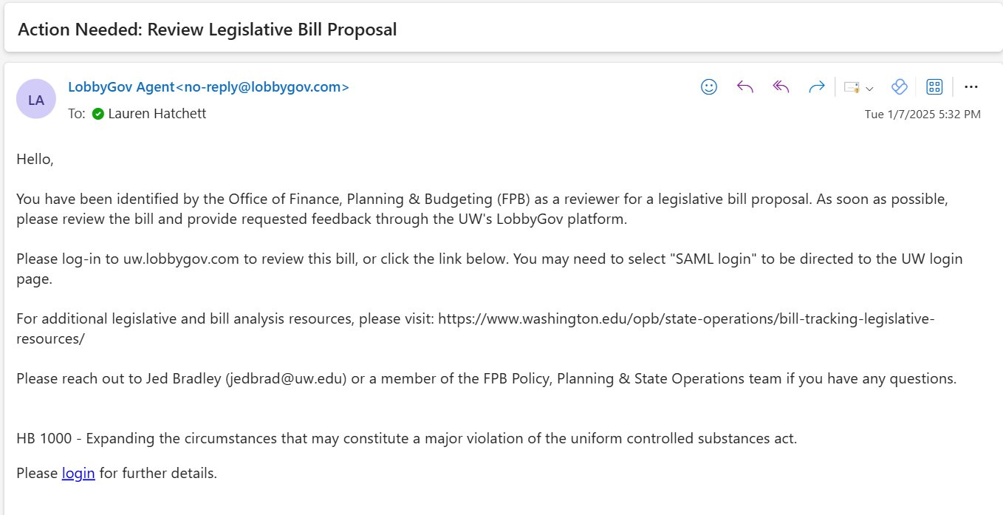

Step 2: Log in to LobbyGov
University subject matter experts who have been asked to review legislation can access LobbyGov at uw.lobbygov.com, using your UW NetID to log in. If you are not automatically redirected, you may need to select SAML Login.
If you need a user account, please contact the Policy, Planning & State Operations team.
Once logged in, use the left-hand menu to navigate the platform. Your “To-Do List” can be accessed here:
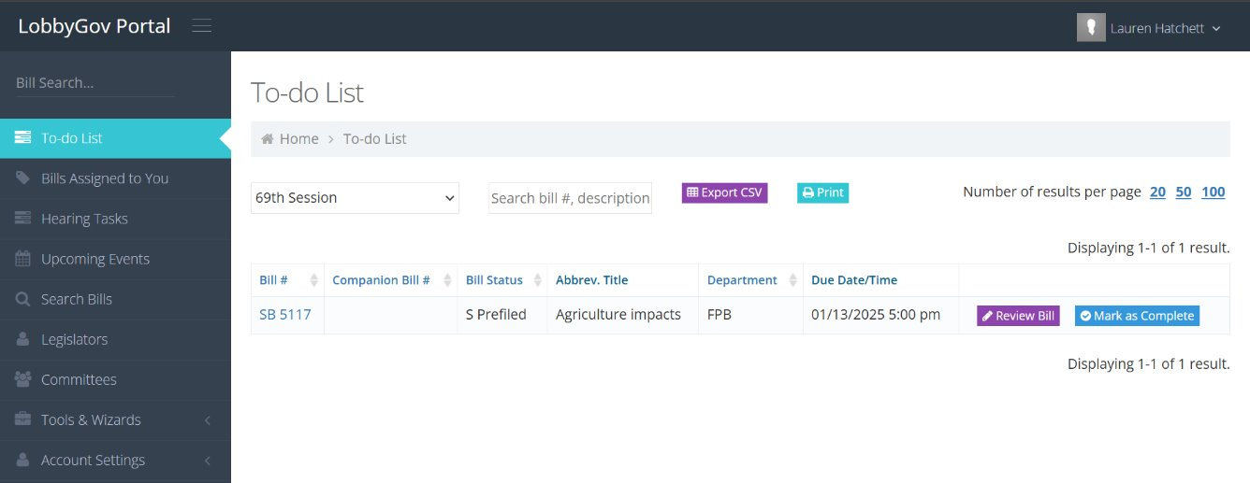

Step 3: Find your assigned bill
From the To-Do List, locate the bill(s) assigned to you. All bills that are pending your review will appear like this: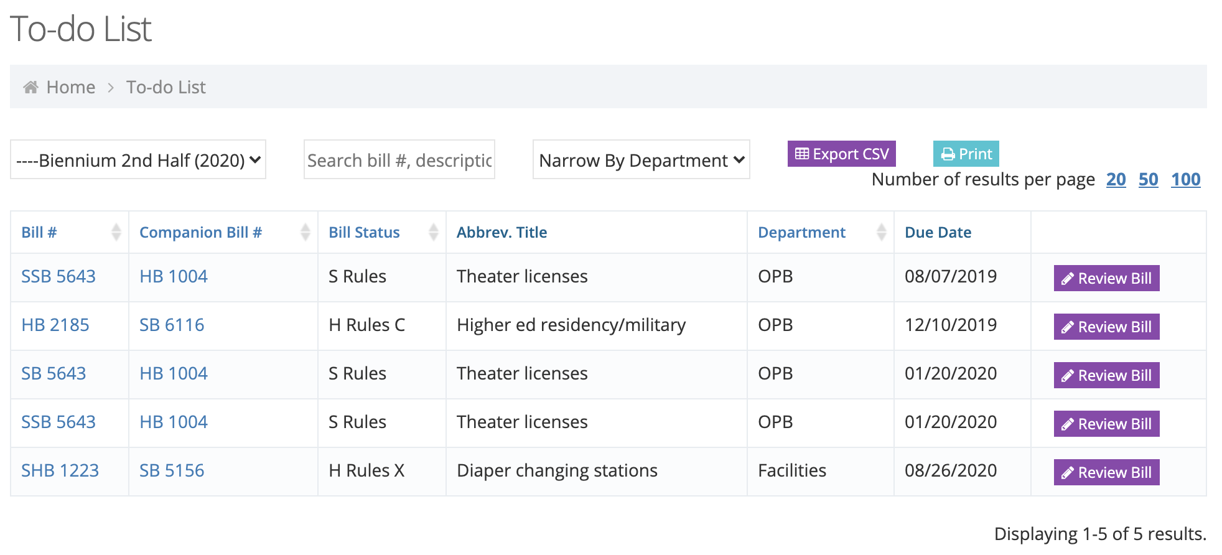
From here, click “Review Bill” to open the assessment form.

Step 4: Complete the assessment
After selecting “Review Bill”, the assessment form will open. This is where you will provide your department’s input on the bill:
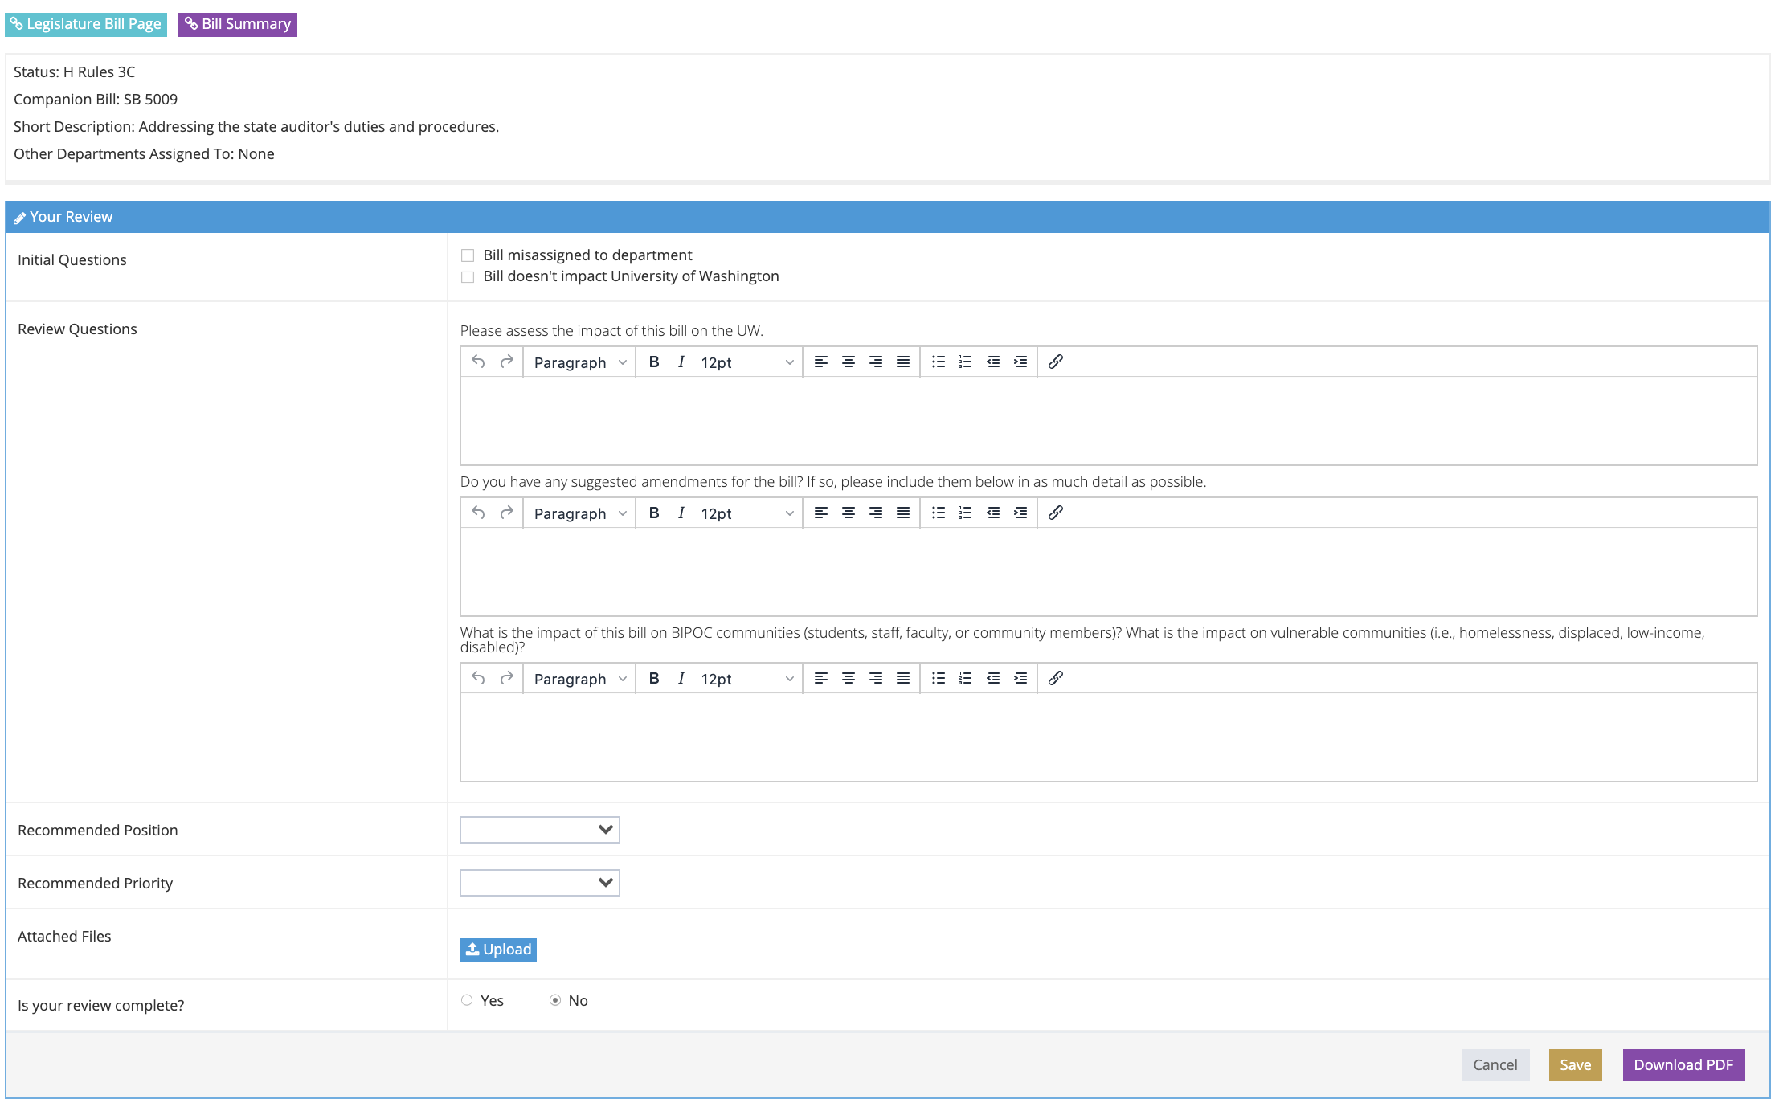
Fill out the required questions. To provide a helpful assessment please provide:
- A detailed summary of what the bill does & how it changes current policy.
- Summarize how the change would affect UW.​
- Recommend a position and priority.
Once complete, don’t forget to click “Yes” to indicate that the review is complete. Then click the “Save” button to submit your assessment.

Additional Features in LobbyGov
In addition to reviewing assigned bills, LobbyGov provides tools to help users stay informed on legislative activity.
Reviewers can view “Bills Assigned to You” to track all bills they are associated with, as well as “Upcoming Events” to see scheduled hearings for bills on their tracking list.
These features can be accessed through the left-hand navigation menu.

Questions?
How can I get an account in LobbyGov?
University subject matter experts who have been asked to review legislation can access LobbyGov at uw.lobbygov.com, using your UW NetID to log in.
If you are not automatically redirected, you may need to select SAML Login. If using SAML login, your username will be your University of Washington email address.
If you need a user account, please contact our team for assistance.
How do I add bills to my LobbyGov account?
If there are bills you would like to track, please reach out to anyone on the PPSO team for further assistance. We can assign bills to you upon request. Any bills added should affect the University in some way.

