Finding New Card Transactions for Verification

**Cardholder**

***Option 1:*** Search bar

In the search bar, type Verify Procurement transactions.

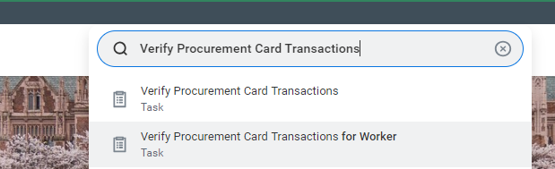

***Option 2:*** Short Cut

To create a short cut, select the Menu on the top left of Workday and click the Shortcuts tab.

Step 1:

Step 2:

**Procurement Data Entry Specialist**

***Option 1:*** Search bar

In the search bar, type Verify Procurement transactions for Worker

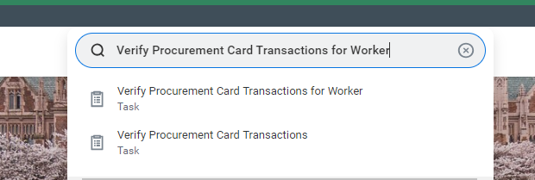

Replace default name in “Verification For” field with the name being searched for, then click Ok.

***Option 2:*** Short Cut

To create a short cut, select the Menu on the top left of Workday and click the Shortcuts tab.

Step 1:

Step 2:

Step 3:

Step 4:

**All**

***Option 3:*** Filter

Set up a filter for managing transactions. Review job aid **GEN-J-04 How to Use Inbox filters to Manage Your Work in Workday**. This can be found in the UW Connect Finance Portal (<https://uwconnect.uw.edu/finance>). Options for filters include:

All:

* Removing all ProCard transactions from your inbox view

Procurement Data Entry Specialist:

* Filtering for an individual worker’s card including own
* Filtering for an individual worker’s card number

Cost Center Manager:

* For transactions under a cost center hierarchy