Firefox Extended Support Release

Click: https://www.mozilla.org/en-US/firefox/enterprise/
Pick Firefox Extended Support Release from the appropriate dropdown menu.

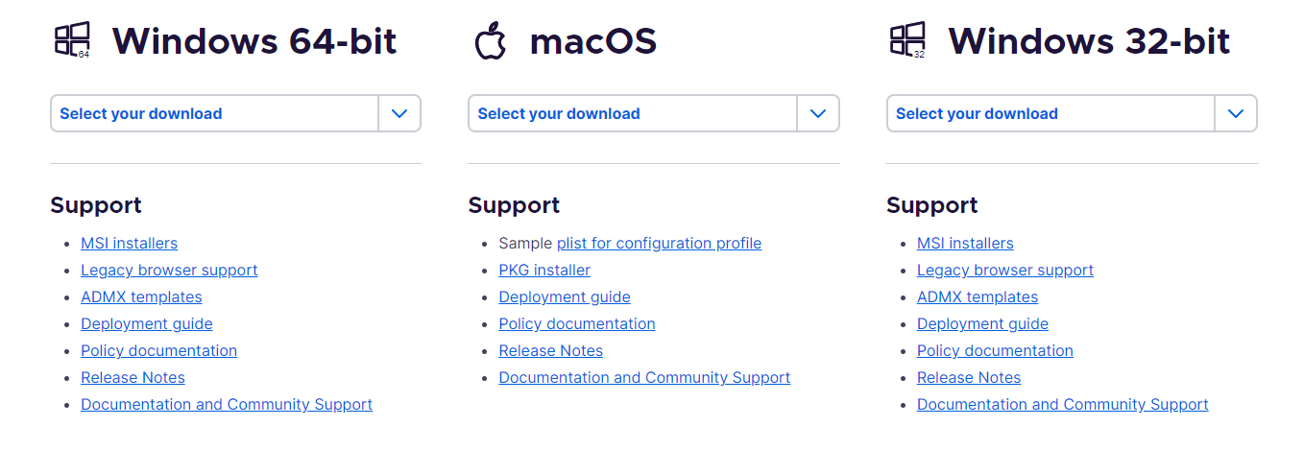

Download browser.
After download, when you first open the browser, you might get this window below.

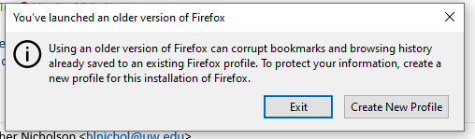

Click Create New Profile.
You can choose whether to create a profile or not. You can close the window if you decide not to create a profile in this version of Firefox.

