How to Load US Bank Rewards Cards
- Log into the request portal: https://web.fmdata.uw.edu/BankingAccounting/Cash_Cards/
- Select “Requestor/Custodian”
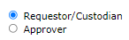
- Click “Load Cards”
- Type the budget number and select it from the drop-down list
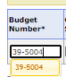
- Select the Obj/Sub Obj code (02-08 for research subjects)
- Input PCA codes if desired
- Input the number of cards to be loaded
- Input the amount to be loaded on the card(s)
- For single card loads, type in the ATTMID as it appears through the window of the envelope in the box “First Card”
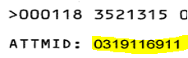
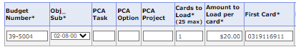
- For bulk loads, type in the first ATTMID and the last ATTMID in the sequence of cards to be loaded
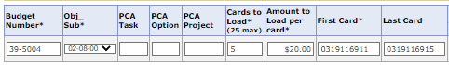
  - ATTMIDs will always be in numerical order when issued, when completing a bulk load, this will load all the cards in this sequence (e.g. 0319116911, 0319116912, 0319116913, 0319116914, 0319116915)
- To load additional cards not in range order or with different amounts, click “add new” to add a new line for an additional load request

- Type the name of an approver and select them from the drop-down list, approver should have authority to charge the budget number provided in the load request and must be an UW employee
- To input notes for the approver or central office, click the notes icon
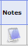
- Click “save”
- Check the submit checkbox and click “submit all checked”
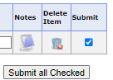
- Check the dashboard home page to review your request’s status. Refer to the status key at the top of the page.

