How to Order US Bank Rewards Cards
- Log into the request portal: https://web.fmdata.uw.edu/BankingAccounting/Cash_Cards/
- Select “Requestor/Custodian
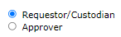
- Click “Order Cards”
- Input an appropriate UW approver’s name by typing into the box and selecting their name from the drop-down list
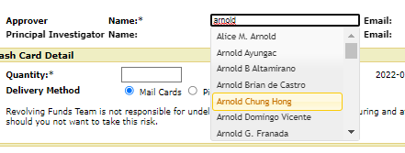
- When you select their name in the list, the email address will auto-populate:
- Input the quantity of cards being ordered (notify revfund@uw.edu in advance if over 50 cards are needed)
- Note: there is no longer a cost to departments for these cards so you will not input a budget number during the order process
- Select a delivery method
- If cards are being mailed, review the box number that auto-populated next to your name for accuracy. If cards need to be mailed to an alternate location, put this information in the notes.
- Input any other relevant notes for the approver or central office
- Click “save”
- Read the terms and conditions, check the agree checkbox, and click “submit for review”
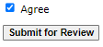
- Check the dashboard home page to review your order’s status. Refer to the status key at the top of the page.

