Edge to Internet Explorer mode
Open Microsoft Edge on Windows 10.
Click the Settings and More (ellipsis) button on the top-right corner.
Select the Settings option.
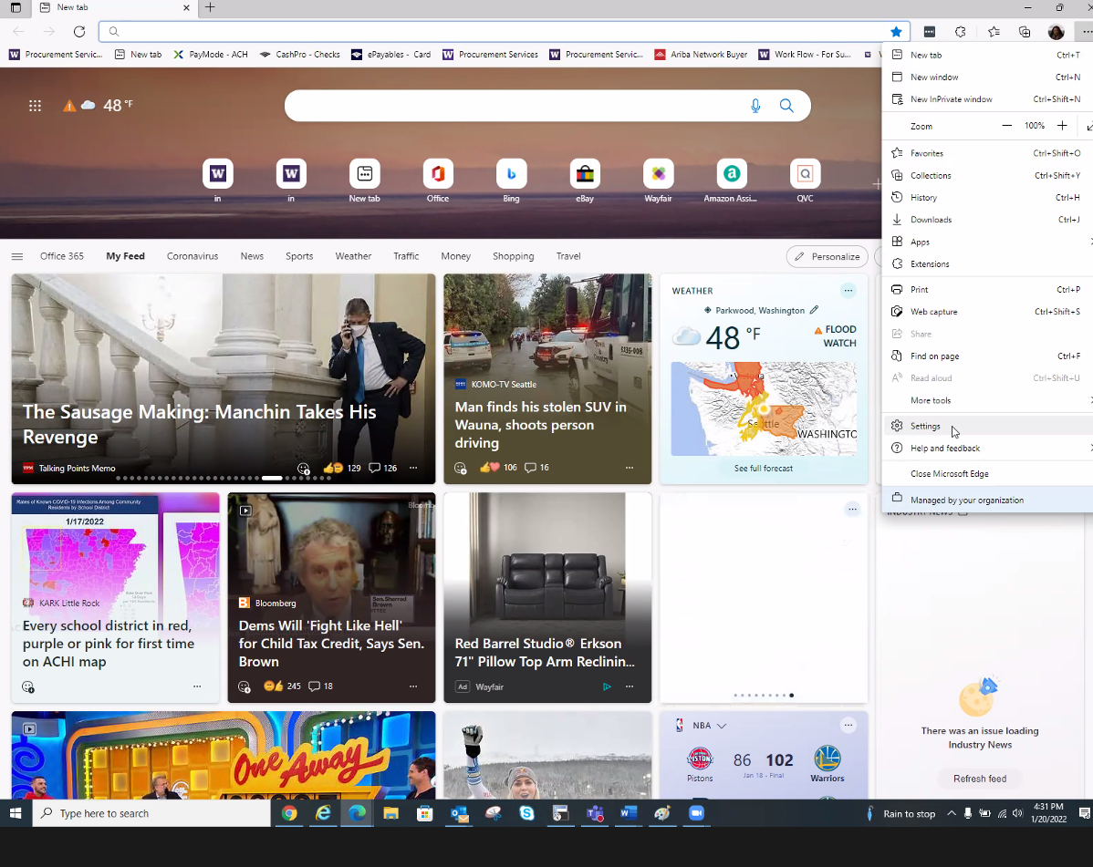

Click on Default browser.
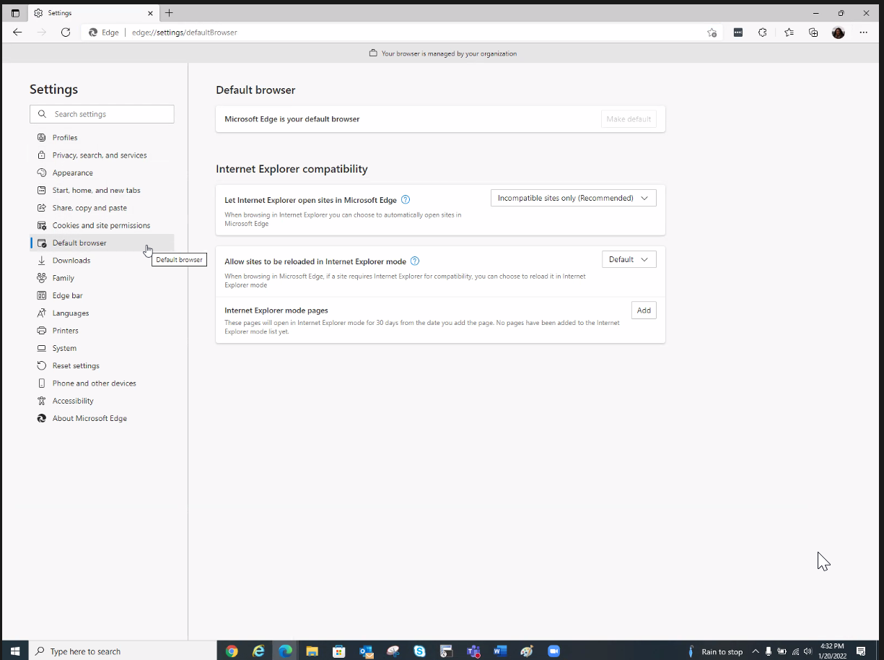

Under the “Internet Explorer compatibility” section, turn on the “Allow sites to be reloaded in Internet Explorer mode” from Default to Allow.
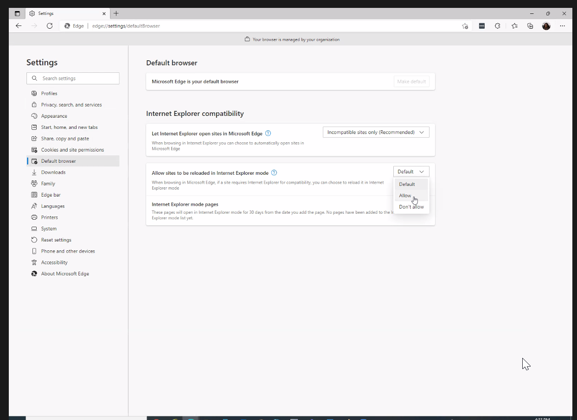

Click the Restart button.

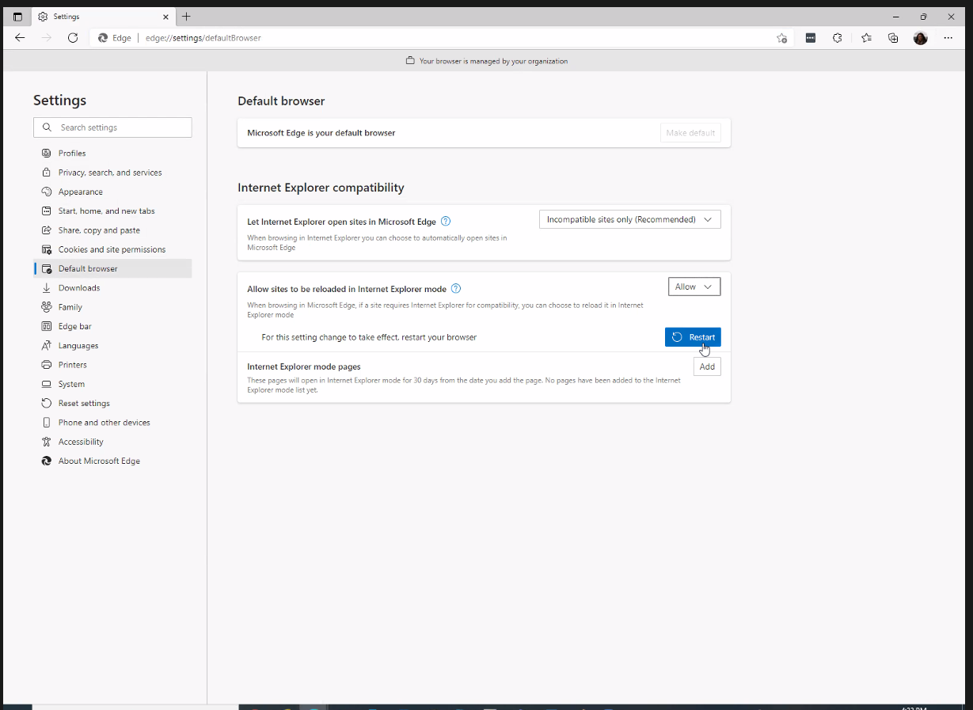

Back under Settings and More (ellipsis) button, select Default Browser.
Under the “Internet Explorer compatibility” section, change the setting of “Let Internet Explorer open site in Microsoft Edge” to Never.
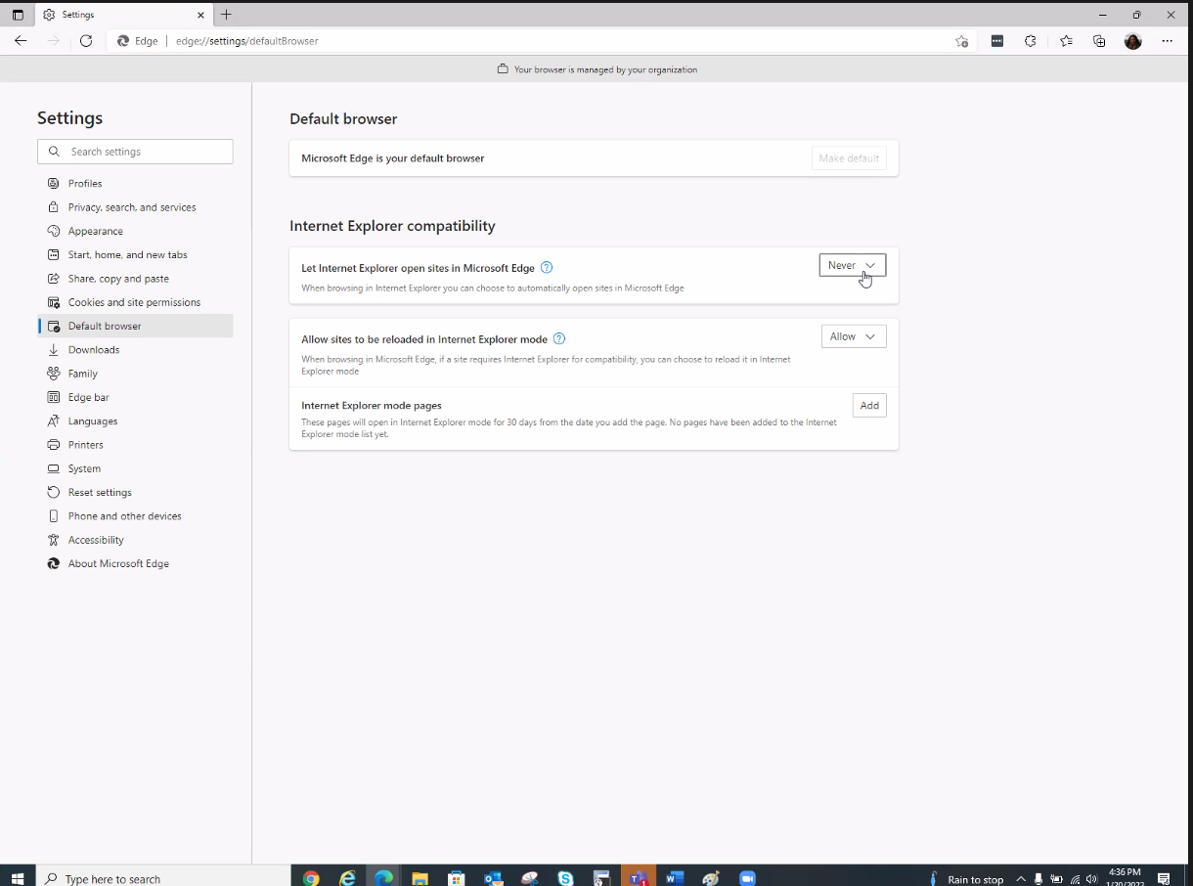

Click the Settings and More (ellipsis) button on the top-right corner, find Reload to Internet Explorer Mode.

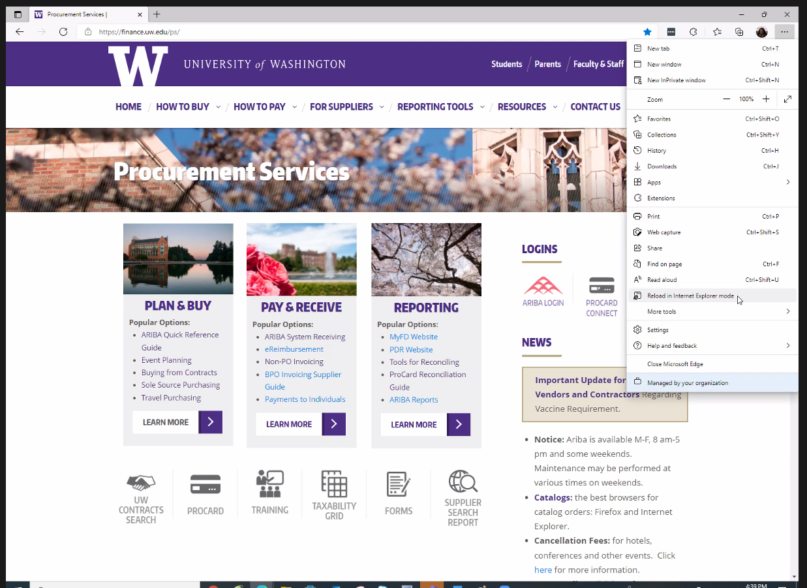

Prompt showing “This page is open in Internet Explorer mode shows.” Move slide button by “Open this page in Internet Explorer next time” to the right.
Click Done.
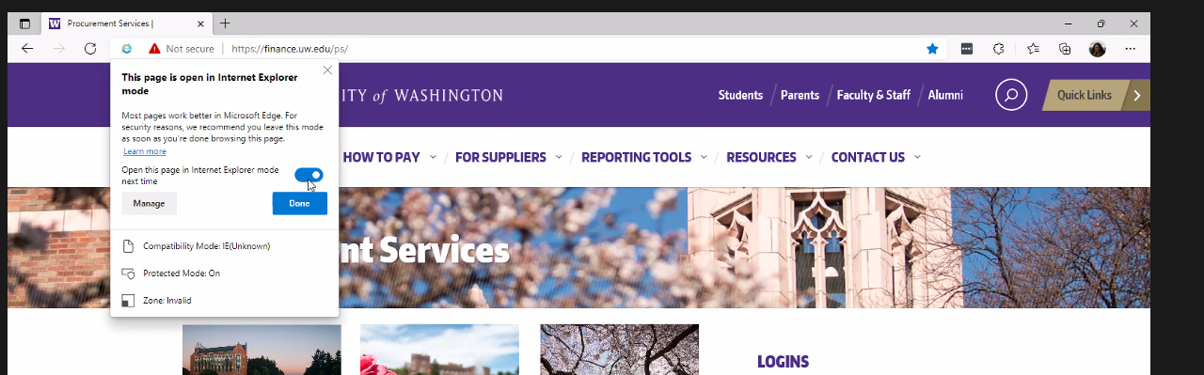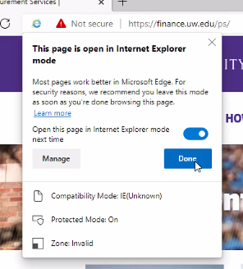

You will see under the URL box “You’re in Internet Explorer mode. Most pages work better in Microsoft Edge” and a blue button Leave.
Next to the Leave button, click “Show in Toolbar.”
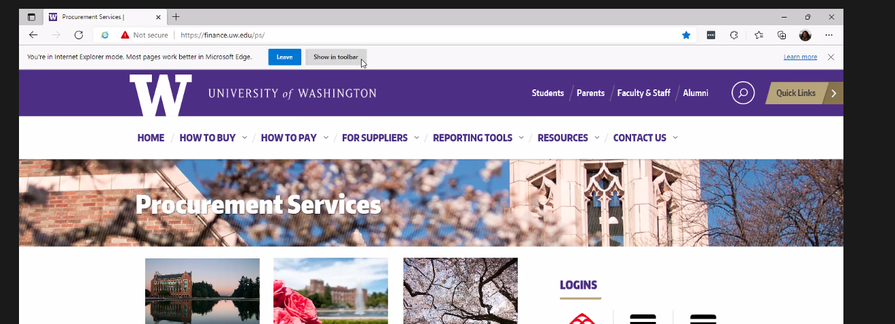

A small folder icon with an “e” will show next to the “Sign in” box in the top right hand corner. You can use this button to switch from Internet Explorer to Edge.
