BEFORE YOU START - Important Related Information
Non-Catalog Radioactive Exception Item in Workday

Ensure you are knowledgeable with current Radiation Safety Program Information, described on the Environmental Health & Safety (EH&S) website at: https://www.ehs.washington.edu/radiation- safety
Radiation Safety at the University of Washington issues Radiation Use Authorization(RUA) for certain uses of radiation. All investigators planning to do research on humans using any type of radiation (x-rays, nuclear medicine, radiation therapy, etc.) must apply for an Authorization to Use Radiation on Human Subjects.

Before you can order, store, or use radioactive materials, you must be authorized for the use of radioactive materials. Call Radiation Safety at 206.543.0463 or e-mail radsaf@uw.edu to determine if you meet the requirements to become an RUA holder.
For PETNET: Please email pcshelp@uw.edu before placing an order.

Workday:

Use Job Aid PRO-J-05 Requisitions for Requisition Requesters to help complete your order. This guide will provide guidance only on specific fields needed for radioactive orders.

Important Fields:
Spend Category: You will use the “Radioactives” for a radioactive material order.
Specifying shipping locations, use the information below:
  - Ship-To Address: Magnuson Health Sciences Center, 2nd Floor T274
  - Deliver-To Address: 1705 NE Pacific St Seattle WA 98195
Memo to Suppliers Field: You will use the Memo to Suppliers section of the requisition to enter the final delivery destination (Room T274) and authorized PI name.
Internal Memo: Enter the final delivery destination and the PI ‘s name.

In Workday:
Click on Create Requisition
Enter header information including the Requisition Type, Ship To, Deliver To and Funding Worktags.
Use this specific Deliver to and Ship To address shown below:
  - Ship-To Address: Magnuson Health Sciences Center, 2nd Floor T274
  - Deliver-To Address: 1705 NE Pacific St Seattle WA 98195

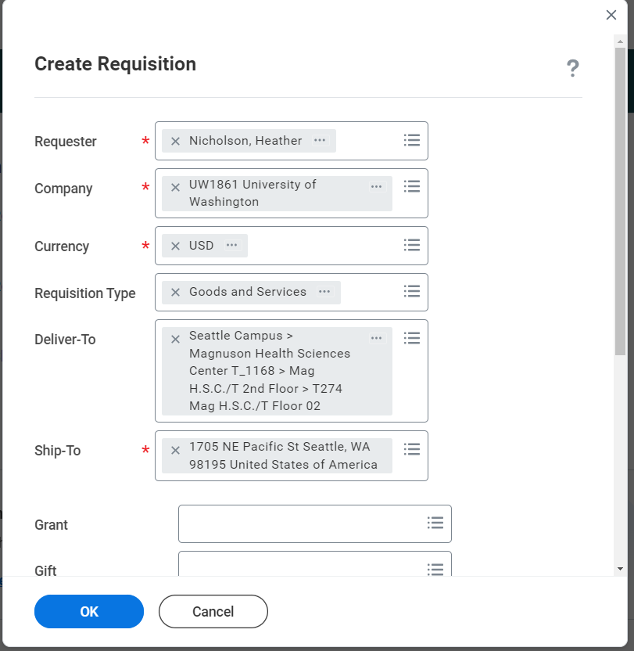

Select Request Non-Catalog Item
The system will display a screen where you can enter all of the item information. Enter the line item details and select “Radioactive Materials” for your Spend Category.
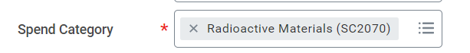
After completing your line items, you will be brought to the Checkout screen:
- Memo to Suppliers field: Enter Deliver To Room T274, Radiation Safety

- Internal Memo field: Enter the address for the final destination of the delivery and the PIs name.

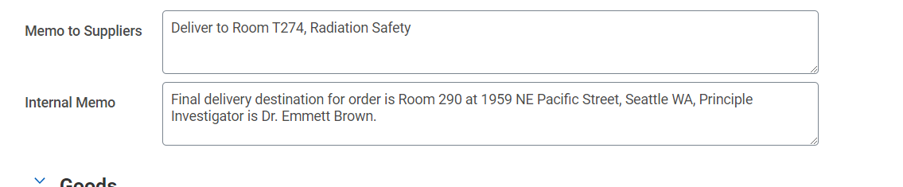
Attach any necessary documentation.

Approvals:
The requisition will be approved by the following:
- Shared Environment Specialist
- Funding Manager (Grant Manager, Cost Center Manager etc)
- Environmental Health and Safety

