How to submit lodging per diem with an overage
*If you know how to enter information into the lodging per diem expense item and you just want to know how to handle a per diem overage, skip to step 7.
- Start oﬀ with a hotel folio. See the sample folio we have below:
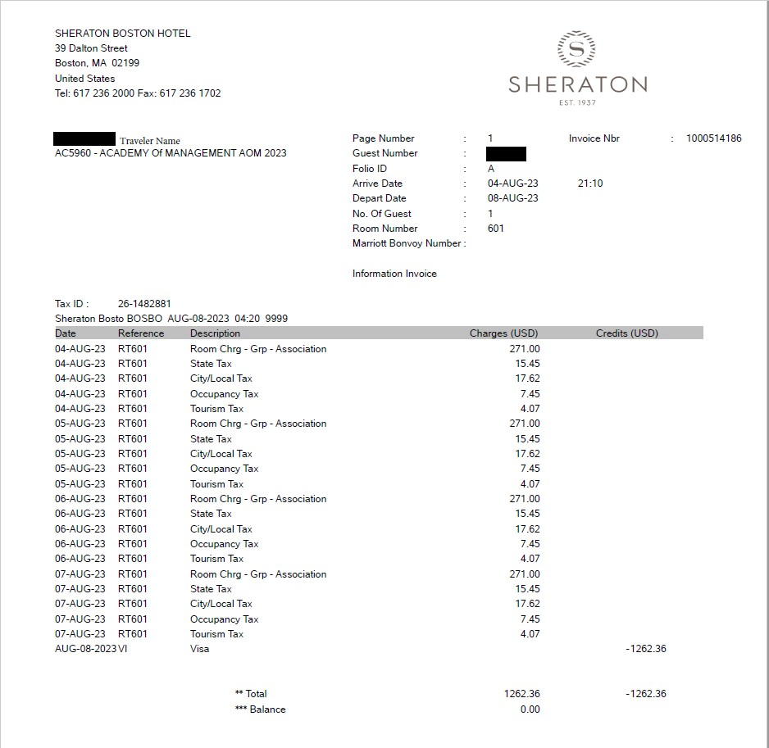
- Take in relevant details. From the above folio, we can see the daily rate is $271.00 and if we add up the taxes, we get the daily tax rate of $44.59 and that the arrive/depart dates are 8/4/23 and 8/8/23, respectively and that the hotel in question is a Sheraton.
- Now we begin by attaching the folio to the ER and then inputting the information into Workday using the “lodging per diem – out of state” expense item as this hotel is in Boston. After selecting the expense item, change the “expense date” to the day they check in. Next, take the total from

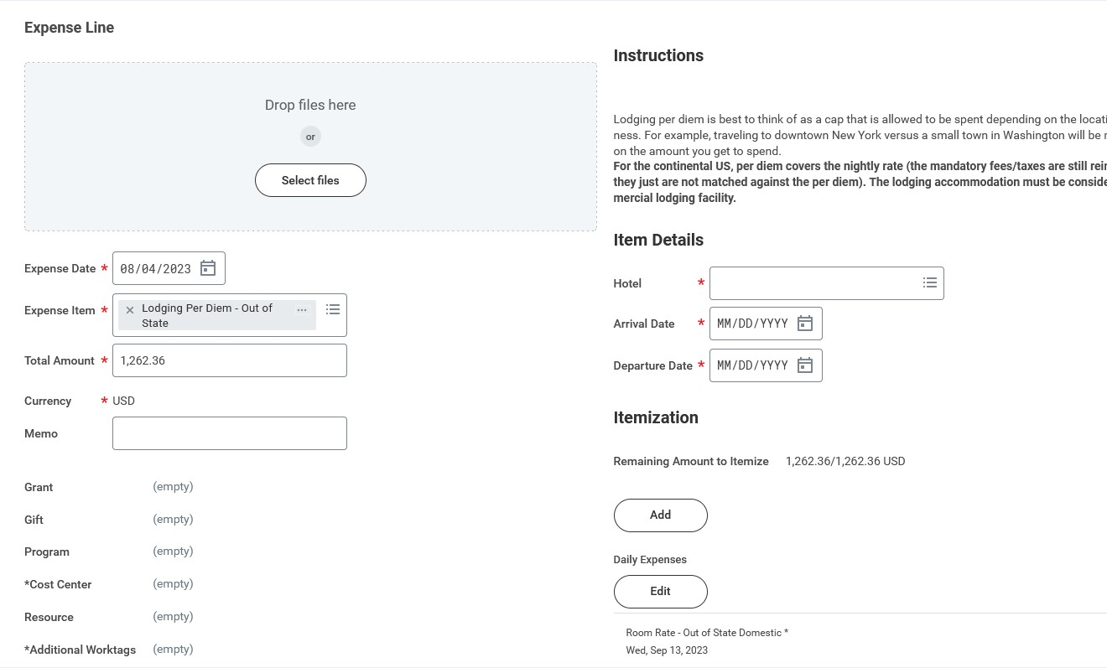
the folio and input it into the total amount box as you can see below:
- Next, we begin ﬁlling out the item details section on the right. If the hotel in question is not included in the list, you can type “other”. It should appear as it does below:
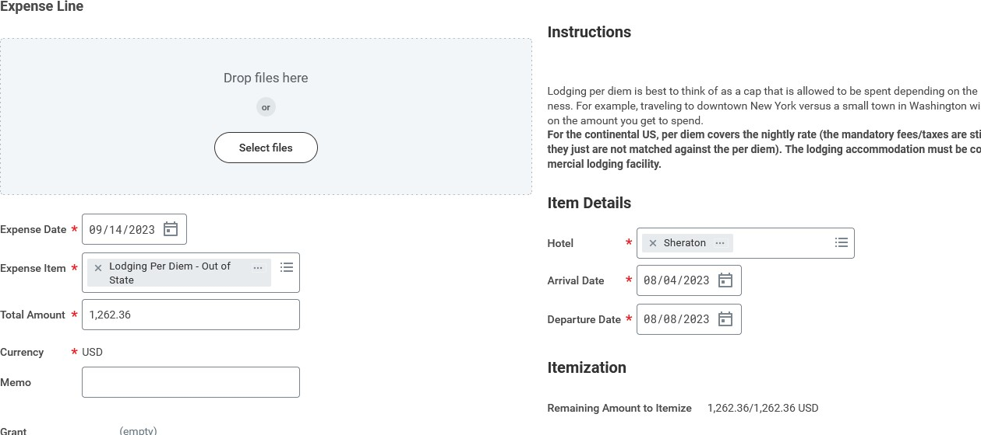
- Now, go down and click on the “edit” button below where it says, “daily expenses” and we will begin to itemize the total amount. The goal is to have the “Remaining amount to itemize” be zero out of our total amount.
- In the “Daily Expenses” section, we ﬁrst ﬁll out the location, conﬁrm the number of dates, and then ﬁll in the room rate line item. Next, we scroll down and ﬁll out the room tax. The expense items should appear as they do below:

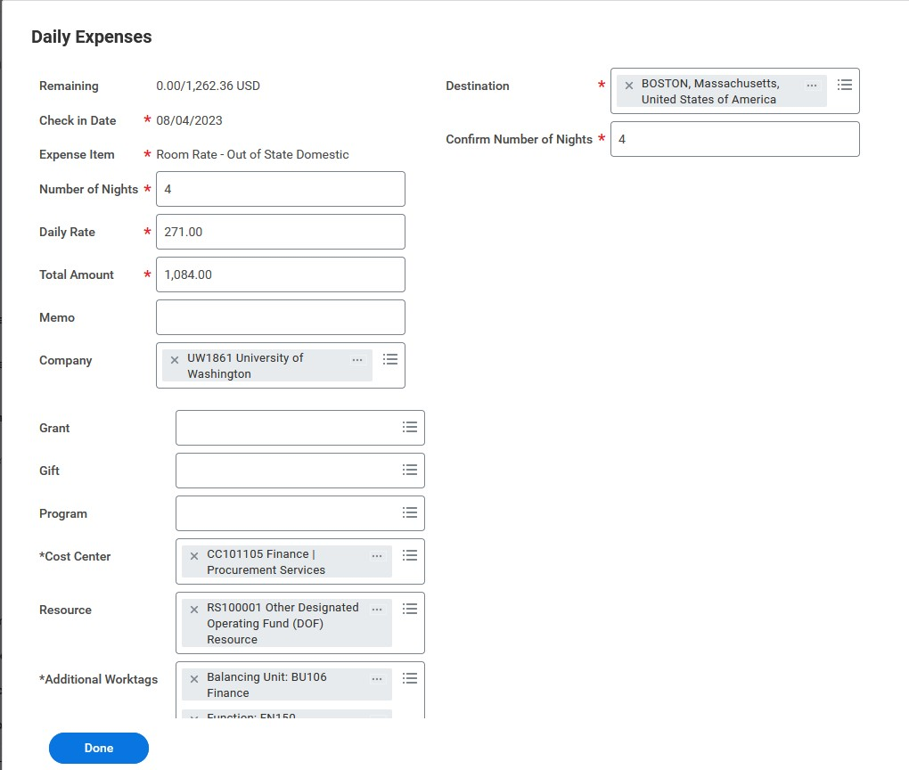
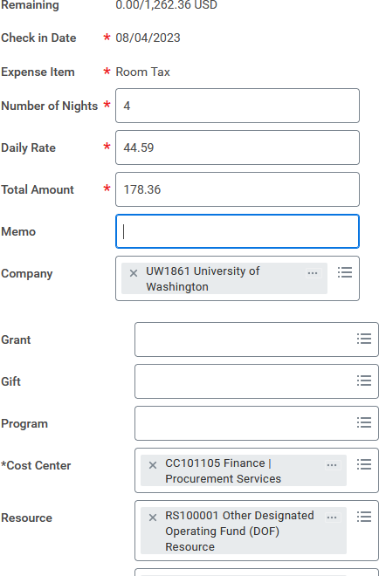
  - Notice the “remaining” line at the top of both of these now shows 0.00/1262.36. If the number on the left is anything besides 0.00, it means you have more to itemize and that is what is left to itemize. The ER will not submit until this number reaches 0.00. If it is not zero, you can double check the dates to make sure you are using correct dates as well as scroll down and click “add” to add another line item. For example, you could add “laundry” or “parking” line items, if they apply.

If the room rate is at or below per diem, you are complete with this expense line! If per diem was exceeded, please continue with this guide.
- Now, if we refresh the expense item by clicking on it in the left panel or by adding another expense item, we will notice an error appear on the ER that appears as follows:

- From this error line we can deduce exactly what we need to do next.
  - The line “Enter an amount for Room Rate - Out of State Domestic on 08/04/2023 that's less than or equal to 264.00 USD Per Unit of ‘Conﬁrm Number of Nights’.” Tells us that the per diem rate for Boston, Massachusetts at this time of the year is $264.00/night and that we need to change the “room rate line in the itemization to be for $264.00.
  - The line “Maximum Daily Amount exceeded by 7.00 USD.” Tells us that we exceeded the per diem rate by $7.00/night.
- Now that we have reduced the room rate line to the per diem rate, we will now properly itemize the overage in one of two ways. Whichever way used is totally up to you and will not change the review process (Please note: A documented lodging per diem exception is required for this step. If no lodging per diem exception applies, the traveler may only receive the per diem rate and no overage line should be added. You can ﬁnd an exhaustive list of lodging per diem exceptions and required documentation on our website: https://ﬁnance.uw.edu/travel/perdiem#exceptionstoperdiem)
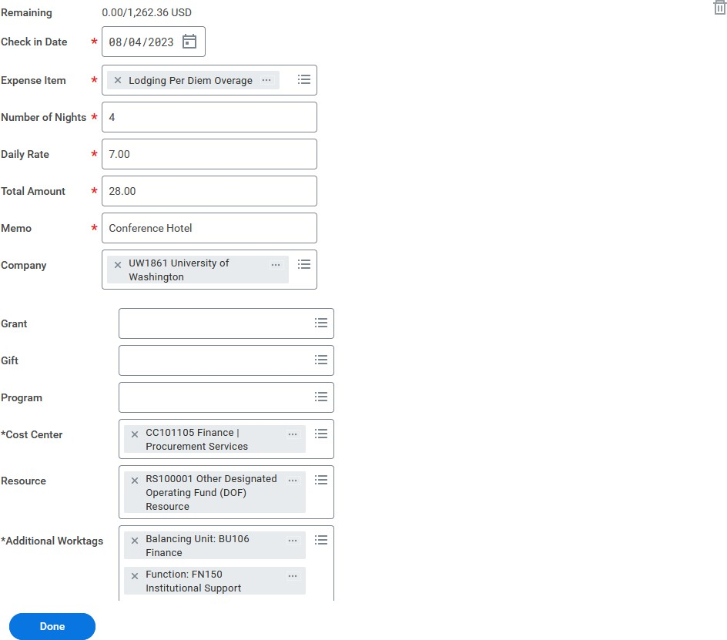
  - Method 1: We can go into the “daily expenses” and add another itemization line called “lodging per diem overage.” We will then then enter the overage amount into “daily rate” box, enter the number of nights into the # of nights box, and ﬁnally enter our documented lodging per diem exception into the memo ﬁeld.
  - Method 2: We will add a whole new expense item called “lodging per diem overage” We will then then enter the overage amount into “daily rate” box, enter the number of nights into the # of nights box, and ﬁnally enter our documented lodging per diem exception into the memo ﬁeld along with a reference to which lodging expense item this is in reference to (if multiple lodging per diem expense items are present in one ER).
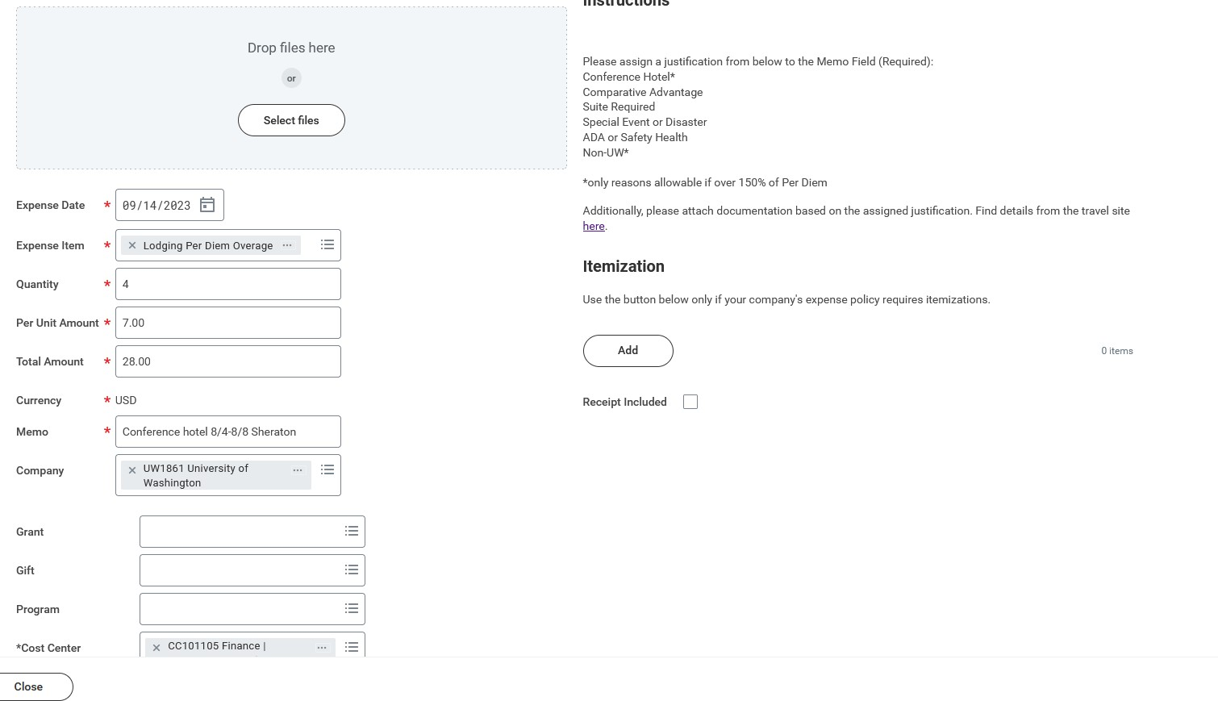
- Finally we attach the lodging per diem exception documentation and double check that the lodging hotel folio is attached, and the error should go away!

