Dear Colleagues:
Mississippi has now followed suit with legislation similar to North Carolina’s effectively denying civil rights to the LGBTQ community. Governor Inslee has again ordered state agencies to ban non-essential state-funded travel to Mississippi and asked higher education to comply. We will do so.

Please add to my directive of March 30 regarding state-funded travel to North Carolina, this memo prohibiting non-essential state-funded travel to Mississippi, under the same guidelines I delineated in that memo.
Sincerely, Ana Mari
ANA MARI CAUCE
President
Professor of Psychology


JAYINSLEE
Governor
STATE OF WASHINGTON
Office of the Governor

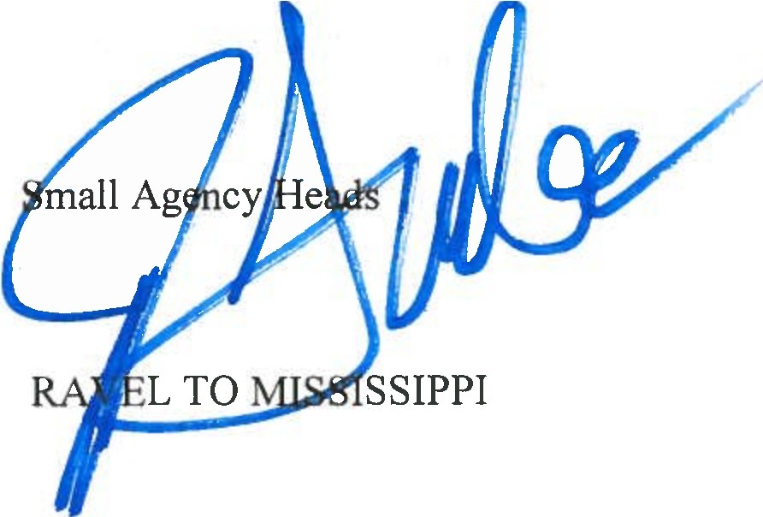
April 5, 2016

TO: All Executive Cabinet and FROM: Jay Inslee, Governor SUBJECT: PROHIBITING PUBLIC T

Washington State has a strong history of prohibiting discrimination and promoting diversity and inclusion. Our Washington Law Against Discrimination (WLAD), Ch. 49.60 RCW, guarantees for all Washingtonians the right to be free from discrimination on the basis ofrace, creed, color, national origin, sex, honorably discharged veteran or military status, sexual orientation, or the presence of any sensory, mental, or physical disability or the use of a trained dog guide or service animal by a person with a disability. And late last year, the Washington Human Rights Commission, through rulemaking, clarified the WLAD and affirmed protections for transgender people to use bathrooms and locker rooms consistent with their gender identity.

Recently, Mississippi passed House Bill 1523, which perpetuates an unfair and injurious prejudice against the LGBTQ community. The law allows government employees and private businesses to deny service based on religious beliefs. It authorizes discrimination against LGBTQ individuals, including but not limited to Washington citizens who may be traveling to Mississippi for work-related purposes, contrary to the protections of the WLAD.

It is the law of Washington State and the policy of my administration to demand equality for all persons. Consequently, I hereby order that no executive cabinet-level agency or small-cabinet agency shall allow publicly funded non-essential travel to the state of Mississippi so long as the recently approved House Bill 1523 exists in its current form. I invite all other statewide elected officials, institutions of higher education, agencies, boards, and commissions to follow the provisions of this directive.

® 16 P.O. Box 40002 • Olympia, Washington 98504-0002 • (360) 902-4111 • www.governor.wa.gov 0

