
How to create a Christopherson Business Traveler Profile

Step 1: Please choose your department Link Below

UW IHME - https://airportal.cbtat.com/enroll/UWA000

UW Dean of Medicine- https://airportal.cbtat.com/enroll/UWA002

UW Student Clerkship - https://airportal.cbtat.com/enroll/UWA005

UW Department of Family Medicine - https://airportal.cbtat.com/enroll/UWA006

UW Department of Global Health - https://airportal.cbtat.com/enroll/UWA009

UW Bothell Campus - https://airportal.cbtat.com/enroll/UWA011

UW Social Work - https://airportal.cbtat.com/enroll/UWA012

UW Student Affairs - https://airportal.cbtat.com/enroll/UWA017

*University of Washington - https://airportal.cbtat.com/enroll/7883
- The above link is for generic UW profiles only- Please inquire with your UW travel manager when appropriate

Note: *Deactivated profiles need to be reactivated not recreated


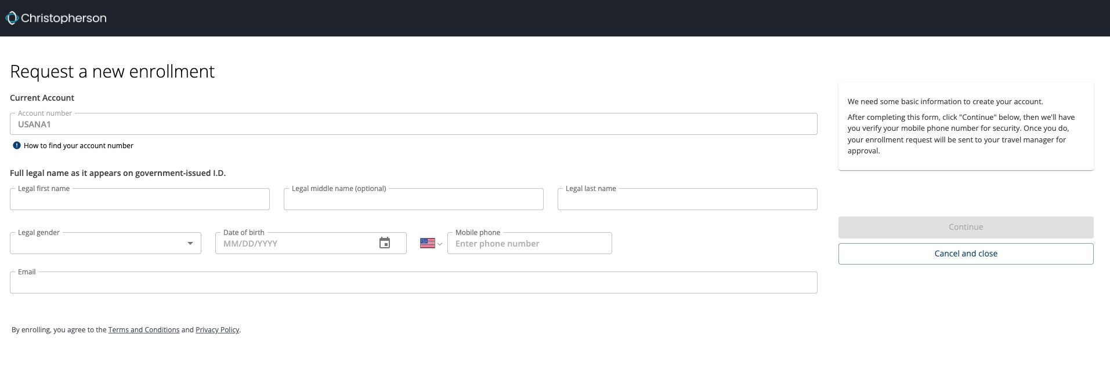
How to create a Christopherson Business Traveler Profile

Step 2:
Validate you are utilizing your correct dept link

The URL will have the following format: https://airportal.cbtat.com/enroll/xxxx
Followed by your company’s account number ex:->13433.

Complete the entire form as these are TSA minimum requirements for booking.

*Use your first, middle, and last name as they appear on your government- issued I.D.

*If you do not have a middle name, leave that field empty

*Airlines require you to provide your mobile phone number and work email

*Legal Gender and Birthdate

Click “Submit” and verify your phone number

*Airlines require cell phone for flight changes, delays and cancellations

University of Washington Travelers Profile continued

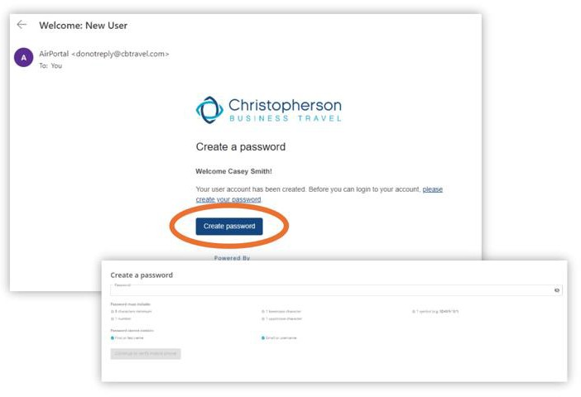
Step 3: (UW employees don’t need to create a separate
AirPortal password – just sign in with your UW NetID)

If your profile enrollment needs to be approved, they will get a notification email on AirPortal will state:
*Go to UW portal and click on the link to complete your travel profile.

Once your profile has been approved, the traveler will receive an email that their account has been activated. They may then logon to https://app.cbtat.com with their UW Net ID

NOTE: only enter the first part of your UW email when logging into your Net ID (ie., not @uw.edu)

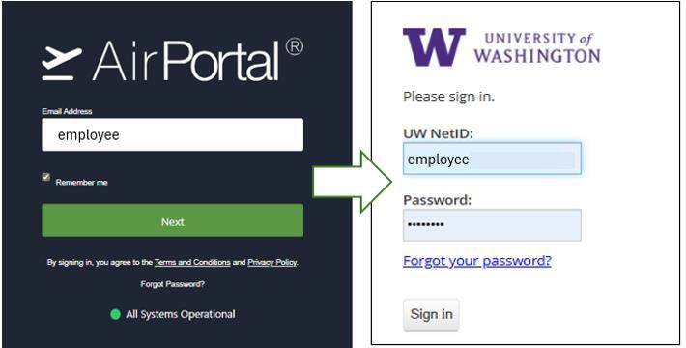

Creating a traveler profile continued – Two factor authentication required

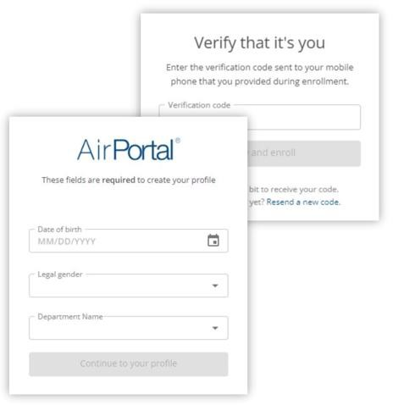
Step 4:
Type in a new password and click “Continue” to
verify your mobile phone.

You will then receive a text that you must enter into the verification code box in AirPortal

You will then be redirected to a screen that of required fields by your University.

After you are done filling out this information click
“Continue to your profile”

Finalizing a traveler profile continued- Personal Info Tab

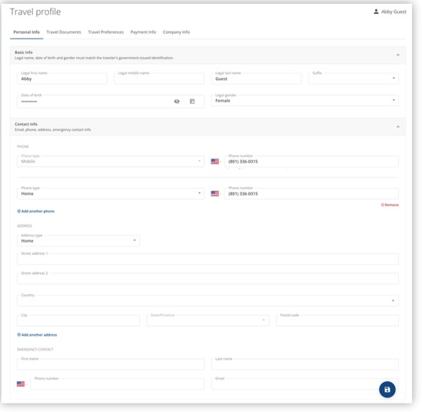
Step 5:
Please finalize any supplementary information under the personal Info tab

*Please validate your full legal name matches the government identification and or matches your TSA Known Traveler number if applicable

  - Work phone if applicable
  - Address
  - Emergency Contacts
  - Click on Save

Creating a traveler profile continued – Travel Documents Tab

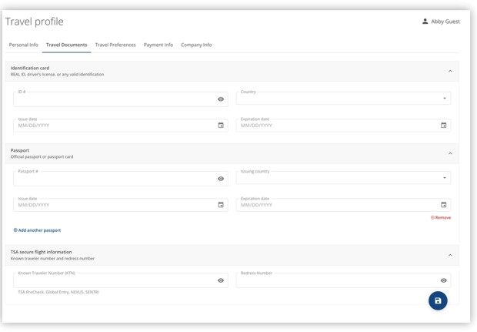
Step 6:
Please enter your Travel documents information

- Known Traveler Number if applicable-TSA
precheck
- Passport number
- Global Entry number
- Click on Save

Creating a traveler profile continued – Travel Preferences Tab

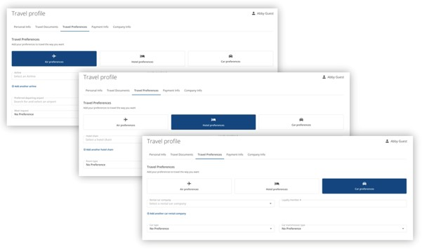
Step 7:
Please enter your Travel Preference and Loyalty numbers if applicable

- Click on payment info and fill out your
University approved payment type
- Car Company Preference and Loyalty numbers
- Hotel preferences and Loyalty numbers
- Click on Save

Creating a traveler profile continued – Payment Tab

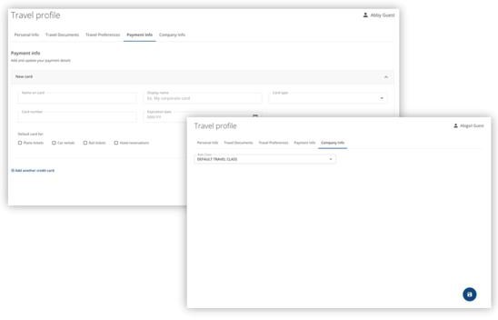
Step 8:
Please click on Payment info tab and enter your company approved payment type

- Click on company info and select your Universities travel type from the drop-down menu
- Click on Save Button bottom right You are done !

Updating your traveler profile

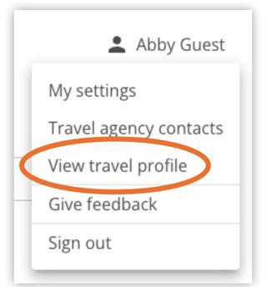
Step 0:
If you have to go back and modify

- Click on your name top right corner and select view travel profile

- Please note if your loyalty numbers and travel/passport information is not in the profile, and you call full service to book, this information will be entered in your booking but not saved in your profile. The traveler needs to input the information themselves to be saved.

- Email: onlinesupport@cbtravel.com for profile errors or issues copy your Customer Success Manager and Account Team.
- Thank You

