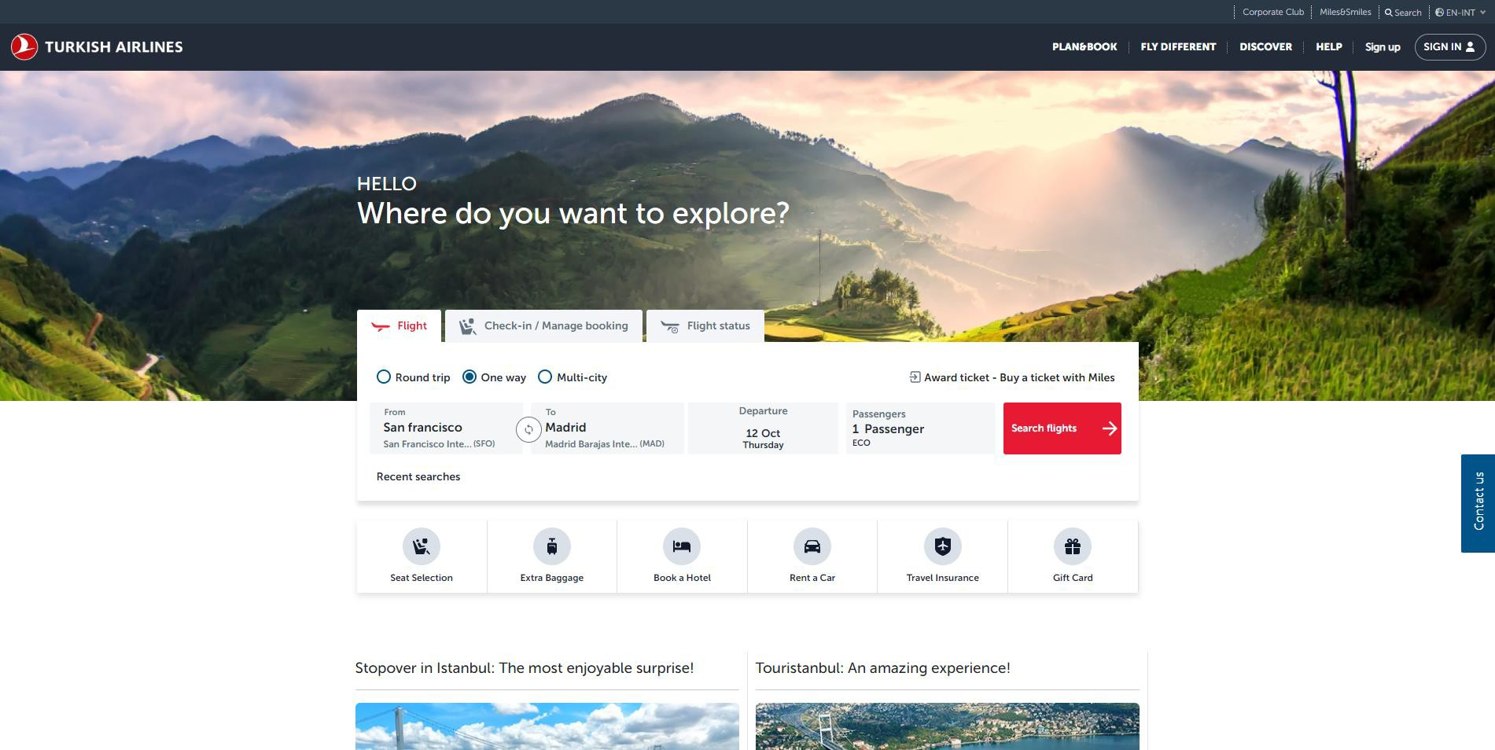
PROMO CODE DISCOUNT PROCESS

Select the flights destination from Turkish Airlines website.

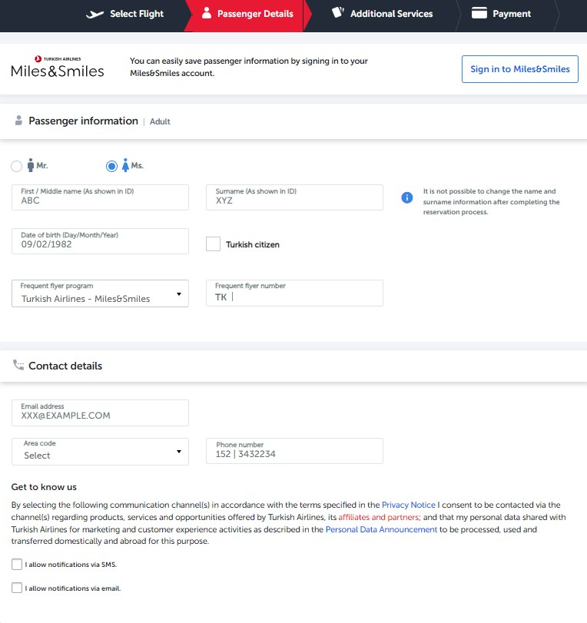

Should be corporate email address that is registered in the system. This is cross checked when validating the promo code on the payment page.

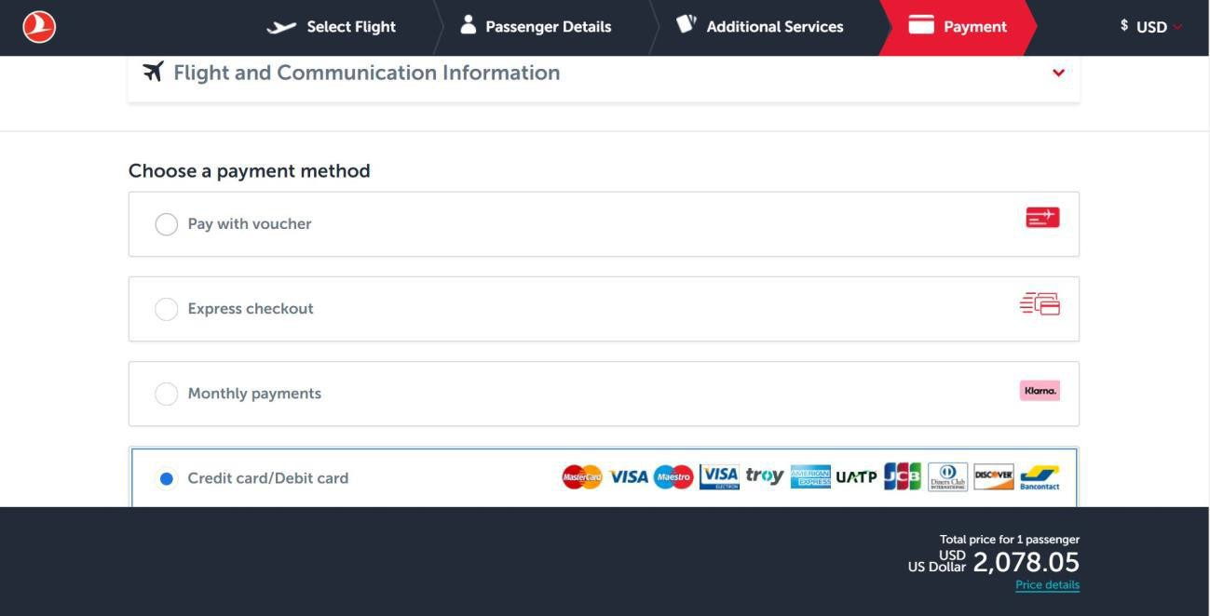
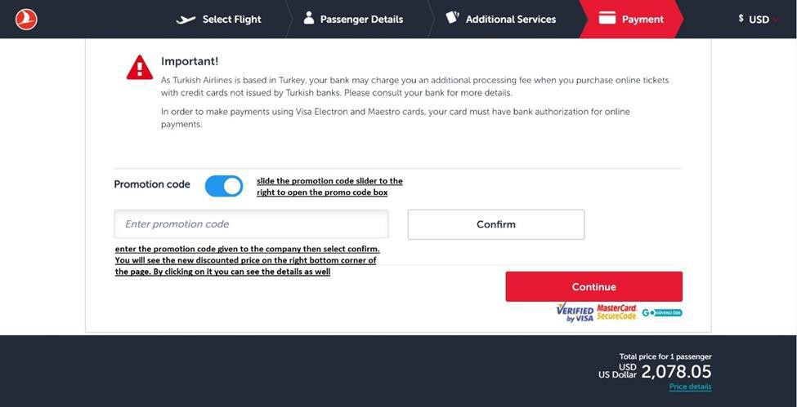

Enter the promo code given to you and select confirm. You will see the discounted price on the bottom right corner of the page. By clicking on it you can see the details as well.

