Ariba eTravel Wire Changes 5/18/2018
All implemented changes in this edition are in support for UW Accounts Payable’s efforts to streamline the wire payment process. The current process is an intensive manual process, and this is part of a multi-year effort to minimize possible errors and manual journal-vouchers.
Please send all questions and concerns to traveluw@uw.edu

Contents
Wire detail on print version of expense report removed 3
Wire Form 4
Wire fee eTravel instruction removed (now automatic) 5

Wire detail on print version of expense report removed
The wire details will no longer be present on the print version of the expense report for wire payment. This is being replaced with the now required Wire Form that must be filled out (typed) and attached to the expense report for wire payment.
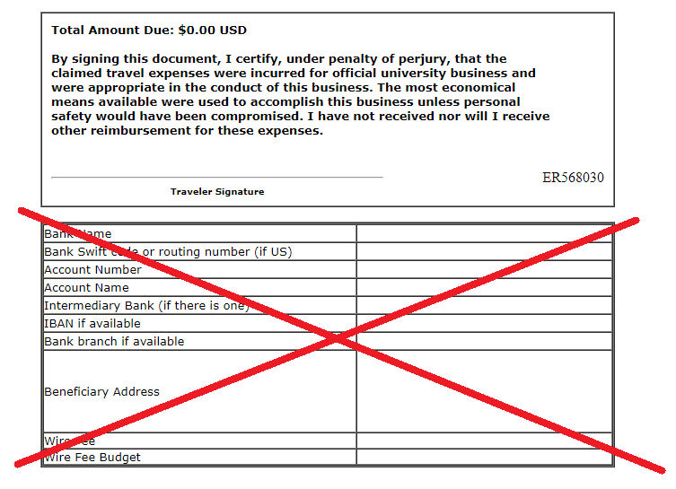

Wire Form
This form is replacing the wire details that populate on the print version of the expense report for wire payment. It must be filled out (typed), and attached to the expense report. Instruction is included on the form.
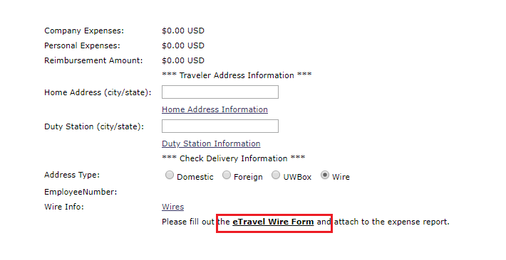

Wire fee eTravel instruction removed (now automatic)
The instruction on how to balance the wire fee in eTravel will now be removed and the wire fee will be process automatically. See below regarding how the fee will be allocated.
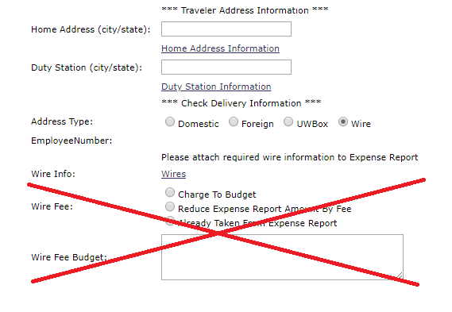

From May 18th to June 15th:
Wire fee will be charged to the predominant budget assigned to the expense report (budget incurring the most expense). If report has single budget, fee will be charged to that budget.
**The transition period is based on finalization of automation from process partners.
From June 15th to future:
Wire fee will be charged based on a percentage relative to amount to each budget.
For example budget A is charged $100 and budget B is charged $50. The wire fee will be allocated proportionally relative to the total expenses on the expense report.
For a $15 wire fee, using the example above, $10 would be charged to budget A and $5 would be charged to budget B.
Budget | Expense | Proportion of Total | Wire Fee
A | $100.00 | 66.66% | $10.00
B | $50.00 | 33.33% | $5.00
Total | $150.00 | 100% | $15.00

