Travel Services Transition to UW Connect Change Management
- There will be no changes to initial contact with Travel Services:
  - Phone calls will still be accepted
  - Emails will still be sent to travel@uw.edu. (These emails will now funnel into the new UW Connect Basic ticketing system)
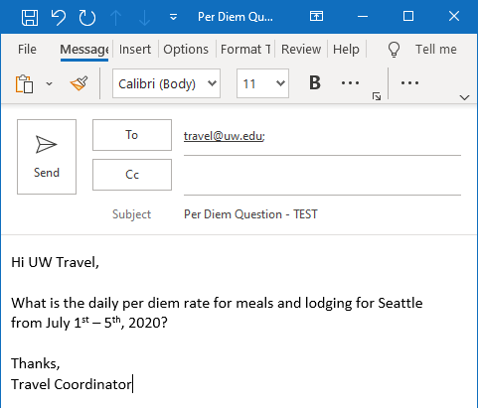
- After the initial email is sent, you will receive an automated email response notifying you the request has been received. A ticket number will be assigned and included in the subject line:
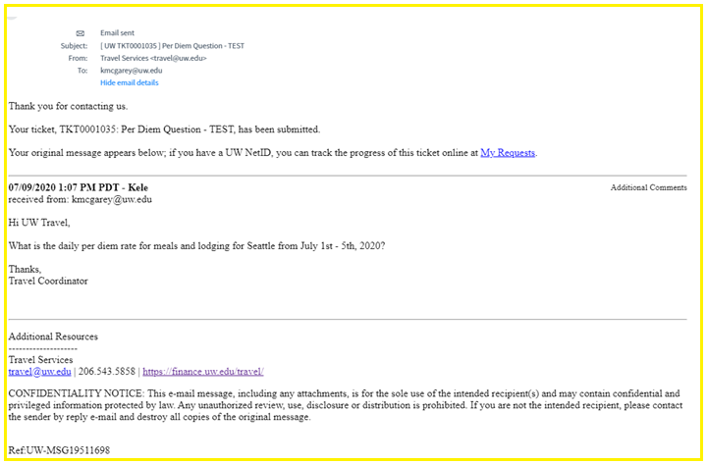

- When Travel Services replies, you will receive another email with the response. A link to the ticket number will be included in the email:
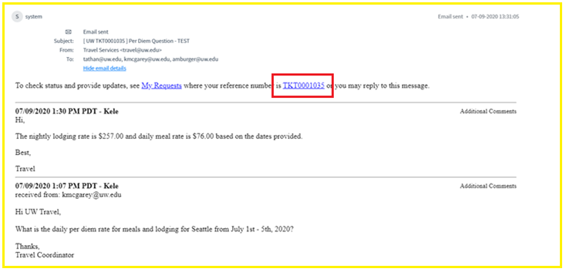
- You have the option to respond via email or by responding directly in the ticket
- Navigating within the ticket will provide you with the full thread of communication and will show any attachments that were included:
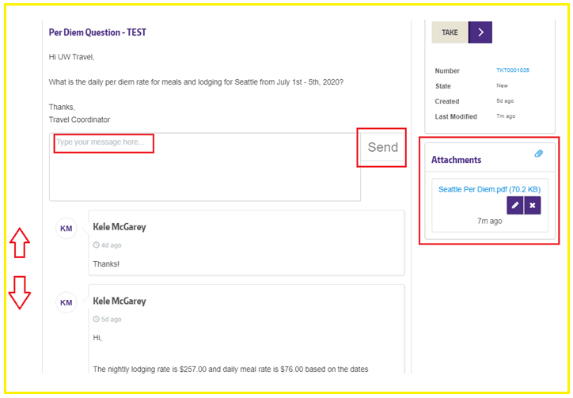
**TIP**
- When initially emailing Travel Services, we recommend including anyone that you would like to be included in the email thread on the ‘to’ or ‘cc’ line but in your subsequent responses, we recommend using ‘reply’ instead of ‘reply all’
  - The additional responses would just include travel@uw.edu in the ‘to’ line
  - This will prevent the individual(s) included on the ‘to’ & ‘cc’ line from receiving an additional email, as the initial email adds them automatically as a watcher on the ticket

